Prometheus Monitoring Architecture: How Metrics Flow End-to-End

Modern cloud-native systems need strong observability to stay reliable and scalable. Prometheus, together with Node Exporter and Grafana, forms a powerful monitoring stack. Let’s walk through how metrics are collected, stored, queried, and visualized.
To understand how this stack gives us deep visibility into system behavior, let’s look at the major components involved:
1. Node Exporter – Metrics Collection Agent
Node Exporter runs on each worker node and is responsible for exposing system-level metrics such as:
- CPU usage
- Memory utilization
- Disk I/O
- Network statistics
These metrics are collected as raw numerical values and exposed in a format that Prometheus can easily scrape and understand.

2. Prometheus – Metrics Engine

Prometheus acts as the core of the monitoring system and performs multiple roles.

a. Data Retrieval (Scraping)

Prometheus periodically scrapes metrics every 15 seconds from Node Exporter endpoints.
This is done over HTTP using the configured scrape targets.

b. Time Series Database (TSDB)

All collected metrics are stored in Prometheus’s Time Series Database (TSDB).
Each metric is stored with:
- Metric name
- Labels (key-value pairs)
- Timestamp
- Value
This structure allows efficient querying and historical analysis.

c. HTTP Server & PromQL
Prometheus exposes an HTTP server (default port 9090).
Users can query stored metrics using PromQL (Prometheus Query Language).
PromQL queries fetch data directly from the TSDB.

3. Service Discovery – Dynamic Target Management

Service Discovery allows Prometheus to automatically find scrape targets instead of relying on hardcoded IP addresses and ports.
Prometheus can dynamically discover:
- Nodes
- Pods
- Services
- Endpoints

This is especially useful in Kubernetes environments where workloads are constantly created, deleted, or rescheduled.

4. Grafana – Metrics Visualization
Grafana is used to visualize metrics in an intuitive and graphical way.
Grafana connects to Prometheus using its HTTP API (port 9090).
It fetches metrics by executing PromQL queries.
Dashboards display metrics as:
- Graphs
- Tables
- Gauges
- Alerts

This makes system behavior easy to understand briefly.
5. Alerting & Alertmanager – Proactive Monitoring

Prometheus can evaluate alerting rules based on metric thresholds.
When a rule is breached alerts are sent to Alertmanager

Alertmanager handles:
- Deduplication
- Grouping
- Routing

Notifications can be delivered through:
- Slack
- Outlook / Email
- PagerDuty
- Webhooks

This ensures teams are notified immediately when something goes wrong.

Summary Flow
- Node Exporter exposes node-level metrics
- Prometheus scrapes metrics every 15 seconds
- Metrics are stored in TSDB
- PromQL queries fetch data from TSDB
- Grafana visualizes metrics
- Alertmanager sends notifications on threshold breaches

Now let’s see how this works in practice using a simple KOPS-based Kubernetes cluster with one control plane node and two worker nodes.
We’ll use Helm to deploy Prometheus and Grafana.
Install Helm:
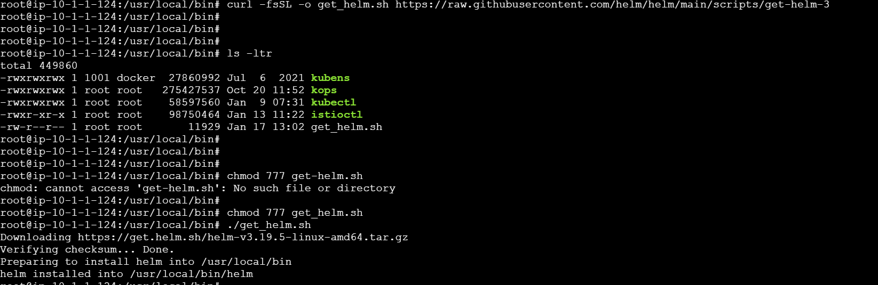
Create a namespace for Prometheus.
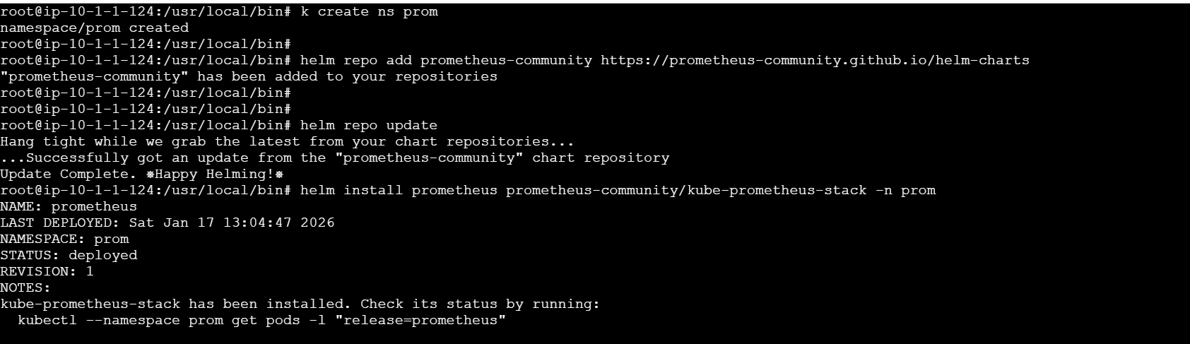

If we look here Prometheus exporter is running as daemon set on all nodes this ensures that it will be available on all the nodes.

If we look at the pods running in the prom namespace, we’ll notice several components created by the Prometheus stack.
Two of the most important ones are Node Exporter (prometheus-prometheus-node-exporter) and kube-state-metrics (prometheus-kube-state-metrics).
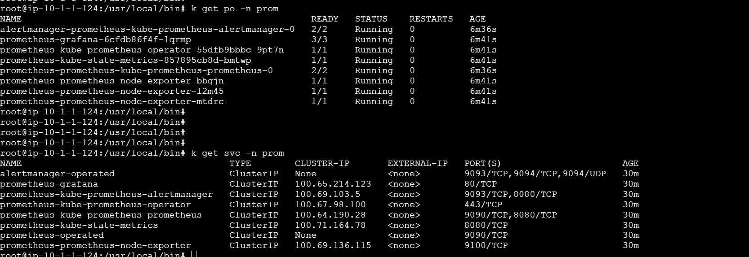
prometheus-prometheus-node-exporter exposes OS-level and hardware metrics from each Kubernetes node.
- Examples of metrics
- CPU usage, load average
- Memory usage & swap
- Disk usage, I/O, filesystem stats
- Network traffic & errors
- Node uptime
Whereas prometheus-kube-state-metrics monitors state of Kubernetes objects, but not resource usage
It reads data from the Kubernetes API server and exposes it as metrics.
Such as
- Pod status (Running, Pending, Failed)
- Deployment replica count
- Desired vs available replicas
- Node conditions (Ready, NotReady)
- PVC status, requests, limits

Now let’s expose the Prometheus port (9090) and try to access the promql you’ll se a screen as below
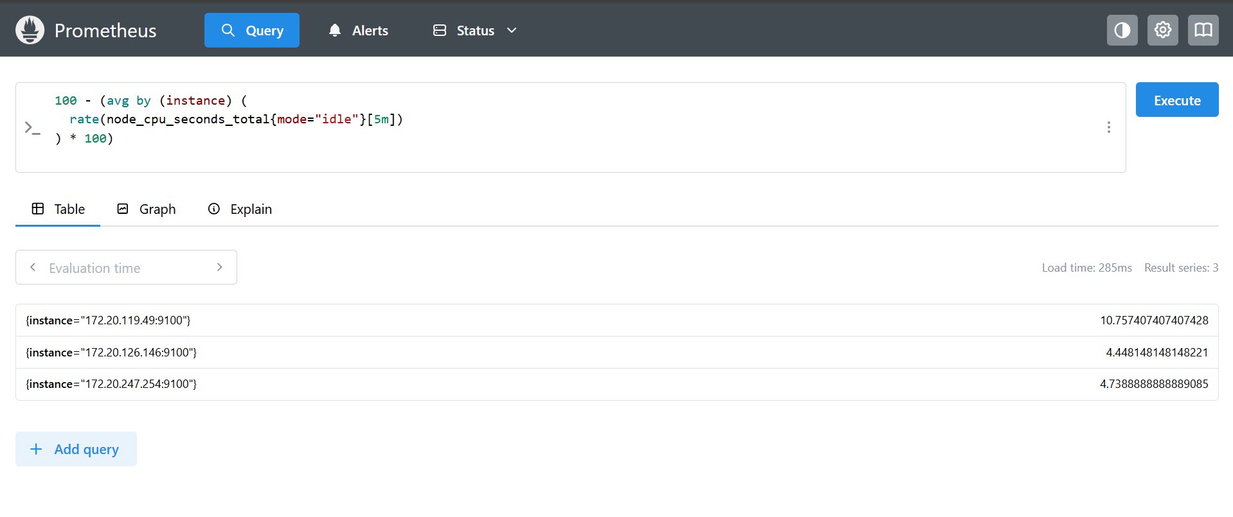

Below query displays the CPU on each node likewise we can query as per our requirement.
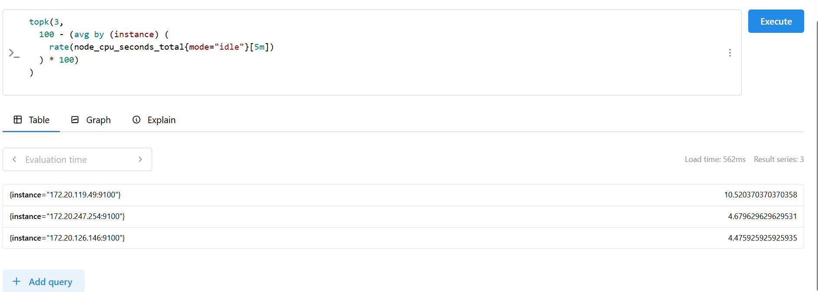
Now as above lets forward Grafana port and lets try to access it’s Dashboard.
You can get the password with below and admin will be the default username.
kubectl get secret -n prom prometheus-grafana \
-o jsonpath="{.data.admin-password}" | base64 -d
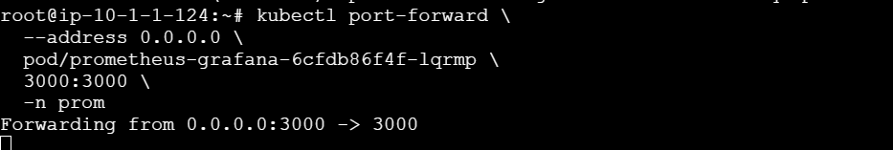
You can create dashboard of your own by using the + symbol on top
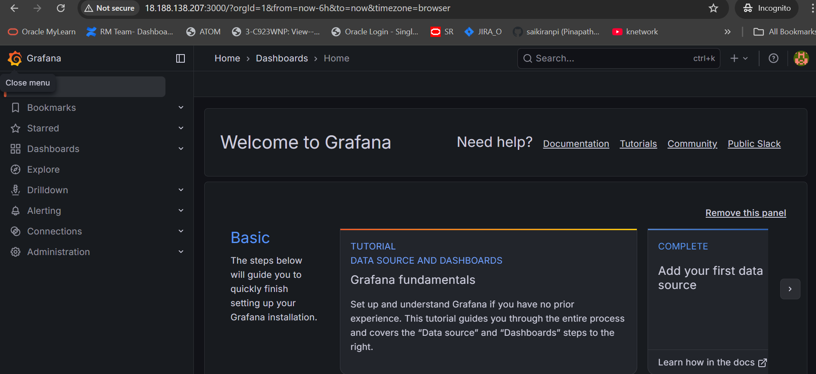

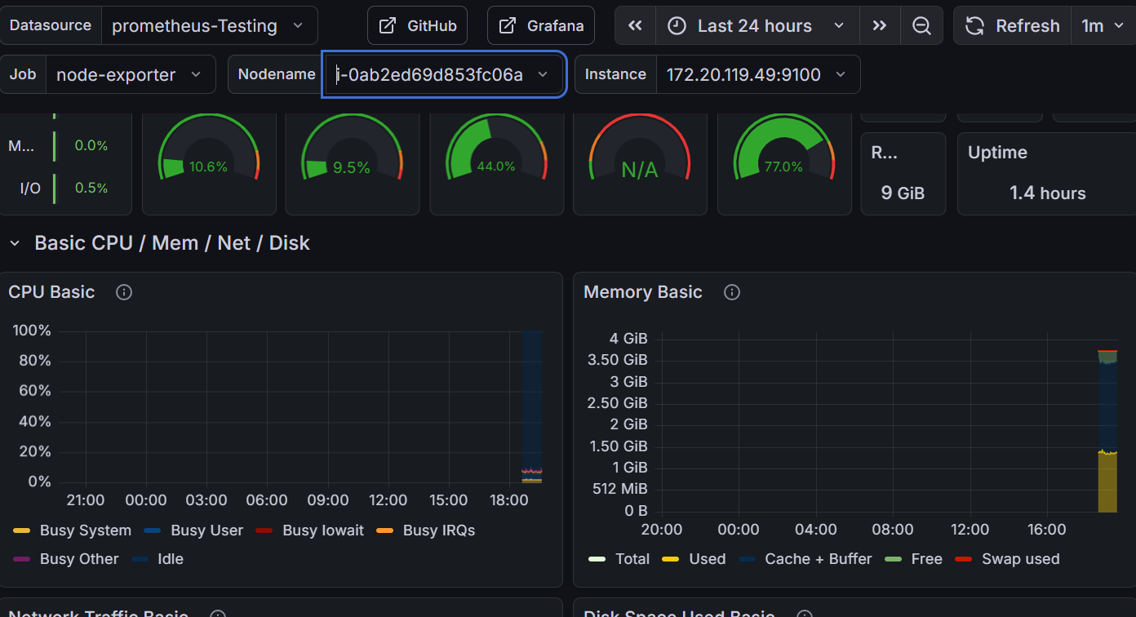
Now lets create a deployment with 6 replicas in default namespace
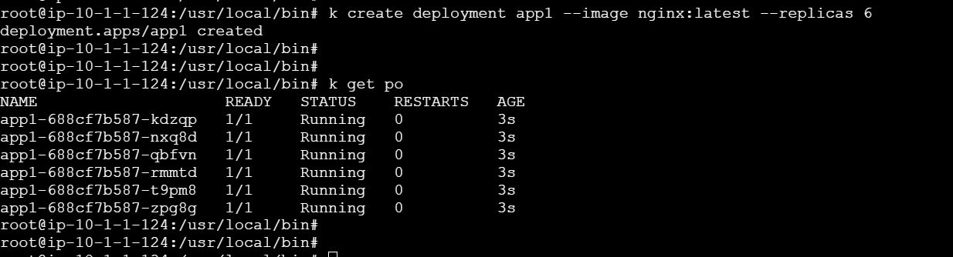
In below dashboard we can see the pod details
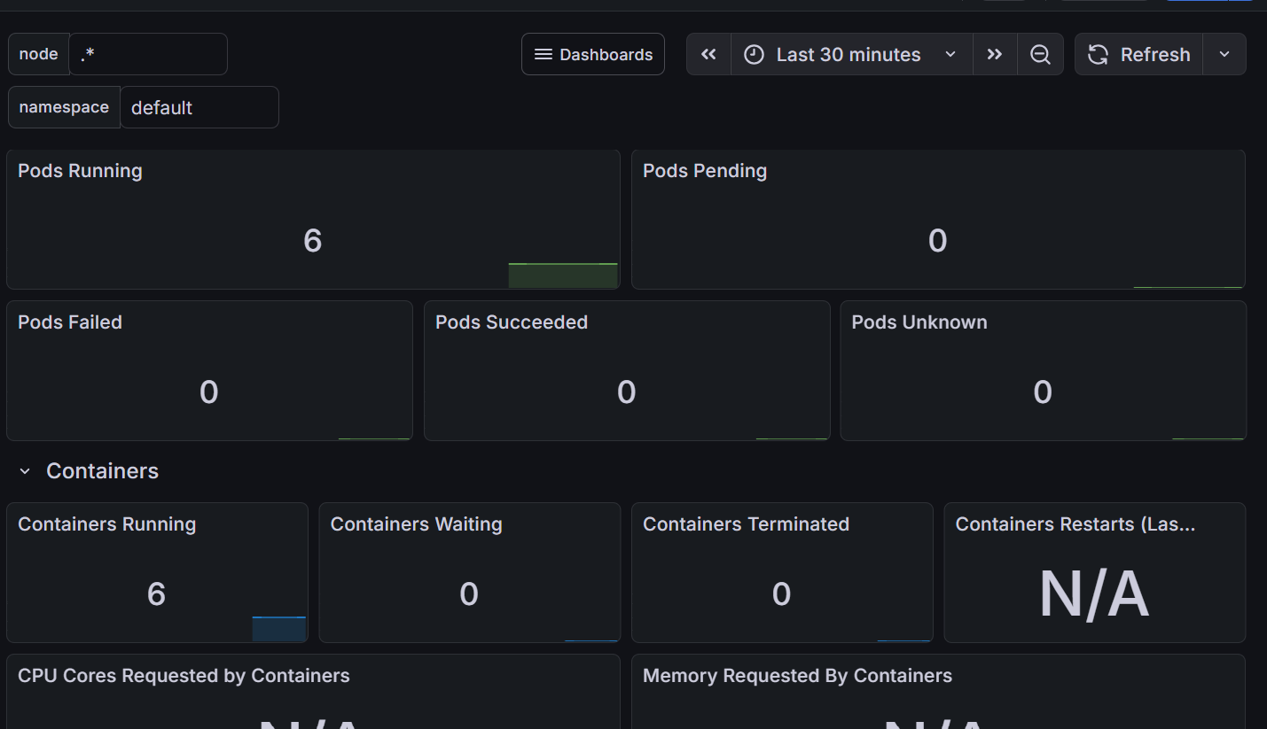

Create new namespace for ELK
