Basically, there should be no network communication between two pods which are in different namespaces and if needed we will allow the communication over a particular port.
This above strategy is considered as a good practice.
We will be using Calico as a CNI for this particular practices there’ll be no public and private IP created as part of the cluster creation as we used Calico

We’ve created two pods in the same namespace(default)

And when we exec into pod1 and ping the IP of another pod we don’t see any packet loss
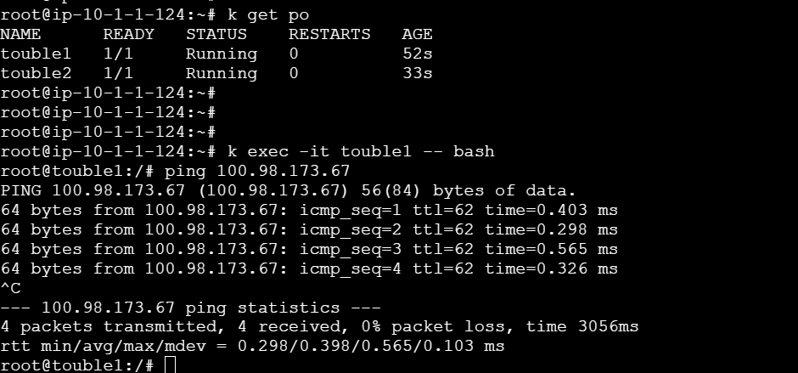

Now if we want to restrict network from one pod to another in same namespace, we can leverage the Networkpolicy in k8s
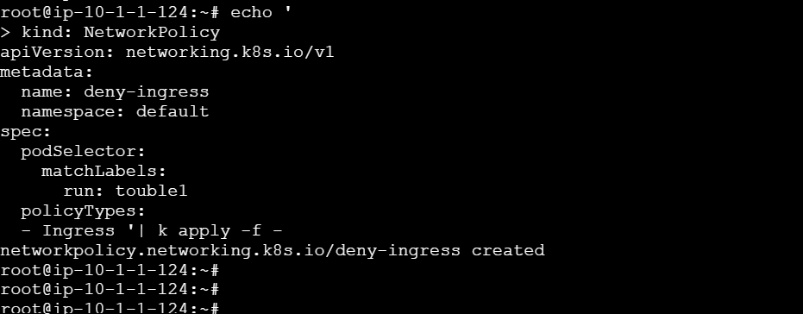
Here we have denied any traffic to enter into pod1 see the labels we used are of pod 1 so we have exec into pod2 and tried ping it resulted in 100% packet loss
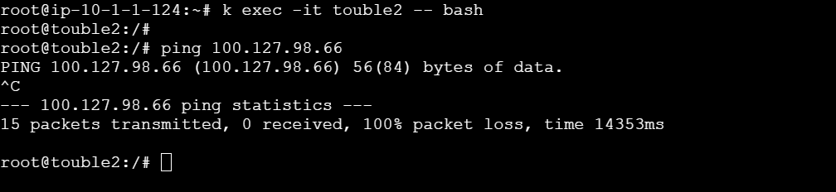

Now we have created new policy to restrict the traffic from going out of the pod1 by doing this we have successfully restricted the communication between two pods

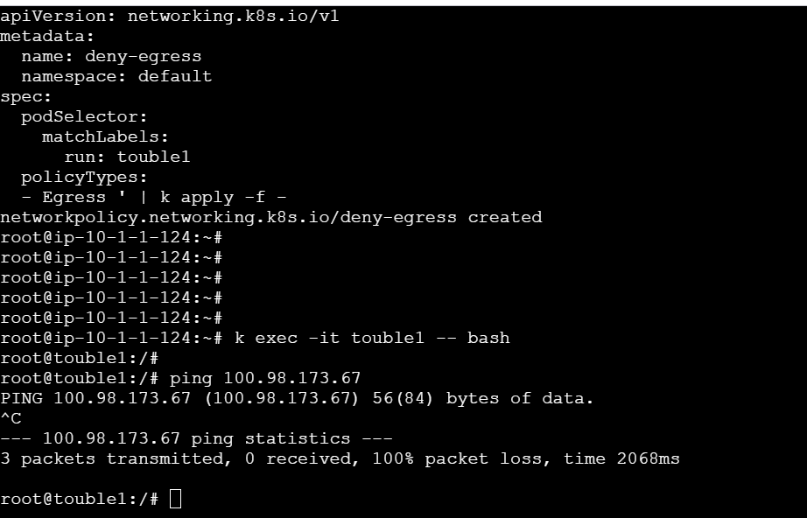

Now lets see how can we restrict the traffic between namespaces for that lets create 3 namespaces prod,qa and dev and add labels for those namespaces.

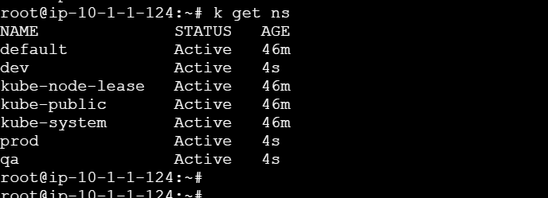
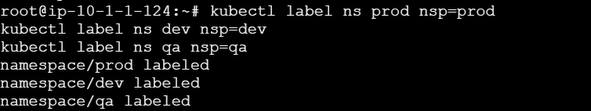

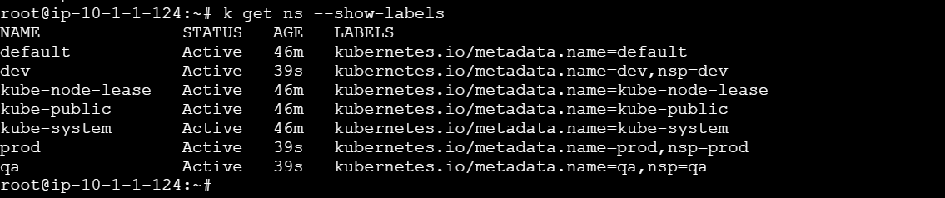

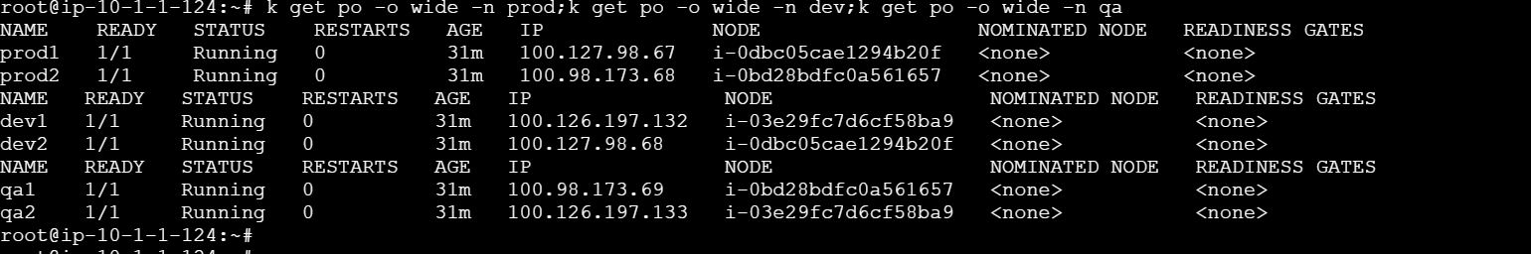

Now we’ll login into each pod and ping the pods in other namespaces below is the command to achieve that and the result would be all pods can communicate with each other but we want to restrict that
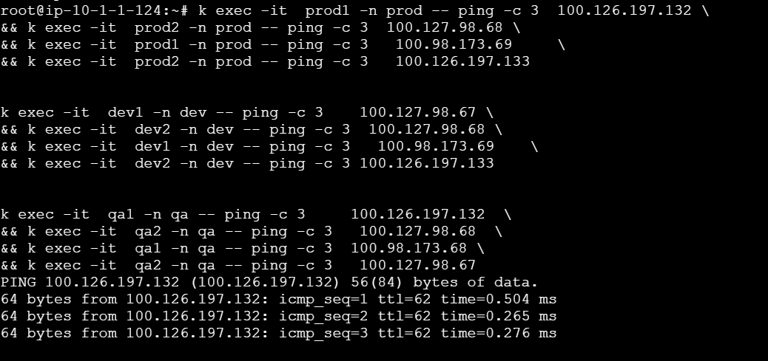
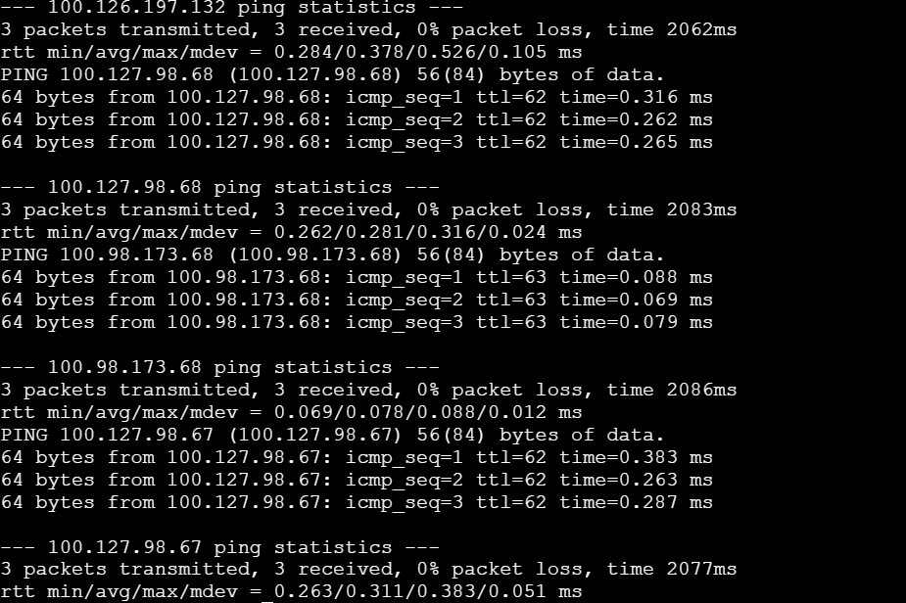

No lets block all the traffic both egress and ingress on all namespaces
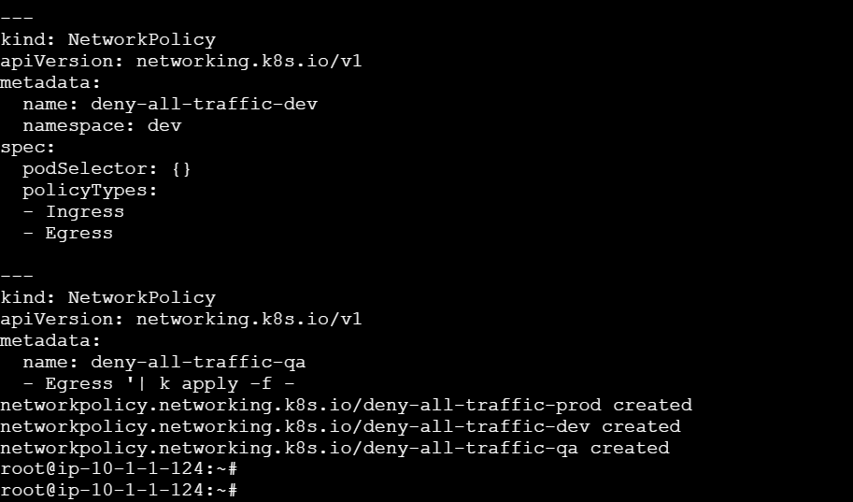

We can see 100% packet loss here after blocking traffic on all namespaces.
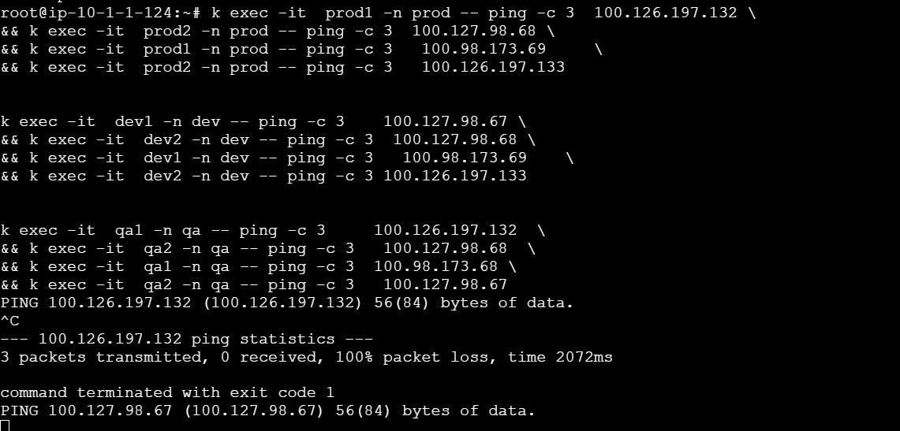

If we want to allow traffic between pods in the same Namespace we can achieve that by
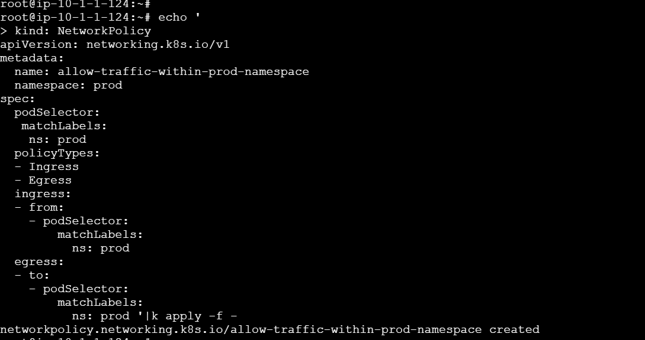
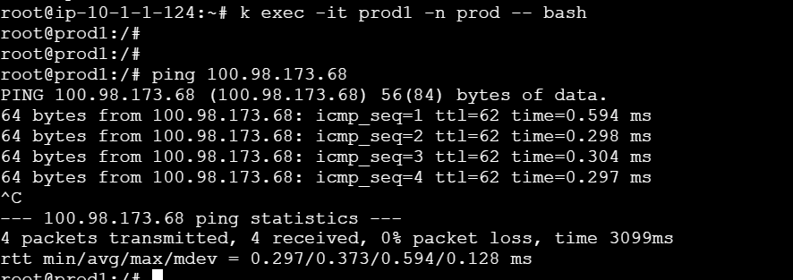

Now let go a step further and allow traffic between pods in Dev and prod namespace
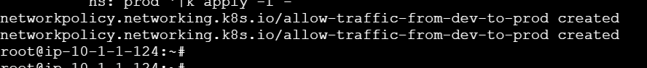

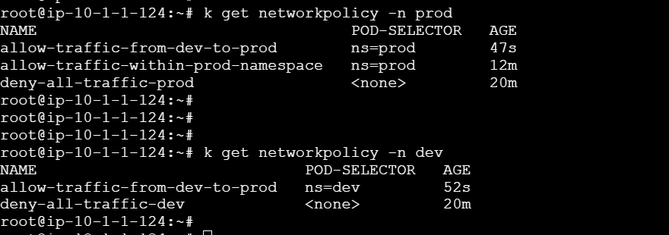
If we see below we are able to ping from Dev pod1 to Prod pod1
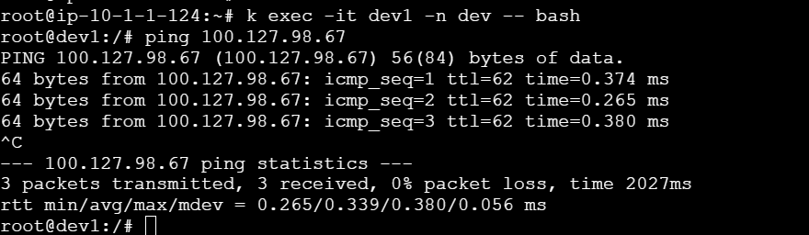

If we want to achieve high and best security practice we can allow ingress and egress only on the port on which our microservice/application is running on.
For example lets allow traffic from prod to qa only on tcp -port 8888
Allowed ingress on prod ns
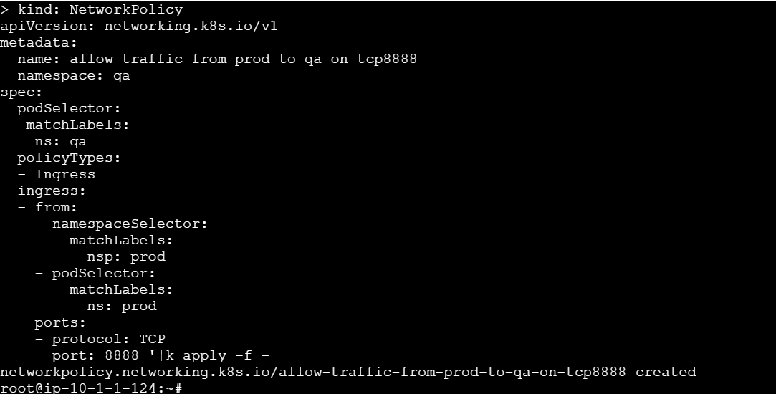

And egress on qa namespace
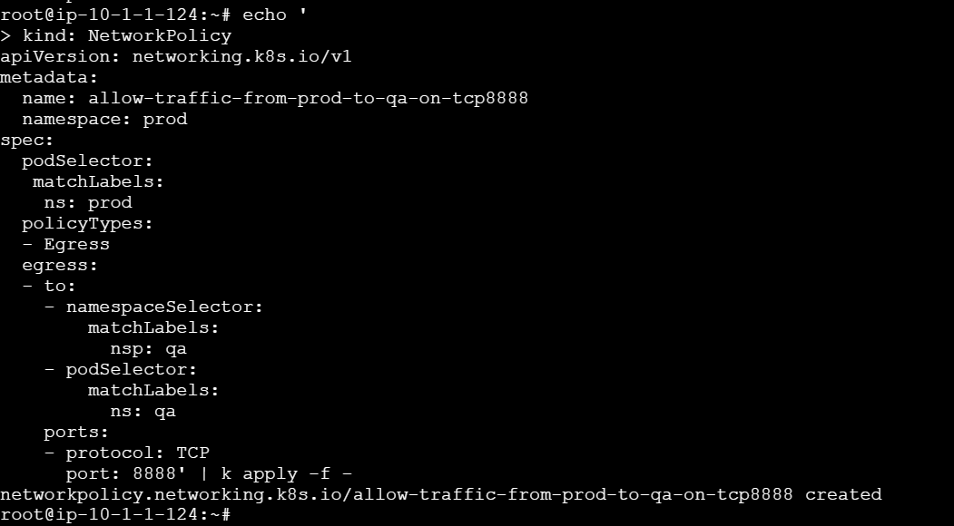

Egress from qa wont work cuz we only allowed ingress on qa and that means it can only receive the outside traffic
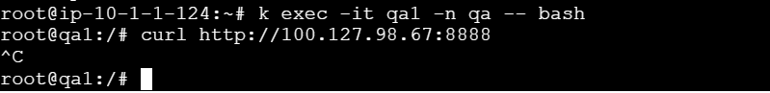
But when we curl from prod to qa pod it is success
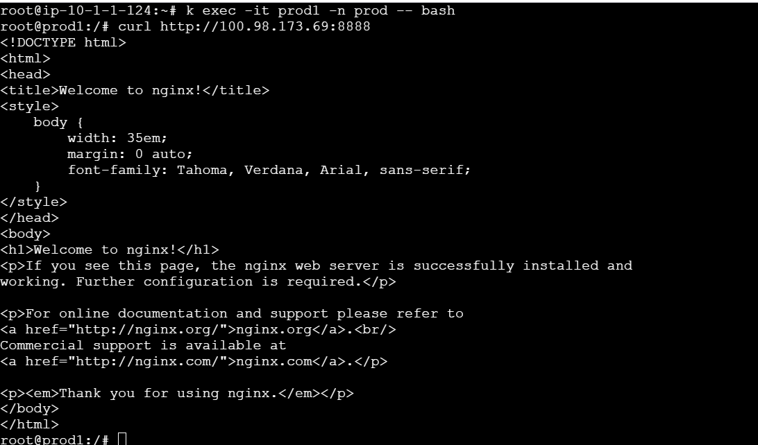

Every pod dns will be stored in core-dns pod in the kube-system namespace so it is important for all pods to access the record in-order to communicate using DNS
So we will use the below labels of coredns to establish a egress connection between prod pods and coredns and we will allow on the port
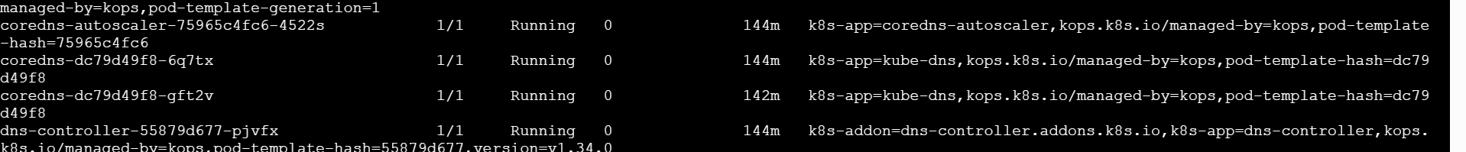

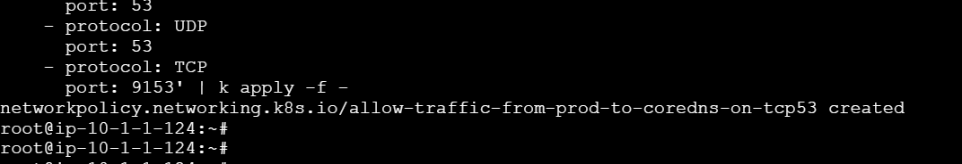

So pods in prod ns curl to coredns on port 53(on which coredns operates for DNS resolution ) and 9153(coredns exposes metrics on this port)
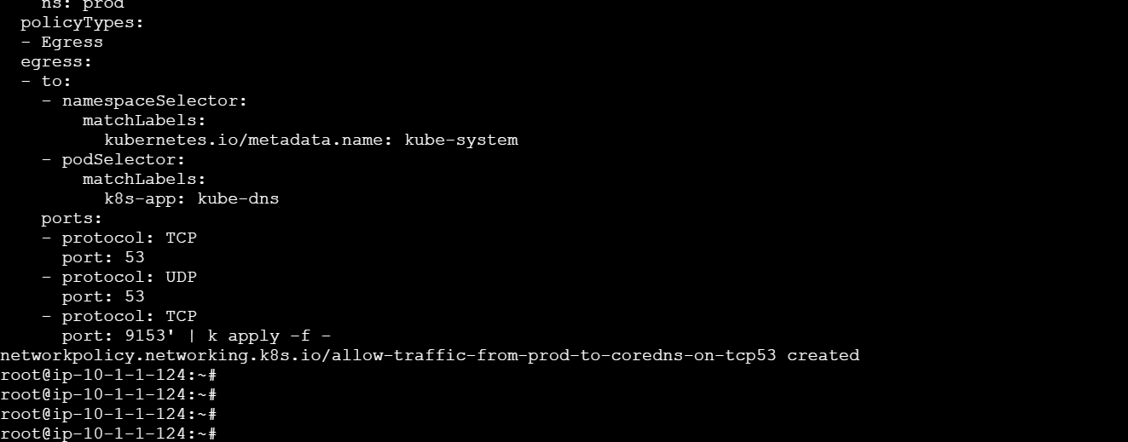

coredns-dc79d49f8-6q7tx 1/1 Running 0 153m 100.126.197.129 i-03e29fc7d6cf58ba9 <none> <none>
coredns-dc79d49f8-gft2v 1/1 Running 0 150m 100.98.173.66 i-0bd28bdfc0a561657 <none> <none>
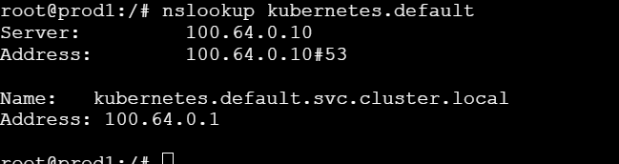
This is the clusterIp 100.64.0.10 of coredns

