EmptyDir
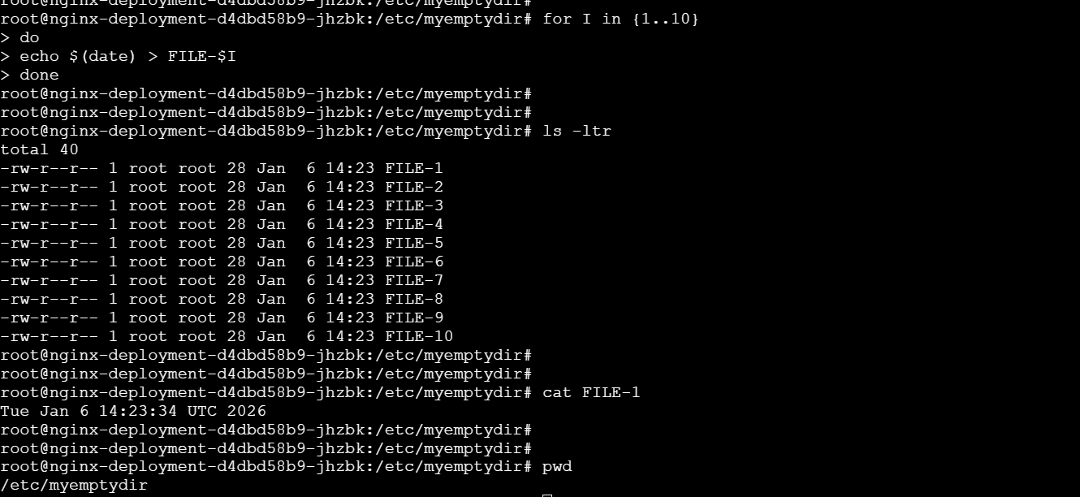

Nginx-container
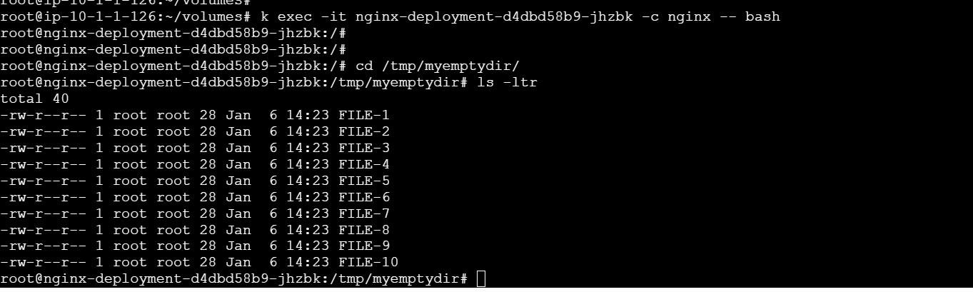

Hostpath
Created Daemonset
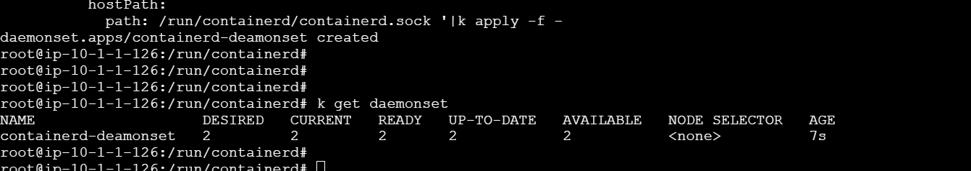

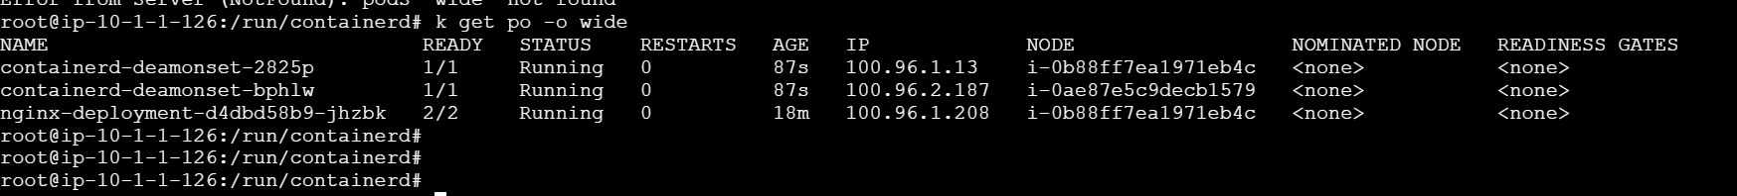

It’s using the host containerd.sock file
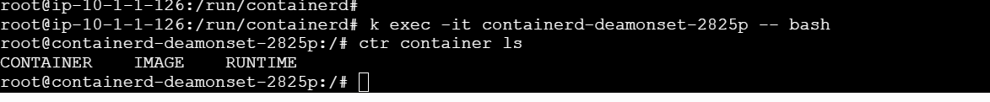

Created mongo db container and attached volume
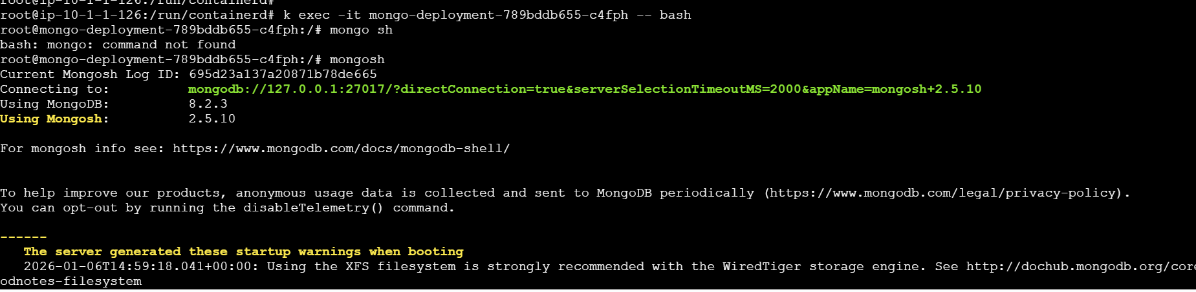

Inserted test Data
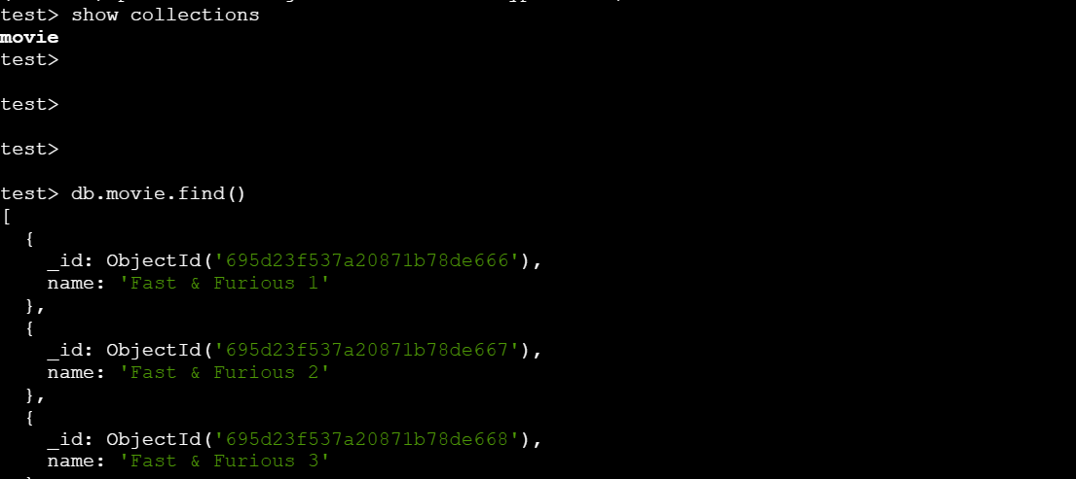
We’ve deleted the pod
Deleted related deployment

Created deployment again
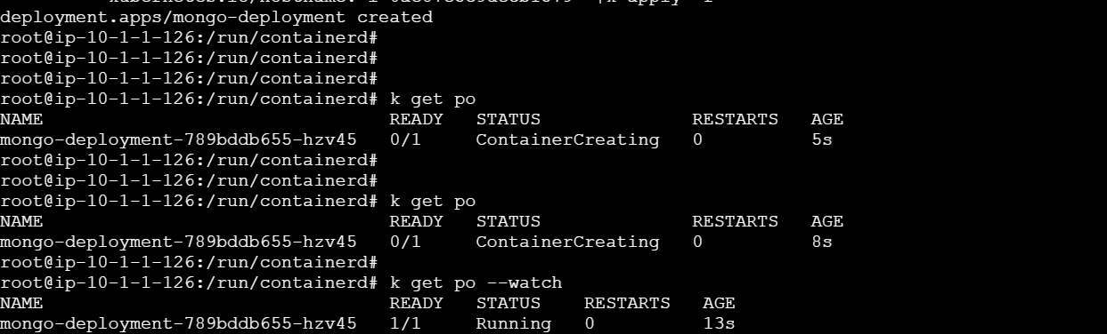

The volume and its data are intact
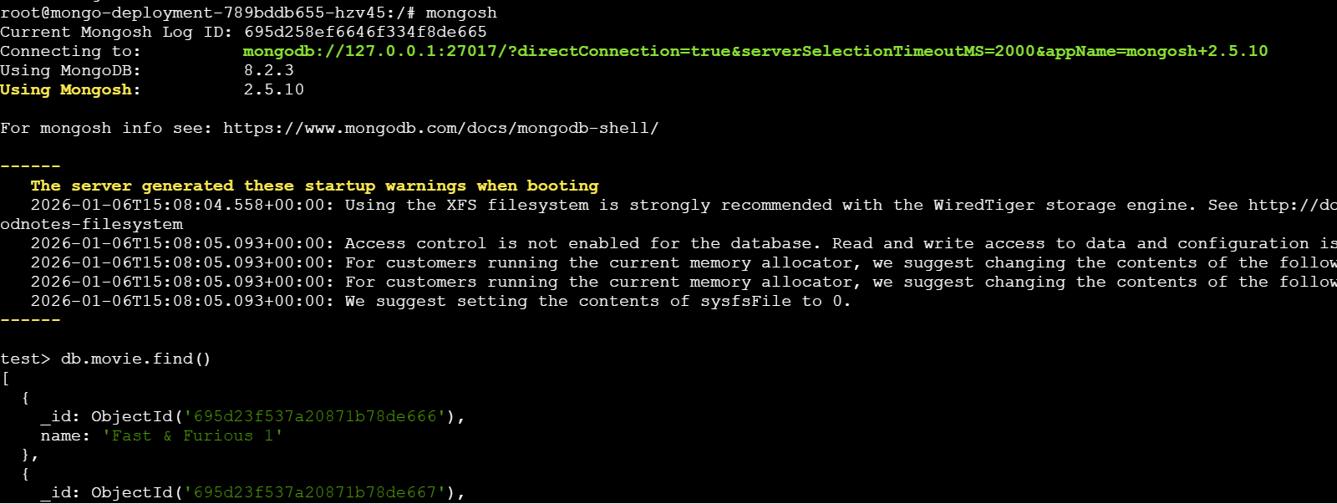

PV

Creating PV

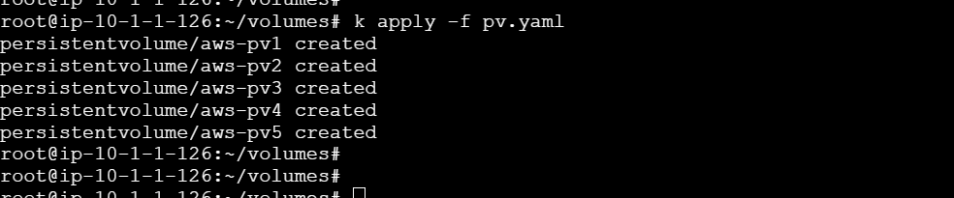
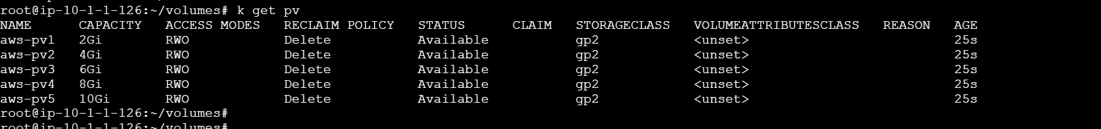

PVC
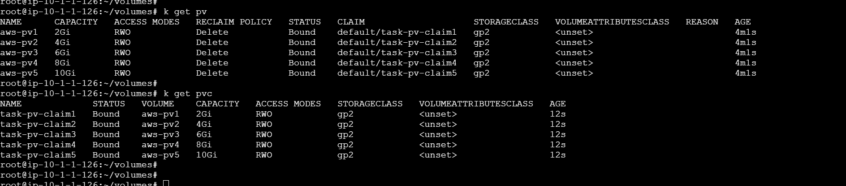
Created mongodb container using volumes
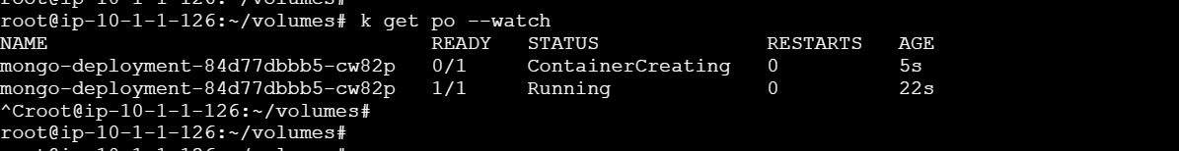

Below are the attached volumes
