Created Deployment:
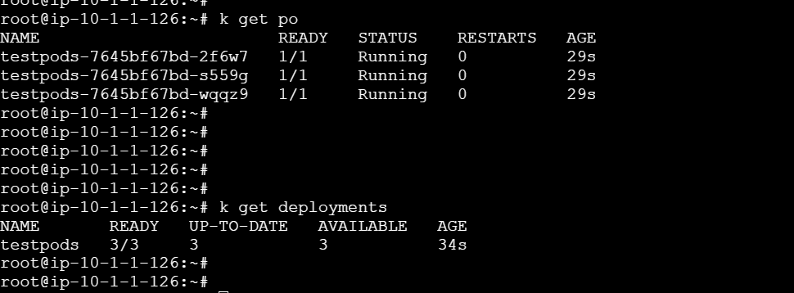

Unable to connect


Updated deployment with liveness probe

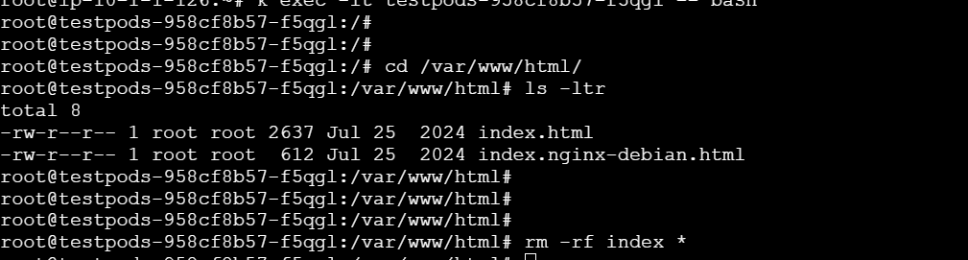

Restarted
