Lets go through how to setup rancher if we already have a Kubernetes cluster in-place

Imported and managed existing Kubernetes clusters into Rancher using cluster-agent model with RBAC, TLS, monitoring, and GitOps via Fleet.
Rancher Mgmt | mgmt-cluster

Existing | prod-cluster (or lab)

Rancher URL | rancher.example.com

Step 1:
Create a namespace to install cert-manager
kubectl create namespace cert-manager
Install cert manager
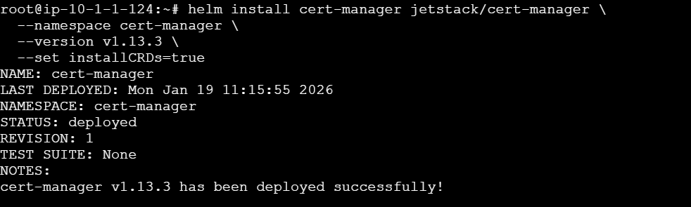

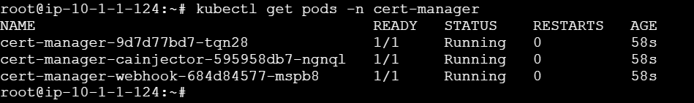

Now install the rancher using helm
helm repo add rancher-latest https://releases.rancher.com/server-charts/latest
Namespace for Rancher
kubectl create namespace cattle-system

