Init-Container

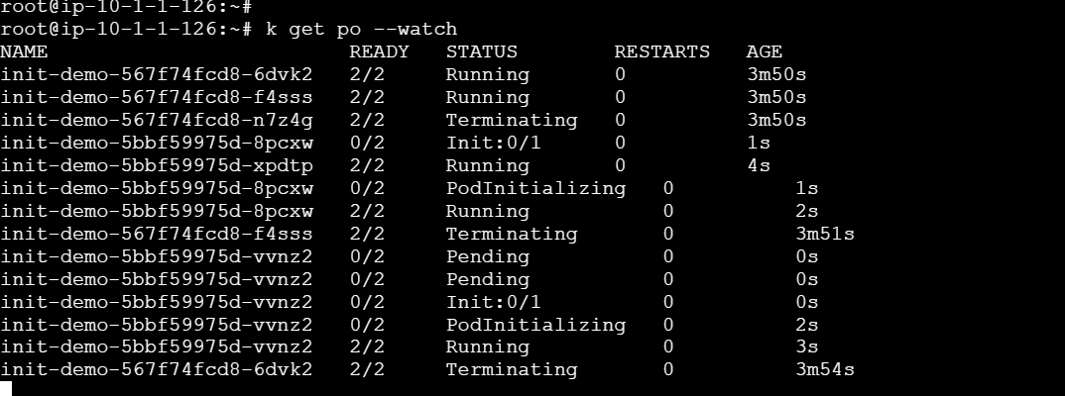

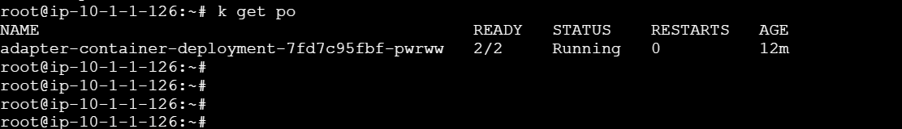

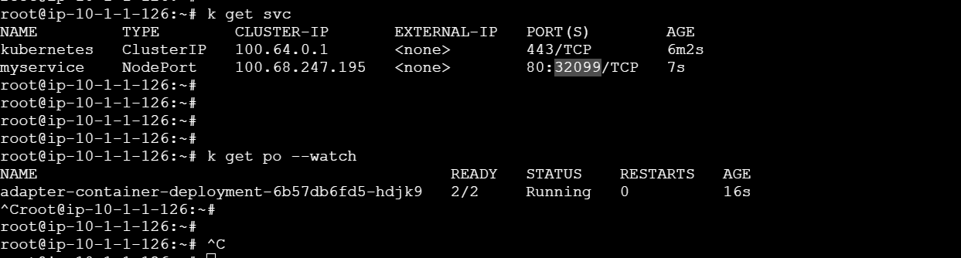
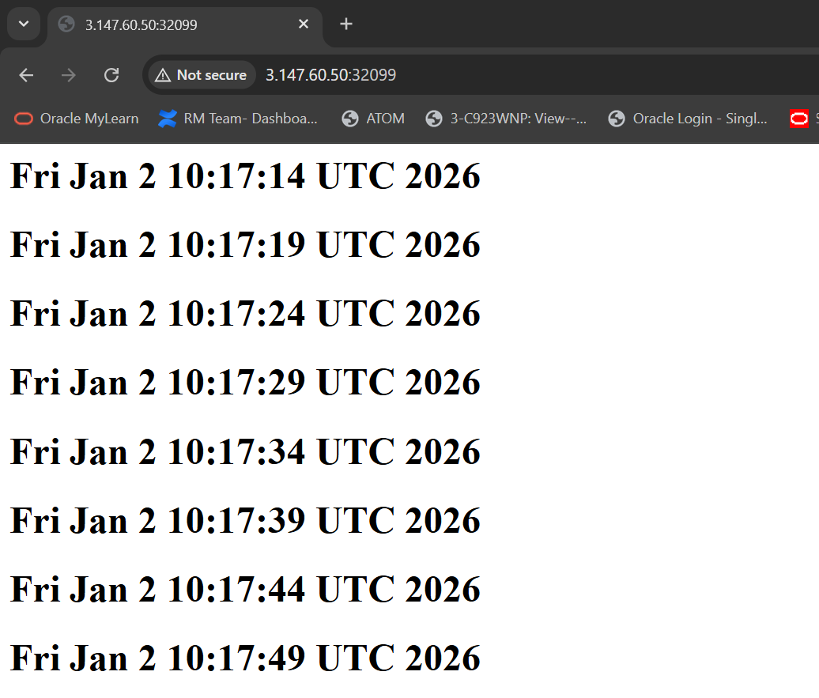

Resource Quotas
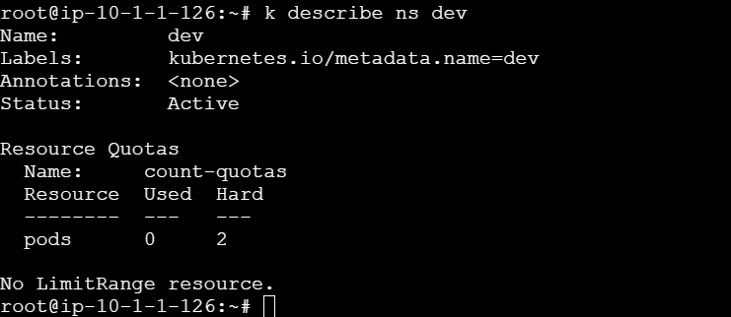

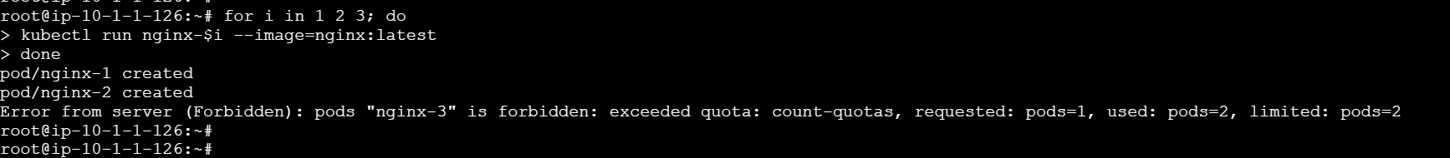

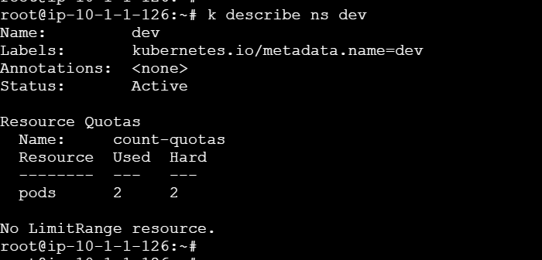

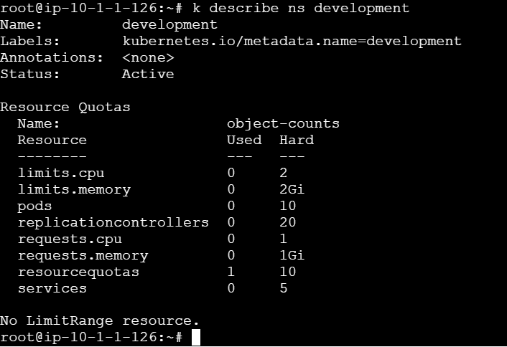

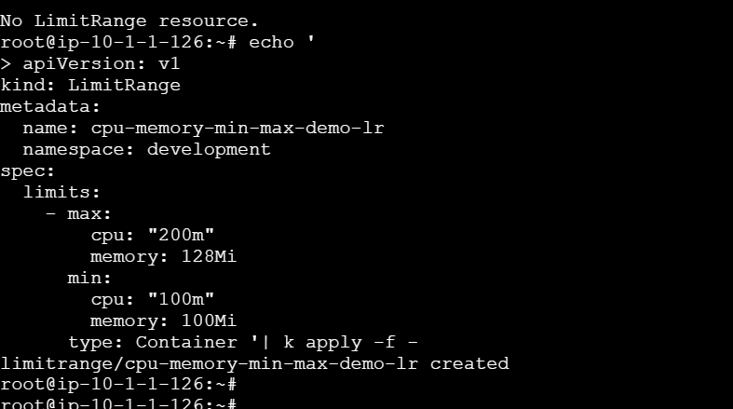

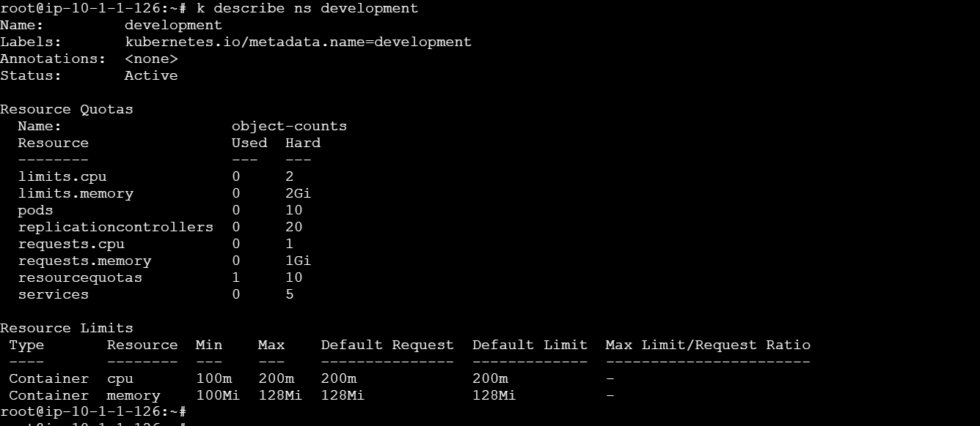

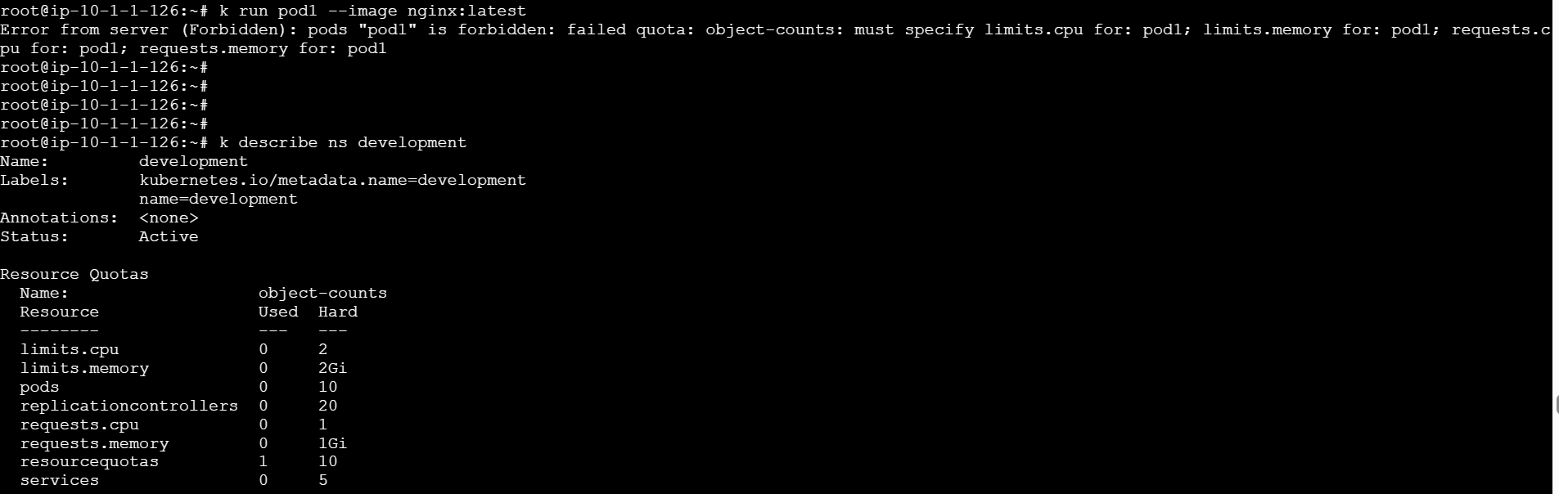

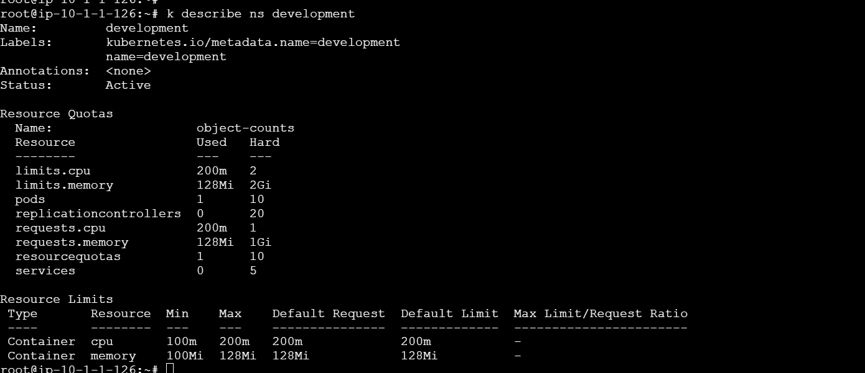

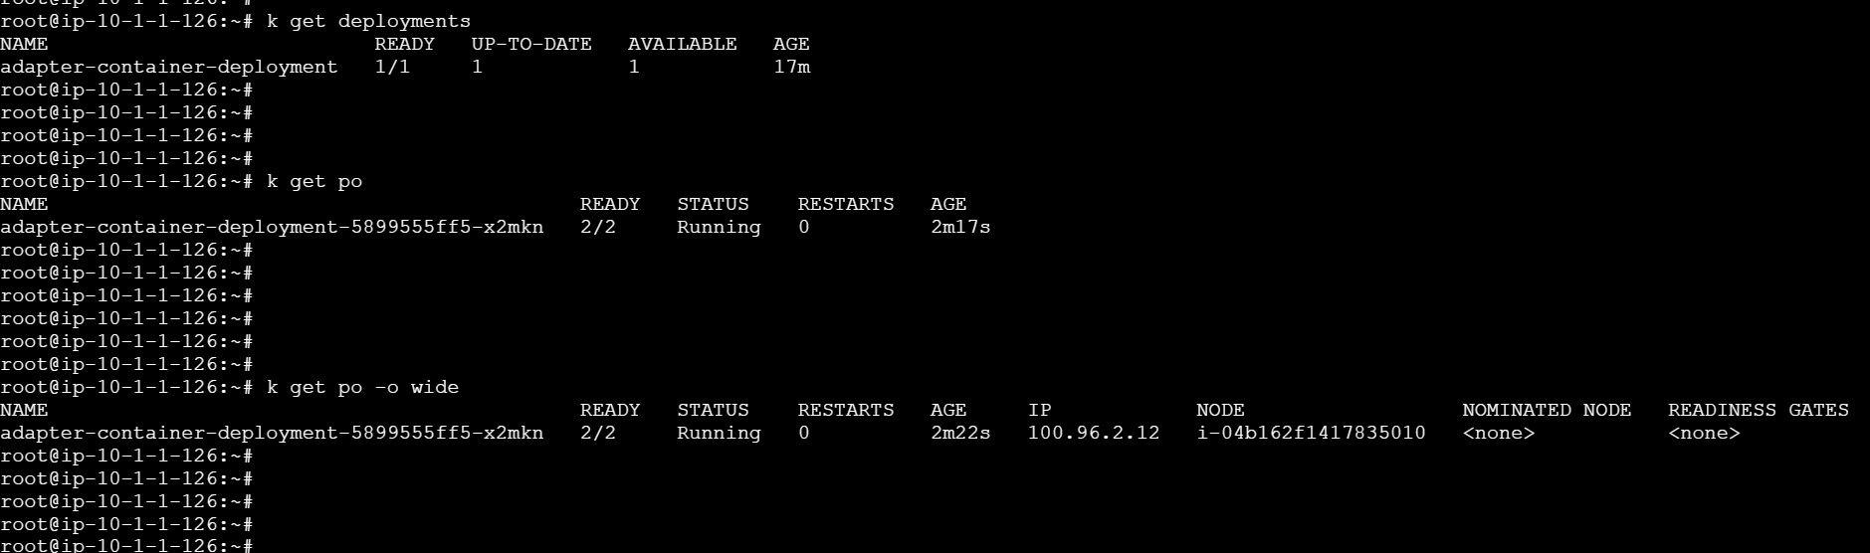

root@ip-10-1-1-126:~# k describe ns devlopment
Error from server (NotFound): namespaces "devlopment" not found
root@ip-10-1-1-126:~# k get ns
NAME STATUS AGE
default Active 114m
development Active 17m
kube-node-lease Active 114m
kube-public Active 114m
kube-system Active 114m
root@ip-10-1-1-126:~#
root@ip-10-1-1-126:~#
root@ip-10-1-1-126:~# k describe development
error: the server doesn't have a resource type "development"
root@ip-10-1-1-126:~# k describe ns development
Name: development
Labels: kubernetes.io/metadata.name=development
name=development
Annotations: <none>
Status: Active

Resource Quotas
Name: object-counts
Resource Used Hard
-------- --- ---
limits.cpu 400m 2
limits.memory 1Gi 2Gi
pods 1 10
replicationcontrollers 0 20
requests.cpu 200m 1
requests.memory 512Mi 1Gi
resourcequotas 1 10
services 2 5

Resource Limits
Type Resource Min Max Default Request Default Limit Max Limit/Request Ratio
---- -------- --- --- --------------- ------------- -----------------------
Container cpu 100m 200m 200m 200m -
Container memory 100Mi 512Mi 512Mi 512Mi -
