Problem:
There are two services one is critical and another one is non-critical now we want our critical service to be deployed on node which has good amount of CPU and storage so that it never encounter downtime
To achieve this, we can either use Node Selector or Node Affinity
Node Selector
NodeSelector is the oldest and simplest way to tell Kubernetes:
“Run this pod only on nodes that have this exact label.”
Example snippet
spec:
nodeSelector:
disktype: ssd
This supports only key = value operations
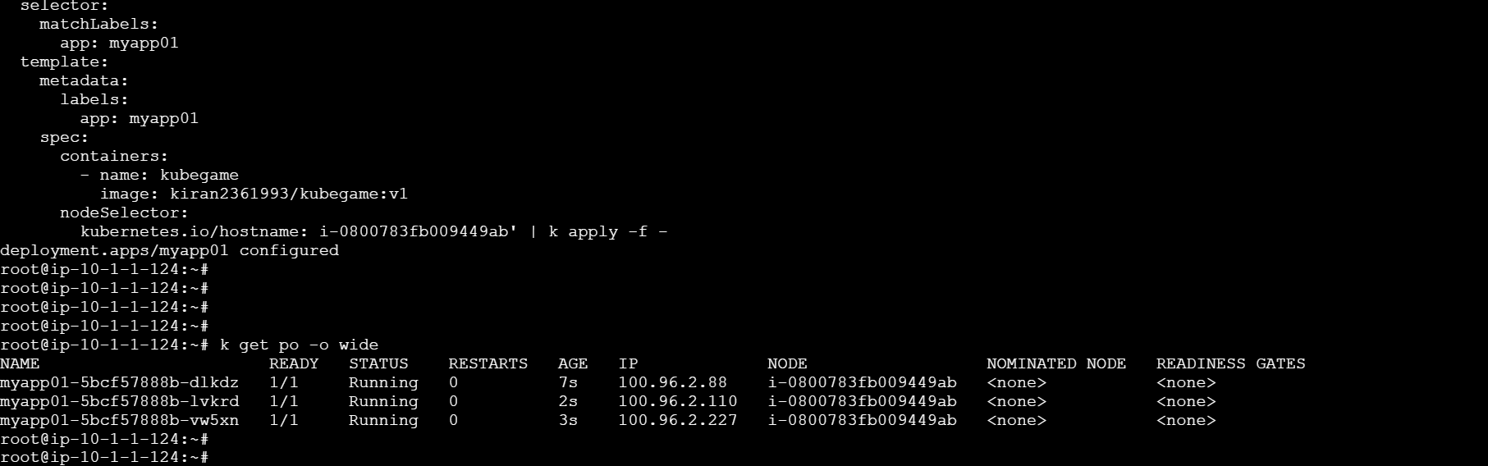

Now we can achieve this by labeling our pod instead of providing instance ID directly
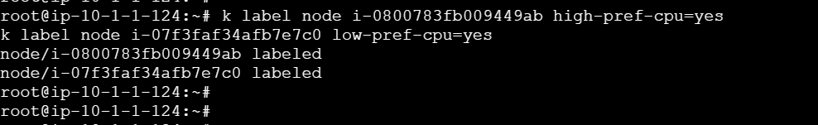
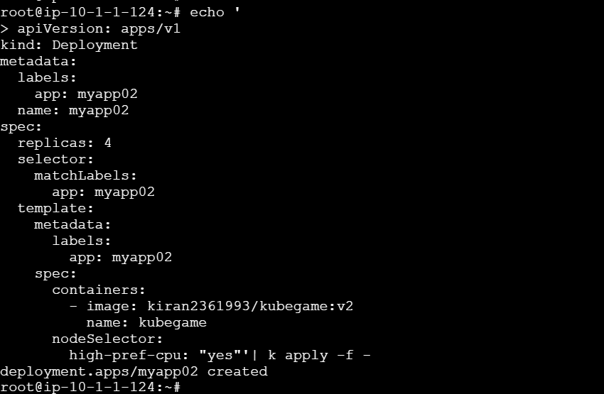

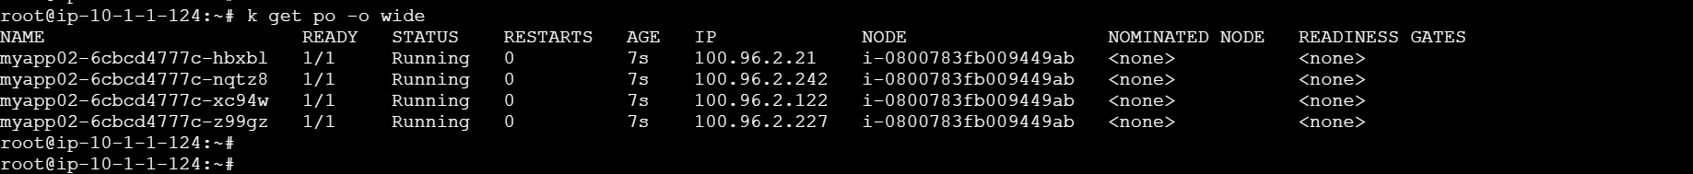
In the above output all the nodes have been scheduled in node with ID i-0800783fb009449ab as we have labeled it as high-perf-cpu

Node Affinity
Node Affinity is the modern, powerful replacement of NodeSelector.
It lets you say things like:
- MUST be on SSD nodes
- Prefer GPU nodes
- Avoid spot instances
- Use OR conditions
- Give priority
It has two modes:
Mode Meaning
requiredDuringSchedulingIgnoredDuringExecution Hard rule (must match)
preferredDuringSchedulingIgnoredDuringExecution Soft rule (best effort)

Example Snippet ( Hard Rule)
nodeAffinity:
requiredDuringSchedulingIgnoredDuringExecution:
nodeSelectorTerms:
- matchExpressions:
- key: disktype
operator: In
values:
- ssd
This is like nodeSelector — pod will NOT schedule if no match.

Example (Soft Preference)
nodeAffinity:
preferredDuringSchedulingIgnoredDuringExecution:
- weight: 50
preference:
matchExpressions:
- key: gpu
operator: In
values:
- "true"
This supports
Operator Meaning
In value in list
NotIn value not in list
Exists label exists
DoesNotExist label not present
Gt, Lt numeric comparisons

operator: NotIn
values: ["spot"]
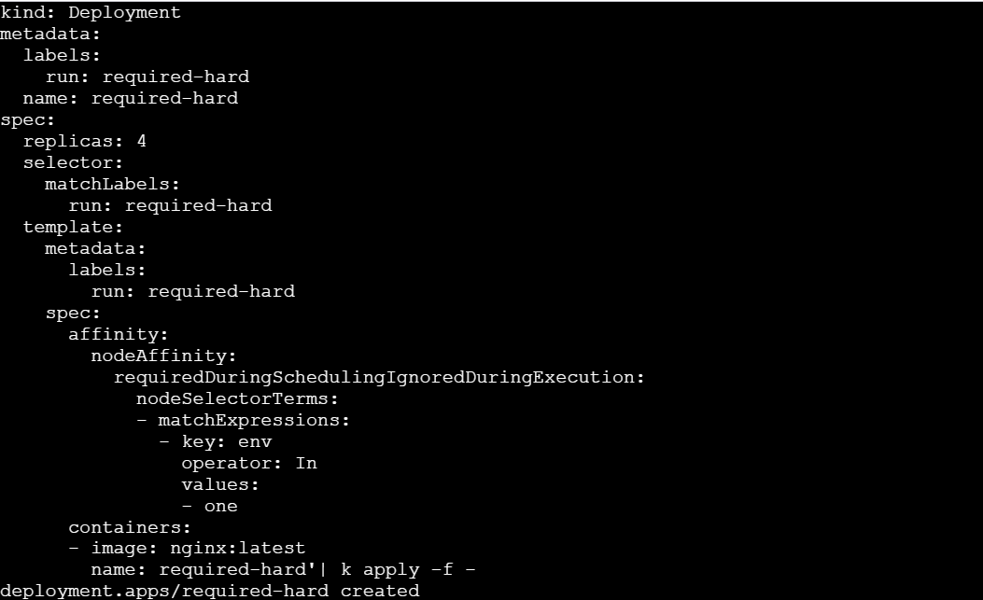
The pods should only create if they gets placed on node with label env=one
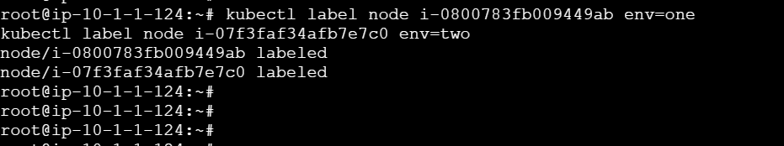
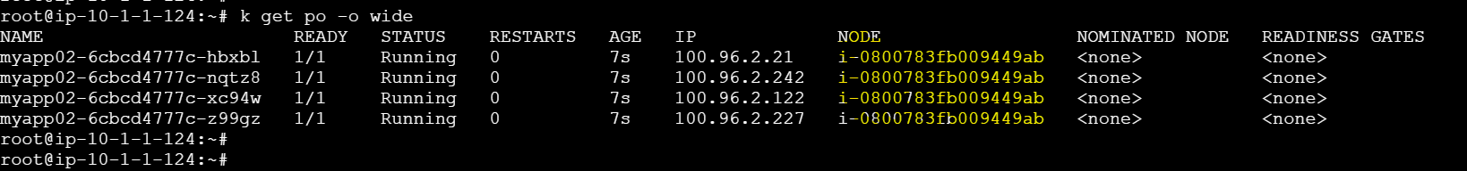

Now lets see how is preferredDuringSchedulingIgnoredDuringExecution(soft refrence) is different from hard reference
Here we can add weights for nodes so that our pods can be scheduled accordingly
Assume we have 10 pods and two nodes node1 weight is 60 and node2 weight is 40 then 6 will be deployed on node1 and remaining 4 on node2
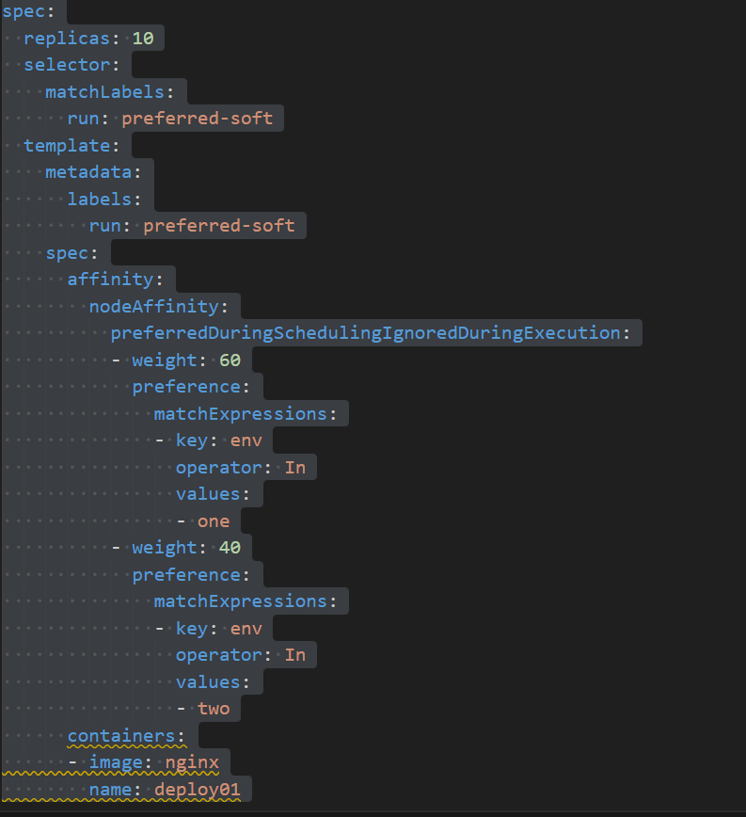
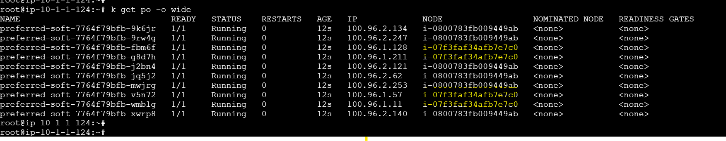
Highlighted ones are node2 and 4 pods have been deployed on node2.

Taint and tolerations:
Taints:
A Taint is applied on node, and it says a pod isn’t allowed to schedule here unless we explicitly allow it.

Example
kubectl taint node i-0800783fb009449ab env=one:NoSchedule

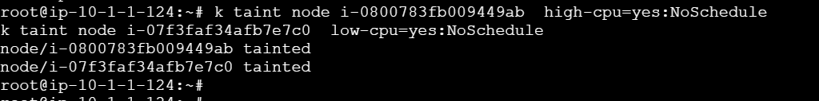
Here we’ve tainted the above nodes
And if we try to deploy a pod it will be in pending state as both our nodes are tainted
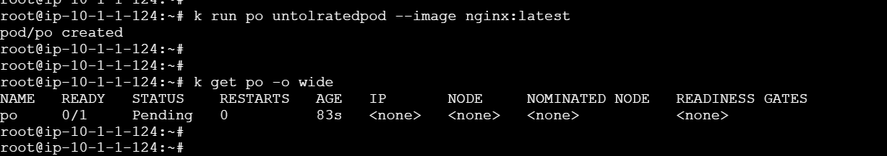
You will see the below if you describe the pending pod
So when we taint a node with no schedule it will not affect the pods which are already running on it but it wont allow any new pods to schedule on that nodes unless they’re tolerated.
Toleration
It is added to a Pod and it says I’m allowed to go onto the pods that have this taint
Example
tolerations:
- key: "env"
operator: "Equal"
value: "one"
effect: "NoSchedule"

So now the above pod can be scheduled on env=one:NoSchedule Node
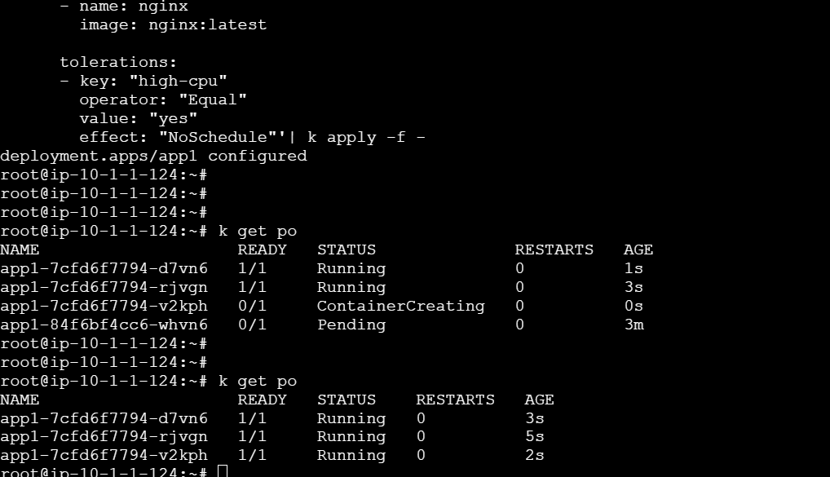
If we add a toleration block in our deployment we can run them on the tainted nodes

Now as we have used NoExecute during taint it has it will evacuate the existing pods
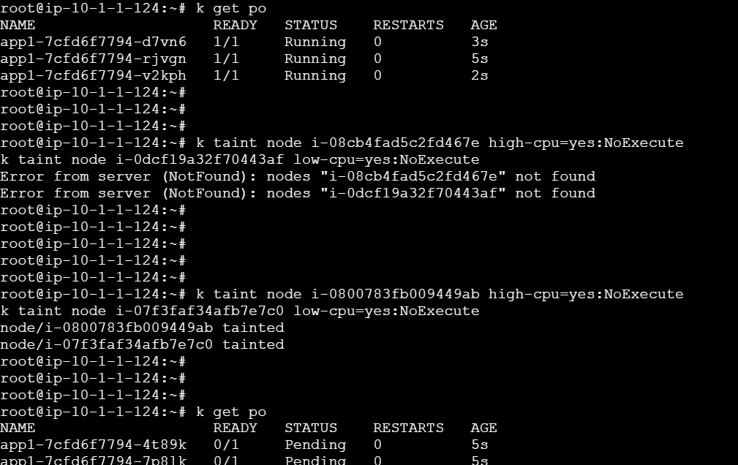

NoExecute Taint
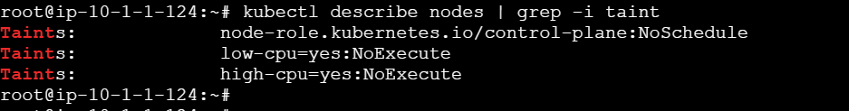
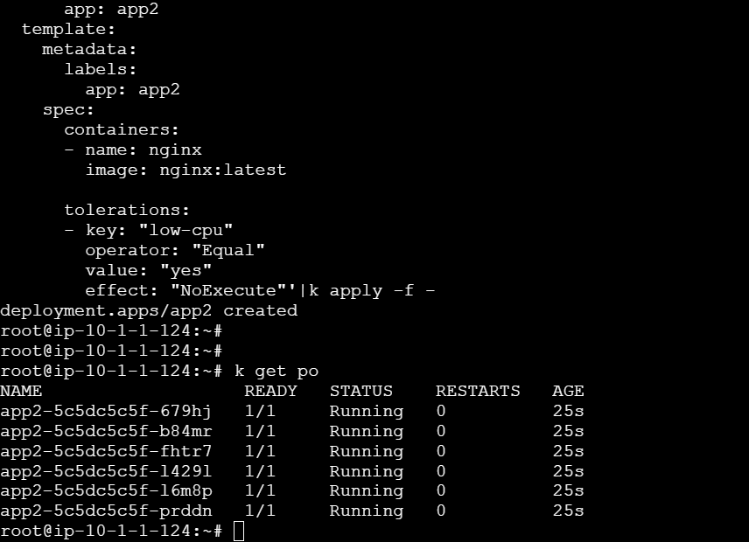

Here we have deployed the pods in different AZ’s as we have two nodes each pods scheduled in each node

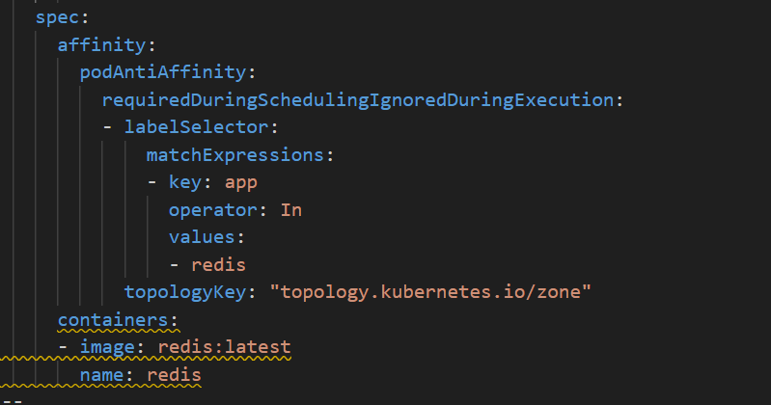

Hard rule only apply on node where label is app:redis and in different AZ’s
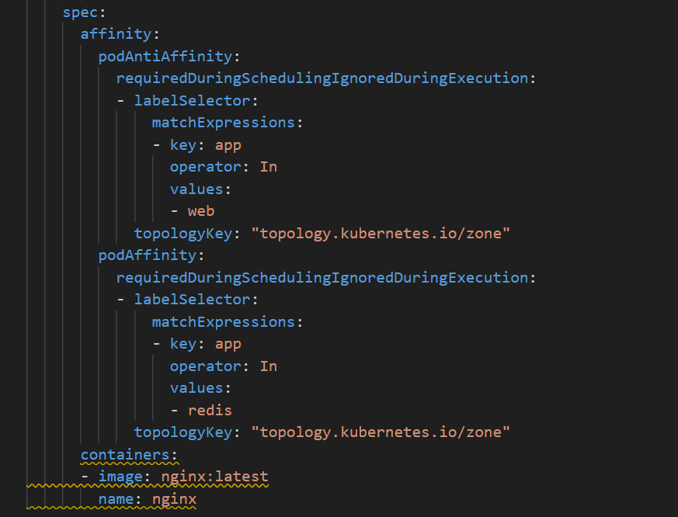
And for the nginx pod we’re saying don’t place two nginx pods in same zone we’ve mentioned it inside podAntiAffinity block
And in podAffinity we’ve mentioned to place it in nodes with label app:redis and in different zones

