Service Mesh

What and why of Service Mesh ?
Assume a application with multiple miscorservices which works perfectly fine every microservice talks to other without any issue then why do we really need service mesh ?
Lets say I want detailed log of the networking between microservices I want timeouts re-try circuit breaking all of these features we need to write them in our application code to implement them

We can instead run those using service mesh which takes care of all the above we get so many powerful features without touching underlying code
It helps us to control communications between service to service. It sits between services and controls the below.
- Routing
- Security
- Retries
- Timeout
- Monitoring
- Encryption
All this can be done without modifying application code.
It is added next to the pod as a sidecar proxy
Kubernetes handles containers & networking
Istio handles who talks to whom, how safely, how fast, and what happens when things break.
Lets deploy voting app as an example and configure istio for our services.

Below commands creates istio-system namespace and installs istio, instio control plane,instio ingress gateway which receives all inbound traffic into our service mesh

kubectl create namespace istio-system
helm repo add istio https://istio-release.storage.googleapis.com/charts
helm install istio-base istio/base -n istio-system --version 1.25.2
helm install istiod istio/istiod -n istio-system --version 1.25.2 --wait
helm install istio-ingress istio/gateway -n istio-system --version 1.25.2

siddharth@masiddha-BKTNS74:~/istio/istio-service-mesh-kubernetes-kiali-grafana$ k get po -n istio-system
NAME READY STATUS RESTARTS AGE
istio-ingress-746f5f5b84-cqkpk 1/1 Running 0 4m4s
istiod-5fdffd9f6c-r86r9 1/1 Running 0 4m22s
siddharth@masiddha-BKTNS74:~/istio/istio-service-mesh-kubernetes-kiali-grafana$
siddharth@masiddha-BKTNS74:~/istio/istio-service-mesh-kubernetes-kiali-grafana$ k get svc -n istio-system
NAME TYPE CLUSTER-IP EXTERNAL-IP PORT(S) AGE
istio-ingress LoadBalancer 10.100.225.22 a58928ebfcb054edea86ad90a1b74029-54273014.us-east-1.elb.amazonaws.com 15021:32674/TCP,80:32452/TCP,443:32653/TCP 4m10s
istiod ClusterIP 10.100.179.254 <none> 15010/TCP,15012/TCP,443/TCP,15014/TCP 4m28s

Now lets install some add-ons for our istio the most important one here is kiali which helps us to visualize everything that’s happening in our servicemesh how traffic is going how’s it splitting circuit breaking.

These run as envoy proxy container runs alongside the application container these send the metrics logs to promethius which we can visualize through graffana.
And jaeger we can use to visualize traces and lifecycle of a request from one service to another

mkdir -p istio-addons
curl -L https://raw.githubusercontent.com/istio/istio/release-1.25/samples/addons/prometheus.yaml -o istio-addons/prometheus.yaml
curl -L https://raw.githubusercontent.com/istio/istio/release-1.25/samples/addons/grafana.yaml -o istio-addons/grafana.yaml
curl -L https://raw.githubusercontent.com/istio/istio/release-1.25/samples/addons/kiali.yaml -o istio-addons/kiali.yaml
curl -L https://raw.githubusercontent.com/istio/istio/release-1.25/samples/addons/jaeger.yaml -o istio-addons/jaeger.yaml

siddharth@masiddha-BKTNS74:~/istio/istio-service-mesh-kubernetes-kiali-grafana$ k apply -f istio-addons/
serviceaccount/grafana created
configmap/grafana created
service/grafana created
deployment.apps/grafana created
configmap/istio-grafana-dashboards created
configmap/istio-services-grafana-dashboards created
deployment.apps/jaeger created
service/tracing created
service/zipkin created
service/jaeger-collector created
serviceaccount/kiali created
configmap/kiali created
clusterrole.rbac.authorization.k8s.io/kiali created
clusterrolebinding.rbac.authorization.k8s.io/kiali created
service/kiali created
deployment.apps/kiali created
serviceaccount/prometheus created
configmap/prometheus created
clusterrole.rbac.authorization.k8s.io/prometheus created
clusterrolebinding.rbac.authorization.k8s.io/prometheus created
service/prometheus created
deployment.apps/prometheus created

Now lets create an ecommerece namespace
siddharth@masiddha-BKTNS74:~/istio/istio-service-mesh-kubernetes-kiali-grafana$ kubectl create namespace ecommerce
namespace/ecommerce created
siddharth@masiddha-BKTNS74:~/istio/istio-service-mesh-kubernetes-kiali-grafana$

Here we’re labelling our namespace with istio-injection
kubectl label namespace ecommerce istio-injection=enabled
What it does is It tells Istio to automatically inject an Envoy sidecar into every Pod created in this namespace.

Istio works using a sidecar proxy model:
- Your app container → does business logic
- Envoy sidecar → handles networking (traffic, security, observability)
But Kubernetes won’t add Envoy by default.
So Istio needs a signal.
That signal = namespace label.
- Istiod watches for:
- istio-injection=enabled

3️Istio modifies the Pod spec (behind the scenes)
It adds:
- An Envoy container
- Init containers
- Volumes
- iptables rules
So your Pod becomes:
Pod
├── app container
└── istio-proxy (Envoy)
Now lets deploy our service and watch
get po -n ecommerce
NAME READY STATUS RESTARTS AGE
contact-support-team-75cb5dfbc4-8xnrb 2/2 Running 0 94s
ecommerce-ui-5554ddb568-gjkzk 2/2 Running 0 106s
order-management-5f8c58ffc6-9qvl8 2/2 Running 0 104s
product-catalog-66489c6df9-kplmt 2/2 Running 0 102s
product-inventory-855c57579-9vwgn 2/2 Running 0 100s
profile-management-698977c54f-cddvt 2/2 Running 0 98s
shipping-and-handling-7cb86f56f8-rg2n9 2/2 Running 0 96s

If you observer here there are two containers for each pods which means there’s an envoy sidecar container attached to our containers.

We can see that when we describe the pod

Type Reason Age From Message
---- ------ ---- ---- -------
Normal Scheduled 3m51s default-scheduler Successfully assigned ecommerce/contact-support-team-75cb5dfbc4-8xnrb to ip-172-31-20-72.ec2.internal
Normal Pulled 3m50s kubelet Container image "docker.io/istio/proxyv2:1.25.2" already present on machine
Normal Created 3m50s kubelet Created container: istio-init
Normal Started 3m50s kubelet Started container istio-init
Normal Pulling 3m47s kubelet Pulling image "rslim087/contact-support-team:1.0.0"
Normal Pulled 3m19s kubelet Successfully pulled image "rslim087/contact-support-team:1.0.0" in 28.015s (28.015s including waiting). Image size: 378761118 bytes.
Normal Created 3m19s kubelet Created container: contact-support-team
Normal Started 3m19s kubelet Started container contact-support-team
Normal Pulled 3m19s kubelet Container image "docker.io/istio/proxyv2:1.25.2" already present on machine
Normal Created 3m19s kubelet Created container: istio-proxy
Normal Started 3m19s kubelet Started container istio-proxy

entry point to our application needs to be our custom ishtio custom resource not any ingress resource specific gateway resource that’s native to ishtio they are similar to nginx or cong ingress this one is native to ishtio it configure the ingress gateway very simply this will act as a front door to our application and we are benifited here as it acts as a single entrypoint for all our external request
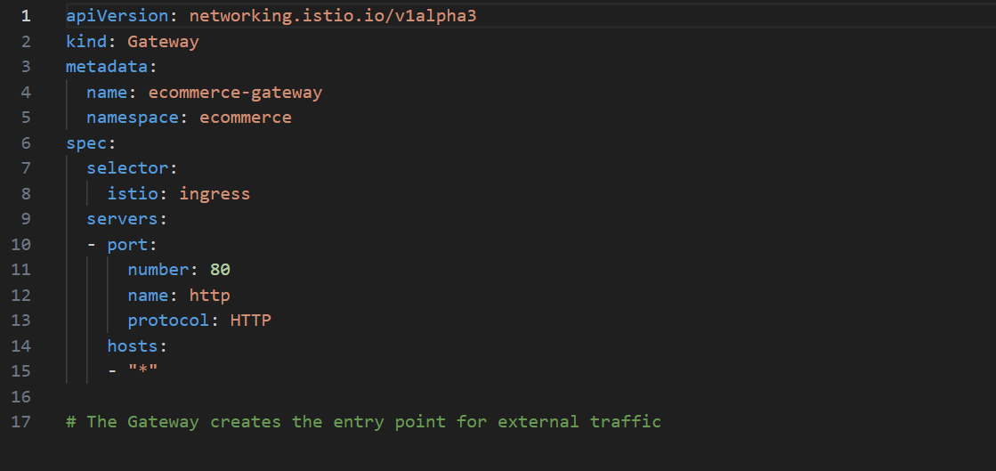

We have peerauthentication resource
As every container will have envoy proxy every request will be intercepted by this with this each request passing to one server to another follows a very strict mtls authentication this ensures all service to service communication is encrypted.
MTLS is a two way authentication protocol in which the issues and the reciver can verify the identity with digital certificates this ensures this provides way stronger encryption than the old one way tls
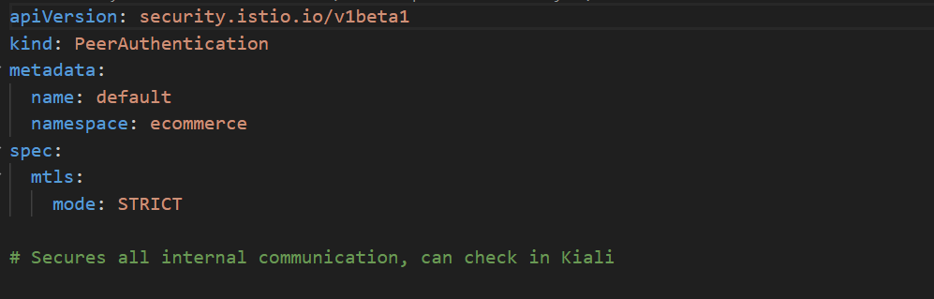

Here we are able to access our ecommerce application now let’s try to generate lots of traffic
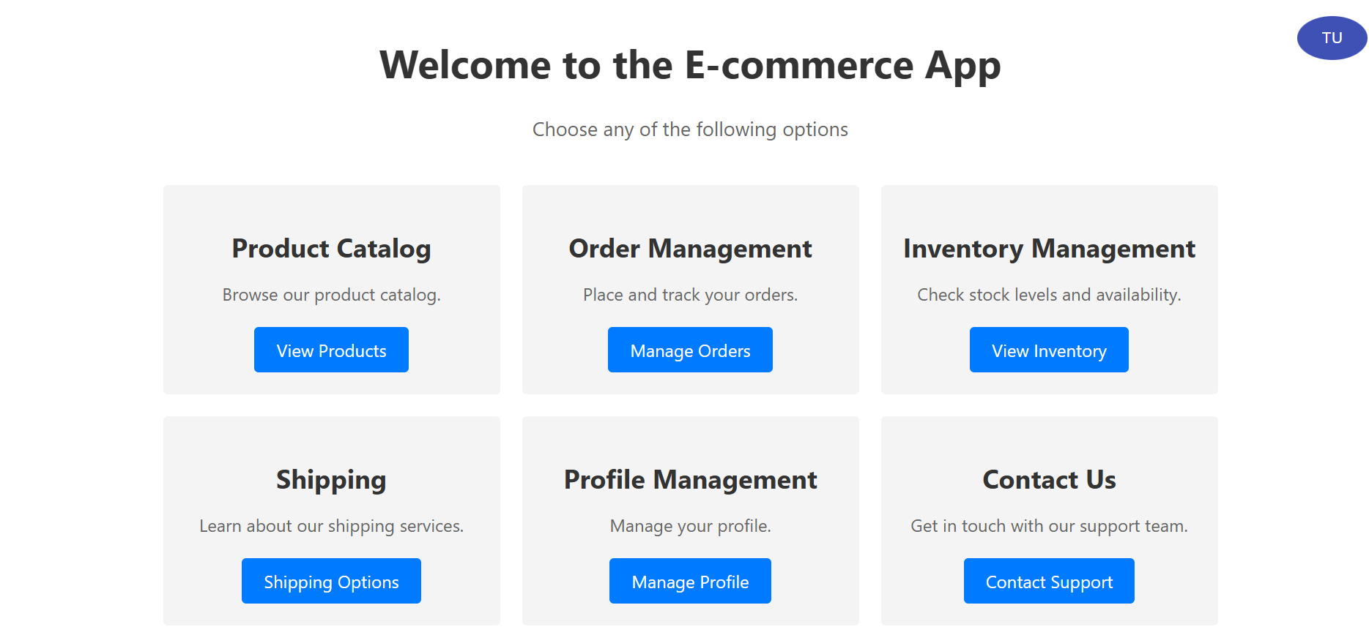
I’ve randomly placed an order for the below items
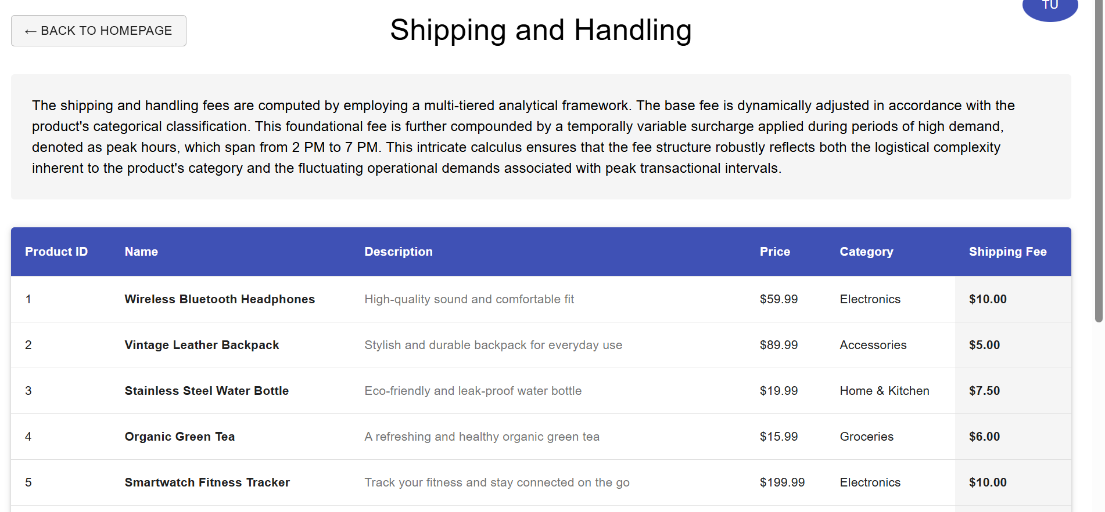
Lets see the traffic visually using kiali
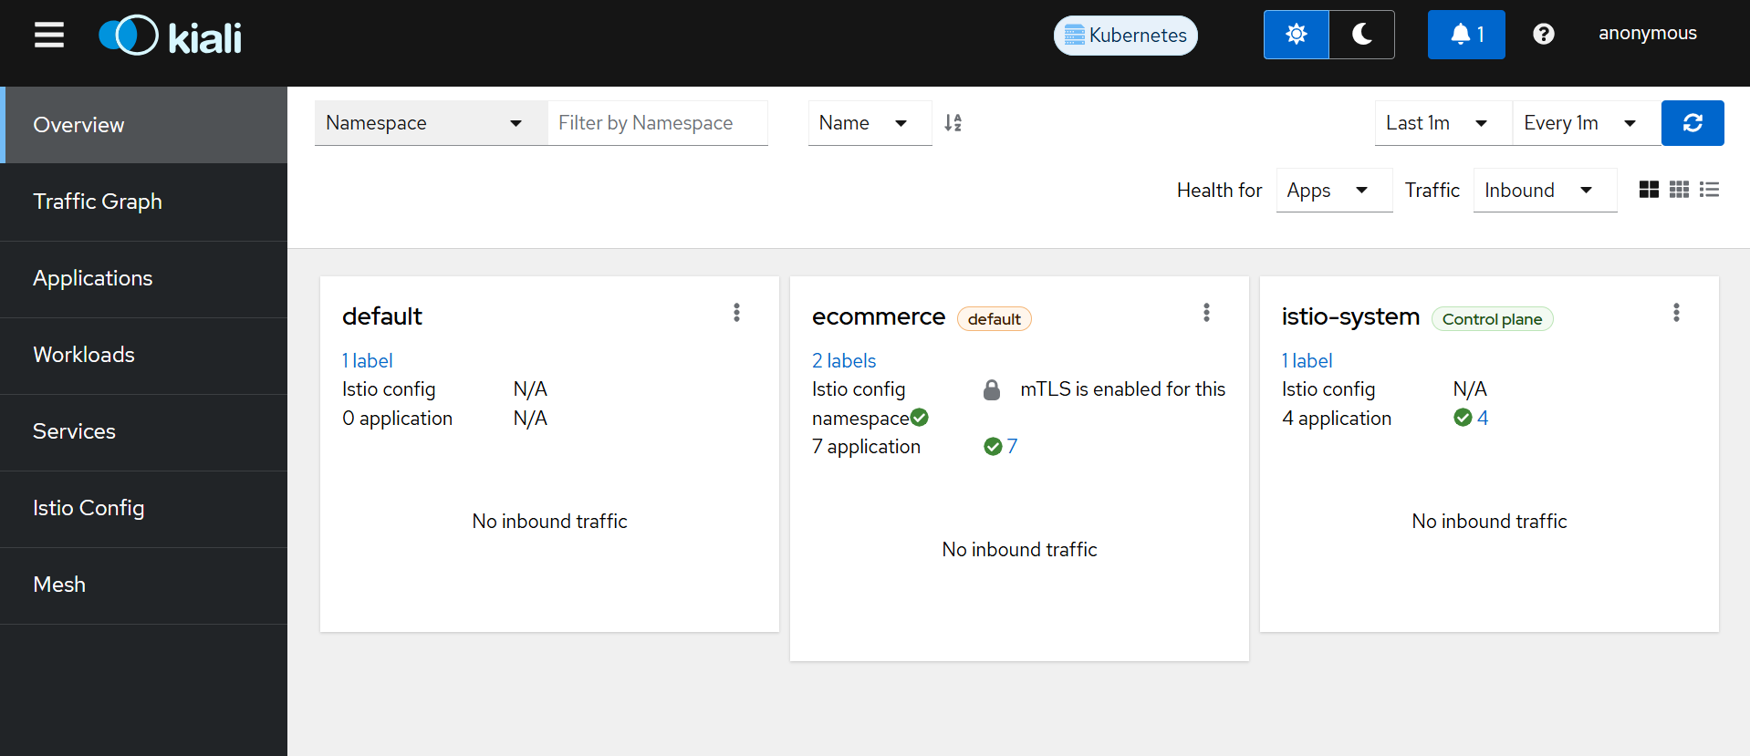
So if you go over the applications tab and select ecommerce namespace in the dropdown you’ll see something similar to this
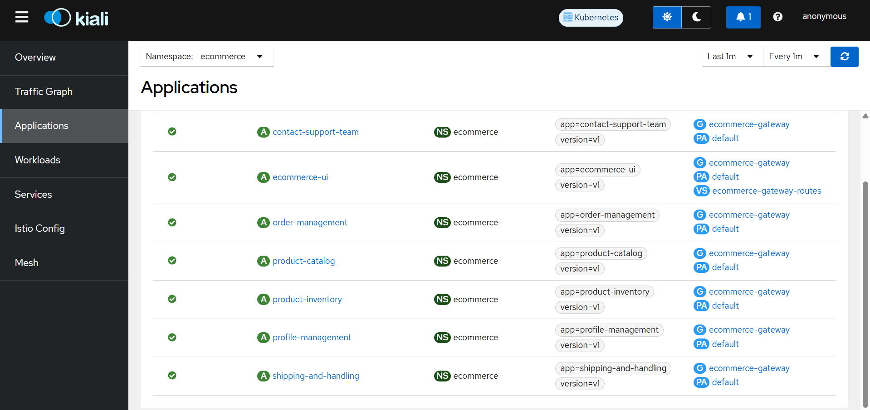
All our services are healthy and if you observe in the right there’s something marked as PA which is peer authentication which is being done securely as we enables PeerAuthentication with mTLS mode
You can also see the graphical representation of the network how it routed from one microservice to another how much time it took
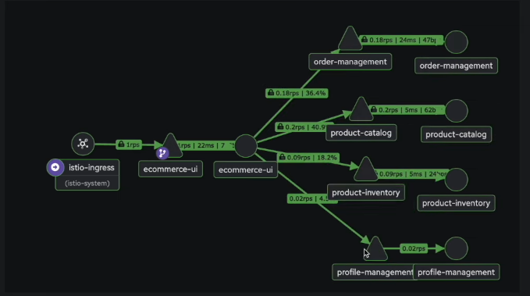

Now lets see how can we implement canary deployment when our services are part of mesh
Assume we have updated our application in a way where we want to store our product catalog in mongoDB
And we aren’t sure how it gonna handle the load so we now we only direct 20% of traffic to version v2 and once we’re sure that the version v2 is able to handel the traffic we will slowly increase the weight for v2
This VirtualService resource in istio helps us to decide how much traffic request is routed to destinations.

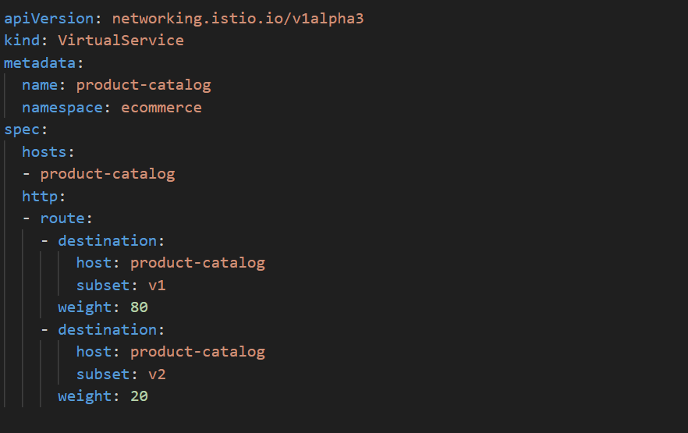

So this service relies on something called subsets if we see here it routes traffic based on the labels in the below deployment of v2 we have defined labels as app: product-catalog and version is v2

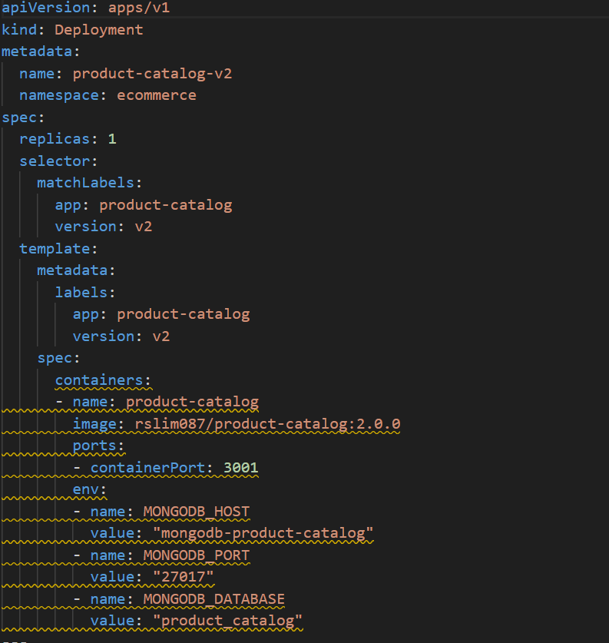

Later we can define a resource DestinationRule and tag subsets to route traffic accordingly these will isolate our pods in different groups v1 (older version)and v2 (latest version)

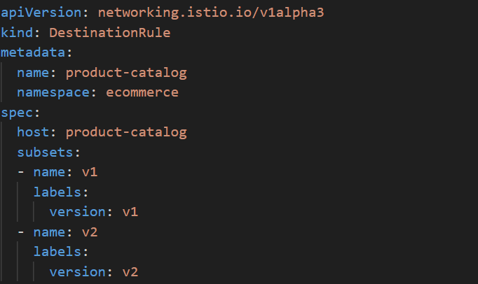

k apply -f canary-deployment/
deployment.apps/product-catalog-v2 created
deployment.apps/mongodb-product-catalog created
service/mongodb-product-catalog created
destinationrule.networking.istio.io/product-catalog created
virtualservice.networking.istio.io/product-catalog created

we can see the v2 pods and mongodb is being run here
k get po -n ecommerce
NAME READY STATUS RESTARTS AGE
contact-support-team-75cb5dfbc4-dpzxp 2/2 Running 0 47m
ecommerce-ui-5554ddb568-chffz 2/2 Running 0 47m
mongodb-product-catalog-5b9bf99887-dhslt 2/2 Running 0 76s
order-management-5f8c58ffc6-g4khw 2/2 Running 0 47m
product-catalog-66489c6df9-q9zx7 2/2 Running 0 47m
product-catalog-v2-97cf9f66d-cwnlq 2/2 Running 0 77s
product-inventory-855c57579-gpczj 2/2 Running 0 47m
profile-management-698977c54f-vnqpj 2/2 Running 0 47m
shipping-and-handling-7cb86f56f8-4zl2x 2/2 Running 0 47m

As we have two versions for product management we can see the same here being reflected in our traffic graph
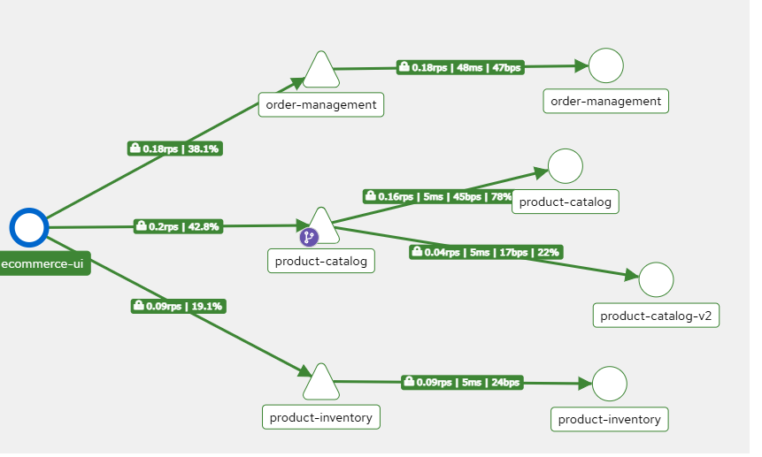
Most of the traffic is going to v1 and some around 22% is going to v2

Now lets see how can we achieve circuit breaking
It’s a very powerful feature and should be integrated in our production infra what is does is
Assume for our application we had done a upgrade v2 and want to deploy that in our production infra testings went well in non-prod but it started giving some issues after integrating in production in v2 all the requests hitting v2 are getting failed.
So here we can put an threshold like if we hit this number of errors we will stop/break the traffic from reaching the problematic v2 and route it to the stable v1
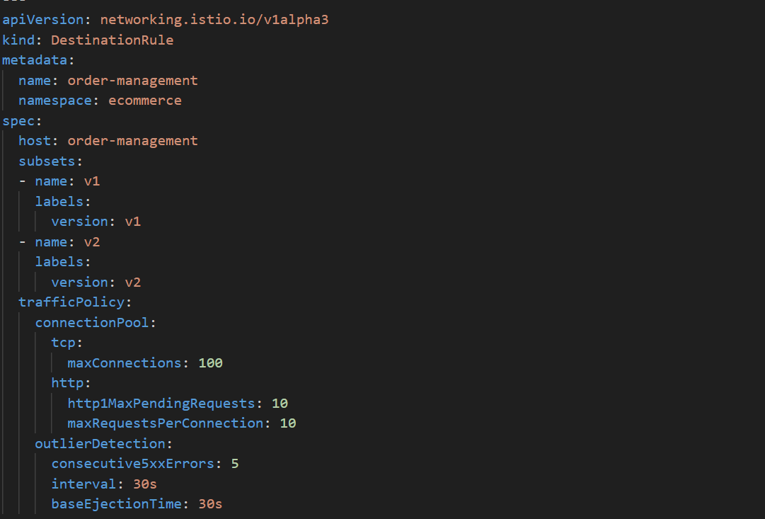
So to achive that we are adding some rules(thresholds) here in our DestinationRule
So this is just a step further to our canary deployment setup here we are adding some protection rules on the 20% of traffic that we are routing to v2
maxConnections: 100
“Envoy can open at most 100 simultaneous TCP connections to this service.”
http1MaxPendingRequests: 10
“Only allow 10 HTTP requests to wait in the queue if connections are busy.”

maxRequestsPerConnection: 10
“Reuse a connection for 10 requests, then close it.”

consecutive5xxErrors: 5
“If a pod returns 5 HTTP 5xx errors in a row, mark it as unhealthy.”

interval: 30s
“Every 30 seconds, check pod health and error stats.”
baseEjectionTime: 30s
“Once a pod is ejected, don’t send traffic to it for 30 seconds.”
Lets deploy the v2 which is actually faulty and observe how the routing behaves
k apply -f circuit-breaker-func/
deployment.apps/order-management-v2 created
destinationrule.networking.istio.io/order-management created
virtualservice.networking.istio.io/order-management created
So this product has went to v2
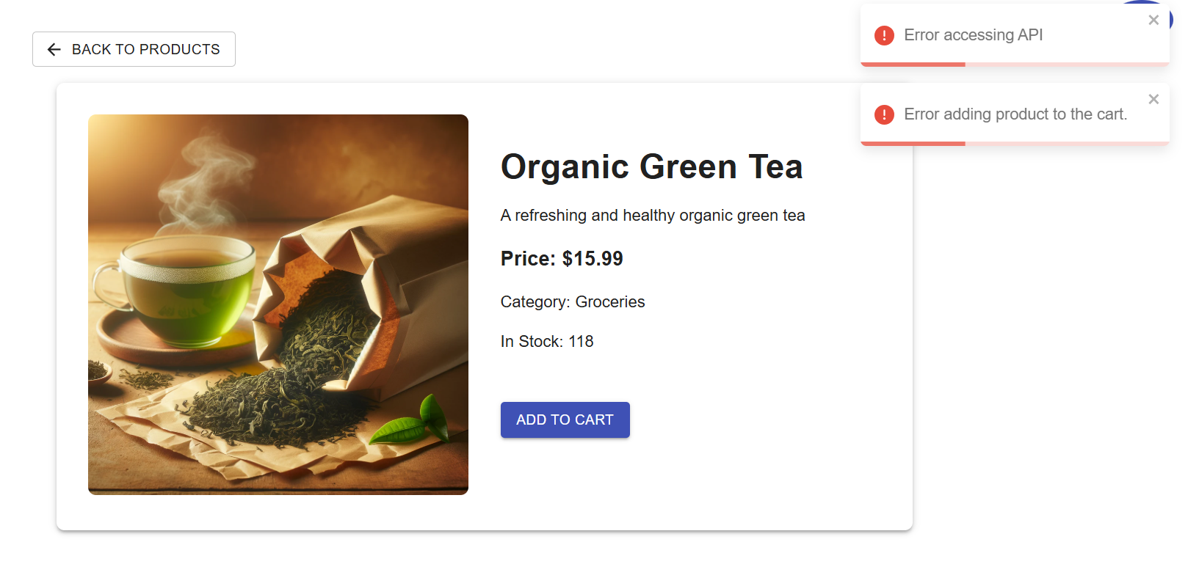
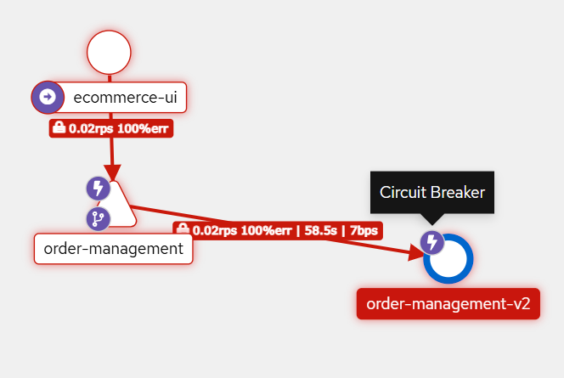
So this is what we will see in workloads>ordermanagement v2 that means it’s blocking any request going to v2
So once the circuitbraker is applied all the requests will be successful as they will be hitting the v1(working) version of application

