**Software Engineering Tools Lab**

**Assignment No 1**

Name -Siddharth Mukkanawar

PRN-2019BTECS00100

Batch-T7

Q) Difference between Free software ,open source software and proprietary software

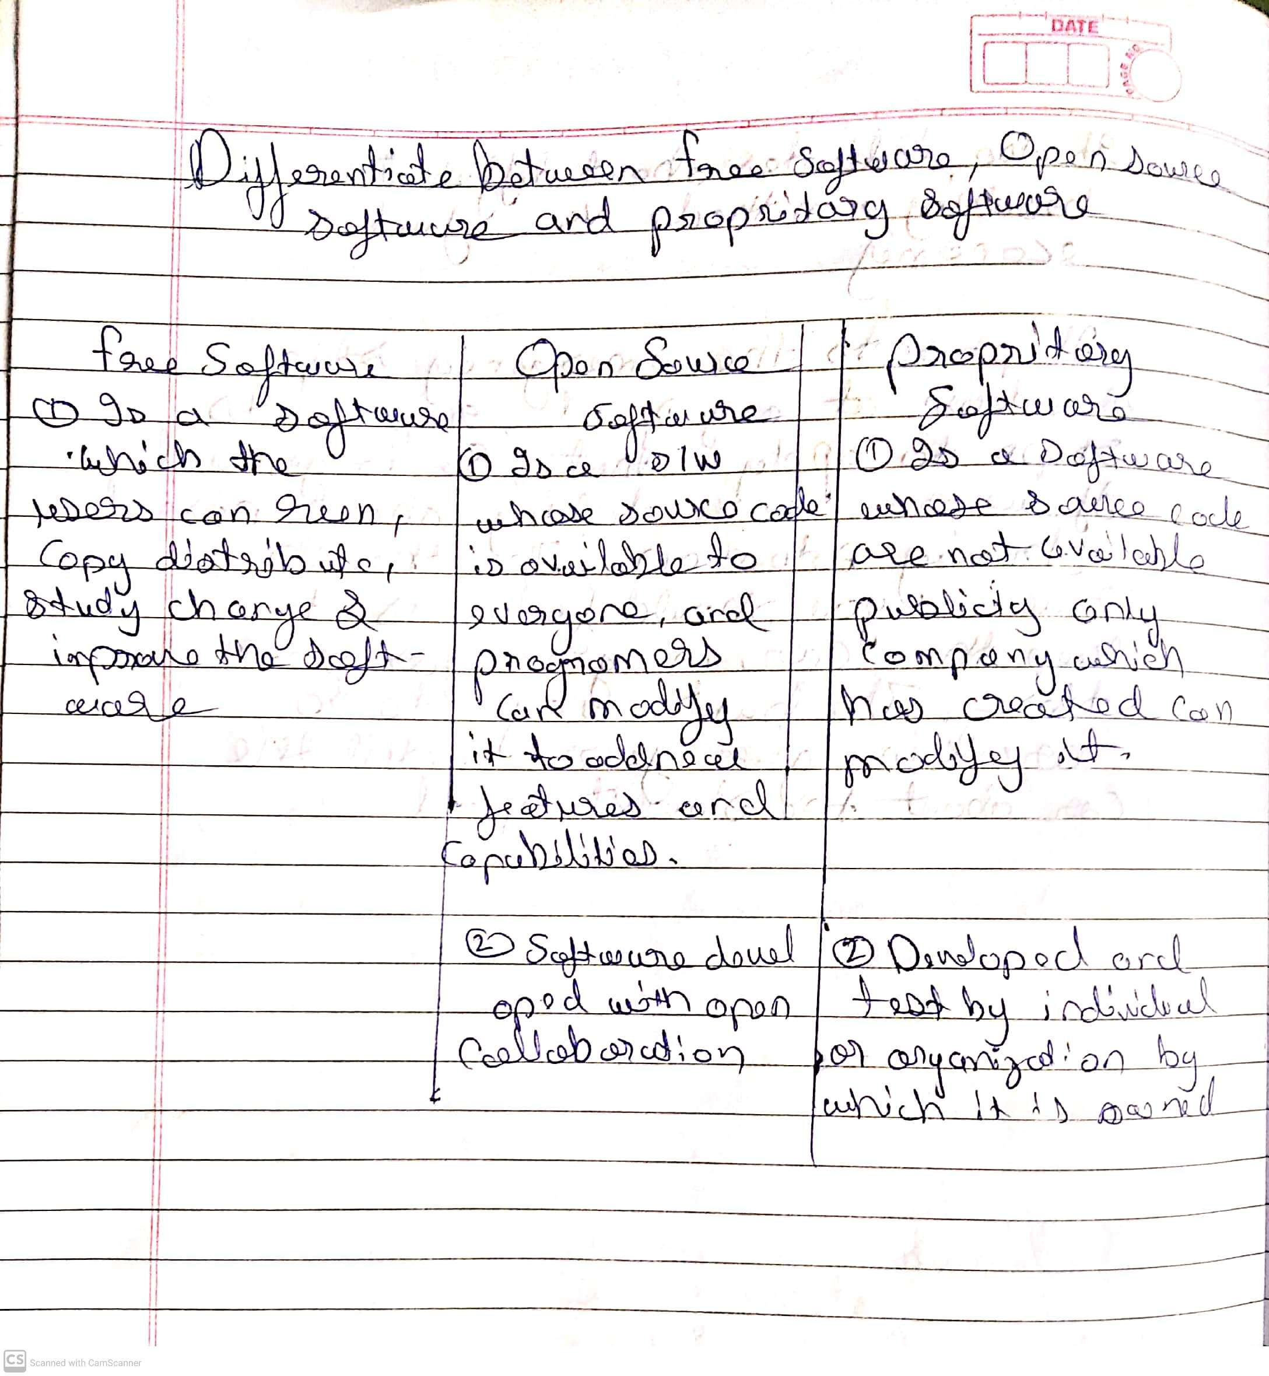

2. Orange is an easy to use data visualization tool with a large toolkit. In spite of being a GUI-based beginner-friendly tool, you mustn’t mistake it for a light-weight one. It can do statistical distributions and box plots as well as decision trees, hierarchical clustering and linear projections.

a. Install orange b. Show data distribution c. Show linear projectiond. show Freeviz\

**Report-**

Orange is a data visualization tool , With the help of this tool we can visualis our data which can be in file format i.e we can see distribution of data using graphs , tree ,linear projections, tables etc.

When we start orange we see the welcome screen which provide different options like new data analysis recent analysis, tutorial etc .When we close the welcome screen we see a window which contains a blank canvas and a tool bar on left side of screen this are called widgets . Widgets are computational units of orange ,They read data ,visualize it ,process it , clustering of data , build predictive model and explore it.

To load a file we click on file widget it appears on blank canvas ,click on it then choose a file , the file will be loaded . To view file in form of table select table widget and then connect the file widget to the table widget using a line connecting then=m on the canvas abd then click on table widget you can see table form of your data. Similaer for other widget select the widget abd connect it with the file you can see visualization of your data in any form .

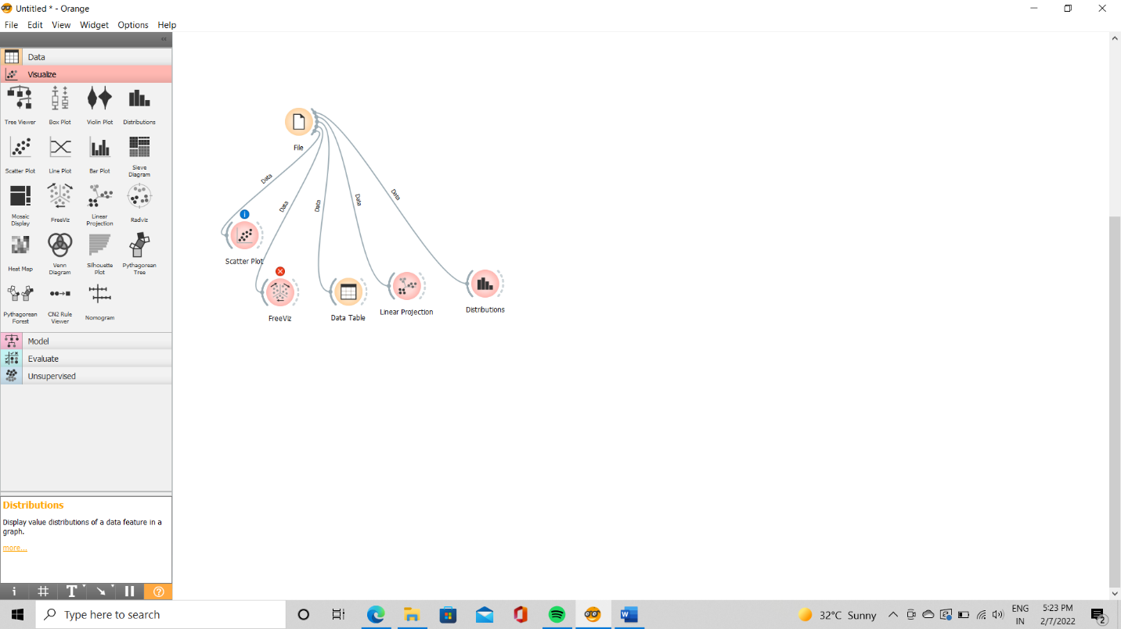

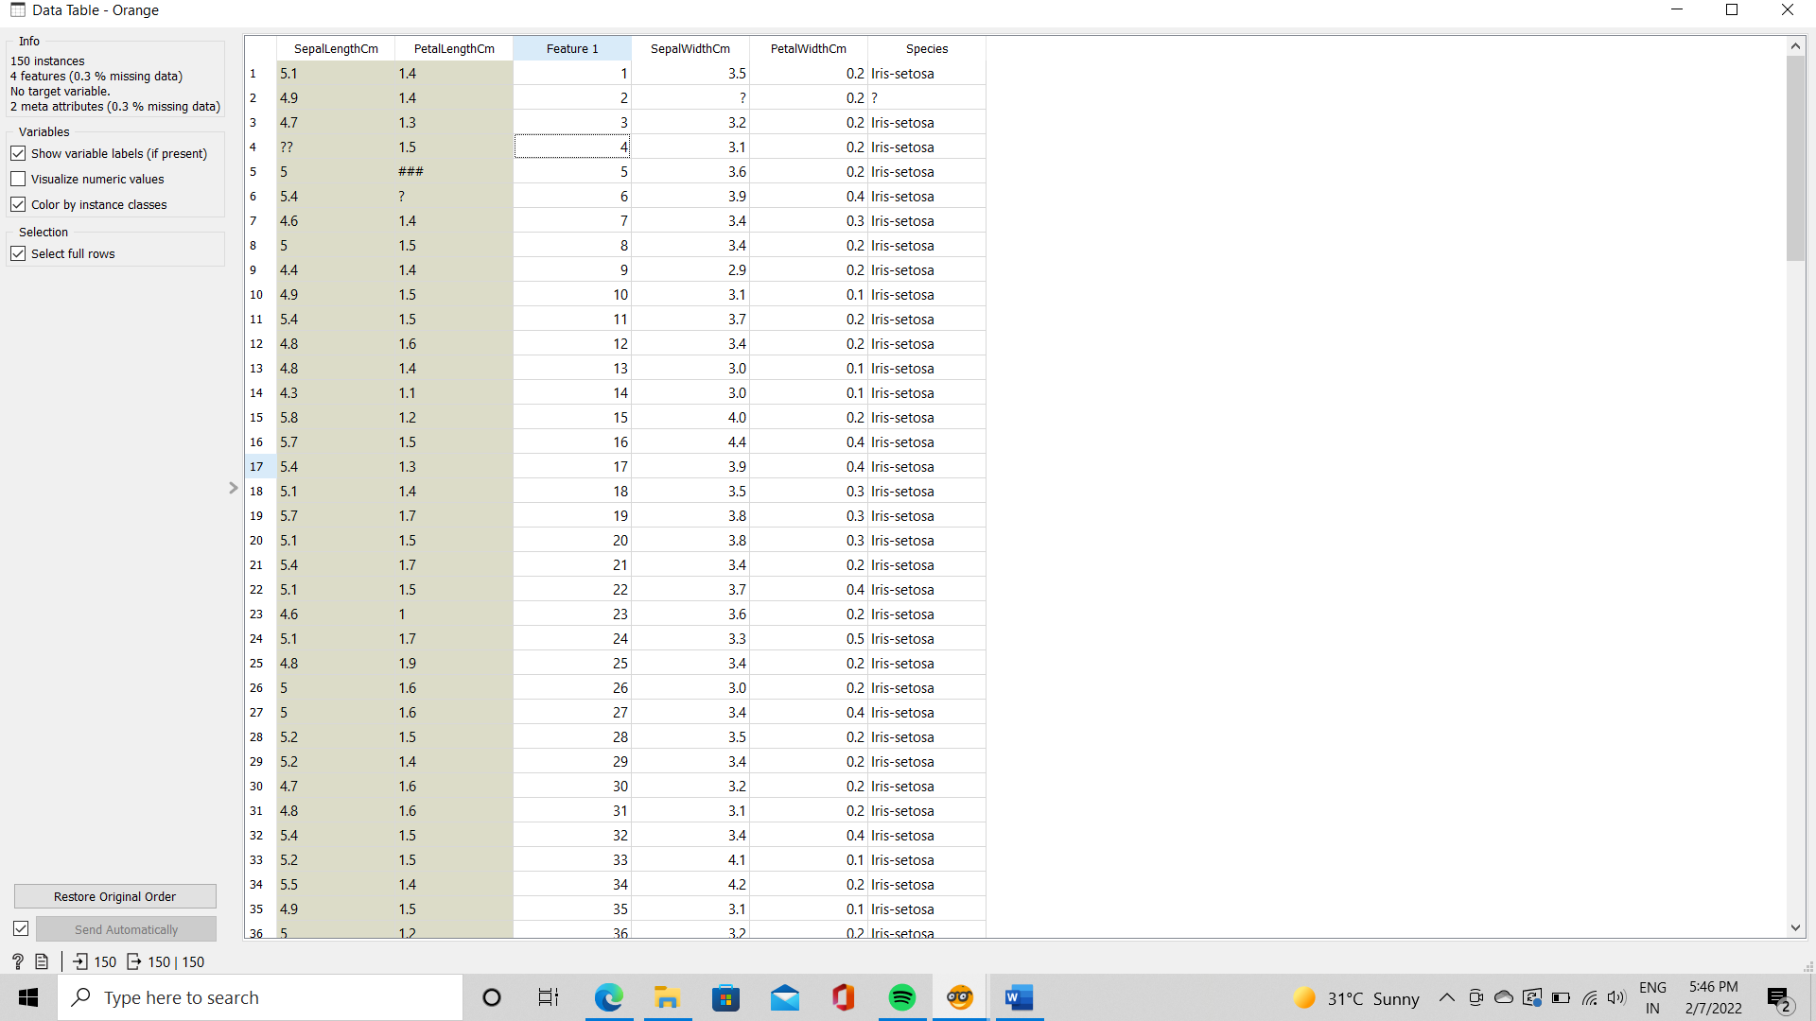

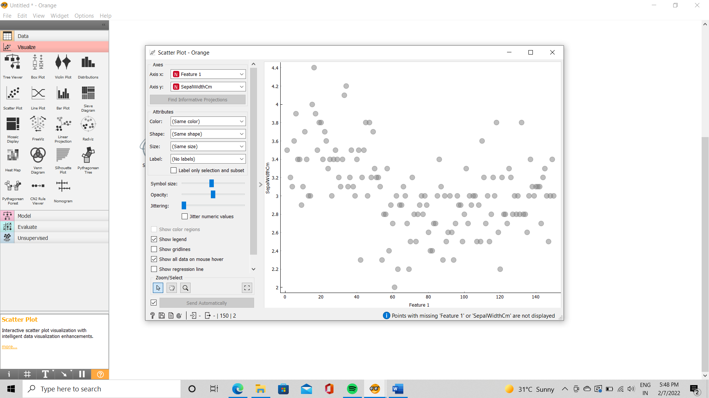

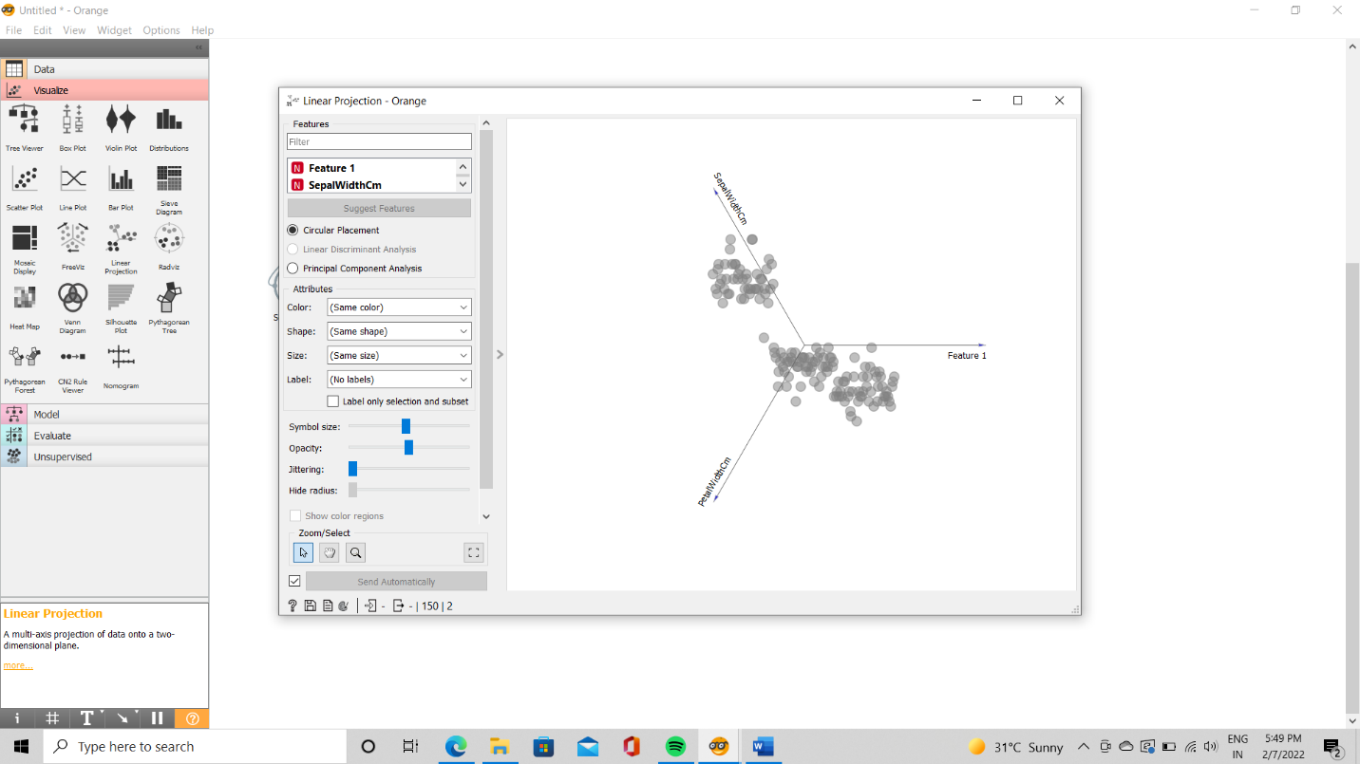

Enlist some examples of FOSS and proprietary software with it’s purpose and properties with respect to database

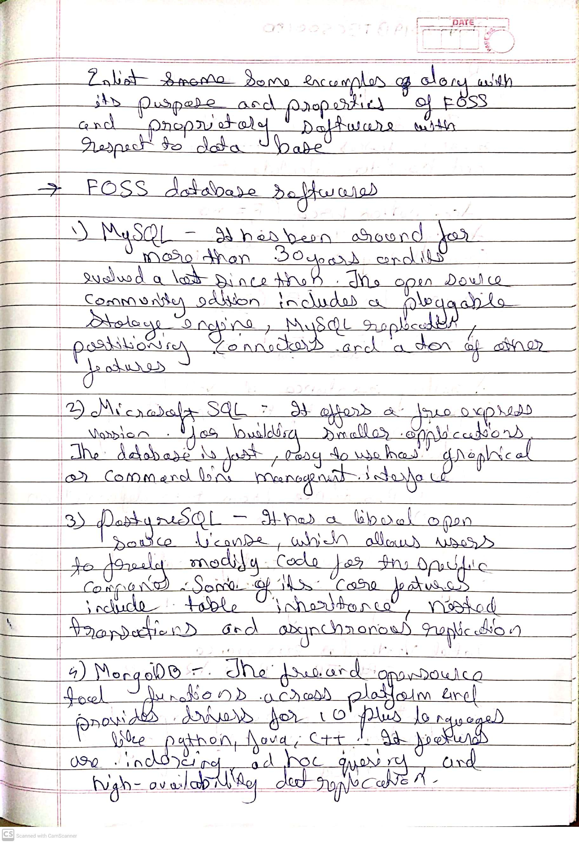

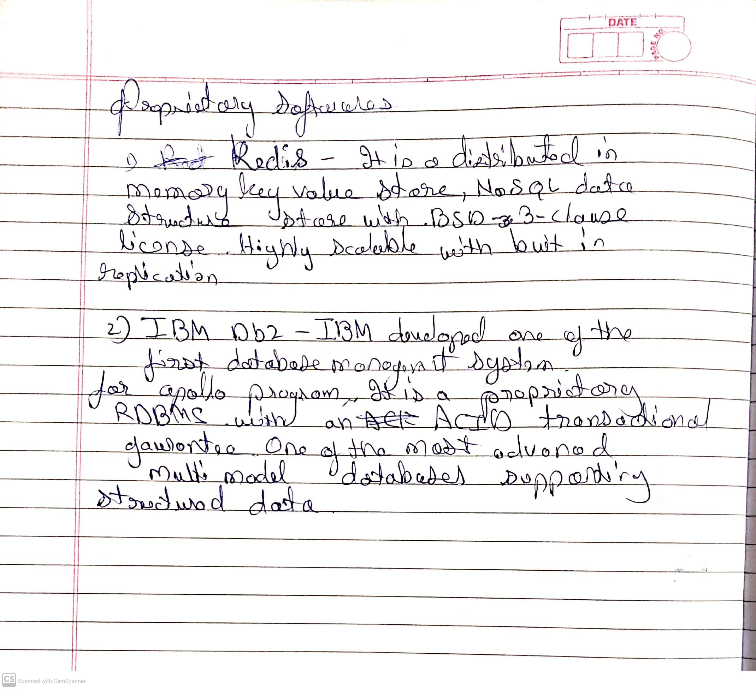

Q4) Using Anaconda Python create Histogram, Scatter plot and Bar plot for the dataset given below. Dataset- https://drive.google.com/file/d/1i11BZFe8Xj9kNq7eeE9KOa_Iz1KhEdXJ/view a. Scatter plot- Scatter plot of Price Vs Age b. Histogram- for Kilometer and CC c. Bar plot- Bar plot for different fuel types 5. Enlist some examples along with its purpose and properties (at least 10) of FOSS and proprietary software with respect to databas

