Use Case Analysis Model (OOA)

Entity classes: User profile.

Boundary classes: AdministerProfileInterface

Control classes: ProfileController

Sequence diagram modeling the use-case behavior:

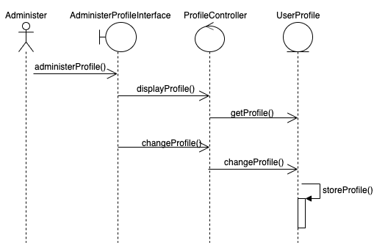

Class diagram (based on the sequence diagram) modeling the use-case structure:

