Use Case Specification

Participating Actors  
Citizens

Brief Description

After user logged in, he/she can update his/her emergency information, including specific self introduction and emergency contact. The user can also select whom to share the information with.

Assumption

The citizen has logged in.

Flow of Events

Basic Flow

1. The use case starts when Citizen1 clicks on update Info.
2. The system shows setting page to Citizen1.
3. Citizen1 fills in all the blanks.
4. Citizen1 clicks on people to share button.
5. The system show share list page.
6. Citizen1 selects Citizen2.
7. Citizen1 clicks on the update button.
8. The system stores Citizen1's emergency information.
9. The system shows setting page.
10. Citizen1 clicks on the update button.
11. The system shows me page.
12. Citizen2 logs in, jumps to directory page and clicks on Citizen1.
13. The system shows Citizen1’s emergency information.
14. Citizen2 click on message button.
15. The system shows private chat box between Citizen2 and Citizen1.

Alternative Flows

* A1. In step 4, Citizen1 does not click on people to share button. The system does nothing on Citizen1’s share list. The use case continues in step 9.
* A2. In step 7, Citizen1 click on cancel button. The system does nothing on Citizen1’s share list. The use case continues in step 9.
* A3. In step 10, Citizen1 click on cancel button. The system does nothing on Citizen1’s emergency information .The use case continues in step 11.
* A4. In step 14, Citizen2 click on the back button. The system does nothing on Citizen1’s emergency information.The use case continues in step 12.
* A5.1. In step 6, Citizen1 unselects Citizen3. The use case continues in step 7.

A5.2 In step 12, Citizen3 logs in, jumps to directory page and clicks on Citizen1.The use case continues in step 15.

* A6. In step 3, Citizen1 click on the back button. The system does nothing on Citizen1’s emergency information.The use case ends.

Rules

* Share List: The system provides a list with all users, except the user himself/herself.

Use Case Analysis Model (OOA)

Entity classes: Emergency information.

Boundary classes: UpdateEmergencyInformationInterface, seeInformationInterface.

Control classes:EmergencyInformationController.

Sequence diagram modeling the use-case behavior:

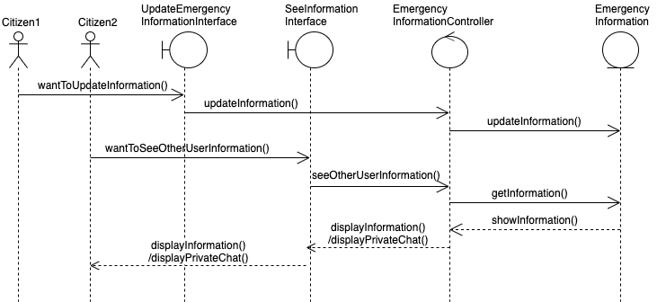Class diagram (based on the sequence diagram) modeling the use-case structure:

