Data Model and Storage Solution Using Data Vault 2.0 Methodology

**1. Technology Stack** To handle the scale, complexity, and real-time requirements of the proposed architecture, I recommend using the following technologies:

**Data Storage:**

Azure Data Lake Storage (ADLS) for storing raw and processed data.

Synapse Analytics (or Azure SQL Database) for structured data storage.

**Data Processing:**

Azure Synapse Pipelines and Azure Databricks for ETL/ELT processes.

**Data Ingestion and Real-Time Processing:**

Azure Event Hubs or Kafka for event streaming, followed by Stream Analytics

or Azure Databricks for real-time data transformation.

**Data Modeling:**

Implement Data Vault 2.0 using Synapse SQL or Databricks Delta Lake tables.

**2. Data Vault 2.0 Table Structure**

Data Vault 2.0 methodology splits data into three primary components:

**Hubs, Links and Satellites.**

***a. Hubs***

Hubs are the core business entities identified by unique keys. Each Hub contains:

- *Primary Key* (Business Key): Unique identifier for the entity ( *\*PII data will be hashed)*

- *Load Date*: Timestamp when the data was loaded.

- *Record Source*: Source of the data.

We create Hubs for Player, Game, and Event

**Hub_Player**

Player_ID: INT --- The unique identifier for the player (mapped from uid in events).

Load_Date: DATETIME --- The timestamp when the data was loaded into the Hub.

Record_Source: VARCHAR --- The source of the data, Ex:"auth_event", "spin_event".

**Hub_Game**

Game_ID: VARCHAR --- The unique identifier for the game/application (ex: "app_3").

Load_Date: DATETIME --- The timestamp when the data was loaded into the Hub.

Record_Source: VARCHAR --- The source of the data.

**Hub_Event**

Event_ID: INT --- The unique identifier for the event (msg_id from each event).

Event_Type: VARCHAR --- The type of event, Ex:"auth_event", "spin_event", "purchase_event".

Load_Date: DATETIME --- The timestamp when the event was loaded into the Hub.

Record_Source: VARCHAR --- The source of the data.

***b. Links***

Links establish relationships between hubs. We define Links to establish connections between players, games, and events. Each link table contains:

*- Primary Key*: Composite key made up of the foreign keys from the linked hubs.

*- Load Date*

*- Record Source*

**Link_Player_Game**

Player_ID: INT --- Foreign key to Hub_Player.

Game_ID: VARCHAR--- Foreign key to Hub_Game.

Event_ID: INT --- Foreign key to Hub_Event (for linking specific events to this relationship).

Load_Date: DATETIME --- The timestamp when the link was created.

Record_Source: VARCHAR--- The source of the data.

**Link_Player_Event**

Player_ID: INT --- Foreign key to Hub_Player.

Event_ID: INT --- Foreign key to Hub_Event.

Load_Date: DATETIME --- The timestamp when the link was created.

Record_Source: VARCHAR--- The source of the data.

**Link_Game_Event**

Game_ID: VARCHAR--- Foreign key to Hub_Game.

Event_ID: INT --- Foreign key to Hub_Event.

Load_Date: DATETIME --- The timestamp when the link was created.

Record_Source: VARCHAR--- The source of the data.

***c. Satellites***

Satellites store descriptive information related to hubs or links and they may include SCD type 2 (attributes that may change over time)

Examples:

**Satellite_Player_Profile**

Player_ID: INT --- Foreign key to Hub_Player.

Email: VARCHAR--- The player’s email address (PII, encrypted or hashed).

Phone: VARCHAR--- The player’s phone number (PII, encrypted or hashed, or null if unavailable).

Load_Date: DATETIME --- The timestamp when the data was loaded.

Record_Source: VARCHAR--- The source of the data (Ex:"auth_event").

**Satellite_Event_Details**

Event_ID: INT --- Foreign key to Hub_Event.

Publish_Timestamp: DATETIME --- The timestamp when the event was published (publish_ts from the event).

Event_Type: VARCHAR--- The type of event, Ex:"auth_event", "spin_event", "purchase_event".

Load_Date: DATETIME --- The timestamp when the data was loaded.

Record_Source: VARCHAR--- The source of the data.

**Satellite_Auth_Event**

Event_ID: INT --- Foreign key to Hub_Event.

UID: INT --- User identifier for linking purposes (uid from auth_msg).

App: VARCHAR--- The app associated with the event (Ex:"app_3").

Email: VARCHAR--- The email address, encrypted or hashed.

Phone: VARCHAR--- The phone number, encrypted or hashed, or null if unavailable.

Load_Date: DATETIME --- The timestamp when the data was loaded.

Record_Source: VARCHAR--- The source of the data.

**Satellite_Spin_Event**

Event_ID: INT --- Foreign key to Hub_Event.

UID: INT --- User identifier (uid from spins_msg).

Spin_Amount: INT --- The amount or number of spins (spin from spins_msg).

App: VARCHAR--- The app where the spin occurred (Ex:"app_3").

Load_Date: DATETIME --- The timestamp when the data was loaded.

Record_Source: VARCHAR--- The source of the data.

**Satellite_Purchase_Event**

Event_ID: INT --- Foreign key to Hub_Event.

UID: INT --- User identifier (uid from purchase_msg).

Amount: DECIMAL(10, 2) --- The purchase amount (amount from purchase_msg).

App: VARCHAR--- The app where the purchase occurred (Ex:"app_3").

Load_Date: DATETIME --- The timestamp when the data was loaded.

Record_Source: VARCHAR--- The source of the data

**Event Mapping to Data Vault Model**

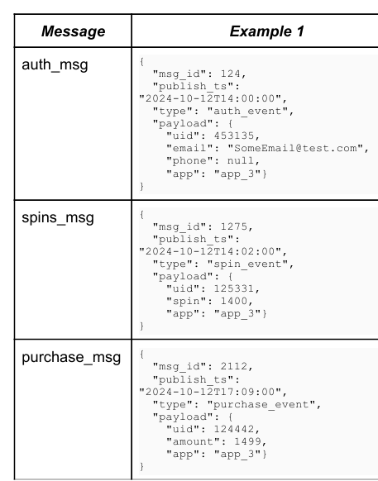

**auth_msg:**

msg_id: 124 → Event_ID in Hub_Event.

publish_ts: "2024-10-12T14:00:00" → Publish_Timestamp in Satellite_Event_Details.

type: "auth_event" → Event_Type in Satellite_Event_Details.

uid: 453135 → Player_ID in Hub_Player.

email: "SomeEmail@test.com" → Email in Satellite_Player_Profile.

phone: null → Phone in Satellite_Player_Profile.

app: "app_3" → App in various tables.

**spins_msg:**

msg_id: 1275 → Event_ID in Hub_Event.

publish_ts: "2024-10-12T14:02:00" → Publish_Timestamp in Satellite_Event_Details.

type: "spin_event" → Event_Type in Satellite_Event_Details.

uid: 125331 → Player_ID in Hub_Player.

spin: 1400 → Spin_Amount in Satellite_Spin_Event.

app: "app_3" → App in various tables.

**purchase_msg:**

msg_id: 2112 → Event_ID in Hub_Event.

publish_ts: "2024-10-12T17:09:00" → Publish_Timestamp in Satellite_Event_Details.

type: "purchase_event" → Event_Type in Satellite_Event_Details.

uid: 124442 → Player_ID in Hub_Player.

amount: 1499 → Amount in Satellite_Purchase_Event.

app: "app_3" → App in various tables.

**3. Additional Components**

Data Ingestion Framework:

Implement a framework using Azure Event Hubs or Kafka for ingesting JSON events into the data lake.

Data Processing and Transformation:

Azure Synapse Pipelines or Azure Dtabricks to handle ETL/ELT, batch processing, and stream processing.

Data Governance and Security:

Use Azure Purview for data cataloging and governance. Implement encryption for PII data using Azure Key Vault.

Reporting and Analytics: Use Power BI to build dashboards and reports.

Data Monitoring & Alerts: Set up monitoring and alerting using Azure Monitor or Application Insights for real-time health checks and performance tracking.

**4. Storage Format**

Raw Data Layer: Store raw JSON events as they arrive in Azure Data Lake Storage

Structured Data Layer:

Use Delta Lake or Parquet format for processed data in Azure Synapse for optimized querying.

PII Management: Store encrypted or hashed PII data and manage encryption keys using Azure Key Vault.