Prompt given to Notebook LM for a Literature Survey for Finding Research Articles (I used Web Search mode, with Deep Research turned ON:
Hi! Please trawl through research articles that you can find online and the full texts of which are accessible to you, giving preference to open-access articles. Keep the search limited to research articles that were published in the last 15 years, to date (11 February 2026). I need you to make a list of the articles that fall in the subset that follow the following restrictions: (1) They have either the word "cancer" itself in the title or have words that indicate a form of cancer in the title and/or the abstract. (2) They have the phrase "differential expression" in the title and/or the abstract. (3) They have the word "India" explicitly mentioned in the address indicating the institute to which the author is affiliated, as mentioned in the paper, for at least one of the study's authors. Please organise the list of resultant articles in (a) table(s) listing the Title of the article in one column, the formal citation for the article in the next column, followed by a column for a link to where I can download the full-text PDF of the article, in cases where the article is open access. If possible, please download the full-text PDFs of all the articles, in the resultant set of articles, that are accessible to you for downloading the full-text PDFs of the same. Name each PDF with the naming format <Title of Scientific Article>_<Name of Journal in Which it was Published>_<Year of Publication> (e.g.: Cryo-EM reveals active site coordn within multi-enzyme pre-rRNA processing complex_Monica Pillon, Robin Stanley et al, Nature SMBL_Sept 2019.pdf). If the PDF naming convention does not accept any particular character that is part of the title of the article, then replace that character with an appropriate replacement character before incorporating the title in the name of the PDF. If the total number of PDF files exceeds 200 or there is some upper limit of the number of PDF files that you can make available to me for direct downloading from this website, at a go, then please compress the PDFs into a TAR-balled or ZIPed file that I can download at a go and decompress offline. In the table in which you list the articles that you found, please organise them into subsections based on the year of publication, listing these subsets from top to bottom in decreasing chronological order of the year of publication (latest at the top) and make subfolders within the ZIPed/TAR-balled file, in the same manner, for segregating PDFs of articles published in different years. Please keep the search restricted to research articles, as opposed to review articles.

Prompt to Cursor AI for Literature Survey for Articles with “cancer” and “differential expression” and “India”:
I have asked for a list of articles on PubMed that conforms to specified search parameters. Here is the URL that lists the search results: https://pubmed.ncbi.nlm.nih.gov/?term=%22cancer%22+and+%22differential+expression%22+and+%22India%22 Please click on the Show More Results button to get to all 493 search hits and, for each search hit listed, navigate to the download button to download the article in PDF format, into the folder titled "Articles_Differential_Expression". Use API keys if you need to.

Prompt to Cursor AI for Literature Survey for Articles with the Advanced Search Query
((biomarker[Title/Abstract]) AND (prospective study[Title/Abstract])) AND ((cancer[Title/Abstract]) OR (leukemia[Title/Abstract]) OR (astrocytoma[Title/Abstract]) OR (blastoma[Title/Abstract]) OR (carcinoma[Title/Abstract]) OR (cholangiocarcinoma[Title/Abstract]) OR (chordoma[Title/Abstract]) OR (craniopharyngioma[Title/Abstract]) OR (ependymoma[Title/Abstract]) OR (esthesioneuroblastoma[Title/Abstract]) OR (glioma[Title/Abstract]) OR (histiocytoma[Title/Abstract]) OR (lymphoma[Title/Abstract]) OR (medulloblastoma[Title/Abstract]) OR (melanoma[Title/Abstract]) OR (mesothelioma[Title/Abstract]) OR (myeloma[Title/Abstract]) OR (neuroblastoma[Title/Abstract]) OR (osteosarcoma[Title/Abstract]) OR (papillomatosis[Title/Abstract]) OR (paraganglioma[Title/Abstract]) OR (pheochromocytoma[Title/Abstract]) OR (retinoblastoma[Title/Abstract]) OR (rhabdomyosarcoma[Title/Abstract]) OR (sarcoma[Title/Abstract]) OR (thymoma[Title/Abstract])):

I have asked for a list of articles on PubMed that conform to specified search parameters. Here is the URL that lists the search results: https://pubmed.ncbi.nlm.nih.gov/?term=%28%28biomarker%5BTitle%2FAbstract%5D%29+AND+%28prospective+study%5BTitle%2FAbstract%5D%29%29+AND+%28%28cancer%5BTitle%2FAbstract%5D%29+OR+%28leukemia%5BTitle%2FAbstract%5D%29+OR+%28astrocytoma%5BTitle%2FAbstract%5D%29+OR+%28blastoma%5BTitle%2FAbstract%5D%29+OR+%28carcinoma%5BTitle%2FAbstract%5D%29+OR+%28cholangiocarcinoma%5BTitle%2FAbstract%5D%29+OR+%28chordoma%5BTitle%2FAbstract%5D%29+OR+%28craniopharyngioma%5BTitle%2FAbstract%5D%29+OR+%28ependymoma%5BTitle%2FAbstract%5D%29+OR+%28esthesioneuroblastoma%5BTitle%2FAbstract%5D%29+OR+%28glioma%5BTitle%2FAbstract%5D%29+OR+%28histiocytoma%5BTitle%2FAbstract%5D%29+OR+%28lymphoma%5BTitle%2FAbstract%5D%29+OR+%28medulloblastoma%5BTitle%2FAbstract%5D%29+OR+%28melanoma%5BTitle%2FAbstract%5D%29+OR+%28mesothelioma%5BTitle%2FAbstract%5D%29+OR+%28myeloma%5BTitle%2FAbstract%5D%29+OR+%28neuroblastoma%5BTitle%2FAbstract%5D%29+OR+%28osteosarcoma%5BTitle%2FAbstract%5D%29+OR+%28papillomatosis%5BTitle%2FAbstract%5D%29+OR+%28paraganglioma%5BTitle%2FAbstract%5D%29+OR+%28pheochromocytoma%5BTitle%2FAbstract%5D%29+OR+%28retinoblastoma%5BTitle%2FAbstract%5D%29+OR+%28rhabdomyosarcoma%5BTitle%2FAbstract%5D%29+OR+%28sarcoma%5BTitle%2FAbstract%5D%29+OR+%28thymoma%5BTitle%2FAbstract%5D%29%29&sort= Please click on the Show More Results button to get to all 938 search hits and, for each search hit listed, navigate to the download button to download the article in PDF format, into the folder titled "Biomarker_Prospective_Study_Cancer". Use API keys if you need to. Before downloading each article, check whether the download link leads to a “proof-of-work” HTML challenge or some other sort of challenge that results in the download link leading to the downloading of a PDF file that does not contain the entire full-text content of the article. Attempt to devise and deploy a strategy for working around such challenges, whenever you encounter them so that, finally, each downloaded PDF file contains the full-text content of its respective research article. While devising a strategy to circumvent any such challenges preventing the direct downloading of the full-text PDFs, please try to avoid a strategy that asks the user( i.e., me) to run sleep commands, from time to time while you are busy downloading the full-text PDF files. If you need such sleep-periods to be activated for the purpose of executing the strategy to circumvent challenges preventing automated downloading of the sought-after full-text PDFs, then please try to use a strategy where you can issue such commands yourself, as needed, without seeking approval for each such sleep command from me, the user.
Please create a CSV file named articles_metadata.csv, that has the column titles/headers PMID, Title, Authors, Journal, Year, DOI, PMC_ID, Free_PMC, PDF_Downloaded, and PDF_Filename, and populate its rows, below the header row, with the corresponding data for each of the 938 articles, listed rowise: PMID of the article, title of the article, list of authors’ names (as parsed from the article), name of the journal in which it was published, year of publication, DOI of the published article, PMC ID of the article, whether or not the article was listed in the search results as a “Free PMC article” (enter Yes/No), whether or not a full-text PDF file was able to be downloaded for it (enter Yes/No), and the file name of the downloaded PDF file (if it was downloaded), respectively.

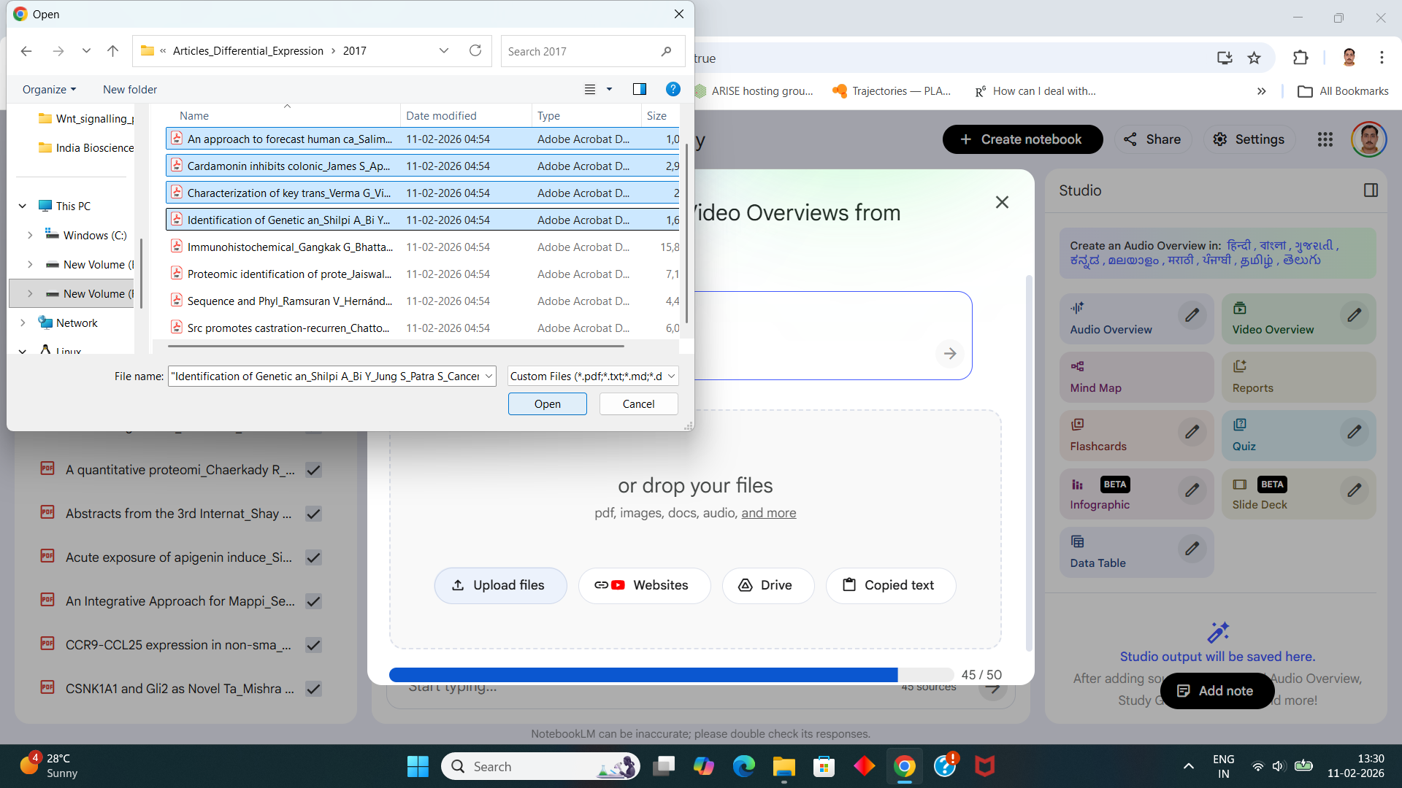

Prompt to Google’s Notebook LM:
Assume that you are a cancer researcher with 20+ years of experience, especially in the fields of differential gene and protein expression. Please read the entire contents of all 50 research articles uploaded here and filter the articles to identify those that explicitly mention differential gene/protein expression in a cancer vs normal or cancer vs paratumoral or test-condition for cancer vs control-condition for cancer context. Next, on these filtered results, apply another filter to identify those research papers in which the fold change or biological fold change is reported either in result tables in the papers or somewhere in the main text. Tabulate these fold changes (which may have been reported in their source research papers directly or as a logarithm of the fold change) in one column, followed by the type of fold change reported (direct, log to the base 2, log to the base 10, etc...) in the next column, the citation of the research paper from which this value was sourced (as reported in the research paper in question) in the next column (for searching for the citation, use the full citation reported in the bibliography for the fold change value being reported in your result table, citing the full citation for the research paper for which PDF file has been named, in cases in which the fold change value is a research finding being reported as a part of the results of the research paper after which the PDF file has been named), followed by the type of cancer for which the fold change was reported, followed by the category of comparison (e.g. tumor/cancer vs normal, tumor/cancer vs paratumoral, tumor/cancer with test condition (e.g.: drug being tested) vs tumor/cancer with control/vector control, etc...). Restrict the set of fold change values reported in the result tables such that you report only those fold change values that pertain to fold changes in the expression of human (Homo sapiens) proteins or genes. Report data for fold change values found in these research papers only if they are definitely present in them. Please do not impute/hallucinate any data in the table. I would rather have no results in the table than have fabricated/false/hallucinated results in it. Thanks! If you have searched for both differential protein expression as well as differential gene expression in the first filter applied, then please split the results table into two results tables- one for each of these two categories.
In each result table, please add an Experiment column at the immediate right side of the one reporting fold change type. Populate it with the type of experiment used to obtain the fold change data (e.g.: mRNA sequencing, microarray, etc…) as sourced from the respective source research paper in which the fold change value in question was reported.
Please add columns titled Protein Name and Gene Name, to the immediate left of the column reporting the fold change value. Populate these columns, in each row below the title/header row, with the corresponding protein name and gene name, respectively, associated with the protein/gene for which the expression fold change value was reported, in the PDF file (research paper) from which the value was sourced. If either the protein name or the gene name associated with the protein/gene is not present in the respective research article, then place a dash (-) as the value in the corresponding cell in the table. Keep the column titles/headers of the two result tables the same across these result tables. Please add columns titled “Adjusted p-value”, “Raw p-value”, and “t-Statistic” immediately to the right of the Fold Change Type column. Populate these columns, below the header/title rows, with the corresponding adjusted p-value, raw p-value, and t-statistic for the fold change value reported in each row of the columns, respectively, sourcing these values from the corresponding research paper (PDF file) from which the respective fold change value was sourced. If the adjusted p-value, raw p-value, or t-statistic value to be filled in a cell in the result tables is not present in the corresponding research paper (PDF file), then fill the corresponding cell with a dash (-) as its cell value.
If you haven't already done so, while forming the final result tables reported in plain tabular form right here in the chat window, please ensure that search hits were only exact matches to all key phrases searched for during filtering and that all phrases reported in the content inside the cells of the tables were directly quoted from the respective source PDF files (research articles) and not inferred or paraphrased. Please display the result tables in the chat window above, after ensuring that they conform to these stipulations.

Another prompt given to Google’s Notebook LM, for Filtering Out Biomarker Data from Literature:

Assume that you are a cancer researcher with 20+ years of experience, especially in the fields of predictive, prognostic, and diagnostic biomarker identification, based on studies in populations/samples of cancer patients. Please read the entire contents of all 50 research articles uploaded here and identify the names of biomarkers or potential biomarkers explicitly mentioned in the titles and/or abstracts of the research papers. Please report all the names of biomarkers and potential/putative biomarkers, along with the sought-after related information for each of the entries in this list of biomarkers, in a result table, as follows, filling each data row with information about a biomarker that was gathered only from one source research paper/PDF file: The headers/column titles will be (1) Biomarker, (2) Protein_Gene_or_Other, (3) Experiment_to_Measure_Biomarker, (4) Type_of_Sample, (5) Predictive_Prognostic_or_Diagnostic, (6) Function_as_Biomarker, (7) Type_of_Cancer_or_Disease, (8) Clinical_Endpoint_or_Characteristic_in_Study, (9) Citation, (10) Year_of_Publication, (11) Country_of_Participants, and (12) State_or_Region_in_Country_of_Participants. These fields will be filled, in each data row beneath the header row, with data as follows, in the respective columns: (1) Name of the biomarker: this will be directly quoted from the title and/or abstract, (2) Whether the biomarker is a protein, a gene (RNA or DNA), or belongs to another category: for protein enter “Protein”, for gene enter “DNA” or “RNA”, depending on which category the measured biomarker falls in, based on the information in the abstract or main text of the source research paper, and for ‘other’ enter “Other” immediately preceding the simple curved parentheses-wrapped type of biomarker other than protein/gene, based on the information about the biomarker given in the abstract or main text of the source research article, (3) enter the type/name of the experiment or technique used to detect and/or measure the amount or concentration of the biomarker, and gather this information from the source research article’s abstract and/or main text, giving priority to directly quoted names/types of experiments over those inferred by you from the context, (4) enter the type of tissue sample or organ in which the biomarker is being detected and/or measured: in cases in which the presence of the biomarker is detected visually in a scan of the body/part of the body, in situ, mention this fact rather than attempting to mention the tissue type of the sample in which the biomarker is being detected, and, in any case, prioritise directly quoted information to fill in this field over inferred information, (5) enter “Predictive”, “Prognostic”, or “Diagnostic”, based on whether the biomarker is predictive, prognostic, or diagnostic, respectively: give higher priority to explicit mentions of whether the biomarker or potential/putative biomarker is predictive, prognostic, or diagnostic, through explanations of what it predicts, is prognostic of, or diagnoses, in the source research article, only inferring which category to assign to the biomarker when such explicit mentions are not present in the source article, (6) enter the function of the biomarker in this field, i.e., what it predicts, is prognostic of, or diagnoses, for the specific type of cancer or disease for which the study on the potential/putative/confirmed biomarker was performed: gather this information from the abstract or main text of the source research article, prioritizing directly quoted information over inferred information, (7) enter the name of the type of cancer or disease: directly quote this from the abstract and/or main text of the source research article, (8) enter the clinical endpoint or characteristic of the disease/ type of cancer that the biomarker or potential biomarker predicts, or is prognostic of, or diagnoses: in cases in which the patients or healthy volunteers participating in the study as subjects are studied until a specific duration is complete (say, a 36-week endpoint, for example), describe the metric with which they are being compared, with respect to the biomarker/potential biomarker (such as odds ratio of survival, total circulating tumor cell count increasing/decreasing, radiation-induced fibrosis, etc…) along with the duration/time point for/at which the metric is reported, in cases in which the end point being tracked is the death of the patient, state the corresponding metric being measured in the study, and mention the type of treatment regimen that was used in the study, if any, (9) enter the full citation of the research article from which the data on the biomarker, in the row currently being filled in the result table, was obtained: in cases in which the information entered in the data row was itself only quoted in the source research article, rather than being part of the original results of the study performed for the research article, then cite the full citation of the research article provided, for the information being entered in the data row, from the corresponding citation listed in the source research article’s bibliography, but directly cite the full citation for the source research article itself, in cases in which the information was obtained from original results published in the respective source research article, (10) enter the year of publication of the research article cited in the “Citation” field/column, (11) enter the explicitly mentioned country to which the study participants, on whom the biomarker study was performed, belonged to, as mentioned in the abstract and/or main text of the source research article, if this information is present, (12) enter the explicitly mentioned state/union territory/other geographical sub-region within the country to which the study participants, on whom the biomarker study was performed, belonged to, as mentioned in the abstract and/or main text of the source research article, if this information is present. If you cannot find information to fill in any of the cells of the result table, as per these stipulations, then please enter a dash (-) in the data cell for which the corresponding information to be filled inside it could not be obtained. Please do not impute or hallucinate any of the values in the cells of the result table. In cases in which you enter inferred values/content in data cells, please base the inferences on the text directly sourced from the source research article. Please try to keep each data cell’s value limited to 3–10 words or 1 to 3 short sentences, as far as possible, without losing any essential information for the field to which the cell belongs.

