Prompt given to Notebook LM for a Literature Survey for Finding Research Articles (I used Web Search mode, with Deep Research turned ON:
Hi! Please trawl through research articles that you can find online and the full texts of which are accessible to you, giving preference to open-access articles. Keep the search limited to research articles that were published in the last 15 years, to date (11 February 2026). I need you to make a list of the articles that fall in the subset that follow the following restrictions: (1) They have either the word "cancer" itself in the title or have words that indicate a form of cancer in the title and/or the abstract. (2) They have the phrase "differential expression" in the title and/or the abstract. (3) They have the word "India" explicitly mentioned in the address indicating the institute to which the author is affiliated, as mentioned in the paper, for at least one of the study's authors. Please organise the list of resultant articles in (a) table(s) listing the Title of the article in one column, the formal citation for the article in the next column, followed by a column for a link to where I can download the full-text PDF of the article, in cases where the article is open access. If possible, please download the full-text PDFs of all the articles, in the resultant set of articles, that are accessible to you for downloading the full-text PDFs of the same. Name each PDF with the naming format <Title of Scientific Article>_<Name of Journal in Which it was Published>_<Year of Publication> (e.g.: Cryo-EM reveals active site coordn within multi-enzyme pre-rRNA processing complex_Monica Pillon, Robin Stanley et al, Nature SMBL_Sept 2019.pdf). If the PDF naming convention does not accept any particular character that is part of the title of the article, then replace that character with an appropriate replacement character before incorporating the title in the name of the PDF. If the total number of PDF files exceeds 200 or there is some upper limit of the number of PDF files that you can make available to me for direct downloading from this website, at a go, then please compress the PDFs into a TAR-balled or ZIPed file that I can download at a go and decompress offline. In the table in which you list the articles that you found, please organise them into subsections based on the year of publication, listing these subsets from top to bottom in decreasing chronological order of the year of publication (latest at the top) and make subfolders within the ZIPed/TAR-balled file, in the same manner, for segregating PDFs of articles published in different years. Please keep the search restricted to research articles, as opposed to review articles.

Prompt to Cursor AI for Literature Survey for Articles with “cancer” and “differential expression” and “India”:
I have asked for a list of articles on PubMed that conforms to specified search parameters. Here is the URL that lists the search results: https://pubmed.ncbi.nlm.nih.gov/?term=%22cancer%22+and+%22differential+expression%22+and+%22India%22 Please click on the Show More Results button to get to all 493 search hits and, for each search hit listed, navigate to the download button to download the article in PDF format, into the folder titled "Articles_Differential_Expression". Use API keys if you need to.

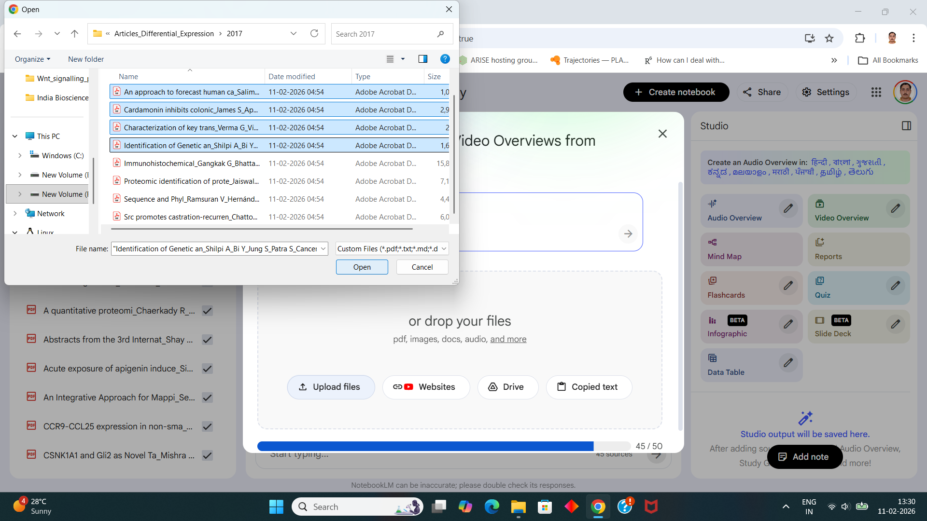

Prompt to Google’s Notebook LM:
Assume that you are a cancer researcher with 20+ years of experience, especially in the fields of differential gene and protein expression. Please read the entire contents of all 50 research articles uploaded here and filter the articles to identify those that explicitly mention differential gene/protein expression in a cancer vs normal or cancer vs paratumoral or test-condition for cancer vs control-condition for cancer context. Next, on these filtered results, apply another filter to identify those research papers in which the fold change or biological fold change is reported either in result tables in the papers or somewhere in the main text. Tabulate these fold changes (which may have been reported in their source research papers directly or as a logarithm of the fold change) in one column, followed by the type of fold change reported (direct, log to the base 2, log to the base 10, etc...) in the next column, the citation of the research paper from which this value was sourced (as reported in the research paper in question) in the next column (for searching for the citation, use the full citation reported in the bibliography for the fold change value being reported in your result table, citing the full citation for the research paper for which PDF file has been named, in cases in which the fold change value is a research finding being reported as a part of the results of the research paper after which the PDF file has been named), followed by the type of cancer for which the fold change was reported, followed by the category of comparison (e.g. tumor/cancer vs normal, tumor/cancer vs paratumoral, tumor/cancer with test condition (e.g.: drug being tested) vs tumor/cancer with control/vector control, etc...). Restrict the set of fold change values reported in the result tables such that you report only those fold change values that pertain to fold changes in the expression of human (Homo sapiens) proteins or genes. Report data for fold change values found in these research papers only if they are definitely present in them. Please do not impute/hallucinate any data in the table. I would rather have no results in the table than have fabricated/false/hallucinated results in it. Thanks! If you have searched for both differential protein expression as well as differential gene expression in the first filter applied, then please split the results table into two results tables- one for each of these two categories.
In each result table, please add an Experiment column at the immediate right side of the one reporting fold change type. Populate it with the type of experiment used to obtain the fold change data (e.g.: mRNA sequencing, microarray, etc…) as sourced from the respective source research paper in which the fold change value in question was reported.
Please add columns titled Protein Name and Gene Name, to the immediate left of the column reporting the fold change value. Populate these columns, in each row below the title/header row, with the corresponding protein name and gene name, respectively, associated with the protein/gene for which the expression fold change value was reported, in the PDF file (research paper) from which the value was sourced. If either the protein name or the gene name associated with the protein/gene is not present in the respective research article, then place a dash (-) as the value in the corresponding cell in the table. Keep the column titles/headers of the two result tables the same across these result tables. Please add columns titled “Adjusted p-value”, “Raw p-value”, and “t-Statistic” immediately to the right of the Fold Change Type column. Populate these columns, below the header/title rows, with the corresponding adjusted p-value, raw p-value, and t-statistic for the fold change value reported in each row of the columns, respectively, sourcing these values from the corresponding research paper (PDF file) from which the respective fold change value was sourced. If the adjusted p-value, raw p-value, or t-statistic value to be filled in a cell in the result tables is not present in the corresponding research paper (PDF file), then fill the corresponding cell with a dash (-) as its cell value.
If you haven't already done so, while forming the final result tables reported in plain tabular form right here in the chat window, please ensure that search hits were only exact matches to all key phrases searched for during filtering and that all phrases reported in the content inside the cells of the tables were directly quoted from the respective source PDF files (research articles) and not inferred or paraphrased. Please display the result tables in the chat window above, after ensuring that they conform to these stipulations.

