**A project Report for Industrial Training**

# “E-COMMERCE (Mobile & Accessories Shopping)”

**Guru Nanak Institute of Technology, SODEPUR**



**Ardent Computech Pvt. Ltd.**

**Submitted By:**

1. Sohom Chowdhury
2. Siddhartha Banerjee
3. Puja Banik
4. Shilpi Dutta
5. Pramila Dey



**BONAFIDE CERTIFICATE**

Certified that this project work was carried out under my supervision

### “E-COMMERCE (JEWELLERY SHOPPING)”

**is the bona fide work of**

**Name of the Student: Signature:**

1. **Sohom Chowdhury 1.**
2. **Siddhartha Banerjee 2.**
3. **Puja Banik 3.**
4. **Shilpi Dutta 4.**

**5 Pramila Dey 5.**

**Name of the Mentor*: JOYDEEP BANERJEE***

**SIGNATURE:**

**Ardent Original Seal**

## ACKNOWLEDGEMENT

It is great pleasure to present this report on the project named ―E-COMMERCE(Mobile & Accessories Shopping) undertaken by me as part of my B. Tech (IT) curriculum.

I am thankful to ARDENT KOLKATA for offering me such a wonderful challenging opportunity and I express my deepest thanks to all coordinators, of ARDENT KOLKATA for providing all the possible help and assistance and their constant encouragement.

It is a pleasure that we find ourselves penning down these lines to express our sincere thanks to the people who helped us along the way in completing our project. We find inadequate words to express our sincere gratitude towards them.

First and foremost we would like to express our gratitude towards our training guide **Mr. Joydeep Banerjee** for placing complete faith and confidence in our ability to carry out this project and for providing us his time, inspiration, encouragement, help, valuable guidance, constructive criticism and constant interest. He took personal interest in spite of numerous commitments and busy schedule to help us complete this project. Without the sincere and honest guidance of our respected project guide we would have not been to reach the present stage.

## 

## ABSTRACT

This is a project report on ―**E-COMMERCE (Mobile & Accessories Shopping)**‖. During the making/developing of this project we explored new ideas and functionality behind the working of a notepad.

This project is the output of our planning, schedule, programming skill and the hard work, and this report reflects our steps taken at various levels of programming skill, planning and schedule.

We have learnt a lot during this project and liked the improvement in our testing skills and deep concept related to these kinds of projects.

Our project is **E-COMMERCE (Mobile & Accessories Shopping)**.

This is a web based application which helps people to find and buy latest Mobile and accessories with different designs on internet. It is useful in the way that it paves an easier way to buy electronics online.

In this application we have basically 2 modules. The first module includes the customer module.

The customer has to register for any enquiry related to mobile phones, speakers and accessories. The unregistered person can‘t access this application. The registered customer can view details of the above mentioned items and he/she can buy the item of his/her choice and need & pay its price accordingly.

The admin module contains the access of admin on the application. The admin can change everything in the application. He has the ability to add, delete, and update any information regarding the products & orders.

**LIST OF CONTENTS**

**CONTENT PAGE NO.**

**1. PROJECT DESCRIPTION**   **7**

**2. COMPONENTS OF THE PROJECTS**    **8**

**3. REQUIREMENT ANALYSIS**    **9**

**4. MODULES**    **10**

**5. INTRODUCTION TO TOOLS**    **10**

1. **BACKEND**
2. **FRONTEND**
3. **FRAMEWORK**

**6. WHY PHP?**    **11**

**7. HISTORY**    **12**

1. **USAGE**
2. **SPEED OPTIMIZATION**
3. **SYNTAX**
4. **DATA TYPES**
5. **FUNCTIONS**

**8. MYSQL**    **17**

1. **USAGE**
2. **FEATURES**

**9.LARAVEL**

**a. HISTORY**

**b. FEATURES**

**10. SYSTEM DEVELPOMENT LIFE CYCLE (SDLC)**    **21**

**11. PROBLEM ANALYSIS**    **22**

1. **APPLICATIONS**
2. **CHALLENGES**

**12. REQUIREMENT ANALYSIS**    **23**

**a. GOAL OF THESIS**

**13. FEASEBILITY STUDY**    **24**

**14. SYSTEM ANALYSIS**    **25**

**15. DESIGN PHASES**    **26**

**16. TEST PLAN**    **27**

**17. MAINTENANCE**    **28**

**18. E-R DIAGRAM**    **29**

**19. DATA FLOW DIAGRAM**    **30**

**20. SCREENSHOTS**    **31**

**21. CODING**    **40**

**22. FUTURE ENCHANCEMENT**    **46**

**23. CONCLUSION**    **47**

**24. BIBLIOGRAPHY**    **48**

## 

## PROJECT DESCRIPTION

E-commerce is fast gaining ground as an accepted and used business paradigm. More and more business houses are implementing web sites providing functionality for performing commercial transactions over the web. It is reasonable to say that the process of shopping on the web is becoming commonplace.

The objective of this project is to develop a general purpose e-commerce store where product like smartphones & accessories can be bought from the comfort of home through the Internet. However, for implementation purposes, this paper will deal with an online shopping for the above mentioned items.

An online store is a virtual store on the Internet where customers can browse the catalog and select products of interest. The selected items may be collected in a shopping cart. At checkout time, the items in the shopping cart will be presented as an order. At that time, more information will be needed to complete the transaction. Usually, the customer will be asked to fill or select a billing address, a shipping address, a shipping option, and payment information such as credit card number.

**COMPONENTS OF THE PROJECTS**

**How to Login**

In this module, the user will enter his email and password to view and buy latest products. There will be 2 types of users Administrator/Customer.

**How to be a member of this application**

In this site, the customers can join this application, if he/she is not a member yet by pressing Register link .User should provide some details that are asked to join.

**How to view the product details**

Any product can be searched by selecting the model which the user wishes to view or buy.

**How** T**o Give ORDER**

First User has to login, and then he will visit the view products page. There he will select the item he/she wants to buy and then the user will click to see products detail after clicking on Add to cart the product will added to cart, Then the user can further proceed to purchase that product.

**How to pay money**

The user can pay through Cash on delivery & debit cards.

## REQUIREMENT ANALYSIS

**Hardware Requirements**

**No. Description**

1. Intel core ,WIN XP/7/vista
2. 320 MB RAM

**Software Requirements**

**No. Description**

1. Windows XP –10
2. Php 5.1
3. MyphpAdmin
4. XAMPPSERVER
5. HTML/JavaScript/CSS/Bootstrap

## MODULES

**Login Module** –In this module user can enter the application by providing email and password and start shopping.

**Admin Module** –Admin can add, modify and delete the latest varieties of smartphones & accessories.

**Join Module** –In this module user can become a part of the site by providing some necessary information for example Name, Address, password, confirm password, email and other details.

**Shopping Module –**The customer can view and buy latest varieties of smartphones & accessories.

**INTRODUCTION TO TOOLS**

**FRONT-END/BACK-END**

**Front-End: Web Pages using HTML,CSS and JavaScript.**

**Back-End:PHP, MYSQL**

**Front End:**

· **HTML** –It is used to generate web page.

HTML is the predominant [markup language f](http://en.wikipedia.org/wiki/Markup_language)or [web pages.](http://en.wikipedia.org/wiki/Web_page) It provides a means to describe the structure of text-based information in a document — by denoting certain text as headings, paragraphs, lists, and so on.

· **JAVASCRIPT** –It is used for checking User information before sending to

JavaScript is a [scripting language m](http://en.wikipedia.org/wiki/Scripting_language)ost often used for [client-sidew](http://en.wikipedia.org/wiki/Client-side)eb development. It is a [dynamic,](http://en.wikipedia.org/wiki/Dynamic_language) [weakly typed,](http://en.wikipedia.org/wiki/Weak_typing) [prototype-based l](http://en.wikipedia.org/wiki/Prototype-based_programming)anguage with

[first-class functions.](http://en.wikipedia.org/wiki/First-class_function) Currently,."JavaScript" is an implementation of the[ECMAScript](http://en.wikipedia.org/wiki/ECMAScript) standard

· **PHP-** Php is a technology that lets you mix regular, static HTML with dynamically generated HTML. Many Web pages that are built by CGI programs are mostly static, with the dynamic part limited to a few small occasions. But most CGI variations, including servlets, make you generate the entire page via your program, even though most of it is always the same.

**Backend:**

· **My SQL** is a [relational database management system(](http://en.wikipedia.org/wiki/Relational_database_management_system)RDBMS) which has more than 6 million installations. MySQL stands for "My Structured Query Language". The program runs as a server providing multi-user access to a number of databases.

· **XAMPP**- Apache is a [web container,](http://en.wikipedia.org/wiki/Web_container) or [application server d](http://en.wikipedia.org/wiki/Application_server)eveloped at the [Apache](http://en.wikipedia.org/wiki/Apache_Software_Foundation)

[Software Foundation (](http://en.wikipedia.org/wiki/Apache_Software_Foundation)ASF).It adds tools for configuration and management but can also be configured by editing configuration files that are normally [XML-](http://en.wikipedia.org/wiki/XML)formatted.

Apache includes its own internal [HTTP s](http://en.wikipedia.org/wiki/Hypertext_Transfer_Protocol)erver.

**WHY PHP?**

**PHP** is a widely used, general-purpose [scripting language t](http://en.wikipedia.org/wiki/Scripting_language)hat was originally designed for [web development,](http://en.wikipedia.org/wiki/Web_development) to produce [dynamic web pages.](http://en.wikipedia.org/wiki/Dynamic_web_page) It can be embedded into [HTML a](http://en.wikipedia.org/wiki/HTML)nd generally runs on a [web server,](http://en.wikipedia.org/wiki/Web_server) which needs to be configured to process PHP code and create [web page](http://en.wikipedia.org/wiki/Web_page) content from it. It can be deployed on most web servers and on almost every [operating system](http://en.wikipedia.org/wiki/Operating_system) and [platform](http://en.wikipedia.org/wiki/Platform_(computing)) free of charge. PHP is installed on over 20 million websites and 1 million [webservers.](http://en.wikipedia.org/wiki/Web_server)

PHP was originally created by [Rasmus Lerdorfi](http://en.wikipedia.org/wiki/Rasmus_Lerdorf)n [1994 a](http://en.wikipedia.org/wiki/1995)nd has been in continuous development ever since. The main implementation of PHP is now produced by **The PHP Group** and serves as the [*de facto* standard f](http://en.wikipedia.org/wiki/De_facto_standard)or PHP as there is no [formal specification.](http://en.wikipedia.org/wiki/Formal_specification) PHP is [free software](http://en.wikipedia.org/wiki/Free_software) released under the [PHP License,](http://en.wikipedia.org/wiki/PHP_License) which is incompatible with the [GNU General Public License](http://en.wikipedia.org/wiki/GNU_General_Public_License)

(GPL) because of restrictions on the use of the term *PHP*.

PHP has evolved to include a [command line interface c](http://en.wikipedia.org/wiki/Command_line_interface)apability and can also be used in [standalone graphical applications.](http://en.wikipedia.org/wiki/Standalone_software)

## HISTORY

*PHP* originally stood for Personal Home Page. It began in 1994 as a set of [Common Gateway Interface binaries w](http://en.wikipedia.org/wiki/Common_Gateway_Interface)ritten in the [C programming language b](http://en.wikipedia.org/wiki/C_programming_language)y the [Danish](http://en.wikipedia.org/wiki/Danish_people)[/Greenlandic](http://en.wikipedia.org/wiki/Greenland) programmer [Rasmus Lerdorf.](http://en.wikipedia.org/wiki/Rasmus_Lerdorf) Lerdorf initially created these Personal Home Page Tools to replace a small set of [Perl s](http://en.wikipedia.org/wiki/Perl)cripts he had been using to maintain his [personal homepage.](http://en.wikipedia.org/wiki/Personal_homepage) The tools were used to perform tasks such as displaying his résumé and recording how much [traffic](http://en.wikipedia.org/wiki/Web_traffic) his page was receiving. He combined these binaries with his Form Interpreter to create PHP/FI, which had more functionality. PHP/FI included a larger implementation for the C programming language and could communicate with [databases,](http://en.wikipedia.org/wiki/Database) enabling the building of simple, dynamic [web applications.](http://en.wikipedia.org/wiki/Web_application) Lerdorf released PHP publicly on June 8, 1995 to accelerate [bug l](http://en.wikipedia.org/wiki/Software_bug)ocation and improve the code. This release was named PHP version 2 and already had the basic functionality that PHP has today. This included Perl-like variables, form handling, and the ability to embed HTML. The syntax was similar to Perl but was more limited, simpler, and less consistent.

[Zeev Suraskia](http://en.wikipedia.org/wiki/Zeev_Suraski)nd [Andi Gutmans,](http://en.wikipedia.org/wiki/Andi_Gutmans) two developers at the [Technion IIT,](http://en.wikipedia.org/wiki/Technion_IIT) rewrote the [parser i](http://en.wikipedia.org/wiki/Parser)n

1997 and formed the base of PHP 3, changing the language's name to the [recursive initialism](http://en.wikipedia.org/wiki/Recursive_initialism)

*PHP:Hypertext Preprocessor*. The development team officially released PHP/FI 2 in November 1997 after months of [beta t](http://en.wikipedia.org/wiki/Development_stage)esting. Afterwards, public testing of PHP 3 began, and the official launch came in June 1998. Suraski and Gutmans then started a new [rewrite o](http://en.wikipedia.org/wiki/Rewrite_(programming))f PHP's core, producing the [Zend Engine i](http://en.wikipedia.org/wiki/Zend_Engine)n 1999. They also founded [Zend Technologies i](http://en.wikipedia.org/wiki/Zend_Technologies)n [Ramat Gan,](http://en.wikipedia.org/wiki/Ramat_Gan)

Israel.

On May 22, 2000, PHP 4, powered by the Zend Engine 1.0, was released. As of August, 2008 this branch is up to version 4.4.9. PHP 4 is no longer underdevelopment nor will any security updates be released. On July 13, 2004, PHP 5 was released, powered by the new Zend Engine II. PHP 5 included new features such as improved support for [object-oriented programming,](http://en.wikipedia.org/wiki/Object-oriented_programming) the PHP Data Objects extension (which defines a lightweight and consistent interface for accessing databases), and numerous performance enhancements. In 2008, PHP 5 became the only stable version under development. [Late static binding h](http://en.wikipedia.org/wiki/Late_static_binding)as been missing fromPHP and has been added in version 5.3. PHP 6 is under development alongside PHP 5. Major changes include the removal of register_globals[magic quotes,](http://en.wikipedia.org/wiki/Magic_quotes) and [safe mode.](http://en.wikipedia.org/wiki/Safe_mode) The reason for the removals was that register_globals had given way to security holes, and magic quotes had an unpredictable nature, and was best avoided. Instead, to escape characters, magic quotes may be substituted with the addslashes () function, or more appropriately an escape mechanism specific to the database vendor itself like mysql_real_escape_string () for [MySQL.](http://en.wikipedia.org/wiki/MySQL) Functions that will be removed in PHP 6 have been deprecated in PHP 5.3 and will produce a warning if used.

Many high-profile open-source projects ceased to support PHP 4 in new code as of February 5, 2008, because of the GoPHP5 initiative, provided by a consortium of PHP developers promoting the transition from PHP 4 to PHP 5.

PHP currently does not have native support for [Unicode o](http://en.wikipedia.org/wiki/Unicode)r multibyte strings; Unicode support will be included in PHP 6 and will allow strings as well as class, method and function names to contain non[-ASCII c](http://en.wikipedia.org/wiki/ASCII)haracters.

It runs in both [32-bit a](http://en.wikipedia.org/wiki/32-bit)nd [64-bit e](http://en.wikipedia.org/wiki/64-bit)nvironments, but on Windows the only official distribution is

32-bit, requiring Windows 32-bit compatibility mode to be enabled while using [IIS i](http://en.wikipedia.org/wiki/Internet_Information_Services)n a 64-bit Windows environment. As of PHP 5.3.0, experimental x64 bit versions are available.

**Usage**

PHP is a general-purpose scripting language that is especially suited for [web development.](http://en.wikipedia.org/wiki/Web_development) PHP generally runs on a [web server.](http://en.wikipedia.org/wiki/Web_server) Any PHP code in a requested file is [executed b](http://en.wikipedia.org/wiki/Execution_(computing))y the PHP runtime, usually to create [dynamic web page c](http://en.wikipedia.org/wiki/Dynamic_web_page)ontent. It can also be used for [command-line](http://en.wikipedia.org/wiki/Command-line) scripting and [client-side GUI a](http://en.wikipedia.org/wiki/Client-side)pplications. PHP can be deployed on most [web servers,](http://en.wikipedia.org/wiki/Web_server) many [operating systems a](http://en.wikipedia.org/wiki/Operating_system)nd [platforms,](http://en.wikipedia.org/wiki/Platform_(computing)) and can be used with many [relational database management systems.](http://en.wikipedia.org/wiki/Relational_database_management_system) It is available free of charge, and the PHP Group provides the complete source code for users to build, customize and extend for their own use.

PHP primarily acts as a [filter,](http://en.wikipedia.org/wiki/Filter_(software)) taking input from a file or stream containing text and/or PHP instructions and outputs another stream of data; most commonly the output will be HTML. Since PHP 4, the PHP [parser compiles i](http://en.wikipedia.org/wiki/Parser)nput to produce [bytecode f](http://en.wikipedia.org/wiki/Bytecode)or processing by the [Zend Engine,](http://en.wikipedia.org/wiki/Zend_Engine) giving improved performance over its [interpreter p](http://en.wikipedia.org/wiki/Interpreter_(computing))redecessor. Originally designed to create dynamic web pages, PHP now focuses mainly on [server-side scripting,](http://en.wikipedia.org/wiki/Server-side_scripting) and it is similar to other server-side scripting languages that provide dynamic content from a web server to a [client,](http://en.wikipedia.org/wiki/Client_(computing)) such as [Microsoft's](http://en.wikipedia.org/wiki/Microsoft) [Active Server Pages,](http://en.wikipedia.org/wiki/Active_Server_Pages) [Sun Microsystems'](http://en.wikipedia.org/wiki/Sun_Microsystems) [Java Server Pages,](http://en.wikipedia.org/wiki/JavaServer_Pages) and [mod_perl.](http://en.wikipedia.org/wiki/Mod_perl) PHP has also attracted the development of many [frameworks t](http://en.wikipedia.org/wiki/Software_framework)hat provide building blocks and a design structure to promote [rapid application development (](http://en.wikipedia.org/wiki/Rapid_application_development)RAD). Some of these include [Cake PHP,](http://en.wikipedia.org/wiki/CakePHP) [Symphony,](http://en.wikipedia.org/wiki/Symfony) [CodeIgniter,](http://en.wikipedia.org/wiki/CodeIgniter) and [Zend Framework,](http://en.wikipedia.org/wiki/Zend_Framework) offering features similar to other [web application frameworks.](http://en.wikipedia.org/wiki/List_of_web_application_frameworks)

The [LAMP a](http://en.wikipedia.org/wiki/LAMP_(software_bundle))nd [WAMP a](http://en.wikipedia.org/wiki/WAMP)rchitectures have become popular in the web industry as a way of deploying web applications. PHP is commonly used as the *P* in this bundle alongside [Linux,](http://en.wikipedia.org/wiki/Linux)

[Apache a](http://en.wikipedia.org/wiki/Apache_HTTP_Server)nd [MySQL,](http://en.wikipedia.org/wiki/MySQL) although the *P* may also refer to [Python o](http://en.wikipedia.org/wiki/Python_(programming_language))r [Perl.](http://en.wikipedia.org/wiki/Perl)

As of April 2007, over 20 million Internet domains were hosted on servers with PHP installed, and mod_php was recorded as the most popular Apache module. Significant websites are written in PHP including the user-facing portion of [Facebook,](http://en.wikipedia.org/wiki/Facebook) [Wikipedia](http://en.wikipedia.org/wiki/Wikipedia) (Media Wiki), [Yahoo!,](http://en.wikipedia.org/wiki/Yahoo!) [My Yearbook,](http://en.wikipedia.org/wiki/MyYearbook) [Digg,](http://en.wikipedia.org/wiki/Digg) [Joomla,](http://en.wikipedia.org/wiki/Joomla) [WordPress,](http://en.wikipedia.org/wiki/WordPress) [YouTube,](http://en.wikipedia.org/wiki/YouTube) [Drupal a](http://en.wikipedia.org/wiki/Drupal)nd [Tagged.](http://en.wikipedia.org/wiki/Tagged)

**Speed optimization**

As with many scripting languages, PHP scripts are normally kept as human-readable source code, even on production web servers. In this case, PHP scripts will be [compiled a](http://en.wikipedia.org/wiki/Compiler)t runtime by the PHP engine, which increases their execution speed. PHP scripts are able to be compiled before runtime using PHP compilers as with other programming languages such as [C (](http://en.wikipedia.org/wiki/C_(programming_language))the language PHP and its extensions are written in).

Code optimizers aim to reduce the computational complexity of the compiled code by reducing its size and making other changes that can reduce the execution time with the overall goal of improving performance. The nature of the PHP [compiler](http://en.wikipedia.org/wiki/Compiler) is such that there are often opportunities for [code optimization,](http://en.wikipedia.org/wiki/Optimization_(computer_science)) and an example of a code optimizer is the [Zend Optimizer](http://en.wikipedia.org/wiki/PHP_accelerator)

PHP extension.

Another approach for reducing overhead for high load PHP servers is using [PHP accelerators.](http://en.wikipedia.org/wiki/PHP_accelerator) These can offer significant performance gains by [catching t](http://en.wikipedia.org/wiki/Caching)he compiled form of a PHP script in [shared memory t](http://en.wikipedia.org/wiki/Shared_memory)o avoid the overhead of [parsing](http://en.wikipedia.org/wiki/Parsing) and [compiling t](http://en.wikipedia.org/wiki/Compiling)he code every time the script runs. A PHP accelerator will be built into PHP 6.

**Syntax**

[Syntax-highlighted P](http://en.wikipedia.org/wiki/Syntax_highlighting)HP code embedded within [HTML](http://en.wikipedia.org/wiki/HTML)

PHP only parses code within its [delimiters.](http://en.wikipedia.org/wiki/Delimiter) Anything outside its delimiters is sent are<?php to open and ?> to close PHP sections. <script language="php"> and </script> delimiters are also available, as are the shortened forms <? Or <?= (which is used to echo back a [string o](http://en.wikipedia.org/wiki/String_(computer_science))r [variable)](http://en.wikipedia.org/wiki/Variable_(programming)) and ?> as well as [ASP-](http://en.wikipedia.org/wiki/Active_Server_Pages)style short forms <% or <%= and %>. While short delimiters are used, they make script files less portable as their purpose can be disabled in the [PHP configuration,](http://wiki.php.net/rfc/shortags) and so they are discouraged. The purpose of all these delimiters is to separate PHP code from non-PHP code, including HTML.

The first form of delimiters, <?php and ?>, in [XHTML a](http://en.wikipedia.org/wiki/XHTML)nd other [XML](http://en.wikipedia.org/wiki/XML) documents, creates correctly formed XML 'processing instructions'. This means that the resulting mixture of PHP code and other markup in the server-side file is well-formed XML.

In terms of keywords and language syntax, PHP is similar to most high level languages that follow the C style syntax. *If* conditions, *for* and *while* loops, and function returns are similar in syntax to languages such as C, C++, Java and Perl.

**Data types**

PHP stores whole numbers in a platform-dependent range. This range is typically that of 32bit [signed integers.](http://en.wikipedia.org/wiki/Signed_number_representations) Unsigned integers are converted to signed values in certain situations; this

behavior is different from other programming languages.

Integer variables can be assigned using decimal (positive and negative), [octal,](http://en.wikipedia.org/wiki/Octal) and [hexadecimal](http://en.wikipedia.org/wiki/Hexadecimal) notations. [Floating point n](http://en.wikipedia.org/wiki/Floating_point)umbers are also stored in a platform-specific range. They can be specified using [floating point n](http://en.wikipedia.org/wiki/Floating_point)otation, or two forms of [scientific notation.](http://en.wikipedia.org/wiki/Scientific_notation) PHP has a native [Boolean t](http://en.wikipedia.org/wiki/Boolean_datatype)ype that is similar to the native Boolean types in [Java a](http://en.wikipedia.org/wiki/Java_(programming_language))nd [C++.](http://en.wikipedia.org/wiki/C%2B%2B)The only value in the null data type is *NULL*. Variables of the "resource" type represent references to resources from external sources. These are typically created by functions from a particular extension, and can only be processed by functions from the same extension; examples include file, image, and database resources. Arrays can contain elements of any type that PHP can handle, including resources, objects, and even other arrays. Order is preserved in lists of values and in [hashes w](http://en.wikipedia.org/wiki/Hash_table)ith both keys and values, and the two can be intermingled. PHP also supports [strings,](http://en.wikipedia.org/wiki/String_(computing)) which can be used with single quotes, double quotes, or [here doc syntax.](http://en.wikipedia.org/wiki/Heredoc)

**Functions**

PHP has hundreds of base functions and thousands more via extensions. These functions are well documented on the PHP site, however, the built-in library has a functions for [thread](http://en.wikipedia.org/wiki/Thread_(computer_science)) programming, although it does support multiprocess programming on POSIX systems.

**5.3 and newer**

PHP gained support for [closures.](http://en.wikipedia.org/wiki/Closure_(computer_science)) True [anonymous functions a](http://en.wikipedia.org/wiki/Anonymous_function)re supported using the

following syntax:

functiongetAdder($x)

{ return function ($y) use ($x) { return $x + $y;

};

}

$adder = getAdder(8);

echo $adder(2); // prints "10"

Here, getAdder() function creates a closure using parameter $x (keyword "use" forces getting variable from context), which takes additional argument $y and returns it to the caller. Such a function can be stored, given as the parameter to other functions, etc. For more details see [Lambda functions and closures RFC.](http://wiki.php.net/rfc/closures)

## MYSQL

**MySQL** is a [relational database management system(](http://en.wikipedia.org/wiki/Relational_database_management_system)RDBMS) which has more than 6 million installations. MySQL stands for "My Structured Query Language".

The program runs as a server providing multi-user access to a number of databases.

The project's [source code i](http://en.wikipedia.org/wiki/Source_code)s available under terms of the [GNU General PublicLicense,](http://en.wikipedia.org/wiki/GNU_General_Public_License) as well as under a variety of [proprietary a](http://en.wikipedia.org/wiki/Proprietary_software)greements. MySQL is owned and sponsored by a single [for](http://en.wikipedia.org/wiki/Business) [profit f](http://en.wikipedia.org/wiki/Business)irm, the [Swedish c](http://en.wikipedia.org/wiki/Sweden)ompany [MySQL AB,](http://en.wikipedia.org/wiki/MySQL_AB) now a [subsidiary o](http://en.wikipedia.org/wiki/Subsidiary)f [Sun Microsystems,](http://en.wikipedia.org/wiki/Sun_Microsystems) which holds the copyright to most of the codebase.

MySQL is commonly used by [free software p](http://en.wikipedia.org/wiki/Free_software)rojects which require a full-featured database management system, such as [WordPress,](http://en.wikipedia.org/wiki/WordPress) [phpBBa](http://en.wikipedia.org/wiki/PhpBB)nd other software built on the [LAMP s](http://en.wikipedia.org/wiki/LAMP_(software_bundle))oftware stack. It is also used in very high-scale [World Wide Web](http://en.wikipedia.org/wiki/World_Wide_Web) products including [Google a](http://en.wikipedia.org/wiki/Google)nd

[Facebook.](http://en.wikipedia.org/wiki/Facebook)

**Uses**

MySQL is used in [web applications a](http://en.wikipedia.org/wiki/Web_application)nd acts as the database component of the [LAMP s](http://en.wikipedia.org/wiki/LAMP_(software_bundle))oftware stack. Its popularity for use with web applications is closely tied to the popularity of [PHP,](http://en.wikipedia.org/wiki/PHP) which is often combined with MySQL. Several high-traffic web sites (including [Flickr,](http://en.wikipedia.org/wiki/Flickr) [Facebook,](http://en.wikipedia.org/wiki/Facebook) [Wikipedia,](http://en.wikipedia.org/wiki/Wikipedia) [Google (](http://en.wikipedia.org/wiki/Google)though not for searches), [Nokia,](http://en.wikipedia.org/wiki/Nokia) Auctionmarts and [YouTube)](http://en.wikipedia.org/wiki/YouTube) use MySQL for data storage and logging of user data.

**Features**

As of April 2009, MySQL offers MySQL 5.1 in two different variants: the MySQL Community Server and [Enterprise Server.](http://en.wikipedia.org/wiki/MySQL_Enterprise) They have a common code base and include the following features:

· A broad subset of [ANSI SQL 99,](http://en.wikipedia.org/wiki/SQL:1999) as well as extensions

· Cross-platform support

· [Stored procedures](http://en.wikipedia.org/wiki/Stored_procedure)

· [Triggers](http://en.wikipedia.org/wiki/Database_trigger)

Update views

True [Varchar s](http://en.wikipedia.org/wiki/Varchar)upport

·INFORMATION_SCHEMA

Strict mode

·

[X/Open XA distributed transaction processing (](http://en.wikipedia.org/wiki/X/Open_XA)DTP) support; [two phasecommit a](http://en.wikipedia.org/wiki/Two-phase-commit_protocol)s part of this, using Oracle's [InnoDBe](http://en.wikipedia.org/wiki/InnoDB)ngine

· Independent [storage engines](http://en.wikipedia.org/wiki/Storage_engine) [(MyISAM f](http://en.wikipedia.org/wiki/MyISAM)or read speed, InnoDB for transactions and [referential integrity,](http://en.wikipedia.org/wiki/Referential_integrity) [MySQL Archive f](http://en.wikipedia.org/wiki/MySQL_Archive)or storing historical data in little space)

· Transactions with the InnoDB, BDB and Cluster storage engines; save points with InnoDB

·

[SSL s](http://en.wikipedia.org/wiki/Secure_Sockets_Layer)upport

· Query [caching](http://en.wikipedia.org/wiki/Caching)

· Sub[-SELECTs (](http://en.wikipedia.org/wiki/Select_(SQL))i.e. nested SELECTs)

· Replication with one master per slave, many slaves per master, no automatic support for multiple masters per slave.

· Full-text [indexing a](http://en.wikipedia.org/wiki/Indexing)nd searching using MyISAM engine

· Embedded database library

· Partial [Unicode s](http://en.wikipedia.org/wiki/Unicode)upport ([UTF-8 s](http://en.wikipedia.org/wiki/UTF-8)equences longer than 3 bytes are not supported;

[UCS-2 e](http://en.wikipedia.org/wiki/UTF-16/UCS-2)ncoded strings are also limited to the [BMP)](http://en.wikipedia.org/wiki/Basic_Multilingual_Plane)

· Partial [ACID c](http://en.wikipedia.org/wiki/ACID)ompliance (only full compliance when using the non-default storage engines InnoDB, [BDB a](http://en.wikipedia.org/wiki/Berkeley_DB)nd Cluster)

·

[Shared-nothing c](http://en.wikipedia.org/wiki/Shared-nothing)lustering through [MySQL Cluster](http://en.wikipedia.org/wiki/MySQL_Cluster)

·

**SYSTEM DEVELPOMENT LIFE CYCLE (SDLC)**

The Systems Development Life Cycle **(SDLC)** is a conceptual model used in project

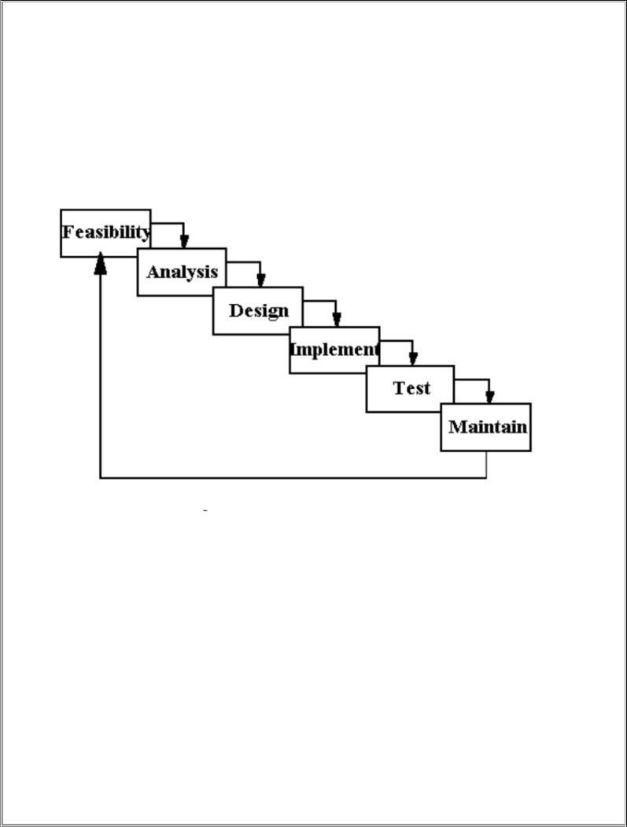management that describes the stages involved in an information system development project from an initial feasibility study through maintenance of the completed application. Various SDLC methodologies have been developed to guide the processes involved including the waterfall model (the original SDLC method). Documentation is crucial regardless of the type of model chosen or devised for any application, and is usually36 done in parallel with the development process. Some methods work better for specific types of projects, but in the final analysis, the most important factor for the success of a project may be how closely particular plan was followed.

**PROBLEM ANALYSIS**

**Applications**

The main applications of the On Line Placement System is the ability of the website to properly show enroll the artists and manage information about them. The administrator has the ability to change, modify, view and delete the various details regarding the users and products. The users have the ability to log in and post their queries

**Challenges**

The challenges mainly lie in detecting attacks like viruses, hacking and also in the implementation of firewall. A virus can enter the system and can disrupt the working of the website. Hacking can be done by some people who want to access some restricted sections of

the website (e.g. administrator‘s area) and to modify or taper some aspects of the website.

Scanning attacks may yield:

1. The method used by viruses to enter the system.
2. The types of database allowed through a firewall.
3. The paths or ways used by hackers to enter the system
4. The loopholes remaining in the system (or website) which are used by attackers.
5. The server from where the viruses or hackers are gaining access to the system.
6. The types of viruses able to affect the website.

And with the implementation of firewall and other security mechanisms that are designed for it, the On Line Placement System Website safe and secure.

## REQUIREMENT ANALYSIS

**Goal of Thesis**

The goal of our thesis is to develop a website that can be used as an enrollment website with the features of interaction and problem solving. The whole project will be based on PHP with

MYSQL as the database with certain security constraints added to it.

Our aim is also to implement the Administrator part in to the project so that the server or administrator himself can view, add, delete and modify.

1. **Administrator**

He has to see whether the website is working properly and whether the details available in the system are relevant and correct. He can view, add, modify, delete details.

1. **Database**

The database keeps all the records of all the users i.e. name, phone no., address,password,email etc. For creating such records it takes the help of tables which is created in the MYSQL.

The tables can have infinite entries of all the registered users as well as administrators.

1. **Clients**

Our aim will also to provide efficient way by which client can enter the website and view and purchase the above mentioned products.

1. **Security Constraints**

There need to be certain constraints which have to be implemented on the database as well as on the administrator in order to work properly the whole system, such as declaring the primary key, or such constraints in order to keep the database work properly.

## FEASIBILTY STUDY

From the inception of ideas for software system, until it is implemented and delivered to customer and even after that the system undergoes gradual developments and evaluations the software is said to have life cycle composed of several phases.

At the feasibility stage, it is desirable that two or three different configuration will be pursed that satisfy the key technical requirement but which represent different level of ambition and cost.

Feasibility is the determination of whether or not a project is worth doing. A feasibility study is carried out select a best system that mate performance requirements.

The data collected during primary investigation examines system feasibilities that is likelihood that the system will be beneficial to the organization. Four tests for feasibility study are as follows:-

* **Technical Feasibility:**This is concerned with specifying equipment and software that will successfully satisfy the use considerably, but might include
* The feasibility to produce output in a given time because system is fast enough to handle multiple users.
* Response time under certain circumstances and ability to process a certain volume of transaction of a particular speed.
* Feasibility to communicate data to distant location.
* **Economical Feasibility:** Economic analysis is the most frequently used technique used for evaluating the effectiveness of a proposed system. More commonly known as cost/benefit analysis the procedure is to determine the benefits and savings that are expected from a proposed system and compared them with cost. Though the cost of installing the system may appear high, it is one time investment. The resulting benefits is that automation results in turnaround time. The resulting cost/benefit ratio is favorable.

**Operational Feasibility:** It is mainly related to human organizational as social aspects. The points to be considered are - The system interface is standard, user friendly and provides extensive help. Hence no special training is not required.

· **Social Feasibility:** Social feasibility is determination of whether a proposed project will be acceptable to people or not, So this project is totally Social and Feasible

## SYSTEM ANALYSIS

The Analysis model:

The analysis model must achieve three primary objectives:

· To describe what the customer requires.

· To establish the basis for the enhancement of a software design.

· To define a set of requirements that can be validated once the software is completely enhanced. The main elements of the analysis model are briefly described below.

· At the core of the model lies the ***data dictionary***, which is a repository that contains descriptions of all the data objects consumed or produced by the software .Three different diagrams surround the core.

· The **entity relation diagram** depicts42 relationships between data objects.

· The **data flow diagram** provides an indication of how the data is transformed as they move through the system.

· The **state transition diagram** indicates how the system behaves as a consequence of external events.

## DESIGN PHASE

The design phase involves converting the informational, functional, and network requirements identified during the initiation and planning phases into unified design specifications that developers use to script programs during the development phase. Program designs are constructed in various ways. Using a top-down approach, designers first identify and link major program components and interfaces, then expand design layouts as they identify and link smaller subsystems and connections. Using a bottom-up approach, designers first identify and link minor program components and interfaces, then expand design layouts as they identify and link larger systems and connections.

Contemporary design techniques often use prototyping tools that build mock-up designs of items such as application screens, database layouts, and system architectures. End users, designers, developers, database managers, and network administrators should review and refine the prototyped designs in an iterative process until they agree on an acceptable design.

implementation, and training plans during the design phase. Additionally, they should draft user, operator, and maintenance manuals.

For design of the website project:

1. First Database has to be designed which can be used to handle all the requirements of the users.
2. The basic structure of the website has to be designed.
3. The main template to be used for the website is designed.

**TEST PLAN**

The testing phase requires organizations to complete various tests to ensure the accuracy of programmed code, the inclusion of expected functionality, and the interoperability of applications and other network components. Thorough testing is critical to ensuring systems meet organizational and end-user requirements. Test plans created during initial project phases enhance an organization‘s ability to create detailed tests.

A bottom-up approach tests smaller components first and progressively adds and tests additional components and systems. A top-down approach first tests major components and connections and progressively tests smaller components and connections.

Bottom-up tests often begin with functional (requirements based) testing. Functional tests should ensure that expected functional, security, and internal control features are present and operating properly. Testers then complete integration and end-to-end testing to ensure application and system components interact properly. Users then conduct acceptance tests to ensure systems meet defined acceptance criteria. Organizations should review and complete user, operator, and maintenance manuals during the testing phase. Additionally, they should finalize conversion, implementation, and training plans.

For testing of the website:

All the features of the website are tested by running each function available in the website.

2. The results of the tests conducted on the website are analyzed properly. Only after getting satisfactory results of testing the website can be uploaded on the network i.e.

internet.

## MAINTENANCE

The maintenance phase involves making changes to hardware, software, and documentation to support its operational effectiveness. It includes making changes to improve a system‘s performance, correct problems, enhance security, or address user requirements. To ensure modifications do not disrupt operations or degrade a system‘s performance or security, organizations should establish

appropriate change management standards and procedures. Routine changes are not as complex as major modifications and can usually be implemented in the normal course of business. Routine change controls should include procedures for requesting, evaluating, approving, testing, installing, and documenting software modifications. Maintaining accurate, up-to-date hardware and software inventories is a critical part of all change management processes. Management should carefully document all modifications to ensure accurate system inventories. Management should coordinate all technology related changes through an oversight committee and assign an appropriate party responsibility for administering software patch management programs. Quality assurance, security, audit, regulatory compliance, network, and end-user personnel should be appropriately included in change management processes. Risk and security review should be done whenever a system modification is implemented to ensure controls remain in place.

For maintenance of the website:

1. The database has to be updated regularly according to new available information.
2. Redundant and false information must be removed from the database.
3. Newer version of PHP,MYSQL can be used for up gradation of website and to improve the overall performance of the system.

## DATA FLOW DIAGRAM

**LEVEL 0:**

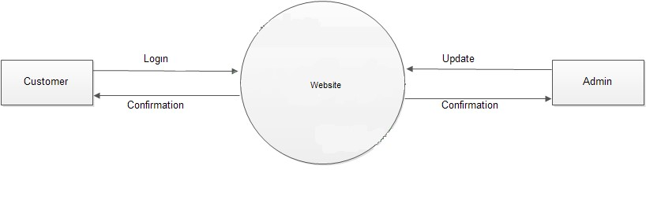

**LEVEL 1:** 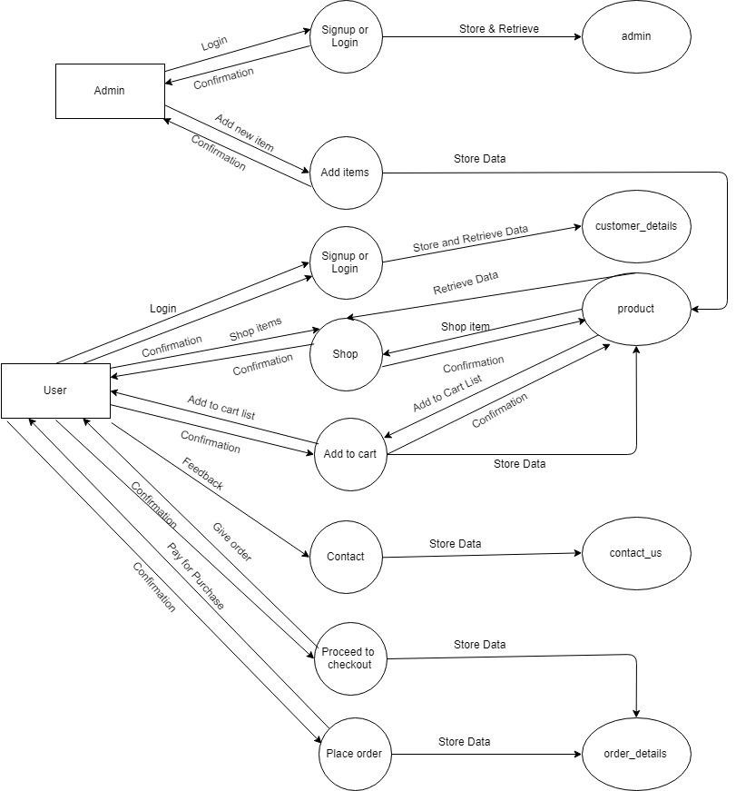

**SCREENSHOTS**

**HOME PAGE:**

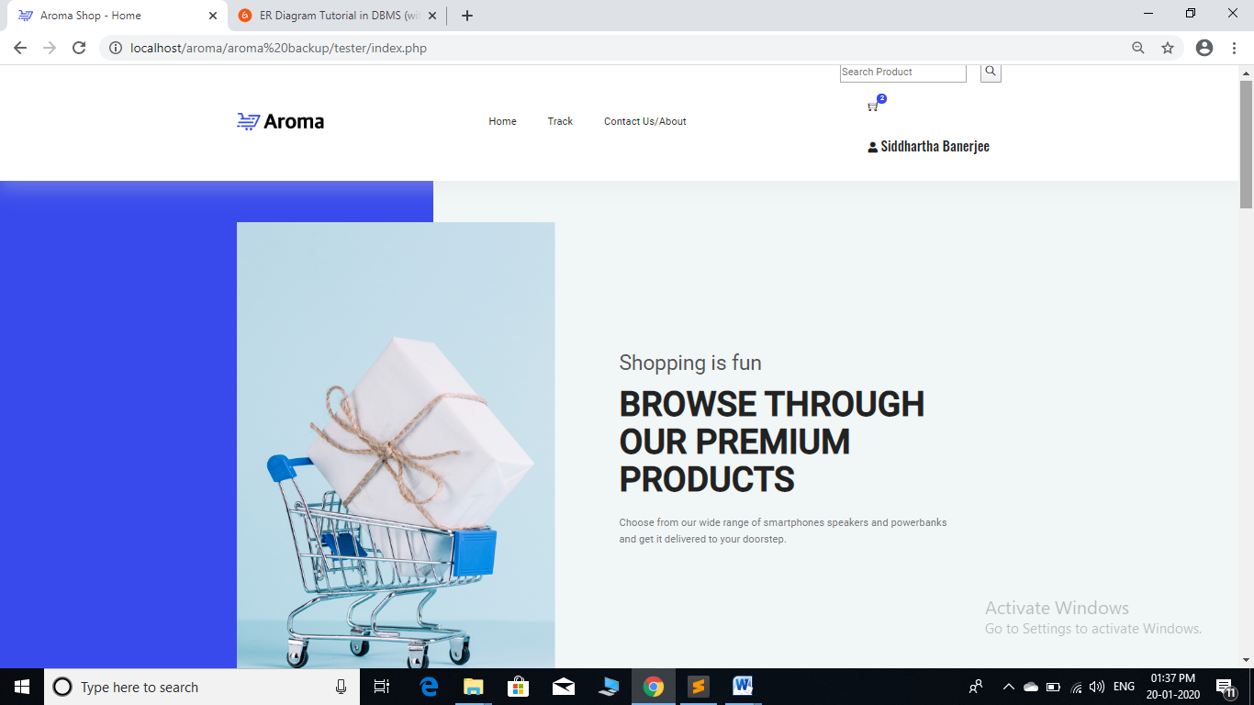

**CART:**

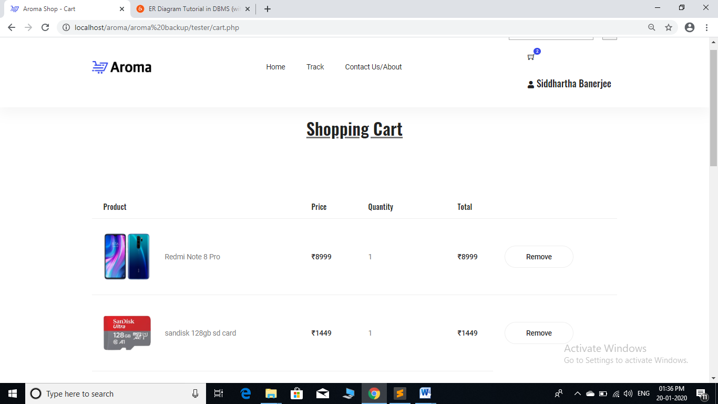

**ADMIN:**

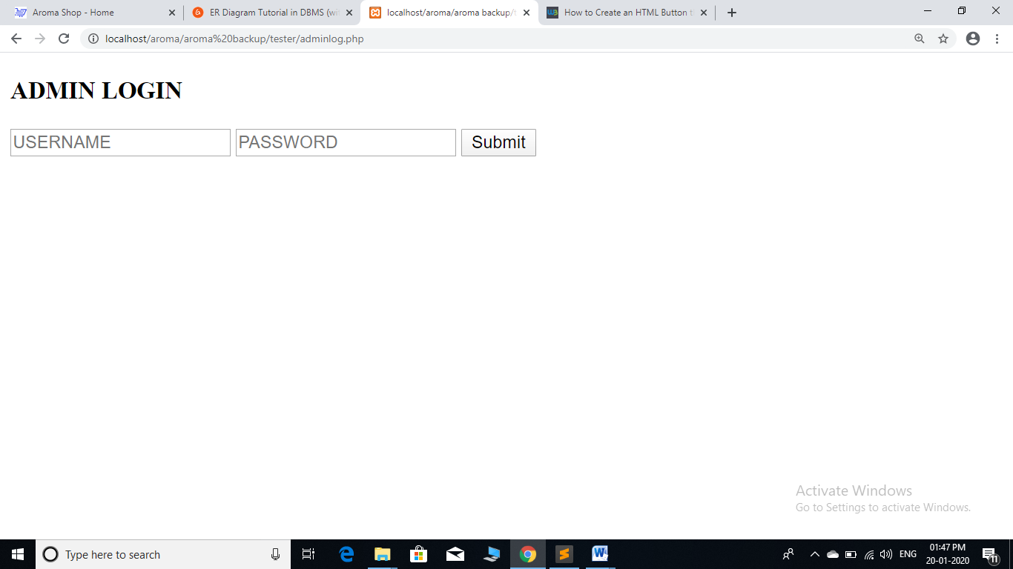

**Index Page Of Admin:-**

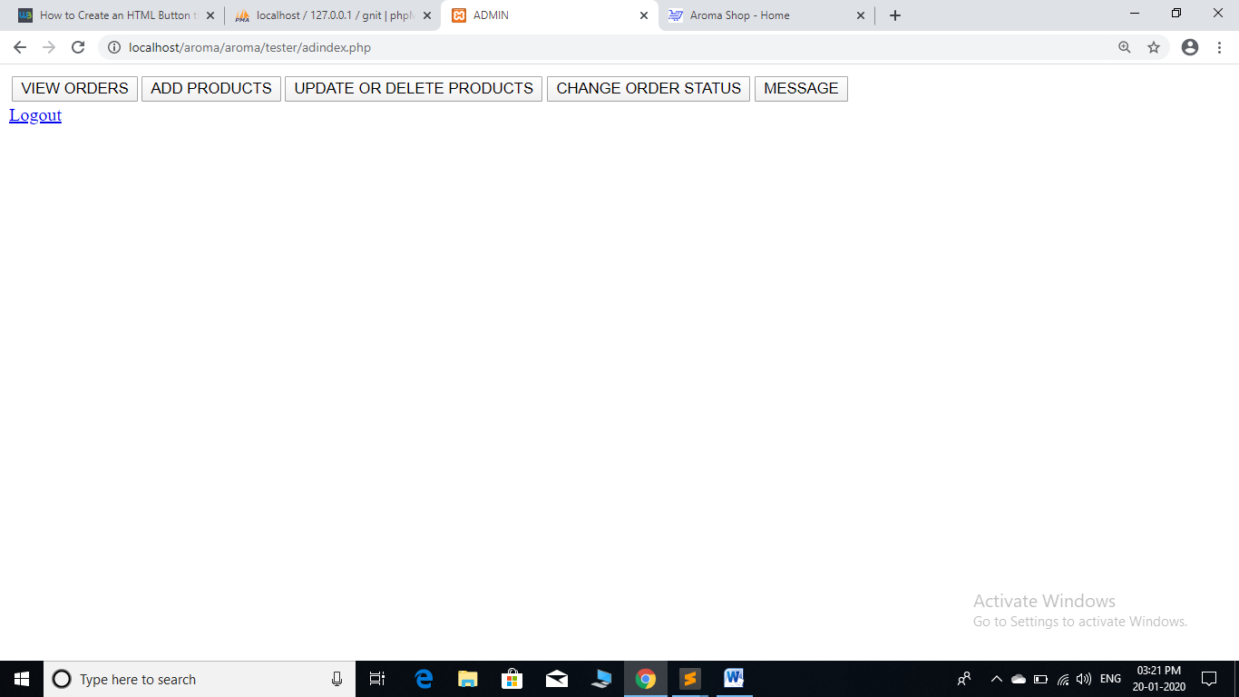

**DATABASE:**

**Product Details Table:-**

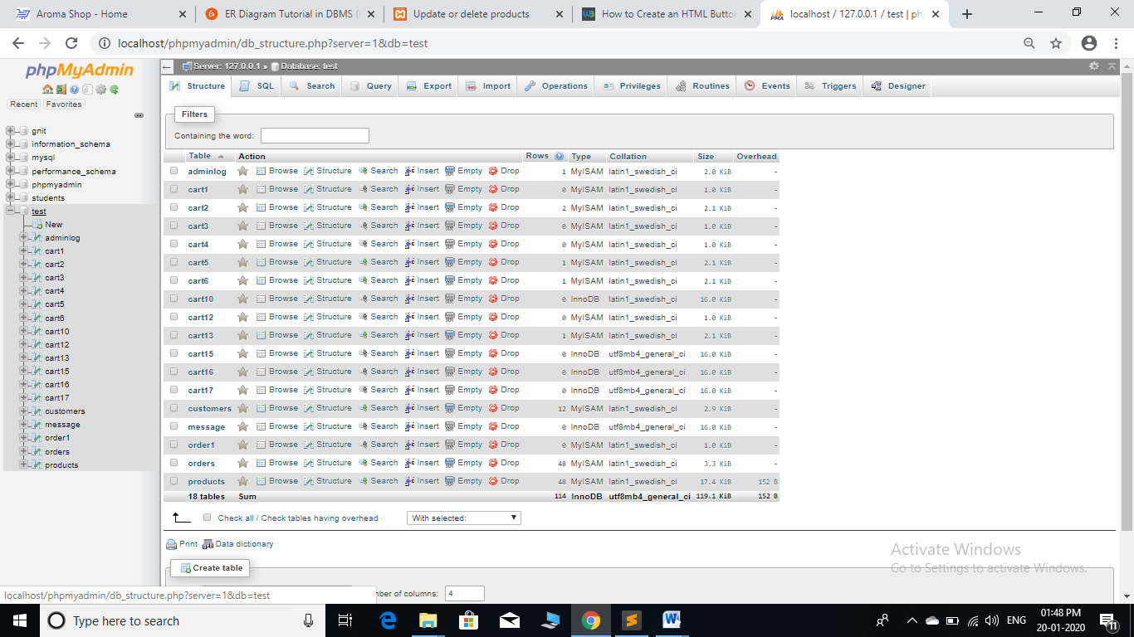

**ORDER DETAILS TABLE:**

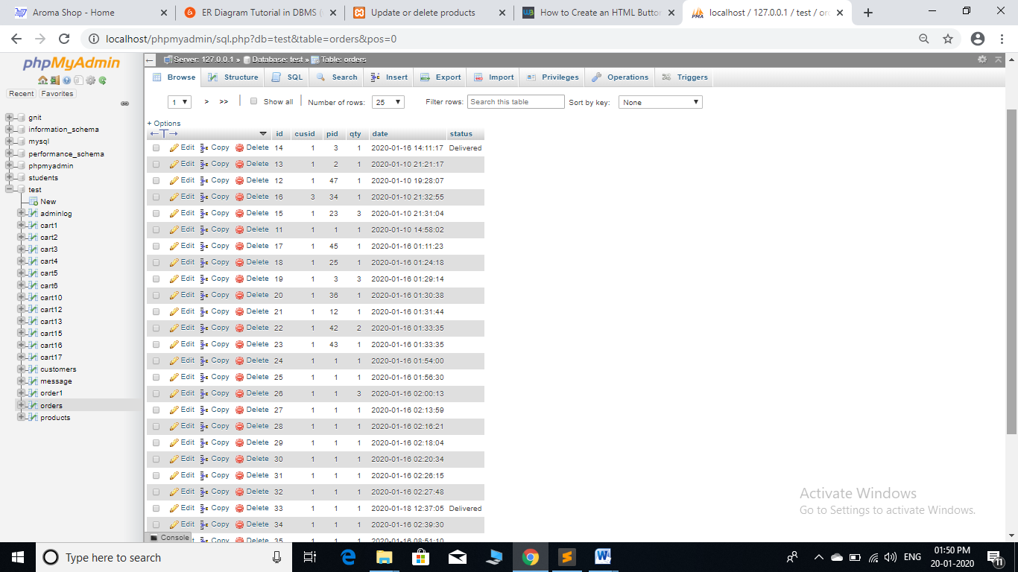

**CUSTOMER DETAILS TABLE:**

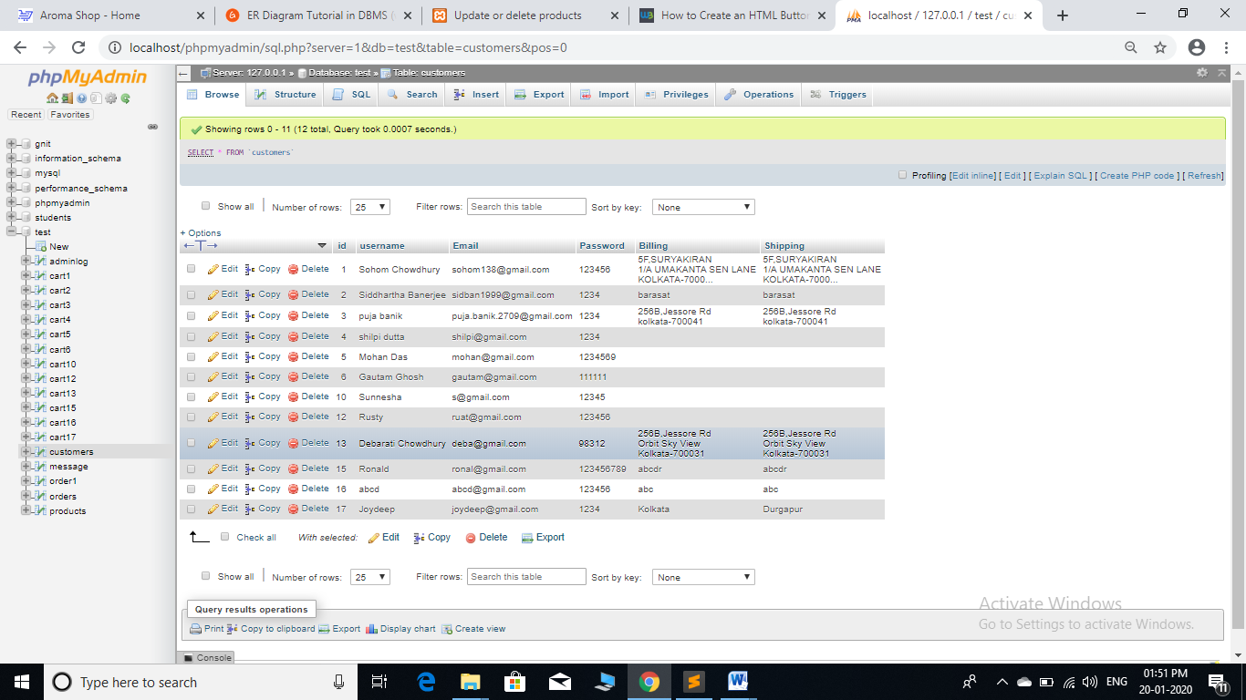

**ADMIN TABLE:**

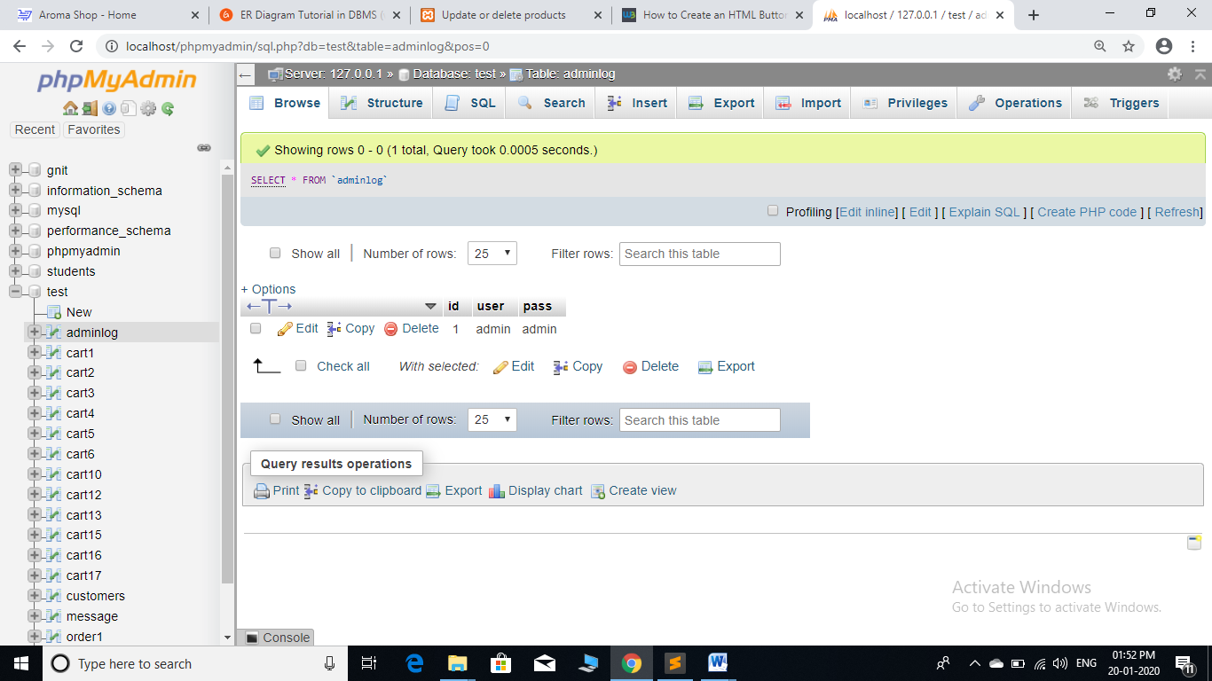

**LOGIN PAGE:**

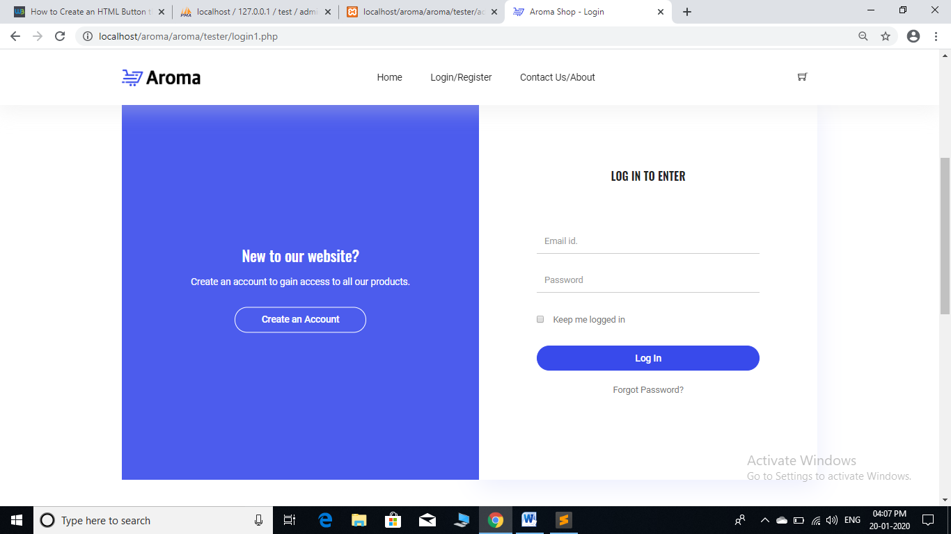

**SIGNUP PAGE:**

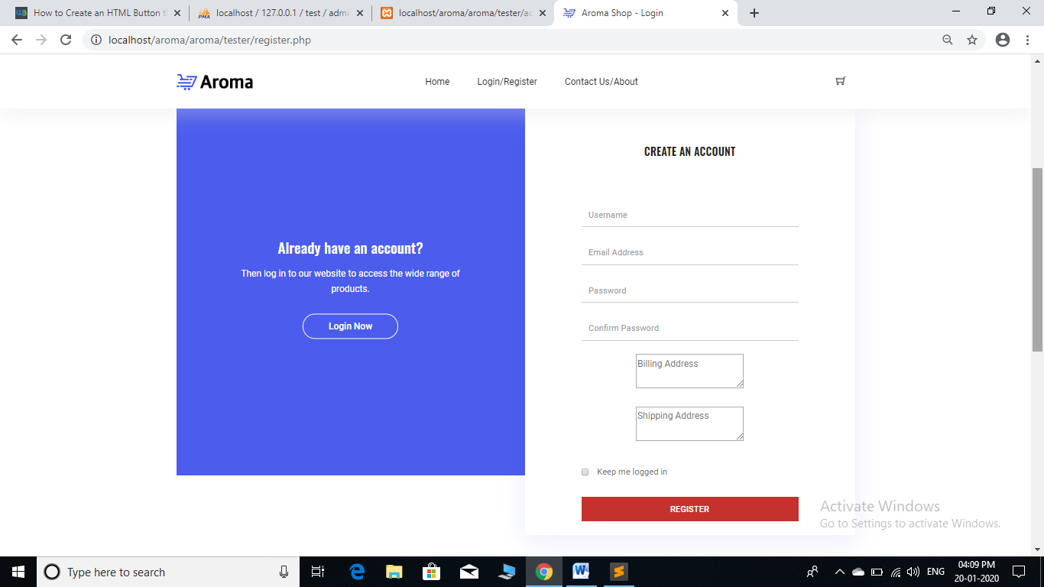

**CHECKOUT PAGE:**

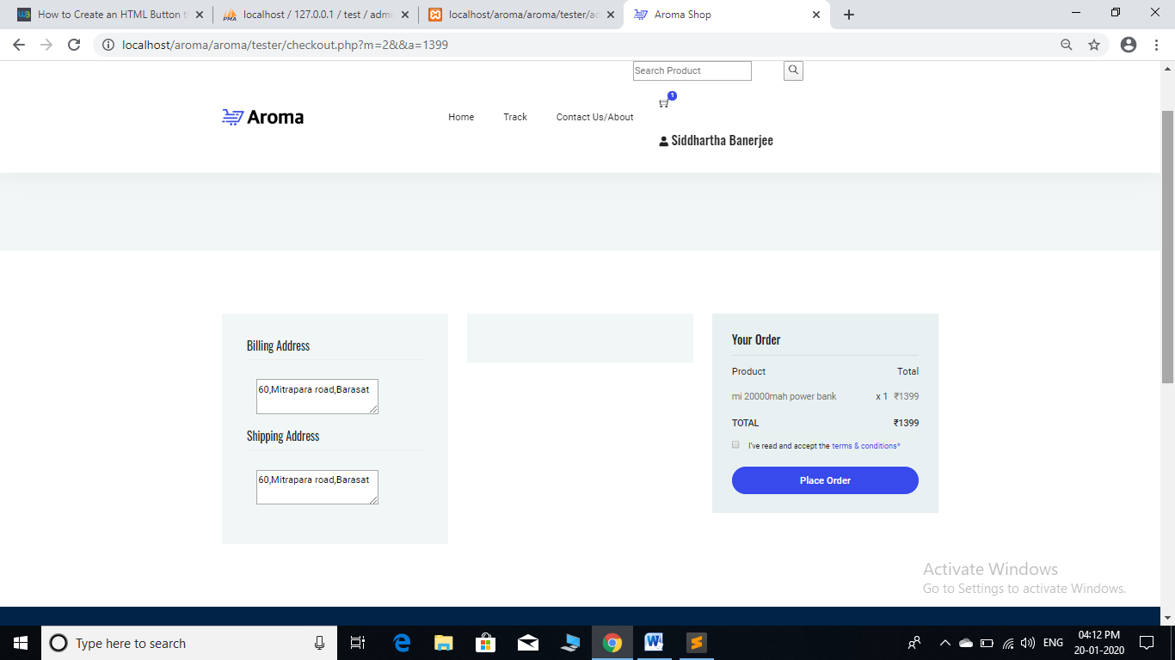

## CODING

**Connection Code**

<?php

session_start();

$host='localhost';

$username='root';

$password="";

$dbname='test';

$connection=mysqli_connect($host,$username,$password,$dbname) or die("Unable to connect MYSQL Server ERROR:".mysqli_error($connection));

?>

**Admin**

**Adminlog.php**

<?php include('config.php');

if (isset($_POST['ok']))

{$u=$_POST['user'];

$p=$_POST['pass'];

$n=mysqli_real_escape_string($connection,$n);

$p=mysqli_real_escape_string($connection,$p);

$q=mysqli_query($connection,"SELECT * FROM adminlog WHERE user='$u' AND pass='$p'");

if(mysqli_num_rows($q)==1)

{ $row=mysqli_fetch_array($q);

$_SESSION['admin']=$row;

?>

<script type="text/javascript">window.location.href="adindex.php";</script>

<?php

}

else

{ ?>

<script type="text/javascript">alert("Wrong username or password combination.");

</script>

<script type="text/javascript">window.location.href="adminlog.php";</script>

<?php

}

}

?>

**Customer**

**register.php:**

<?php include('config.php');

if (isset($_POST['ok']))

{

$n=$_POST['name'];

$e=$_POST['email'];

$p=$_POST['password'];

$cp=$_POST['cpassword'];

$ba=$_POST['baddress'];

$sa=$_POST['saddress'];

$n=mysqli_real_escape_string($connection,$n);

$e=mysqli_real_escape_string($connection,$e) ;

$p=mysqli_real_escape_string($connection,$p);

$cp=mysqli_real_escape_string($connection,$cp);

if($p!=$cp)

{ ?>

<script type="text/javascript">alert("Passwords did not match!!!");

window.location.href="register.php";</script>

<?php

}

else

{

$q=mysqli_query($connection,"SELECT * FROM customers WHERE Email='$e'");

$co=mysqli_num_rows($q);

if($co==1)

{ ?>

<script type="text/javascript">alert("Email provided has already been taken!!!");

window.location.href="register.php";</script>

<?php

}

else

{

$i=mysqli_query($connection,"INSERT INTO customers VALUES(0,'$n','$e','$p','$ba','$sa')");

$i1=mysqli_query($connection,"SELECT * FROM customers WHERE Email='$e'");

$id=mysqli_fetch_array($i1);

$q=mysqli_query($connection,"CREATE TABLE cart$id[0](id INT AUTO_INCREMENT,pid INT ,pname TEXT,pfile TEXT,ifile TEXT,price INT,qty INT,primary key(id))");

if ($i)

{?>

<script type="text/javascript">alert("Registered successfully!!!");

window.location.href="login1.php";</script>

<?php }

}

}

}

?>

**Customer:**

**Phone.php**

<section class="section-margin calc-60px">

<div class="container">

<div class="section-intro pb-60px">

<h2>Smartphones</h2>

</div>

<div class="row">

<?php $q=mysqli_query($connection,"SELECT * FROM products WHERE pfile LIKE 'ph%'");

$count=mysqli_num_rows($q);

if($count>=1)

{ while($row=mysqli_fetch_array($q))

{ ?>

<div class="col-md-6 col-lg-4 col-xl-3">

<div class="card text-center card-product">

<div class="card-product__img">

<a href="phone1.php?id=<?php echo $row[0] ?>"><img class="card-img" src="<?php echo $row[3] ?>" height=250px alt=""></a>

<ul class="card-product__imgOverlay">

<li><a href="phone1.php?id=<?php echo $row[0] ?>"><button><i class="ti-search"></i></button></a></li>

<li><a href="phone1.php?id=<?php echo $row[0] ?>"><button><i class="ti-shopping-cart"></i></button></a></li>

<li><a href="phone1.php?id=<?php echo $row[0] ?>"><button><i class="ti-heart"></i></button></li>

</ul>

</div>

<div class="card-body">

<h4 class="card-product__title"><a href="phone1.php?id=<?php echo $row[0] ?>"><?php echo $row[1] ?></a></h4>

<p class="card-product__price">₹ <?php echo $row[4] ?></p>

</div>

</div>

</div>

<?php } } ?>

</div>

</section>

**Customer**

**cart.php:**

<div class="container">

<div class="cart_inner">

<div class="table-responsive">

<table class="table">

<thead>

<tr>

<th scope="col">Product</th>

<th scope="col">Price</th>

<th scope="col">Quantity</th>

<th scope="col">Total</th>

</tr>

</thead>

<tbody>

<?php $sum=0;

if($count>=1){

while($row=mysqli_fetch_array($q)){

?>

<tr>

<td>

<div class="media">

<div class="d-flex">

<?php if($row[3]=="phone") { ?>

<a href="phone1.php?id=<?php echo $row[1] ?>"><img src="<?php echo $row[4] ?>" height= 100px alt=""></a>

<?php

} elseif($row[3]=="s") { ?>

<a href="s1.php?id=<?php echo $row[1] ?>"><img src="<?php echo $row[4] ?>" height= 100px alt=""></a>

<?php

} else { ?>

<a href="p2.php?id=<?php echo $row[1] ?>"><img src="<?php echo $row[4] ?>" height= 100px alt=""></a>

<?php } ?>

</div>

<div class="media-body">

<p><?php echo $row[2] ?></p>

</div>

</div>

</td>

<td>

<h5>₹<?php echo $row[5] ?></h5>

</td>

<td>

<?php echo $row[6] ?>

</td>

<td>

<h5>₹<?php echo $row[5]*$row[6];$sum=$sum+($row[5]*$row[6]); ?></h5>

</td>

<td>

<form method="POST">

<input type="number" name="id" value="<?php echo $row[0] ?>" hidden>

<input type="submit" name="ok" class="button button-header" value="Remove">

</form>

</td>

</tr>

<?php } }

if (isset($_POST['ok'])) {

$id1=$_POST['id'];

$q2=mysqli_query($connection,"DELETE FROM cart$id WHERE id='$id1'");

?> <script type="text/javascript">window.location.href="cart.php"</script>

<?php }

?>

<tr class="bottom_button">

<td>

<a class="button" href="#">Update Cart</a>

</td>

<td>

</td>

<td>

</td>

<td>

<div class="cupon_text d-flex align-items-center">

<input type="text" placeholder="Coupon Code">

<a class="primary-btn" href="#">Apply</a>

<a class="button" href="#">Have a Coupon?</a>

</div>

</td>

</tr>

<tr>

<td>

</td>

<td>

</td>

<td>

<h5>Subtotal</h5>

</td>

<td>

<h5>₹<?php echo $sum ?></h5>

</td>

</tr>

<tr class="shipping_area">

<td class="d-none d-md-block">

</td>

<td>

</td>

<td>

<h5>Shipping-Free</h5>

</td>

<br>

<td>

<div class="shipping_box">

<h4><br><br><u>Payment Options</u></h4>

<a href="checkout.php?m=1&&a=<?php echo $sum ?>">Debit Card</a><br>

<a href="checkout.php?m=2&&a=<?php echo $sum ?>">Cash On Delivery</a>

</div>

</td>

</tr>

<tr class="out_button_area">

<td class="d-none-l">

</td>

<td class="">

</td>

<td>

</td>

<td>

<div class="checkout_btn_inner d-flex align-items-center">

<a class="gray_btn" href="index.php">Continue Shopping</a>

</div>

</td>

</tr>

</tbody>

</table>

</div>

</div>

</div>

## FUTURE ENHANCEMENTS

We can have a Website that will cover more range of products.

We can improve our reach by enabling shipping outside India.

· Providing links to news which will elaborate more information about them.

## CONCLUSION

We have successfully implemented the site Online Phone and Accessories Shopping System. With the help of various links and tools, we have been able to provide a site which is live and running on the web. We have been successful in our attempt to take care of the needs of both the customers as well as the administrator. Finally we hope that this will go a long way in popularizing the organization and making its work of enrollment, keeping track of Customers etc much more efficient.

**BIBLIOGRAPHY**

1. [**www.google.com**](http://www.google.com/)
2. [**www.w3cschools.com**](http://www.w3cschools.com/)
3. [**www.phpbuddy.com**](http://www.phpbuddy.com/)
4. [**www.mysql.com**](http://www.mysql.com/)
5. **www.phpeasystep.com**