**Linux System Load History |**



system load average, CPU usage and memory usage history shell script. run on multiple servers from single server

# Code

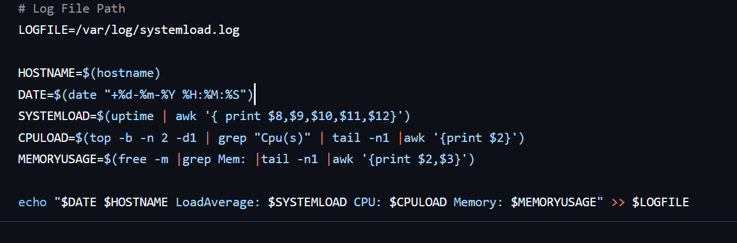

systemload.sh

