ML/DL/NLP /CV/Time Series/ Reinforcement Learning/ Gen- AI

Link1 - : <https://www.youtube.com/@krishnaik06/playlists>

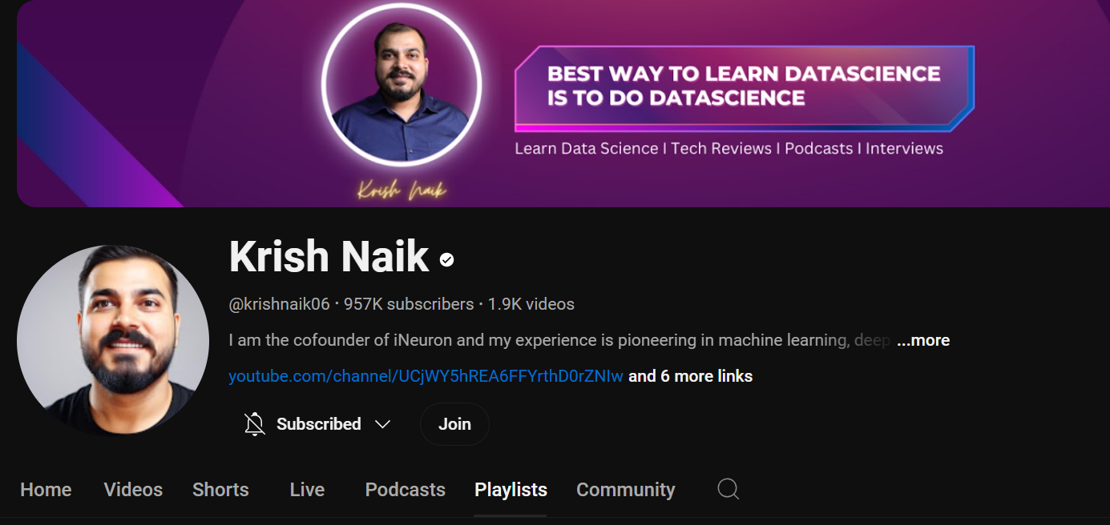

Link2 -: <https://www.youtube.com/@campusx-official/playlists>

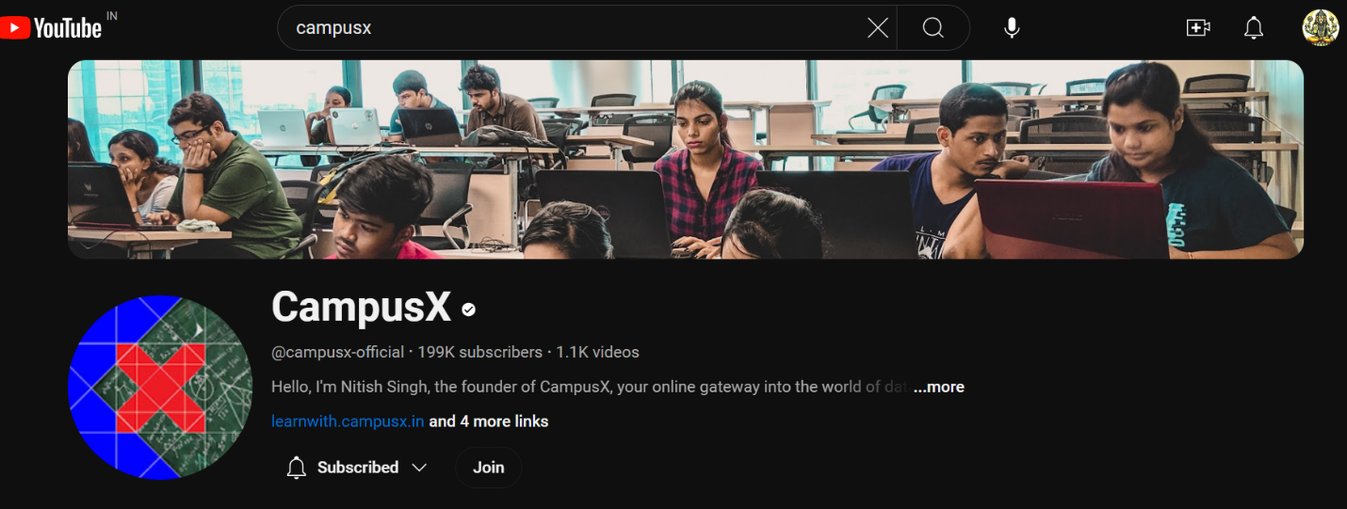

# Gen – AI

Link3:- <https://www.youtube.com/@sunnysavita10/playlists>

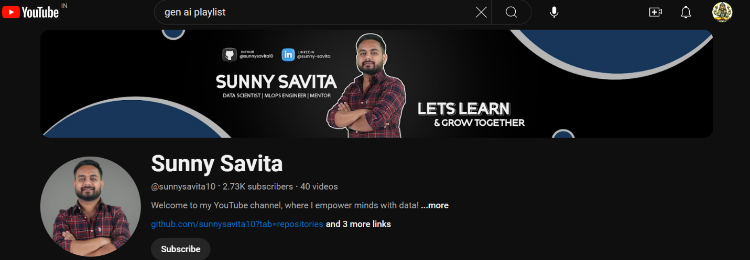

# SQL ( MS SERVER – 2019)

# Link 1 : - <https://www.youtube.com/playlist?list=PL08903FB7ACA1C2FB>

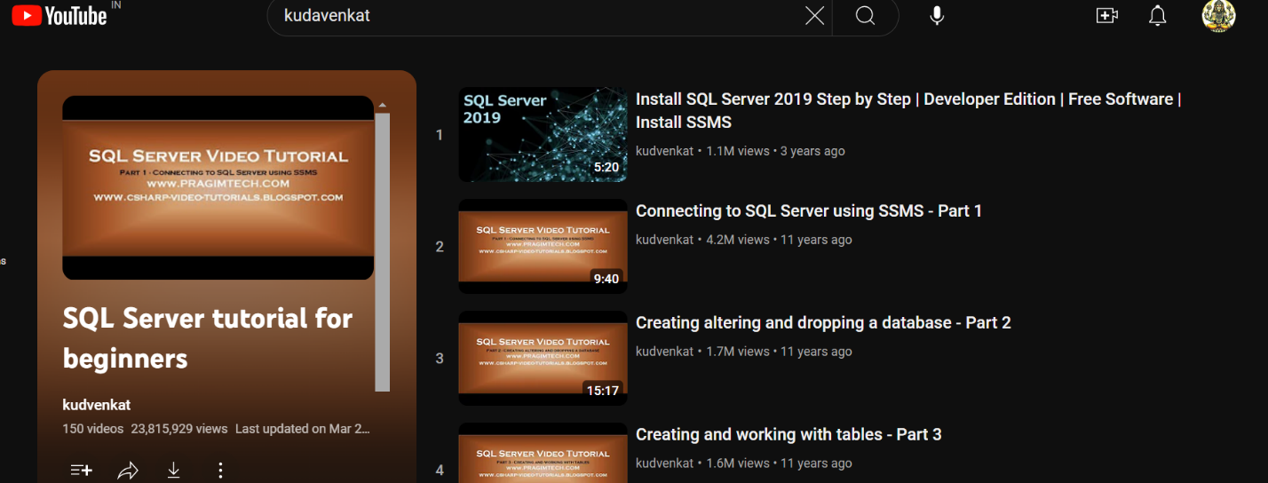

# Link 2: - <https://www.youtube.com/@ankitbansal6/playlists>

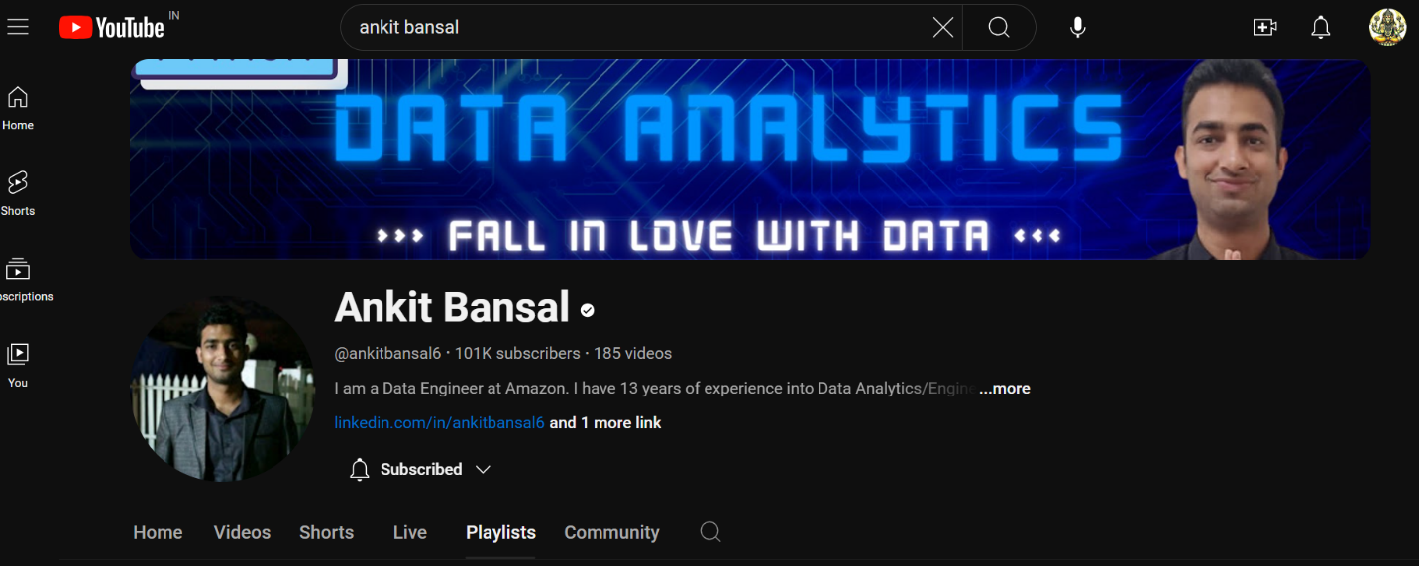

# Latest on AI

#link : - <https://www.youtube.com/@AIAnytime/playlists>

