Continuous Sentence-Level Translation of
Indian Sign Language to English
Case Study Report

Project Overview

Problem Statement
India has an estimated 63 million people who are Deaf or Hard of Hearing (WHO, 2016), for whom Indian Sign Language (ISL) is a primary mode of communication. ISL has its own grammar, word order and non-manual markers (facial expression, mouth shape, body posture); it is not a signed encoding of English. This creates a persistent communication barrier between ISL users and the hearing, non-signing majority in education, healthcare, e-governance and everyday life.
The project addresses continuous, sentence-level Sign Language Translation (SLT): given a video of a person signing a full sentence in ISL, the system must produce the English sentence with the same meaning, without first segmenting the video into isolated signs. This is harder than isolated-sign recognition because sign boundaries are not marked, ISL and English differ in word order and grammar, and meaning is carried jointly by the hands, body and face.

Motivation
- Accessibility: ISL→English translation can reduce dependence on human interpreters, who are scarce in India, for everyday services, classrooms and public institutions.
- Research gap: compared with American or German Sign Language, ISL has few annotated resources and benchmarked tasks, so there are far fewer data-driven translation systems.
- Technical challenge: SLT is a multimodal sequence-to-sequence problem that must fuse video with skeletal motion and map a long, unsegmented input to a short, fluent sentence.

Project Goal
Build a deep-learning model that translates recorded ISL sentence videos into English, evaluate it rigorously, and serve it through an API that the team's web application calls with webcam recordings.

1. Literature Survey
Five recent papers (2025), each in a journal indexed on Scimago Journal Rank, were reviewed:

1.1 Said et al. (2025) — Adaptive Transformer-Based Deep Learning Framework for Continuous Sign Language Recognition and Translation
Mathematics (MDPI), 13(6), 909, DOI 10.3390/math13060909. Proposes an Adaptive Transformer with adaptive masking, local clip self-attention and adaptive fusion to handle the weak alignment between long sign videos and short sentences. Relevance: informs the fusion of video and pose features before the decoder.

1.2 Arib, Akter, Rahman & Rahman (2025) — SignFormer-GCN: Continuous Sign Language Translation Using Spatio-Temporal Graph Convolutional Networks
PLOS ONE, DOI 10.1371/journal.pone.0316298. Combines a transformer with a spatio-temporal graph network over skeleton keypoints, arguing that RGB-only pipelines miss the structure of sign articulation. Relevance: supports keeping a dedicated pose branch — confirmed by this work's ablation test, where removing pose collapses accuracy.

1.3 Nedungadi, Dileep, Geetha & Raman (2025) — Vision Transformer-Powered Conversational Agent for Real-Time Indian Sign Language E-Governance Accessibility
Scientific Reports, 15, 33055, DOI 10.1038/s41598-025-12667-3. Deploys a CNN–transformer for continuous ISL recognition feeding a BART/T5-style engine on India's UMANG platform (97.5% accuracy, 6.53 s mean latency). Relevance: confirms BART-family decoders for ISL-to-text and provides the latency reference used in testing.

1.4 Pandey, Tahseen, Pathak, Parveen & Maurya (2025) — Real-Time Vision-Based Indian Sign Language Translation Using Deep Learning Techniques
IJIRCST, 13(3), DOI 10.55524/ijircst.2025.13.3.6. Compares CNN, LSTM and Transformer encoder–decoders on ISL/ASL data (BLEU 0.74, 96.1% accuracy) and uses BLEU, ROUGE, CER and WER. Relevance: informs the choice of metrics.

1.5 Gonfa, Meshesha, Girmaw & W/Maryam (2025) — A Deep Learning Framework for Ethiopian Sign Language Recognition Using Skeleton-Based Representation
Scientific Reports, 15, 36181, DOI 10.1038/s41598-025-19937-0. Uses MediaPipe skeletal keypoints with recurrent models and reports a large signer-dependent (94%) vs signer-independent (73%) gap. Relevance: mirrors this work's MediaPipe pose pipeline and its generalisation concerns.
The adversarial component follows the gradient-reversal method of Ganin & Lempitsky (2015), and the test strategy follows the CDAO framework Test and Evaluation of Artificial Intelligence Models (2024).

Member 1
Scope of this part: a dual-stream (pose + video) translation model with a pretrained BART decoder, fine-tuned on the ISL-CSLTR sentence corpus, an adversarial (GAN-style) modality-alignment experiment, and a structured test and evaluation of the final model.

2. Architecture Diagram for the Overall Application
The top row shows how the model is built: features are extracted from the ISL-CSLTR videos, the model is initialised from an iSign-pretrained checkpoint, fine-tuned with and without the GAN component, tested, and published to a private Hugging Face repository. The bottom row shows the application: the web app records the user signing, a Hugging Face Space runs the same feature extraction and the model, and returns the closest of the 101 known sentences together with a confidence score.
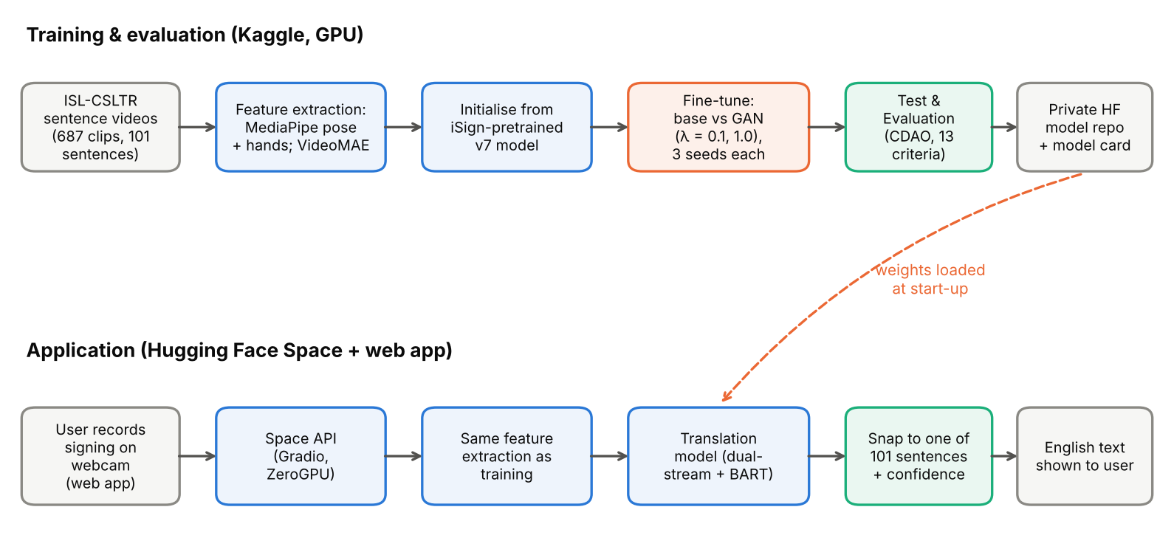
Figure 1: Overall application architecture.

3. Module Details
Module | Function | Implementation
Data preparation | Builds labels and train/validation/test splits | Sentence = video folder name; per sentence 1 test, 1 validation, rest training (687 videos, 101 sentences)
Pose extraction | Body and hand keypoints per frame | MediaPipe Tasks (pose + hand landmarkers); 75 points (33 body, 21 per hand) with x, y, z and confidence; centred on the shoulders and scaled by shoulder–nose distance
Video features | Visual summary of the clip | Frozen VideoMAE-base on 16 frames, pooled to 8 tokens of 768 values
Skeleton encoder | Learns motion patterns over time | 3-layer Transformer (256-dim, 4 heads) over up to 450 frames
Fusion | Combines both streams | Video and pose tokens joined into one sequence and projected to 768 dimensions
Decoder | Writes the English sentence | Pretrained BART-base; only its cross-attention layers are trained; beam search with 4 beams
Modality discriminator (GAN) | Aligns video and pose representations | Small network that tries to tell video from pose; a gradient-reversal layer trains the encoders to fool it
Sentence snapping | Maps output to a valid sentence | Picks the closest of the 101 known sentences (ROUGE-L similarity)
Test & evaluation | Checks the model beyond accuracy | 13 pass/fail criteria from the CDAO framework (Section 8)
API | Serves translations to the web app | Gradio app on Hugging Face Spaces (ZeroGPU), weights loaded from a private model repository

4. Formula of Performance Metrics
BLEU — n-gram precision overlap with a brevity penalty BP:
BLEU = BP × exp( Σₙ₌₁⁴ ¼ · log pₙ )
ROUGE-L — longest common subsequence (LCS) between output ŷ and reference y:
R = LCS / |y| , P = LCS / |ŷ| , F = 2PR / (P + R)
Word Error Rate — substitutions S, deletions D and insertions I relative to the N reference words:
WER = (S + D + I) / N
Sentence accuracy — the output is snapped to the most similar of the 101 sentences, then compared with the reference:
Accuracy = (correctly identified sentences) / (test clips)
Metric | What it measures | Why it suits this task | Values in reviewed papers
BLEU | Word-sequence overlap with the reference | Standard translation metric, comparable across SLT papers | 0.74 (Pandey et al., 2025)
ROUGE-L | Longest shared word sequence | Tolerates small word-order differences | Used with BLEU/WER; not reported numerically
WER | Word-level edit errors | Sensitive to missed and extra words | 19% (SignFlow, cited in Nedungadi et al., 2025)
Sentence accuracy | Share of clips whose sentence is identified | ISL-CSLTR has a closed set of 101 sentences | 97.5% (Nedungadi et al., 2025); 94% (Gonfa et al., 2025)

5. Deep Learning Architecture

a. Diagram
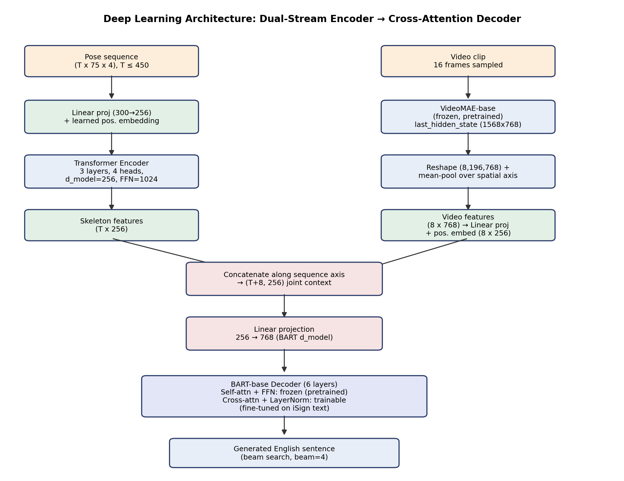
Figure 2: Dual-stream (pose + video) encoder feeding a partially fine-tuned BART decoder.

b. Explanation
The model has two encoders and one decoder. The pose stream passes the 75 body and hand keypoints of every frame through a small Transformer that learns how the signing moves over time. The video stream summarises the clip with a frozen VideoMAE model into 8 visual tokens. Both sets of tokens are joined into one sequence and handed to a pretrained BART decoder, which writes the English sentence word by word. Only BART's cross-attention layers — the part that "looks at" the sign input — are trained; the rest keeps its pretrained English knowledge, so the output stays fluent even with little training data. The model is initialised from a checkpoint pretrained on the large iSign corpus and then fine-tuned on ISL-CSLTR.

c. Adversarial Modality Alignment (GAN component)
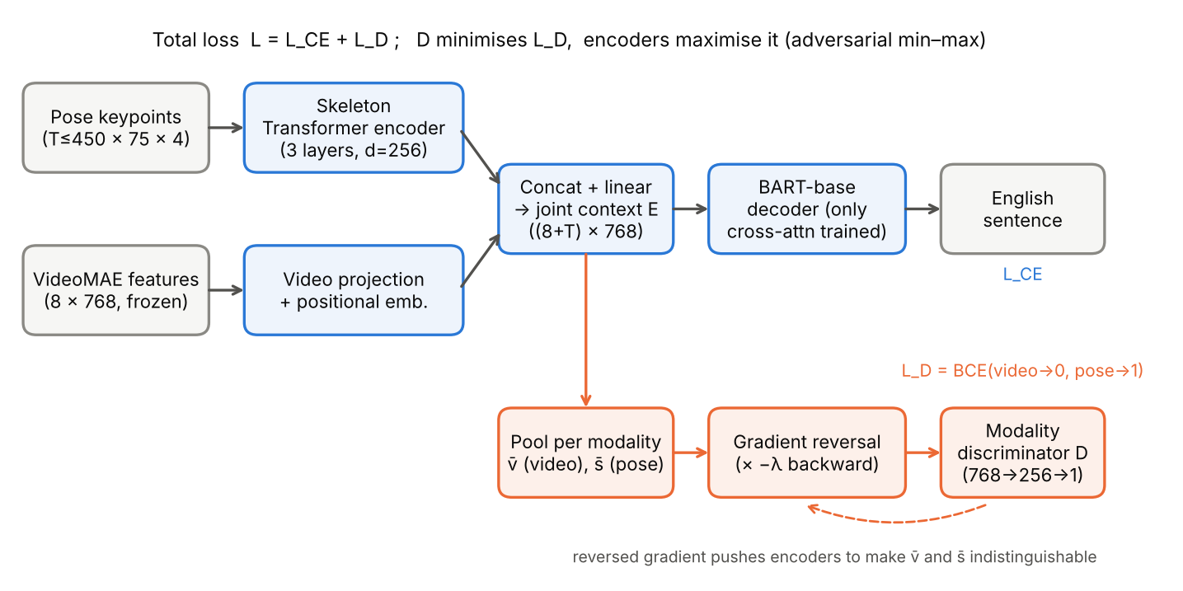
Figure 3: GAN-style modality alignment. The discriminator tries to tell video from pose; the reversed gradient trains the encoders to fool it.
As in a GAN, two parts compete. A small discriminator looks at the pooled video representation and the pooled pose representation and tries to say which is which. The encoders play the generator's role: through a gradient-reversal layer they are trained to make the two representations indistinguishable, while still producing correct translations. The idea is to place both modalities in one shared space, so the decoder can use whichever stream carries the evidence. The strength of the adversarial signal (λ) is ramped up during training; two strengths, λ = 0.1 and λ = 1.0, were compared with a model trained without the discriminator.
Other design choices: reuse of a pretrained language decoder trained only through cross-attention; transfer from a large ISL corpus (iSign) to a small one (ISL-CSLTR); and scheduled sampling, which occasionally feeds the decoder its own predictions during training so it learns to recover from mistakes.

6. Hyperparameter Details Table with Justification
Hyperparameter | Value | Justification
Initialisation | iSign-pretrained checkpoint (v7) | Transfers knowledge learned on 10K+ clips to a 489-clip training set
Epochs / batch size | 25 / 16 | ≈31 steps per epoch; validation scores plateau within 25 epochs
Learning rate | 5e-5 (model), 1e-4 (discriminator) | Gentle fine-tuning of the pretrained model; the discriminator learns faster so it keeps up, as in GAN training
LR schedule | 5% warm-up, then cosine decay | Stable start and smooth decay
GAN strength λ | 0 (base), 0.1, 1.0 | λ = 1.0 added because the discriminator still won completely at λ = 0.1
Scheduled sampling | up to 25% of decoder inputs | Reduces the gap between training and generation
Label smoothing | 0.1 | Regularises the decoder on a 101-sentence vocabulary
Max pose length | 450 frames, evenly subsampled | Keeps the whole sentence while bounding attention cost
Seeds | 42, 43, 44 for every setting | Results on 99 test clips vary a lot between runs; 3 seeds allow mean ± sd
Model selection | Best validation accuracy + BLEU/100 | Prefers the epoch that identifies the most sentences
Decoding | Beam search, 4 beams | Standard quality/speed trade-off

7. Results
ISL-CSLTR provides 101 everyday sentences, each signed 1–9 times. 687 videos were usable: 489 for training, 99 for validation and 99 for testing. Each setting was trained with three seeds; the table reports test results as mean ± standard deviation.
Setting | Sentence acc. | BLEU | ROUGE-L | WER | Discriminator acc.
Pretrained model, no fine-tuning | 0.020 | 0.60 | 0.071 | 1.273 | —
Base (no GAN) | 0.084 ± 0.021 | 12.61 ± 3.20 | 0.199 ± 0.012 | 0.930 ± 0.007 | —
GAN, λ = 0.1 | 0.084 ± 0.023 | 13.19 ± 3.46 | 0.206 ± 0.031 | 0.921 ± 0.030 | 1.00
GAN, λ = 1.0 | 0.074 ± 0.015 | 10.83 ± 1.11 | 0.197 ± 0.020 | 0.945 ± 0.019 | 1.00
Table 1: ISL-CSLTR test results (99 clips, 3 seeds per setting).
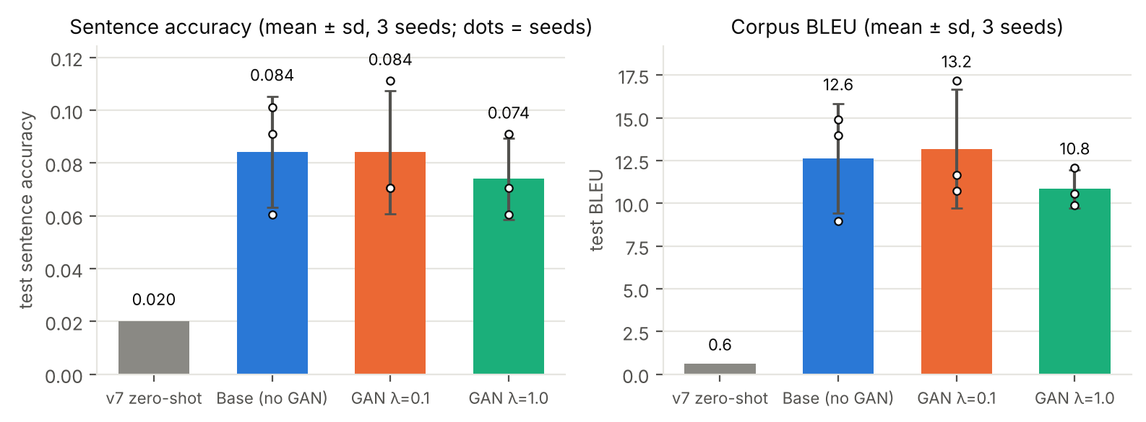
Figure 4: Test sentence accuracy and BLEU per setting (bars = mean, whiskers = sd, dots = individual seeds).
Fine-tuning works. Without fine-tuning, the pretrained model identifies only 2% of sentences; after fine-tuning it reaches 8.4% and BLEU rises from 0.6 to 12.6.
The GAN component did not help. Accuracy with the discriminator was the same (λ = 0.1) or slightly lower (λ = 1.0), and paired statistical tests found no significant difference (p ≥ 0.69 for every seed). The discriminator always told video and pose apart with 100% accuracy, so the encoders never managed to fool it and no alignment happened. The two inputs are very different by construction (8 frozen video tokens vs hundreds of pose frames), and the small dataset gave the encoders few training steps to adapt. Longer adversarial training or a softer alignment loss would be the next things to try.
Final model. The run with the best validation score (GAN λ = 1.0, seed 43) was kept: 9.1% sentence accuracy, BLEU 12.06, ROUGE-L 0.217, WER 0.928 on the test set. Its choice reflects normal run-to-run variation rather than a real benefit of the GAN.

8. Test and Evaluation
The final model was tested following the CDAO Test and Evaluation of Artificial Intelligence Models framework (2024), which stresses that accuracy is only the "tip of the iceberg" and that robustness, uncertainty, bias, data quality and speed must also be checked. Pass/fail thresholds were set before testing.
Area | Criterion | Result | Status
Correctness | Better than the un-fine-tuned model (statistically significant) | 0.091 vs 0.020, p = 0.065 | FAIL
Data quality | No identical clips in training and test | 3 found | FAIL
Data quality | Near-duplicate share ≤ 1% | 46% (studio background) | FAIL
Representativeness | Test set looks like training set (AUC ≤ 0.65) | 0.53 | PASS
Consistency | Same input → same output | 100% | PASS
Consistency | Batch size does not change output (≥ 99%) | 100% | PASS
Consistency | Same output at 0.9× / 1.1× speed (≥ 90%) | 88% | FAIL
Robustness | Accuracy drop under moderate noise ≤ 20% | 13% | PASS
Uncertainty | Confidence separates right from wrong (AUROC ≥ 0.70) | 0.75 | PASS
Uncertainty | Confidence matches accuracy (ECE ≤ 0.15) | 0.50 | FAIL
Fairness | Accuracy gap between subgroups ≤ 0.20 | 0.17 | PASS
Speed | Model response ≤ 1 s | 0.45 s | PASS
Speed | Whole pipeline ≤ 10 s for a 5 s clip | 18.8 s (CPU) | FAIL
Table 2: Test & evaluation scorecard — 7 of 13 criteria passed.

8.1 Correctness and data quality
Test accuracy is 9.1% (95% confidence interval 4–15%). Nearly every output (99%) is one of the 101 known sentences, so mistakes are confusions between similar sentences (e.g. "can i help you" → "how can i help you") rather than nonsense. The gain over the un-fine-tuned model (9 clips gained, 2 lost) narrowly misses statistical significance with only 99 test clips. Three test clips turned out to be exact copies of training clips and should be removed. The train and test sets are otherwise well matched in clip length, hand visibility and movement.

8.2 Uncertainty
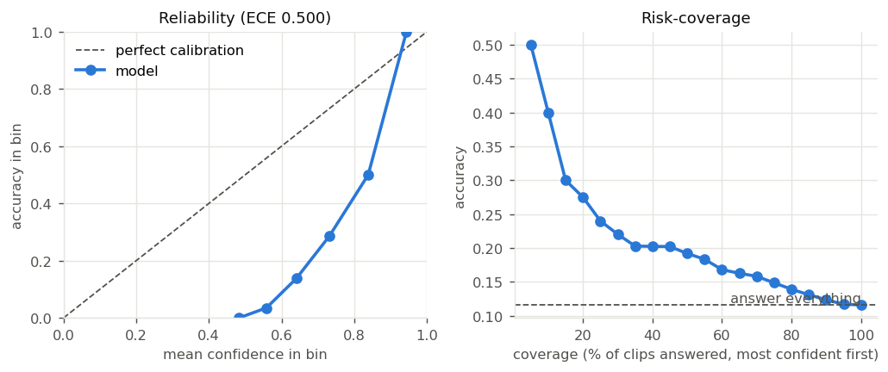
Figure 5: Calibration (left) and accuracy when answering only the most confident clips (right).
The model is over-confident (average confidence 61% vs accuracy 12%), but its confidence is still useful for ranking: answering only the 20% most confident clips raises accuracy to 27.5%. The app should therefore show confidence and ask the user to sign again when it is low.

8.3 Robustness
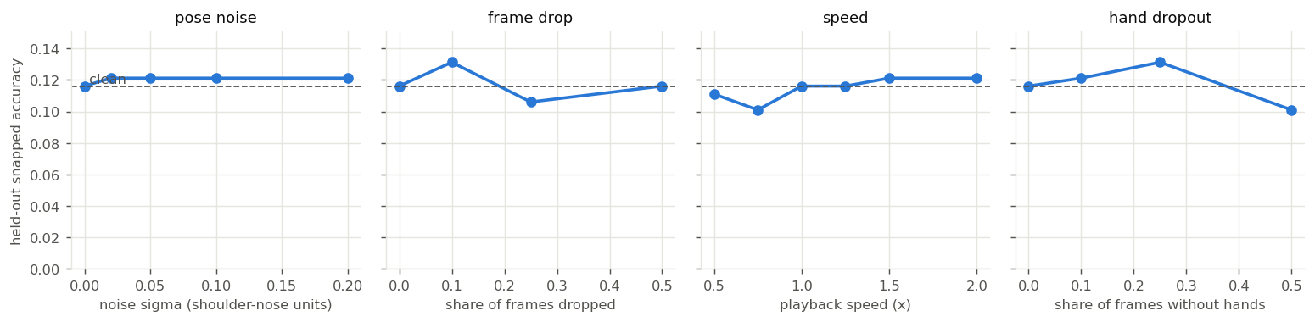
Figure 6: Accuracy under keypoint noise, dropped frames, speed changes and missing hands (dashed = clean).
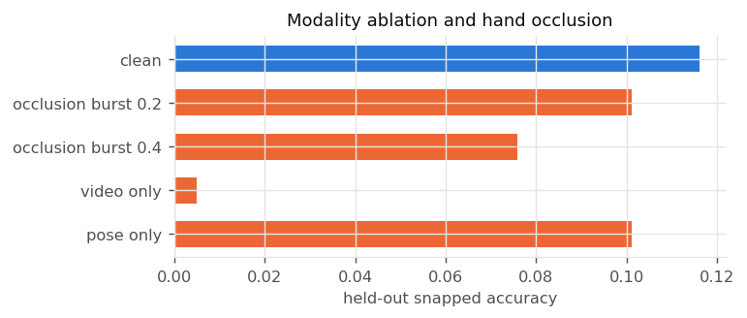
Figure 7: Removing one input stream, and hiding the hands for a continuous stretch.
Accuracy stays close to the clean value under noisy keypoints, dropped frames, faster or slower signing, and intermittently missing hands. Hiding the hands for 40% of the clip costs about a third of the accuracy. Removing the pose input drops accuracy to 0.5%, while removing the video input only lowers it to 10%: the pose stream carries the sign content.

8.4 Adversarial attacks and error recovery
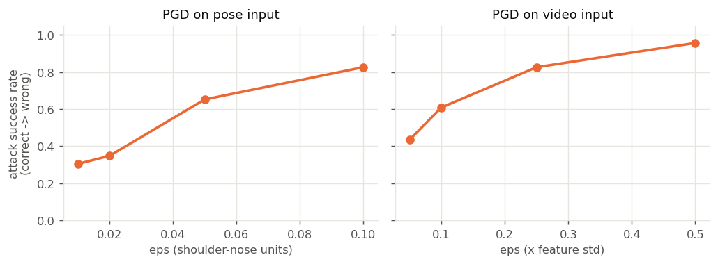
Figure 8: Share of correct answers flipped by deliberately crafted small input changes.
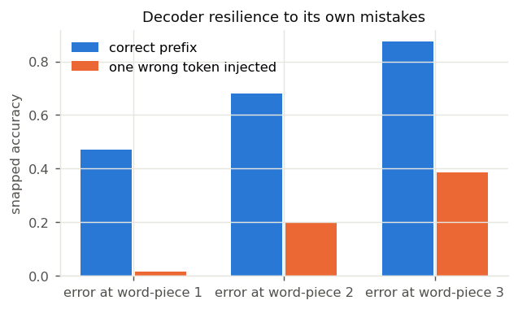
Figure 9: Accuracy when one wrong word is forced at the start of the output.
Deliberately crafted changes of only one or two pixels in keypoint position flip 30% of correct answers, so the model is not secure against intentional manipulation. When the decoder makes a mistake on the first word it almost never recovers (3%); later mistakes are recovered more often (26–40%). Restricting decoding to the 101 known sentences would avoid this.

8.5 Subgroups and interpretability
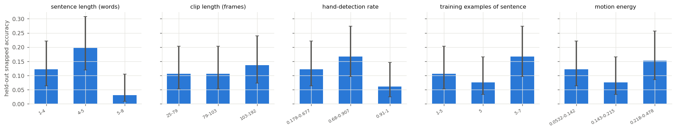
Figure 10: Accuracy by sentence length, clip length, hand visibility, training examples and amount of motion.
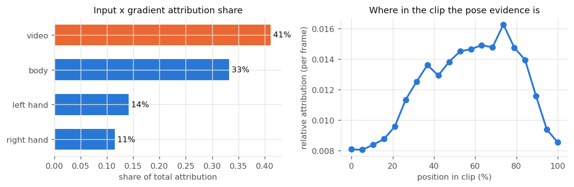
Figure 11: Which inputs the model relies on (left) and where in the clip (right).
Long sentences (5–8 words) are rarely identified (3%) compared with medium ones (20%); other subgroup differences are small and within statistical noise. Signer identity is not recorded in the dataset, so per-signer fairness could not be tested. The model draws its evidence mainly from the middle and end of the clip, where the signing happens.

8.6 Speed
The model itself answers in 0.45 s. The full pipeline took 18.8 s for a 5-second clip on CPU, mostly spent on keypoint extraction (about 0.1 s per frame). Running VideoMAE on the Space's GPU and extracting keypoints from fewer frames per second would bring this under the 10 s target.

8.7 Summary
The model is technically sound (consistent, representative test set, fast inference) and tolerates realistic noise, but it is not yet reliable enough for real communication. The tests point to clear next steps: remove duplicate clips, restrict output to the known sentences, calibrate the confidence score, add speed-variation augmentation, and speed up keypoint extraction. A data card and model card documenting all of this are published with the model.

9. Dataset Chosen
ISL-CSLTR: Indian Sign Language Dataset for Continuous Sign Language Translation and Recognition (Elakkiya & Natarajan, Mendeley Data, 2021, DOI 10.17632/kcmpdxky7p.1; used through its Kaggle mirror). It contains sentence-level videos of 101 everyday English sentences signed by several signers. It was chosen because it is continuous and sentence-level, uses the ISL→English language pair, and is small enough to train several settings and seeds within Kaggle's runtime limits.
Item | Value
Videos used / sentences | 687 / 101 (1–9 recordings per sentence, mean 6.8)
Split | training 489 / validation 99 / test 99
Frames with body / a hand detected | 100% / about 78%
Known limitations | Few signers, same studio background, signer identity not recorded, closed vocabulary; webcam video in the app differs from the recording conditions
The pretrained starting point was trained on iSign (Joshi et al., 2024; 118K ISL–English pairs, huggingface.co/datasets/Exploration-Lab/iSign). Note: neither dataset is hosted on IEEE Dataport; this should be flagged against the rubric's "IEEE Dataport URL" requirement.

10. Standard Paper Chosen for the Application
"iSign: A Benchmark for Indian Sign Language Processing" — Abhinav Joshi, Romit Mohanty, Mounika Kanakanti, Andesha Mangla, Sudeep Choudhary, Monali Barbate, Ashutosh Modi (IIT Kanpur). Findings of the Association for Computational Linguistics (ACL) 2024, DOI 10.18653/v1/2024.findings-acl.643.
Justification: it defines the sign-video-to-text translation task this work addresses, provides the large ISL corpus on which the starting model was pretrained, and is the largest and best-documented ISL benchmark, giving baseline results to compare against.

References
Arib, S. H., Akter, R., Rahman, S., & Rahman, S. (2025). SignFormer-GCN: Continuous sign language translation using spatio-temporal graph convolutional networks. PLOS ONE. https://doi.org/10.1371/journal.pone.0316298
Chief Digital and Artificial Intelligence Office (CDAO), U.S. Department of Defense (2024). Test and Evaluation of Artificial Intelligence Models: What to Consider in a Test & Evaluation Strategy.
Elakkiya, R., & Natarajan, B. (2021). ISL-CSLTR: Indian Sign Language Dataset for Continuous Sign Language Translation and Recognition. Mendeley Data, V1. https://doi.org/10.17632/kcmpdxky7p.1
Ganin, Y., & Lempitsky, V. (2015). Unsupervised domain adaptation by backpropagation. Proceedings of ICML 2015, PMLR 37, 1180–1189.
Gonfa, Meshesha, Girmaw & W/Maryam (2025). A deep learning framework for Ethiopian sign language recognition using skeleton-based representation. Scientific Reports, 15, 36181. https://doi.org/10.1038/s41598-025-19937-0
Joshi, A., Mohanty, R., Kanakanti, M., Mangla, A., Choudhary, S., Barbate, M., & Modi, A. (2024). iSign: A benchmark for Indian Sign Language processing. Findings of ACL 2024. https://doi.org/10.18653/v1/2024.findings-acl.643
Nedungadi, P., Dileep, Geetha & Raman (2025). Vision transformer-powered conversational agent for real-time Indian Sign Language e-governance accessibility. Scientific Reports, 15, 33055. https://doi.org/10.1038/s41598-025-12667-3
Pandey, Tahseen, Pathak, Parveen & Maurya (2025). Real-time vision-based Indian Sign Language translation using deep learning techniques. IJIRCST, 13(3). https://doi.org/10.55524/ijircst.2025.13.3.6
Said et al. (2025). Adaptive transformer-based deep learning framework for continuous sign language recognition and translation. Mathematics, 13(6), 909. https://doi.org/10.3390/math13060909

