

**e-Yantra Robotics Competition 2016**

**Theme - Launch a Module**

**Theme and Implementation Analysis**

**<Team ID>**

|  |  |
| --- | --- |
| **Team leader name** | Shubham Bhuyan |
| **College** | National Institute of Technology, Rourkela |
| **Email** | 115ec0261@nitrkl.ac.in |
| **Theme assigned** | Launch a Module |
| **Date** | 05.02.2017 |

**Arena Setup (5) Q1. Insert pictures of the fully assembled arena as instructed in the Rulebook.**

< Prepare the arena as per instructions given in Section 3 of Rulebook. Refer to the Sample_Arena_Configuration.pdf provided with this document and set up the arena according to the configuration. You must insert two images: (i) image of the arena with all the Objects, Obstacles and Color Markers clearly visible and (ii) image of the Overhead Camera Setup (you may refer to the sample image Figure 8, in the rulebook). Insert the images below. >

The images are provided below:

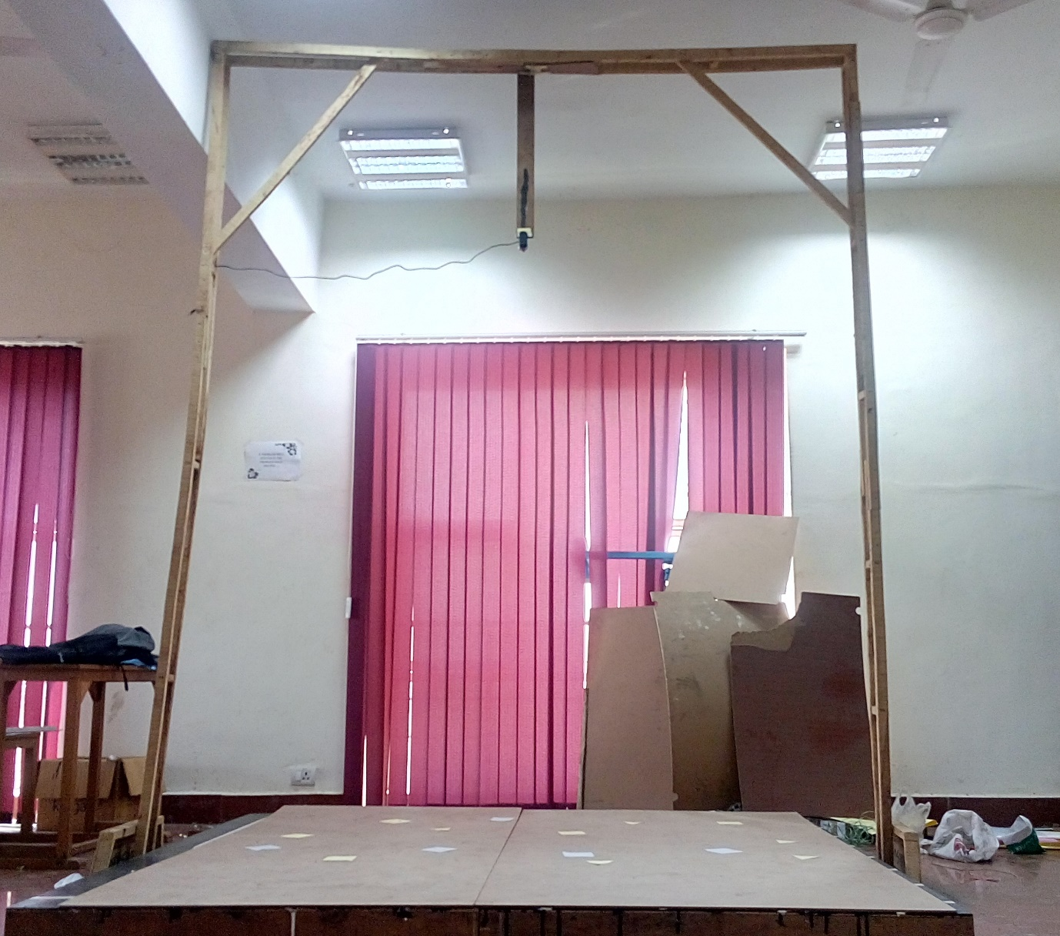

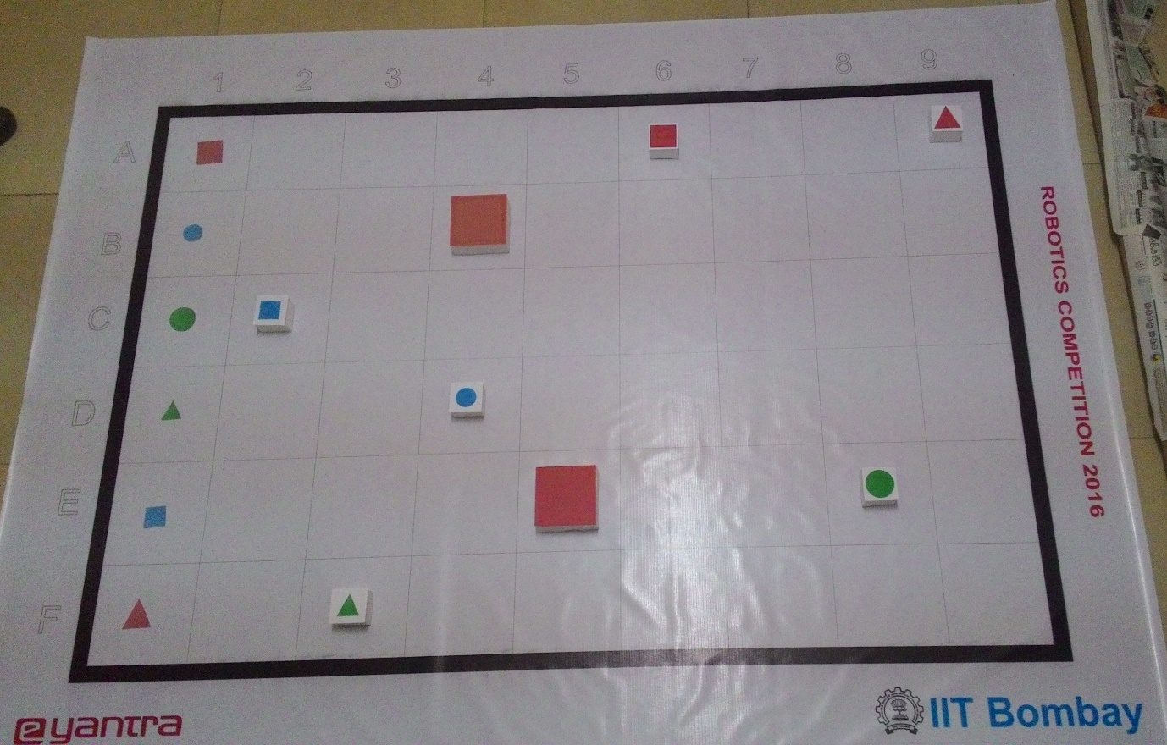

**Scope (5) Q2. State the scope of the theme assigned to you.**

< Teams should briefly explain the assigned theme in their own words. What in your opinion is the purpose of such an application? You may use figures / diagrams to support your answer.

Answer format: Text - limit: 50-100 words>

The given theme can be used in several fields to optimize various operations. It can be used in mega factories like food manufacturing factories to place the items, just manufactured, in their respective places before shipping. The overhead camera will recognize where to place the items and the bot will place it in the shortest possible path. It can also be used in the warehouses of big companies.

**Building Modules (5)**

**Q3. Identify the major components required for designing the robotic system for the solution of the theme assigned to you.**

< Teams should classify the components into various categories: mechanical systems, electronic systems etc. and mention how these will be used in the theme. You may draw diagrams/figures to illustrate your answer.

Answer format: Bulleted form

1. Component 1

2. Component 2

3. Component ….etc.

1. **Mechanical Systems :**
2. *Chassis:* The base of the bot on which every other components are placed.

Diameter : 16cm

1. *Locomotion:* The bot uses two DC-motor wheels of diameter 51mm and one caster wheel at front for locomotion.

Top speed: 24cm/s

1. *Actuators:* The bot uses four actuators for different operations. Two DC gear motors are used to control the rotatory motion of the wheels while two servo motors are used to control the gripping mechanism of the bot.
2. *Gripping Mechanism :* The gripper is made using two servo motors and pivot joints. The mechanism is explained below.
3. **Electronic Systems :**
4. *ATMEGA2560:* This 8-bit micro-controller is placed on the bot to process the different functionalities of the bot.
5. *Xbee Module* : This module is used for the serial communication between the computer and the bot.
6. *Webcam :* The webcam is used for capturing the feed upon which the processing is to be done.
7. *Encoder :* The encoder is used to detect the distance travelled by the bot in the arena.
8. *Buzzer :*To signify the end of the task once it is completed.
9. *Computer :* To perform different image processing operations in Python and OpenCV and send the data to the bot.
10. **Software Tools :**
    1. *AVR Studio and WinAVR :* These IDEs are used to code in the ATMega

in embedded C.

* 1. *Python :* This programming language is used to code the image processing part.
  2. *OpenCV :* This library is included to perform the various functions of image processing.

**Actuators (15)**

**Q4. List all the actuators present on Firebird V robot. Besides the existing actuators, please mention any additional actuators that may be required for designing the robot system in your theme. Mention and justify the use of additional components. (5)**

< Team should list all types of actuators they will need for making the complete system. Teams have to mention: (i) actuators that are already present on Firebird V robot and (ii) actuators that they need to interface with the Firebird V robot.

You can also draw some diagrams/figures to illustrate your answer.

Answer format: Bulleted form

1. Actuator1

2. Actuator2

3. Actuator3…. etc.>

1. Two DC gear motors connected in differential drive mode, are used for motion of the robot. They are used to navigate the robot throughout the arena.
2. A Servo motor is used to move the gripper up and down for picking and dropping the object.
3. The gripper uses another servo motor for opening and closing the arms of the gripper. This helps in grabbing and releasing of the object.

**Q5. Explain the design and working of the mechanism used to pick up Objects and how it is mounted on the Robot. (10)**

<

Explain and draw figure(s) of your mechanism and show how you are planning to mount the mechanism on the robot.

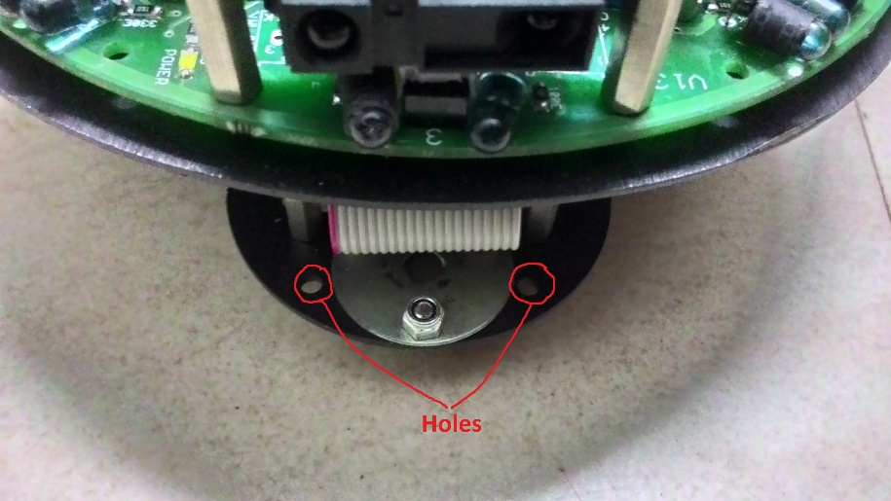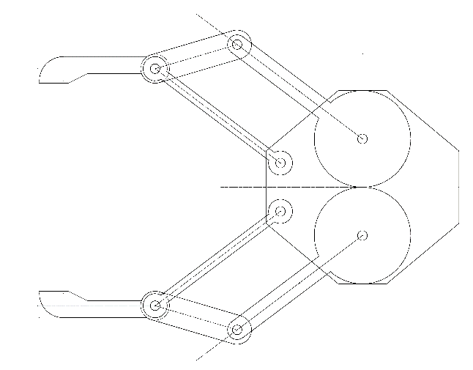>

* The holes shown above are used to mount the gripper.
* One servo motor is used to rotate the gripper gear (Gear 1 or 2) which in turn rotates the other gear in opposite direction. In one direction, the two arms move away while in other direction they move closer.

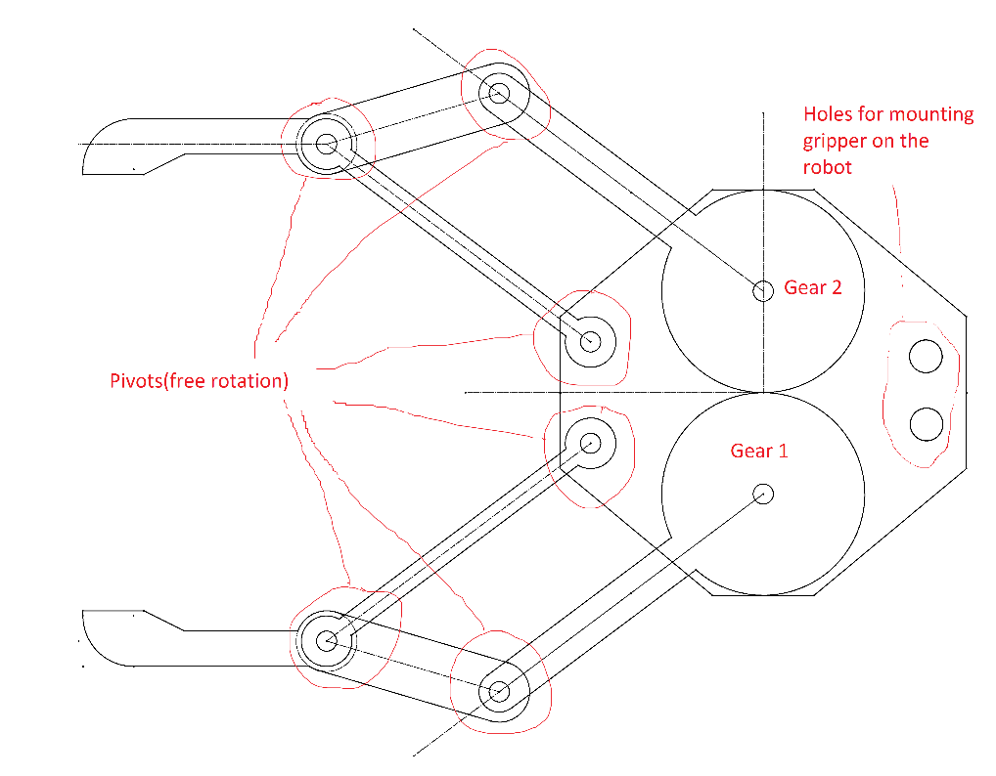

* This gripper is attached with another servo that will move the gripper up and down after grabbing the object.

**Testing your knowledge (related to rule-book) (10)**

**Q6. What is the difference between an Object and an Obstacle? (5)**

< Please explain the answer in your own words. The answers copied directly from rulebook will not be considered for evaluation. You can also draw some diagrams/figures to illustrate your answer.

Answer format: Text/Bullets

Word-limit: 50 words

>

* An object can be of any one of the three colors namely Red, Blue and Green while an Obstacle can only be of Red Color.
* An Object can be a Circle, Square or Triangle while an Obstacle can only be a Square.
* The biggest difference is that an Obstacle is at least four times the size of an Object.

**Q7. What will the robot do (according to your algorithm) if a {Red, Square, Large} colour marker is present in the Door Area and two {Red, Square, Large} Objects are present in the Working Area.(5)**

< Please explain the answer in your own words. You can also draw some diagrams/figures to illustrate your answer.

Answer format: Text/Bullets

Word-limit: 100 words

>

In the given case the bot will perform the following operations:

* From the robot’s present location in the working area and with the help of the overhead camera, the program will calculate the paths from the current location to both the objects using Djikstra algorithm and subsequent paths to the door area.
* Then the bot will traverse on the selected path to the object selected through Step 1.
* On reaching there, it will lift the Object via the gripping mechanism.
* Once lifting is done, it will continue the rest of the journey to the door area.
* Now the other Object, which is not picked, is considered as an Obstacle for the remaining task.

**Camera and Image Processing (15)**

**Q8. How will you detect the Position and Orientation of the robot in the arena using the Overhead Camera? What kind of Image processing technique would you use? (10)**

<

Explain in detail the process you will adopt in order to detect the position and orientation of robot. You can also draw some diagrams/figures to illustrate your answer.

Answer format: Text/Bullets

Word-limit: 150 words

>

Detecting the position of the robot:

* We use a specified colored paper (other than the color of the obstacle and color of objects) at the top of the robot which has 2 markers on it which are diametrically opposite, such that the top view enables us to view the robot as a circular object.
* By tracking the midpoint of the line joining the centers of the two markers, the position of the robot in the arena is determined.

Orientation of the robot in the arena:

* By using markers of specified shape and color, which would be present on the paper on top of the robot, orientation of the bot can be determined.
* Two Markers would be present on a diameter of the circular paper that would be placed on top of the robot. Then a virtual line would be drawn in the code, joining the centers of the two markers.
* Both markers would be of different color hence the direction in which the robot is facing, can be determined, through the positioning of the markers on the robot.

The angle made by the virtual line with the 2 reference axis, i.e. one vertical axis and one horizontal, which are parallel to the borders of the arena, would enable the robot to determine its orientation with respect to the arena.

**Q9. How will you differentiate between an Obstacle and a Red colored Object ? (5)**

<

Explain in detail the process you will adopt in order to differentiate between the two. You can also draw some diagrams/figures to illustrate your answer.

Answer format: Text/Bullets

Word-limit: 100 words

>

Obstacle’s size is at least four times the size of the object; hence, they can be distinguished from the red colored objects, via the area of the obstacle from the image captured by the overhead camera.

Method used:-

1. Moment of the contours of the objects and obstacle is used to find the area of the object and obstacle.

2. The area of the objects and obstacle are stored in a list and list is sorted.

3. Then the ratio of the consecutive elements in the list is determined and where the ratio is at least three times (approximate ratio between object and obstacle), that is the bridge between obstacle and object.

**Navigation Scheme (5)**

**Q10. How will you navigate the robot in the arena using the Overhead Camera? (5)**

<

Explain in detail the process you will adopt for navigating the robot in the arena. You can also draw some diagrams/figures/flowcharts to illustrate your answer.

Answer format: Text/Bullets

Word-limit: 100 words

>

Method for navigation in the arena:-

1. Detection of the grid and the grid size.
2. Detection of object, obstacle, robot and the markers in the door area.
3. 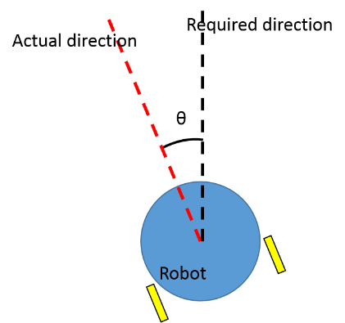Every turn taken by the robot to reach the destination is treated as a checkpoint, in the algorithm. And to ensure that the robot is moving towards the next checkpoint a corrective mechanism is implemented, in which the angle between the robot and the checkpoint(i.e. theta) is kept as minimum as possible(ideally zero)
4. After reaching the target position, the robot would pick up the object block and by traversing in the shortest path, it would place the block in its respective cell in the door area, and continue to do the above steps until the task is completed.

**Communication (5)**

**Q11. Describe how you plan to implement communication between the computer and the robot. Will this communication be uni-directional or bi-directional ? Justify your answer. (5)**

<

Mention the kind of data you will be transmitting to the robot to/from the computer.

Answer format: Text/Bullets

Word-limit: 100 words

>

* In order to implement communication between the computer and the bot we shall use the Xbee Module.
* Since we only need to send commands to the robot, the communication will be uni-directional
* The robot will be programmed to move forward or make a soft left/right or stop based on a character received from the Xbee Module. (E.g. w-forward, a-soft left, s-stop, d-soft right and characters for gripper control: i-grab object, k-release object, j-lift, l-drop).
* The python code running on the laptop sends the appropriate character corresponding to the direction in which the bot is required to go.

**Algorithm Analysis**   **(25)**

**Q12. Draw a flowchart to explain the algorithm you propose to use to complete the given task. (25)**

< The flowchart should elaborate the major functions that they will be using for completing the assigned theme.

Follow the standard pictorial representation used to draw the flowchart.

>

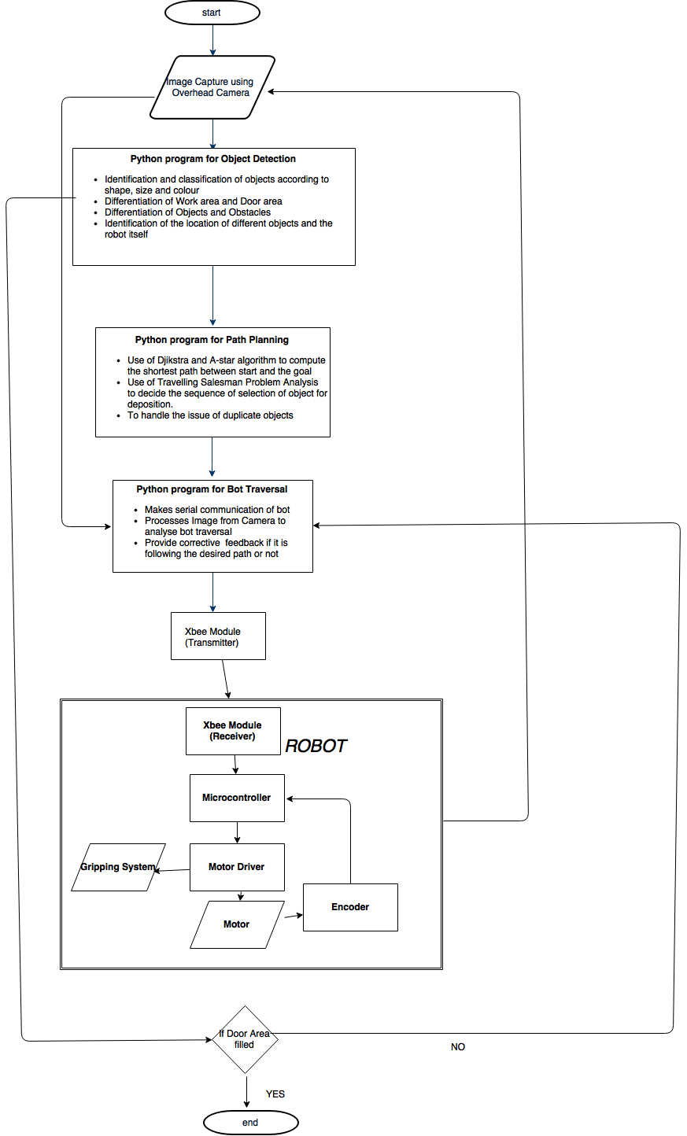

**Challenges (10)**

**Q13. What are the major challenges that you anticipate in addressing this theme? How do you plan to overcome these challenges? (10)**

< Answer format: Bulleted form

1. Challenge 1

2. Challenge 2

3. Challenge 3, etc.

The different challenges we may face in this theme and their remedies are:

* The detection of the location and orientation of the bot in the arena. We are thinking of applying two markers on the bot, one at front and another at back of same shape and different colours to identify the location and orientation of the bot.
* Keeping a track of the distance traversed by the bot and making it move in a straight line. Due to different motors, the two wheels are moving at different speed for the same pwm. In order to make the bot move straight we are going to adjust the pwm value of the two motors such that they have equal speed. In case the robot still does not move straight, we will use the encoder to monitor the orientation of the bot.
* The noises in the camera feed. To overcome this we shall use various noise reducing techniques such as blurring and others provided by OpenCV.
* The study of various optimization algorithms and implementation.
* Graphical visualization of problems to understand it better and come out with solutions and debug the intermediate stages of getting to the solution. We prepared a turtle program in Python to tackle this challenge.

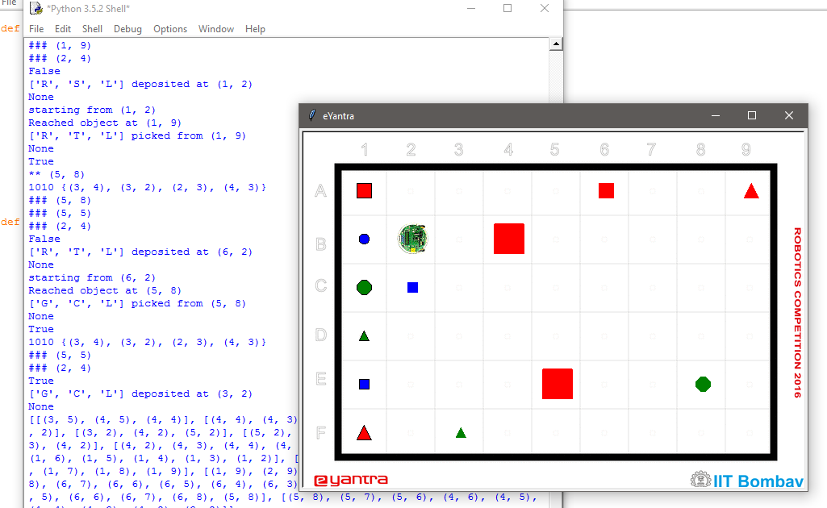

* Orientation of bot to grip and pick an object using Image processing without dropping it and placing it in the desired cell