**Project Proposal on**

**<Stock Market Information Management System>**

**<Siddhartha Neupane>**

**<00164084>**

**Computing Project**

**Level 5 Diploma in Computing**

**Softwarica College of IT & E-Commerce**

**Kathmandu, Nepal**

**<Proposal submission date: -14th July>**

Contents

Introduction: - 3

1.1 Main Features: - 3

1. Scope: - 4

1.1 Aims: - 4

1.2 Objectives: - 4

1.3 Development method: - 4

2. Project Plan: - 5

1.1 Work Breakdown Structure: - 5

1.2 Milestone: - 6

1.3 Scheduling: - 6

3. Risk Management: - 7

4. Configuration Management: - 8

5. Conclusion: - 9

References: - 10

# Introduction: -

Stock/securities exchange is the market in which shares are issued and exchanged, which is otherwise called the value or offer market. It is a standout amongst the most imperative ranges of a market economy. The securities exchange is the critical hotspot for organizations to raise cash. This is the place organizations are traded on an open market. With the advancement of online frameworks, online offer showcasing has turned into a pattern.

The Project is based on Stock Market Information Management System. System is conducted of a web based site which provides all necessary information about Stock Market. The site also gives basic information about the buyers, sellers and stock too. This web based system keeps the records of selling and buying of stocks/share and the information of stock too. With the help of this site we can reduce paper work. This Information System is fast and efficient record keeping system. It contains pre-defined data. This software helps user/organizations to reduces the data duplication while transactions of data. The site is mainly built for the broker company which gives online information about sellers and buyers and it produces certificate too. Thus this site is time efficient for buyers and sellers.

## 1.1 Main Features: -

* It gives basic information about stock market.
* Buyers and sellers can sign-up and search their shares.
* Admin(Broker) can Insert, Update, Retrieve and delete information.
* Login page is available for users.
* Buyers and sellers can print certificates.

# Scope: -

# Aims: -

* It’s a web based system which gives a web view to buyer and seller of their shares.
* Brokers can easily record information about their clients using this system.

## Objectives: -

* To Analyze and monitor the user requirements.
* To store the information in a legitimate way.
* To replace the older system of information backup system.
* To give integrated data.
* To reduce duplicate data.

## Development method: -

There are different types of methodologies used for developing the projects such as agile method, waterfall method, scrum, DSDM, XP and many more. I have chosen waterfall method for this project. Steps in waterfall method is shown in below waterfall diagram:

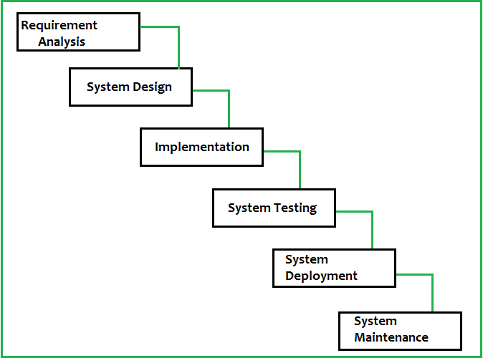

Fig: - Waterfall Method

Reasons that I will be using waterfall model for this project is because: -

* Very simple to use and understand.
* In this model phases do not overlap.
* Used for small projects where requirements are well understood.

# Project Plan: -

Learning and planning will be the best tool and techniques for the best projects. Laravel framework is used to develop the project. Step by step plans for the projects are given by WBC (Work Breakdown Structure), Time Estimation, defining Milestones and scheduling tasks and time through Gantt chart which will help to develop systematic way of system.

## Work Breakdown Structure: -

Below given table illustrates simply the time estimation and the tasks breakdown structure for this project (Stock Market Information Management system). WBS is mainly used to divide works into given timeframe. References: -

|  |  |  |
| --- | --- | --- |
| **S.N** | **Project Name** | **Total Days** |
| **0** | Stock Market Management System | 101 |
| **1** | Project Management | 15 |
| **1.1**  **1.2**  **1.3** | Scoping  Planning  Monitoring and Controlling | 5  5  5 |
| **2** | Analysis | 15 |
| **2.1**  **2.2**  **2.3** | Requirement Analysis  Use Case  Architecture | 5  5  5 |
| **3** | Design | 23 |
| **3.1**  **3.2**  **3.3** | User Interface Design  Structural Model  Behavior Model | 8  8  7 |
| **4** | Coding | 29 |
| **5** | Testing | 20 |
| **5.1**  **5.2** | Unit Testing  Integration Testing | 10  10 |
| **6** | Reporting | 9 |
| **6.1**  **6.2**  **6.3**  **6.4** | Presentation  User Manual  Report  Final report completion | 3  3  3  1 |

## Milestone: -

Timeframe proposed for this project is given in the below table: -

|  |  |
| --- | --- |
| **Tasks** | **Deadline** |
| Project Proposal | 2017/JULY/14 |
| Analysis Specification | 2017/August/1 |
| Design Specification | 2017/August/23 |
| Coding | 2017/September/17 |
| Testing | 2017/October/9 |
| Final Project | 2017/October/22 |
| Hard Copy | 2017/October/25 |

## Scheduling: -

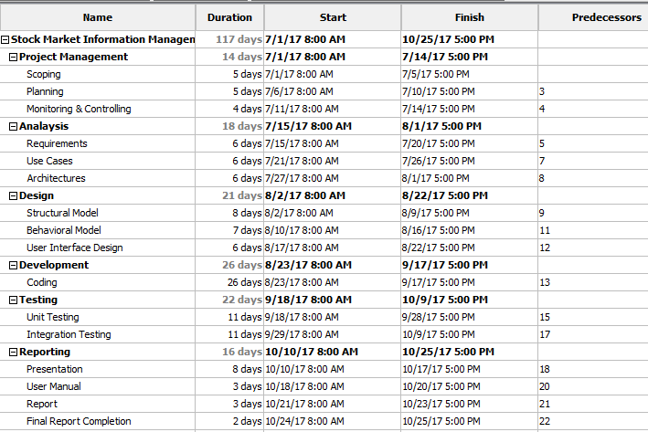

Fig: - Gantt chart

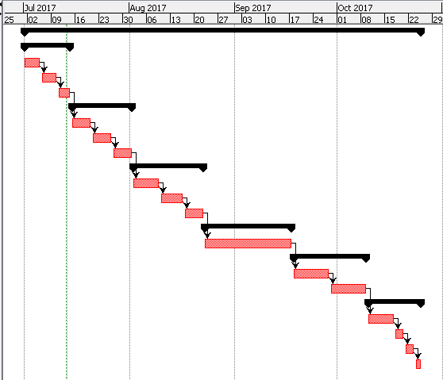

Fig: -Gantt chart

# Risk Management: -

Identifying risk is the vital thing in this project firstly, identifying threats and acting it according to its chances and impact we should illustrate the highest risk that can occur to our project. The risk management are as follows: -

Impact= Likelihood * Consequence

|  |  |
| --- | --- |
| **Likelihood** | **Value** |
| Low | 1 |
| Medium | 2 |
| High | 3 |

Table: Risk likelihood values

|  |  |
| --- | --- |
| **Consequence** | **Value** |
| Very low | 1 |
| Low | 2 |
| Medium | 3 |
| High | 4 |
| Very high | 5 |

Table: Risk consequence values

|  |  |  |  |  |
| --- | --- | --- | --- | --- |
| **Risk** | **Likelihood** | **Consequence** | **Impact** | **Action** |
| Error while doing coding | 2 | 4 | 8 | Coding should be done properly |
| Hard disk crash | 2 | 3 | 6 | Should prepare reliable back up |
| Natural disaster | 1 | 4 | 4 | Proper back up should be made |
| Difficult to operate | 1 | 3 | 3 | Should make user friendly system |

# Configuration Management: -

The point by point recording and refreshing of data that portrays a venture's equipment and programming. It additionally alludes to a train for assessing, organizing, affirming or objecting, and executing changes in antiquities that are utilized to develop and keep up programming frameworks. SearchDataCenter, (2016).

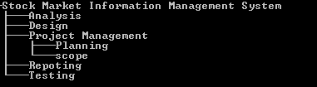

# Conclusion: -

I have now designed the planning of the project “Stock Market Information Management System” which keeps the records of the transitive data. To design this system, I have used Waterfall method to develop this project. I have used DDL, DML operations which includes CRUD functions. Mainly this system is made for web based site and contains a database system. In this way I have fulfilled my requirements to accomplish the task.

# References: -

SearchDataCenter, (2016). What is configuration management (CM)? - Definition from WhatIs.com. [online] Available at: [http://searchdatacenter.techtarget.com/definition/configuration-management-CM](http://searchdatacenter.techtarget.com/definition/configuration-management-CM%20) [Accessed 16 Jul. 2016].

www.tutorialspoint.com, (2016). Work Breakdown Structure. [online] Available at:

<http://www.tutorialspoint.com/management_concepts/work_breakdown_structure.htm> [Accessed 16 Jul. 2016].