Supplement

Outline
1. Splicing commitment model – time delay implementation
1.1. Model topology
1.2. Numerical simulation
1.3 Relationship between gene structure, time delays and polymerase speed
1.4 Analytical solution
2. Splicing commitment model – multistep implementation
3. Mechanistic exon definition model
4. Stochastic simulations
5. Supplemental Tables with parameter values

1. Splicing commitment model - time delay implementation

1.1 Model topology

In Figs. 1, 2 and 5A-C, we performed simulations using the splicing commitment or time delay model, in which we describe the splicing fate of a transcript during its synthesis and consider splicing reactions that eventually occur with delays.

We implemented a system of four ordinary differential equations (ODEs) describing unspliced transcripts (“mRNA”), spliced transcript with the alternative exon included (“Incl”) or skipped (“Skip”) and inhibited mRNA (“mRNAinh”), in which the unspliced mRNA is bound by an inhibitory RBP and inclusion is no longer possible (Fig. 1B).

(Equation 1)

All splicing commitment reactions are assumed to irreversible and occur with the parameters ki (inclusion), ks (skipping) and kesc (inhibitor-mediated commitment to skipping). To implement co-transcriptional splicing, we consider that splicing commitment reactions can occur after different delay times (see below), and chose these delay times based on known molecular mechanisms of splicing. Specifically, we assumed an exon definition mechanism which is known to apply for most splicing events in human cells (REF). In exon definition, not only the spliced intron, but also the flanking exons need to be fully recognized by the spliceosome for intron splicing to occur. Hence, during transcript elongation, splicing of the first and second intron is only possible after synthesis of exon 2 and 3 is complete, respectively.

For, simplicity, we neglect the initial, splicing-less phase before exon 2 is fully synthesized (State P0 in Fig. 1B), and model only the transcript fate afterwards (State P1 in Fig. 1B). In terms of splicing commitment, exon inclusion is immediately possible after start of the simulation, whereas skipping can only occur only later, once both introns and all exons have been synthesized (States P7-P8 in Fig. 1B). To implement the time shift of skipping relative to inclusion, we did not explicitly model polymerase progression, but considered a time delay τ for the skipping reaction (Fig. 1C, “time delay model”). Specifically, the rate of commitment to skipping (kS) is initially zero and then increases in a step-like manner, whereas the commitment rate to inclusion (ki) is time-invariant.

1.2 Numerical simulation
To numerically implement these time delays, we performed our simulations in several consecutive simulation steps, each of which represents the interval between two time delays. The simulation starts at time t=0 (completion of exon 2 synthesis, see above) and we set all species to zero, except for the unspliced mRNA, which we assume to be 1. Thus, we assume a synchronized population of mRNA molecules (100% just elongated through exon 2), and will use the numerical simulation routine described below to calculate the relative probability to end up in a certain splicing fate.

To do so, the ODE system is initially integrated until the first time delay using ODE solver odeint from the phyton package scipy (v. 1.3.1), subpackage integrate. In Fig. 1C and D, no skipping can occur in this first time phase (ks = 0), and inhibitor-mediated skipping does not occur (kesc = 0). Thus, the ODE system reduces to:
(Equation 2)
The integrals of the simulated mRNA and Incl time courses represent the likelihood of a transcript to be unspliced or spliced to inclusion until the time delay τ, i.e., until exon 3 is fully synthesized. To determine the final fate of all transcripts, we continue the simulation for t > τ, now considering that skipping is possible.
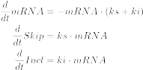 (Equation 3)
The initial value vector of species in this second time phase is the final species from the first integration step (Eq. 2) at the end time point t = τ. The simulation is performed till the unspliced mRNA species approaches zero, i.e., until all molecules are spliced. Then, the time courses of the first and second time steps are merged and integrals are calculated to determine the probability of skipping and inclusion. Then the courses of the first and second time steps are merged to get the total time course representing the probability of each species to be there. At the end time point of merged simulation (in practice t = 10000) the value of mRNA is expected to be 0. The values Incl_{t→∞} and Skip_{t→∞} show the probability for the corresponding Isoforms.

Then, alternative splicing is quantified using the PSI metric, which equals the probability of inclusion.

(Equation 4)

In Fig. 2, the RBP inhibitor prevents inclusion and this is implemented using the “escape” reaction kesc which results in early transcript commitment to skipping. It is assumed that inhibitor binding and early skipping commitment can occur in a restricted time window between the delays tau_{inh,1} and tau_{inh,2}. Thus, when considering this inhibitor-mediated skipping, the number of integration steps or time phases increases to four (Fig. 2B). For each time phase there are different effective set of constants and ODEs:

Time phase | constants | Effective ODEs
0 - τ_{inh,1} | ki = ki_{model}  ks = 0  kesc = 0 | 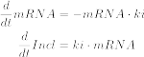
τ_{inh,1} - τ_{inh,2} | ki = ki_{model}  ks = 0  kesc = kesc_{model} | 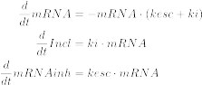
τ_{inh,2} - τ | ki = ki_{model}  ks = 0  kesc = 0
τ - ∞ | ki = ki_{model}  ks = ks_{model}  kesc = 0 | 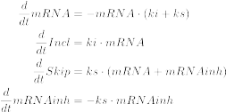

1.3 Relationship between gene structure, time delays and polymerase speed
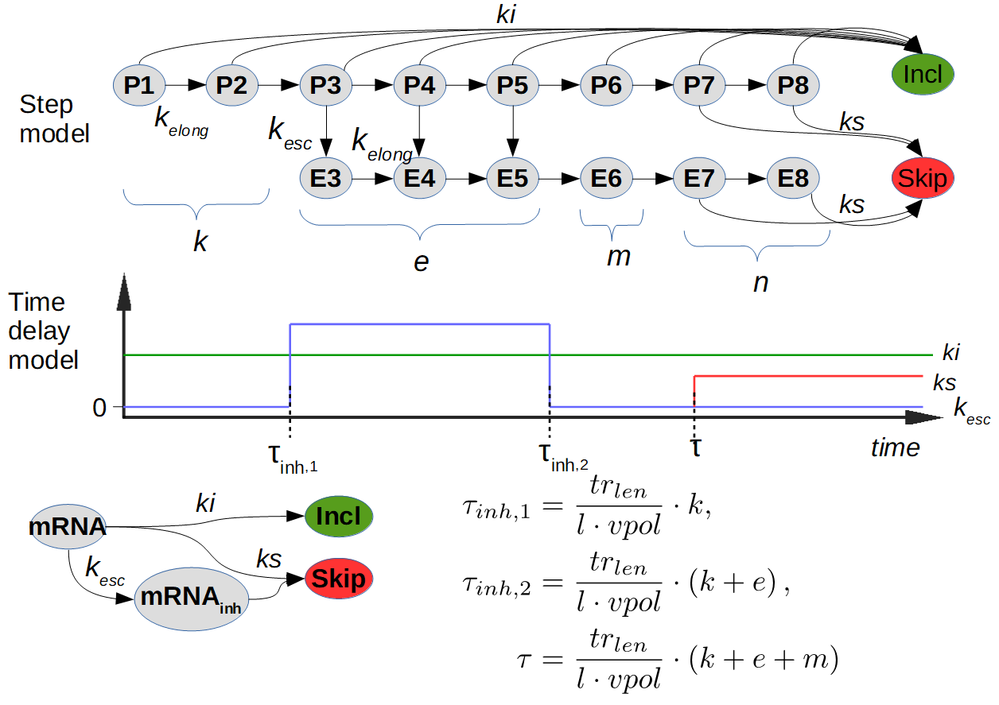Figure 1: Topology definition and time delay model derivation

To be completed - hier wuerde ich die Gleichungen, die frueher im Bild waren, einfuehren und alle Groessen erklaeren.

For the analysis of the time delay and multi-step models a fixed transcript length tr_{len}=300 nucleotides is assumed. This is the length of pre-mRNA segment between exon 2 end end transcript end including second intron end third exon. All models in Fig. 1 and Fig. 2 are determined by the model topology, consisting of a tuple (k, e, m, n) defining the amount of steps in each phase for the multi-step model (Fig. 1S). The sum of the steps is the total number of elongation steps: l = k+e+m+n. The delays for the time delay models are based on the given topology. So they can be calculated for a given transcription length tr_{len} and polymerase II speed vpol:

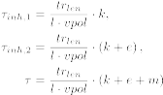 (Equation 5)

These values were calculated before each simulation. In SBML format these rules are defined as InitialAssignments. The time delays are realized as time triggered Events. Thus, the tools for import and simulation of the given models have to support those SBML elements.

1.4 Analytical solution
The approach for calculation the analytical solution for PSI of time delay models is based on the probability for the inclusion reaction. Under the assumption that the simulation starts with one molecule of mRNA one can calculate the probability of inclusion reaction for each of the four time phases dt1, dt2, dt3, dt4 (Fig. 1).
The first step is the calculation of p1 representing the probability for inclusion within the first phase dt1. Assuming a poisson process we can calculate the expected value 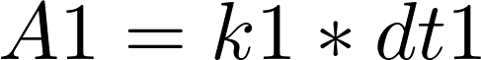, showing the amount of expected inclusion reactions whitin the phase 1. Considering exponential distribution we get 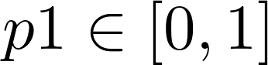 as the value from cumulative distribution function:
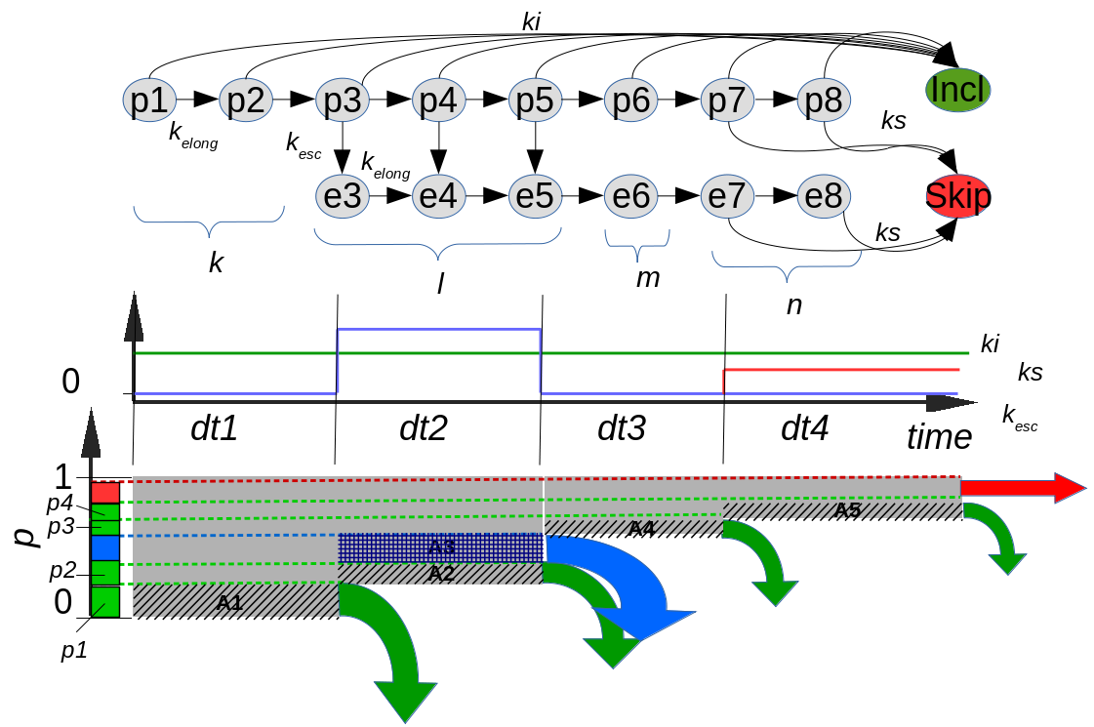
Illustration 1: Schematic representation of analytical solution approach. At the top is the step model we are originating from. In the middle is the parameter time course of the derived time delay model. The analytical approach is based on this model (bottom). p1-p4 are absolute probabilities for inclusion reaction in the corresponding phases 1-4.
(Equation 6)
The probability that a reaction won't take place in the first phase is . The general formula for rest/remaining probability after the phase i is:
(Equation 7)
The following applies here: the value of is 1, and
In the second phase there are two competing reactions. The expected value for both reactions is . The probability for one of the reaction will occur is . The probability for inclusion reaction results from:
(Equation 8)
Consequently the rest probability for phase 3 is .
For the two remaining phases we can proceed in the same manner. It is important to note that . And in the forth phase there are two competing reactions, which are handled similar to the second phase.
Eventually we get the PSI-value as a sum of all absolute probabilities for inclusion p₁-p₄:
(Equation 9)

2. Splicing commitment model – multi-step implementation

Ich bin nicht sicher, wie Du hier gerechnet hast – ich war eigentlich davon ausgegangen, dass hier “ganz normal” ODEs simuliert werden, also ein System mit konstanter p1-Synthese und gleicher Degradation (1. Ordnung) fuer alle Spezies. Auch bei einer unsynchronisierten Simulationen (alle Spezies initial null) wuerde sich hier ein Steady State einspielen und der Delay ist intrinsisch durch die vielen Schritte fuer jedes Molekuel “eingebaut”. Das waere eigentlich der Weg gewesen, wie ich das Problem implementiert haette (oder ueber wesentlich kompliziertere Delay Differentialgleichungen, wo jedes Molekuel wiederum sein eigenes Alter bekommt). Das war im Bello-Modell auch so implementiert und so denken eben viele ODE-Leute (also die Mass der Modellierer). Du scheinst es aber aehnlich dem time delay modell implementiert zu haben, nur dass die Schritte der Delay sind (?). Aus Zeitgruenden lassen wir es dann jetzt mal so, muessen aber das andere uU in einer Revision machen. Du muesstest die Beschreibung hier moeglichst kurz ergaenzen, aehnlich wie in Section 1, also wie wurde simuliert (Initialbedingung; Solver), Was ist der PSI, wie wurde vpol berechnet, wo fliesst kesc ein?

To verify the time delay implementation (Section 1), we also performed more conventional implementations of the same behavior. Here the elongation of pre-mRNA is simulated not by time delay, but by the transition between the states P_{i} → P_{i+1} and E_{i} → E_{i+1} as reactions of first order with the reaction rate constant k_{elong} (Fig. 2B). The ODE system resulting from the given reaction network looks like the following:
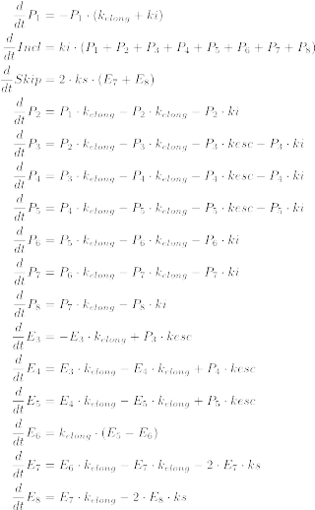

The initial state of all species is set to 0, with the exception of P₁, which is set to 1. It corresponds to the initial state of mRNA from the time delay model and shows the probability for a pre-mRNA to be in the elongation state P₁ (Fig. 1B).

For integrating/solving the System of given ODEs we use the function odeint from the phyton package scipy (v. 1.3.1), subpackage integrate.
The result is the time course of all species representing the probability of each species to be there at a specific time point. After integration of the ODE system until t=∞ (in practice t = 1e4) the values of P_{i} and E_{i} are expected to be 0. The PSI value at the end of simulation can be calculated as:

Relationship between gene structure, time delays and polymerase speed

For the analysis of the multi-step models a fixed transcript length tr_{len}=300 nucleotides is assumed. This is the length of pre-mRNA segment between exon 2 end end transcript end including second intron end third exon. All models in Fig. 1 and Fig. 2 are determined by the model topology definition, consisting of a tuple (k, e, m, n) defining the amount of steps in each phase for the multi-step model (Fig. 1S). The sum of the steps is the total number of elongation steps: l = k+e+m+n. So the elongattion rate constant k_{elong} can be calculated for a given transcription length tr_{len} and polymerase II speed vpol:

This value was calculated before each simulation. In SBML format these rules are defined as InitialAssignments. Thus, the tools for import and simulation of the given models have to support those SBML elements.

3. Mechanistic exon definition model
Text unten ist aus dem Haupttext einkopiert, also nicht final

Ich schlage folgende Gliederung vor

1) Short introduction: Motivation, Which figures were simulated with this model?

2) Model topology (Equations and their meaning)

3) Numerical simulations – evtl kein eigener Abschnitt werden – du kannst wohl auf Section 1 verweisen, musst nur sagen, wodurch nun die Delays entstehen;
-alle Exon-Enden sind ein Delay\
-t=0 ist wirklich Start des Transkripts;
-Ende des Transkripts schaltet Retention an und wieso ist das so angenommen

4) Spatial range RBP-mediated inhibition: Was genau sind die Inhibitionsfunktionen in Fig. 4 (Gleichungen)

Introduction
To explicitly model binding of the inhibitory RBP to the pre-mRNA, we turned to mechanistic modeling. Specifically, we considered RBP binding to the pre-mRNA, assumed that the RBP inhibits nearby splice sites and considered that introns may be retained if splicing becomes inefficient.

This mechanistic model was based on our previous work on exon definition, in which we modeled recruitment of pioneering spliceosome U1 and U2 subunits to splice sites (Fig. 3A and Enculescu et al., 2020). Specifically, we considered that all three exons may be “defined” by cooperative U1 and U2 binding across exons. Initially, the pre-mRNA is synthesized as an unbound precursor (P000), and then irreversible exon definition may occur in a combinatorial fashion with the rate constants k₁-k₃ (Fig. 3A, left). For instance, the both outer exons are defined in the states P101 and P111, whereas the middle exon is either undefined (P101) or defined (P111). These spliceosome binding patterns impact on splicing outcomes, as we assume splicing reactions (k_{spl}) to inclusion (state P111), skipping (P101) or retention (k_{ret}) (all other states).

As depicted in Fig. 3A (right), the inhibitory RBP modulates splicing outcomes by irreversibly binding to all unspliced pre-mRNA states (e.g., P000 → P000_inh). Subsequently, spliceosome binding occurs at reduced rates (k_{1,inh}-k_{3,inh}), but splicing rates (k_{spl}) remain unchanged. Thus, the inhibitory RBP changes splicing outcomes by blocking initial spliceosome recruitment. Importantly, this occurs only locally around the sites of RBP binding, i.e., around an assumed RBP motif (Fig. 3B; vertical dashed line). For simplicity, we initially assumed a bell-shaped inhibition profile, in which the RBP effects on k₁-k₃ decay within ~100 bp around the binding site. Consequently, when binding with sufficiently short introns, the RBP can simultaneously affect the definition of two exons as schematically depicted in Fig. 3B.

Co-transcriptional spliceosome binding and splicing were considered in the model by assuming that an exon can only be defined just after its synthesis is complete. Hence, the rate constants k₁-k₃ and k_{1,inh}-k_{3,inh} change in a time-dependent manner after transcript initiation and increase in a step-like manner with delays that reflect the relative positions of exons within the pre-mRNA (Fig. 3C). For the RBP, we again assumed RNA polymerase-dependent recruitment, and therefore modeled RBP binding as a short window-of-opportunity, reflecting the phase when the elongating enzymes passes the RBP motif.

Model topology
The mechanistic model is a reaction network of first order reactions (Fig. 3A). It consist of two equal subnetworks with different exon definition rates (k_{x} and k_{x,inh}). Additionally there are three species Incl, Skip, ret (ret is not depicted in the Figure). The transition between the two subnetworks is only possible in one direction (from left to right), representing irreversible RBP binding. The transition can only happen between two corresponding species (Pxyz → Pxyz_{inh}) with the reaction rate constant rbp_{br}. The ODE system resulting from the given reaction network looks like the following:
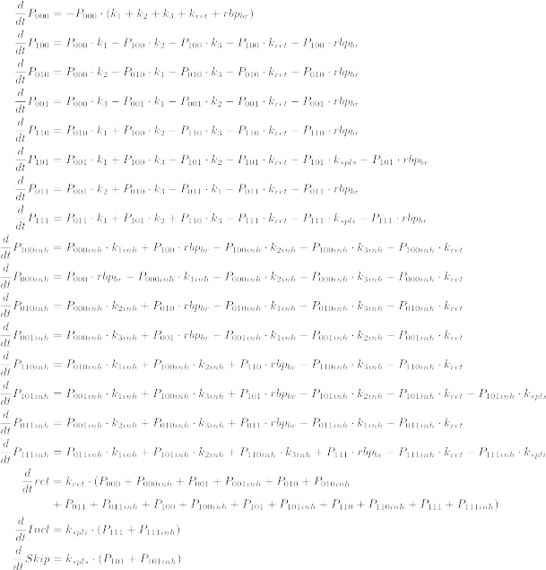

Numerical simulation
With the given reaction network is it possible to simulate post-transcriptional splicing with RBP binding. For simulation of co-transcriptional splicing it is necessary to simulate the elongation of nascent pre-mRNA. This happens in the same manner as in the commitment model by using time delays (chapter 2).
The time delay are determined by the gene structure and the position of RBP binding site. In this work we used the structure of the RON mini-gene from in the previous work (Enculescu et al., 2020).
The model have 6 time delays standing for specific elongation states. At each time delay one or several model parameters are changed, enabling or disabling some reactions. The time delays are calculated based on model parameters (gene structure, polymerase speed) before each simulation. The following table lists all time delay and the terms for their calculation.
Time delay | Term | Description
τ1 |  | End of exon 1: k1 and k1_{inh} on
τ2 |  | End of exon 1: k2 and k2_{inh} on
τ3 |  | End of exon 1: k3 and k3_{inh} on
τ4 |  | RBP binding side transcribed: rbp_{br} on
τ5 |  | Pol II passes RBP binding site : rbp_{br} off  τ4 and τ5 constitute the window of opportunity for RBP binding
τ6 |  | Gene transcription end. Retention can take place: k_{ret} on

Before integration of the ODE system the calculated delays are sorted. In regards to Fig. 3C there are 7 temporal phases with different parameters:

The integrations of the ODE system with the time delays is done similar to time delays models of commitment models in chapter 2. The simulation starts at time t=0 (transcription initiation) and we set all species to zero, except for the P000, which is set to 1. Then the first phase will be integrated until first τ. All subsequent phases uses the end species vector from the previous time phase as initial state.

Then, alternative splicing is quantified using the PSI metric, which equals the probability of inclusion:

(Equation 1)

RBP-mediated inhibition
The values of kx_{inh} are dependent on RBP binding site and the inhibition function (Fig. 3B). The values are calculated before each simulation using the model parameters (in sbml format it is done by InitialAssignments).
(Equation 2)
5´SS and 3´SS are the relative (to RBP binding site) positions of U2 and U1 binding sites of an exon.
The inhibition function is a parametrized piecewise defined function:
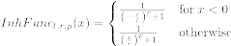 (Equation 3)
The parameters l, r, and p determine the range and the shape of the inhibition function:
l – upstream range in [nt]
r – downstream range in [nt]
p – hill-coefficient like parameter determining the shape /steepness of the function
x – distance from RBP binding site

4. Stochastic simulations
1) Introduction

To quantify uncertainties in splicing outcomes, we performed stochastic simulations using our co-transcriptional splicing models and compared all previously introduced model variants…..

2) Implementation: Hier muss beschrieben werden, wie Du das gemacht hast. Also Gillespie bestimmt ja erstmal, wann die naechste Rkt stattfindet (e-Fkt) und dann welche (aus den Probabilities) – so zumindest meine Erinnerung.... Ich denke, du hast einfach alle Events gesampelt und geguckt, welches als erstes stattfindet, oder? So hatte ich es im Gruppentreffen verstanden. Ich denke, es laeuft auf das gleiche raus, muss aber beschrieben werden. Wenn Du doch nur Gillespie benutzt hast, musst du das Package erwaehnen und ausserdem wuerde ich der Reproduzierbarkeit alle Reaktionen einzeln auflisten. Wie wurden die Reaktionswahrscheinlichkeiten bestimmt – da es nur Reaktionen erster Ordnung sind, kann man sie mit den kinetischen Parametern im ODE-Modell gleichsetzen, oder?

For stochastic simulations we used the Gillespie algorithm (Gillespie, D. T. (1976)) instead of deterministic ODE solver. Thereby the models and their parameters remain the same.

Commitment models
The initial state of mRNA in the commitment model was varied between 10 and 1000 molecules (Fig. 5B). The PSI value was varied in the same manner like in Figures 1,2 by variation of vpol.
delay times, commitment rates and inhibitor/spliceosome binding rates to mRNA were sampled from exponential distributions to determine the order of reaction steps in a manner reminiscent of the Gillespie algorithm (Supplement). This way, we take into account stochastic variation in transcript elongation (delay times) and biochemical steps of splicing decision making. The stochastic simulation was repeated 5000 times for each parameter and initial state combination. So we have got 5000 trajectories for each combination. The PSI metric was calculated at the end of simulation to obtain splicing distributions across 5000 cells (Fig. 5A). For comparison with the binomial distribution we used the mean value of PSI as the probability and the sum of Incl and Skip as molecule count for the noise calculation of binomial distribution. Therefore we used stats.binom.std from the python package scipy (v. 1.3.1).:
stats.binom.std(Skip+Incl, mean(PSI))

Mechanistic model
The initial state of P000 in the commitment model was varied between 10 and 40 molecules. The PSI value was varied by changing the RBP binding site position between 220 and 280 nts. Because of the retention reaction the sum of Incl and Skip does not remain constant and may not correspond to initial state of P000. So the comparison to binomial distribution noise cannot be done like in Fig. 5B. The stochastic simulation was repeated 5000 times for each parameter and initial state combination. So we have got 5000 trajectories for each combination. The PSI metric was calculated at the end of simulation to obtain splicing distributions across 5000 cells. For comparison with the binomial distribution we used the mean value of PSI as the probability and the sum of Incl and Skip as parameters for the noise calculation of binomial distribution. Therefore we used stats.binom.std from the python package scipy (v. 1.3.1).:
stats.binom.std(Skip+Incl, mean(PSI))

3) Evtl Details zum Vergleich mit der binomialen Verteilung? Wieso wurden die Modelle unterschiedlich behandelt?

