Supplement

Chain and time delays models

Modeling and simulation
All introduced models in chapters XY are reaction networks. All transitions from one species or state to another are considered as first order reactions. The reaction rates are determined by the chemical kinetics. Thus for each species one can formulate a ordinary differential equation (ODE), representing derivatives with respect to time. Considering the time delay model from chapter XY we get a system of ODEs:
(Equation 1)

The ODE system for the step model from the same chapter looks like the following:

(Equation 2)

For integrating/solving the System of given ODEs we use the function odeint from the python package scipy. (https://docs.scipy.org/doc/scipy/reference/generated/scipy.integrate.odeint.html). The result is the time course of all species.

Delay model simulation
The delay model is a abstraction of the step model. The delays are determined by the step count for each phase (Fig SXX), the gene structure and the RNAP II speed (vpol).
The simulation starts with a certain initial value vector of species . All species except mRNA are set to 0. mRNA is set to 1 representing 100% of produced mRNA molecules.
(Equation 3)

The 1 can also be considered as one molecule being unspliced with a probability of 100%.
Then the ODE system will be integrated until the first time delay. In this first time phase some parameters are set to 0, so some reactions are disabled. Hence the effective ODE system is reduced to:
(Equation 4)

After the integrating the ODE system for the first phase the parameters are modified. So we get a new effective ODE system:
(Equation 5)

The initial value vector of species for the next time phase is the result from the previous integration at the (end) time point : .

The next time phases are treated in the same way. Each phase uses the end result of the previous as the initial value.

PSI calculation

Calculation of the analytical solution
The approach for calculation the analytical solution for PSI of simple models is based on the probability for the inclusion reaction. Under the assumption that the simulation starts with one molecule of mRNA one can calculate the probability of inclusion reaction for each of the four time phases dt1, dt2, dt3, dt4 (Fig. 1).
The first step is the calculation of p1 representing the probability for inclusion within the first phase dt1. Assuming a poisson process we can calculate the expected value 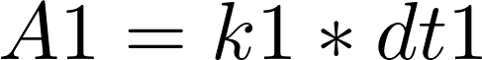, showing the amount of expected inclusion reactions. Considering exponential distribution we get 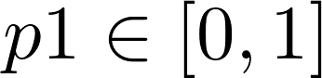 as the value from cumulative distribution function:
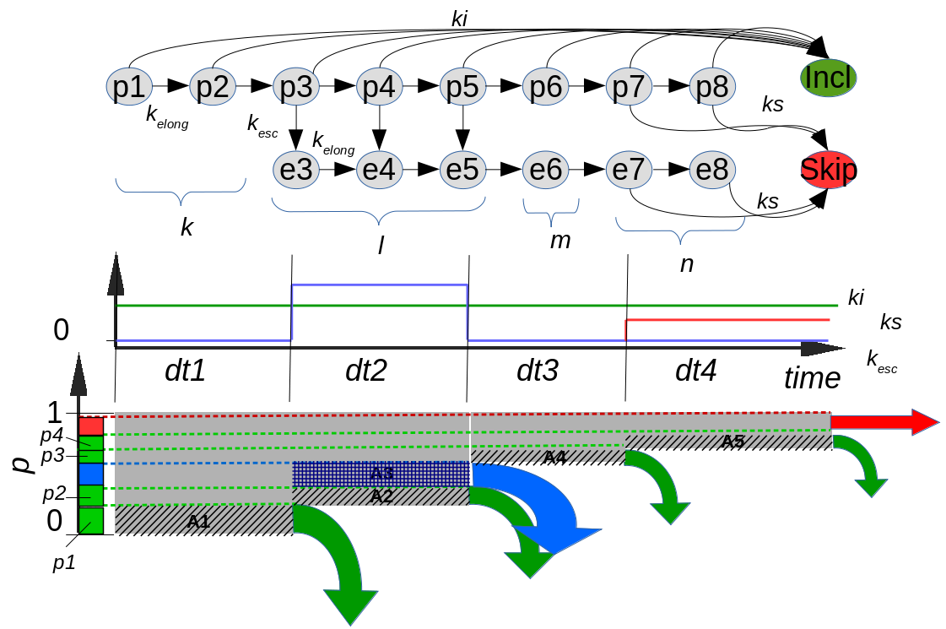
Illustration 1: Schematic representation of analytical solution approach. At the top is the step model we are originating from. In the middle is the parameter time course of the derived time delay model. The analytical approach is based on this model (bottom). p1-p4 are absolute probabilities for inclusion reaction in the corresponding phases 1-4.
(Equation 6)
The probability that a reaction won't take place in the first phase is . The general formula for rest/remaining probability after the phase i is:
(Equation 7)
In the second phase there are two competing reactions. The expected value for both reactions is . The probability for one of the reaction will occur is . The probability for inclusion reaction results from:
(Equation 8)
Consequently the rest probability for phase 3 is .
For the two remaining phases we can proceed in the same manner. Eventually we get the PSI-value as a sum of all absolute probabilities for inclusion p₁-p₄:
(Equation 9)

