Predictive Modeling and Risk Scoring for Bank Customer Churn
Research Paper and Analytical Report
Prepared from the supplied European_Bank.csv dataset | Modeling date: October 2026

Abstract
Customer churn is a material business risk for retail banking because the loss of an established customer can reduce lifetime value, recurring revenue, cross-sell potential and relationship depth. This project develops an end-to-end predictive churn intelligence workflow that converts customer attributes into a probability of churn and an actionable risk band. The analysis uses 10,000 customer records and an observed churn rate of 20.37%. CustomerId and Surname are excluded from modeling, categorical variables are one-hot encoded, numerical variables are standardized, and additional behavioral/relationship features are engineered. Five supervised learning approaches are compared: Logistic Regression, Decision Tree, Random Forest, Gradient Boosting and XGBoost. Gradient Boosting is selected as the champion based on the highest ROC-AUC in the held-out test set (0.869). The dashboard exposes a customer risk calculator, portfolio analytics, feature importance and what-if simulation. Results indicate that age, number of products, activity status, balance and geography are important predictive signals. The findings are intended for educational and analytical decision support; bank-specific validation, fairness assessment and governance are required before production use.

1. Introduction and Business Context
Traditional churn analysis is primarily descriptive: it identifies patterns after customers have already exited. A predictive approach changes the decision point from post-event investigation to pre-event intervention. For a bank, this means prioritizing customers for relationship review, service recovery, engagement campaigns, product-fit discussions or other retention actions before churn occurs. A probability score also supports portfolio segmentation, allowing limited retention resources to be allocated to customers with the greatest predicted risk and potential value.

2. Problem Statement
Despite having rich customer-level information, a bank may lack an accurate and explainable mechanism for identifying customers who are likely to churn. Reactive or broad retention programs can create unnecessary cost and customer fatigue. The project therefore addresses three core questions: (1) Can churn be predicted from available customer attributes? (2) Can each customer receive a quantitative probability score? and (3) Which features provide the strongest predictive signal for churn?

3. Objectives
- Predict customer churn using supervised machine learning.
- Generate a probability score between 0 and 1 for each customer.
- Create threshold-based low, medium and high risk bands.
- Compare interpretable and tree-based algorithms using accuracy, precision, recall, F1 and ROC-AUC.
- Identify major predictive drivers to support explainable business decisions.
- Provide an interactive dashboard with customer scoring and scenario analysis.
- Reduce false churn alarms while retaining enough recall for meaningful intervention.

4. Dataset and Data Quality
The supplied dataset contains 10,000 records and 14 original columns. The target is Exited, where 1 indicates churn and 0 indicates retention. There are no missing values in the supplied data. The observed churn rate is 20.37%. The average customer age is 38.9 years, average balance is 76,485.89, and 51.5% of customers are marked active.
Field | Role | Treatment
CustomerId | Identifier | Removed
Surname | Identifier/text | Removed
CreditScore, Age, Tenure, Balance, EstimatedSalary | Numerical predictors | Impute if needed + scale
Geography, Gender | Categorical predictors | One-hot encoding
NumOfProducts, HasCrCard, IsActiveMember | Behavior/product predictors | Numeric/binary
Exited | Target | 0 = retained; 1 = churned

5. Feature Engineering
- Balance-to-Salary Ratio = Balance / (EstimatedSalary + 1).
- Product Density = NumOfProducts / (Tenure + 1), providing a simple relationship-depth measure.
- Engagement-Product Interaction = IsActiveMember × NumOfProducts.
- Age-Tenure Interaction = Age × (Tenure + 1).
- Zero Balance Flag = 1 when Balance equals zero, otherwise 0.
These features are designed to represent financial intensity, product depth, engagement and relationship duration. They are predictive features, not causal variables.

6. Modeling Methodology
A stratified 80/20 train-test split with random state 42 preserves the churn/retention class proportion between training and validation data. Five models are trained using the same feature pipeline. Logistic Regression provides an interpretability benchmark. Decision Tree and Random Forest capture non-linear interactions. Gradient Boosting and XGBoost provide stronger ensemble-based alternatives.

7. Model Evaluation
Model | Accuracy | Precision | Recall | F1 | ROC-AUC
Logistic Regression | 0.713 | 0.387 | 0.705 | 0.500 | 0.776
Decision Tree | 0.762 | 0.451 | 0.786 | 0.573 | 0.842
Random Forest | 0.834 | 0.577 | 0.681 | 0.625 | 0.866
Gradient Boosting | 0.869 | 0.786 | 0.486 | 0.601 | 0.869
XGBoost | 0.871 | 0.799 | 0.489 | 0.607 | 0.865
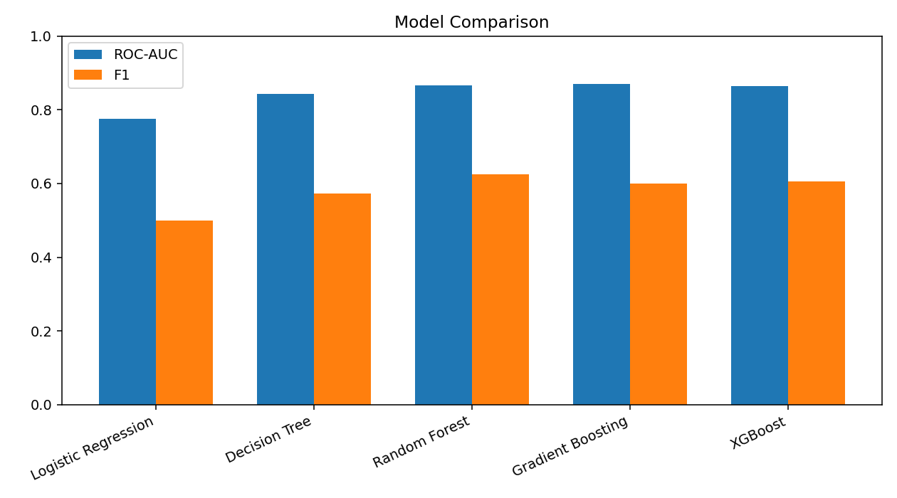
The selected champion is Gradient Boosting, which achieved the highest ROC-AUC of 0.869. XGBoost achieved the highest accuracy at 0.871, illustrating why model selection should consider the business objective rather than accuracy alone. The Gradient Boosting model has a precision of 0.786 and recall of 0.486 at the default 0.50 threshold.

8. Churn Risk Scoring
The model outputs a probability p = P(Exited=1 | customer features). The dashboard converts this probability into a risk band: Low below 0.30, Medium from 0.30 to below 0.60, and High at 0.60 or above. These thresholds are operational defaults for the prototype, not validated bank policy. In production, thresholds should be optimized against retention budget, customer value, intervention cost and acceptable false-positive/false-negative trade-offs.
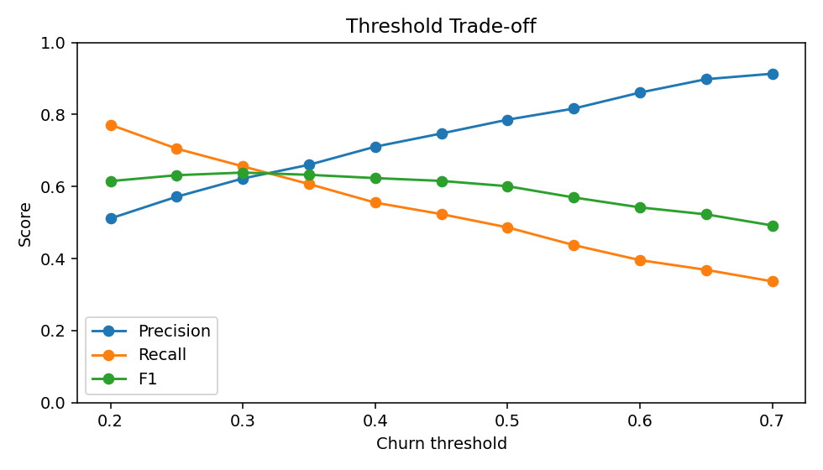

9. Explainability and Key Findings
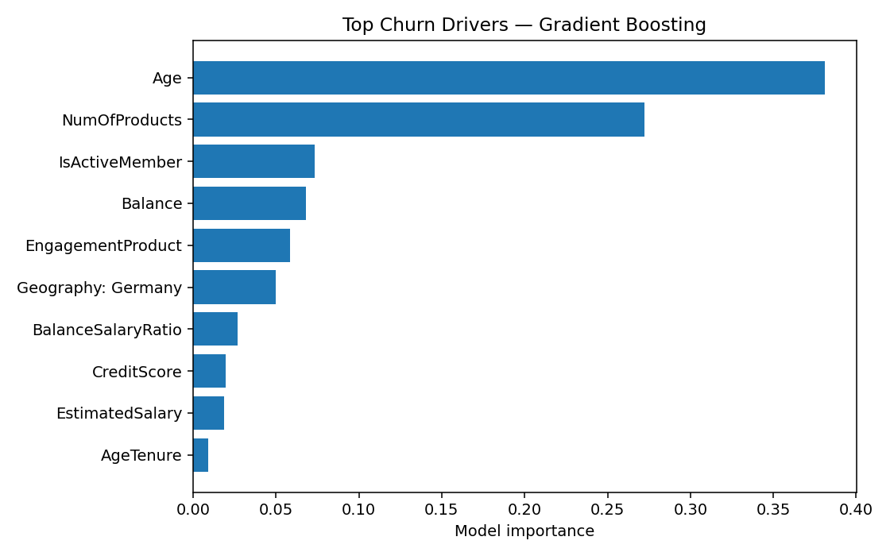
The Gradient Boosting feature ranking places Age and NumOfProducts at the top, followed by IsActiveMember, Balance and the engagement-product interaction. Geography—especially the Germany indicator—also contributes meaningful predictive signal. Descriptively, Germany has the highest observed churn rate in the supplied data (32.44%), compared with 16.15% for France and 16.67% for Spain. Inactive customers show a higher observed churn rate (26.85%) than active members (14.27%). Customers with one product have 27.71% observed churn, while the two-product group has 7.58%; small groups with three or four products show much higher churn and should be interpreted cautiously because of their low counts.
Feature importance indicates predictive association and should not be treated as proof of causation. SHAP or partial-dependence analysis can be added in a governed production workflow to examine directionality and individual explanations.

10. Business Recommendations
- Prioritize engagement interventions for customers with high predicted risk and low activity.
- Investigate product-fit issues, particularly unusual product counts, instead of assuming more products always mean lower churn.
- Use geography as a segmentation variable for further service, pricing, competition and customer-experience investigation.
- Combine churn probability with customer lifetime value so retention resources are not allocated on risk alone.
- Use threshold calibration to control campaign volume and false-positive cost.
- Establish human review and documented intervention rules before using scores for consequential customer decisions.
- Monitor model drift, calibration, subgroup performance and intervention outcomes after deployment.

11. Streamlit Dashboard
The delivered Streamlit application contains four modules: Risk Calculator, Portfolio Analytics, Model Explainability and What-if Simulator. The visual design uses a bright pastel light-blue interface with white cards and high-contrast blue typography. Users can enter a customer profile and obtain a churn probability and risk band. Portfolio views summarize churn distribution, geography and model metrics. The explainability module presents model feature importance, while the scenario simulator lets users adjust activity, product count, age, tenure, balance and salary to observe score changes.

12. Limitations and Governance
- The supplied dataset is limited to the listed customer attributes and may not represent a live bank's population.
- The target is historical churn; it does not establish causal drivers.
- Accuracy, precision and recall depend on the chosen threshold and the historical data distribution.
- Demographic variables can introduce fairness concerns and require subgroup performance testing.
- Production deployment should use calibrated probabilities, temporal validation, drift monitoring and documented model governance.
- Customer churn scores should support human decision-making rather than automatically trigger adverse actions.

13. Conclusion
This project demonstrates a complete predictive churn intelligence pipeline from data preparation to risk scoring and interactive decision support. On the supplied dataset, Gradient Boosting provides the strongest ROC-AUC among the tested models at 0.869. The analysis shows that customer age, product usage, activity and balance-related variables are important predictive signals. The accompanying dashboard converts the model into an accessible workflow for customer-level scoring and what-if analysis. The solution should be treated as a project prototype and validated with bank-specific, temporally ordered and governed data before operational use.

Appendix: Deliverable Files
- app.py
- churn_model.joblib
- metrics.json
- feature_importance.csv
- test_predictions.csv
- threshold_analysis.csv
- dataset_summary.json
- plots/
- requirements.txt
- README.md

