EXECUTIVE SUMMARY
Factory-to-Customer Shipping Route Efficiency Analysis
Nassau Candy Distributor | Prepared for Unified Mentor | September 2026

Purpose
This summary presents the headline findings and recommended actions from a route-level efficiency analysis of Nassau Candy Distributor's shipping operations, based on 10,194 shipment records covering five factories and customer deliveries across the United States and Canada. It is intended for stakeholders who need the conclusions and required decisions without the full technical analysis.

Headline Finding: A Data Quality Issue Blocks Part of the Original Scope
The shipment records' Ship Date field does not reliably reflect real delivery timing — every one of the 10,194 records shows a shipping duration of roughly 900 to 1,640 days, which is not physically plausible for a candy distributor. This affects 100% of records, not a subset that can simply be discarded. As a result, three planned metrics — Shipping Lead Time, Delay Frequency, and a time-based Route Efficiency Score — cannot be reported without being misleading, and are not included below. Everything else in this summary is based on sales, volume, and profit data, which is complete and reliable.
Recommended action: correct the Ship Date field at the source system, then re-run the timing-based analysis; the profitability analysis below is ready to merge with it immediately.

What the Reliable Data Shows
Metric | Value
Total shipments analyzed | 10,194 (8,549 orders, 5,044 customers)
Total sales | $141,783.63
Total gross profit | $93,442.80
Overall gross margin | 65.9%
Factories | 5 (2 factories = 96.6% of volume)
Highest-volume state | California — 2,001 shipments (19.6% of network)

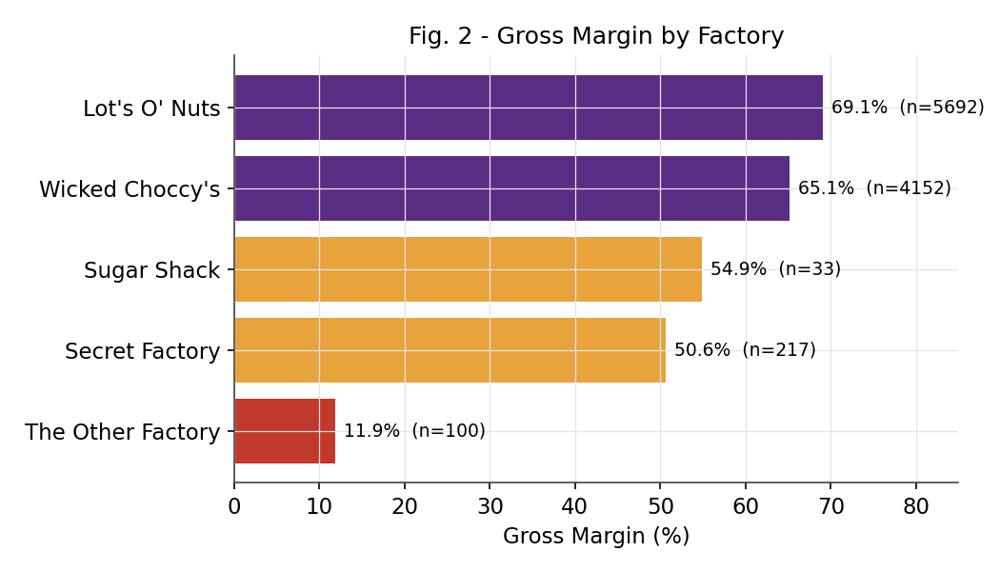
Gross margin by factory — The Other Factory is a clear outlier at 11.9%.

Key Issues Requiring Attention
- Data integrity: the Ship Date field must be corrected before any delivery-time or delay reporting can be trusted (see above).
- Margin outlier: The Other Factory operates at 11.9% gross margin versus a 50–69% norm elsewhere in the network — a cost or pricing review is warranted.
- Concentration risk: two factories and one product division (Chocolate) generate 96.6% of shipment volume and the great majority of profit; three smaller factories contribute only 3.4% of volume.
- Geographic concentration: California, New York, and Texas together account for over 40% of shipments, making them the priority states for capacity and carrier planning.

Recommendations
- Immediate: Fix the Ship Date data source and add validation rules to prevent recurrence; this is the single highest-leverage next step.
- Operational: Review The Other Factory's cost structure for its two product lines (Kazookles, Hair Toffee).
- Operational: Prioritize California, New York, and Texas for route optimization and carrier negotiations.
- Strategic: Evaluate the long-term viability of the three low-volume factories' product lines.

Deliverables Provided
- Full research paper — detailed EDA, methodology, data-quality findings, and route/region/ship-mode analysis with supporting charts and tables.
- Interactive Streamlit dashboard — route efficiency overview, geographic view, ship-mode comparison, and drill-down filters by date, region, state, and ship mode.
- This executive summary.

