Factory-to-Customer Shipping Route
Efficiency Analysis
Nassau Candy Distributor
Prepared for Unified Mentor
Research Paper — Exploratory Data Analysis, Insights & Recommendations
Prepared by: Siddhartha | Data Science Intern
September 2026

1. Executive Overview
Nassau Candy Distributor ships confectionery products from five factories to customers across the United States and Canada. This paper analyzes 10,194 shipment records to evaluate route-level shipping efficiency, identify geographic bottlenecks, compare shipping modes, and benchmark performance across factory-to-customer routes.
The dataset's most important finding is a data-quality issue: the recorded Ship Date field is inconsistent with the Order Date field for every single record, producing implausible shipping durations of roughly 900 to 1,640 days. Section 4 documents this in detail. Because of it, time-based KPIs (Shipping Lead Time, Delay Frequency, time-based Route Efficiency Score) cannot be computed reliably from the data as supplied. This paper instead delivers a rigorous route, regional, and ship-mode performance analysis built on the metrics that remain trustworthy — sales, units, gross profit and margin, and shipment volume — and flags exactly what is needed to restore the time-based analysis once corrected data is available.
Key findings at a glance:
- Total sales across the dataset are $141,783.63 on 38,654 units, generating $93,442.80 in gross profit — an overall margin of 65.9%.
- Two factories — Lot's O' Nuts and Wicked Choccy's — account for 96.6% of all shipments and nearly all profit; three smaller factories (Secret Factory, The Other Factory, Sugar Shack) together handle only 3.4% of volume.
- The Other Factory runs a gross margin of just 11.9%, far below the network average of 65.9% — the single clearest profitability problem in the network.
- California, New York and Texas are the highest-volume destination states by a wide margin, led by the Lot's O' Nuts → California route (1,125 shipments).
- Standard Class carries 60% of all shipments; the ship-mode mix is heavily skewed toward slower, lower-cost service.

2. Background & Problem Statement
Nassau Candy Distributor operates as a national distributor, shipping products from factories to customers across multiple US regions and into Canada. Shipping efficiency directly affects customer satisfaction, delays increase operational cost, and inefficient routes reduce scalability. Despite having rich order and shipment data, logistics decisions have historically been made without route-level efficiency intelligence.
Specifically, the organization lacks clarity on:
- Which factory-to-customer routes are consistently efficient and profitable
- Which routes experience the weakest margins or performance
- How shipping performance varies by region, state, and ship mode
- Where operational and geographic bottlenecks exist

3. Dataset Description
The analysis uses a single transactional dataset of 10,194 line-item shipment records (8,549 distinct orders, 5,044 distinct customers) spanning 18 fields: order identifiers, order and ship dates, ship mode, customer geography (country, city, state, postal code, region), product identifiers and names, product division, and financial fields (sales, units, gross profit, cost). There are no missing values in any field.
Two reference tables accompanied the dataset and were joined into the analysis:
- A Factory Coordinates table giving latitude/longitude for the five factories (Lot's O' Nuts, Wicked Choccy's, Sugar Shack, Secret Factory, The Other Factory).
- A Product–Factory correlation table mapping each of the 15 products to its originating factory and division (Chocolate, Sugar, Other). This mapping was joined onto every shipment record to reconstruct the factory-to-customer route for each order — the dataset itself does not contain a factory field.
99.98% of shipments (9,994 of 10,194) go to United States destinations; the remainder (200) go to Canada.

4. Methodology & Data Quality Findings

4.1 Cleaning & Feature Engineering
Order Date and Ship Date were parsed, geographic fields standardized, and each shipment mapped to its factory via the product-factory correlation table (all 15 products matched with no unmapped rows). A Route field was engineered at two grains — Factory → Region and Factory → State/Province — matching the two-level route definition specified in the project brief. Gross margin percentage (Gross Profit ÷ Sales) was computed per row and used as the primary profitability metric in all aggregations.

4.2 Critical Data Quality Finding: The Shipping Lead Time Field Is Not Usable As Recorded
The brief's methodology calls for computing Shipping Lead Time as Ship Date minus Order Date, then using it to rank routes and evaluate ship-mode performance. Applying that calculation to this dataset produces the following:
- Order Date ranges from 2 Jan 2024 to 31 Dec 2025 — a plausible two-year order history.
- Ship Date ranges from 30 Jun 2026 to 28 Jun 2030 — years after the order history ends.
- The resulting lead time is between 904 and 1,642 days for every one of the 10,194 records (mean 1,321 days, ≈ 3.6 years). 0% of records fall inside a realistic 0–30 day shipping window.
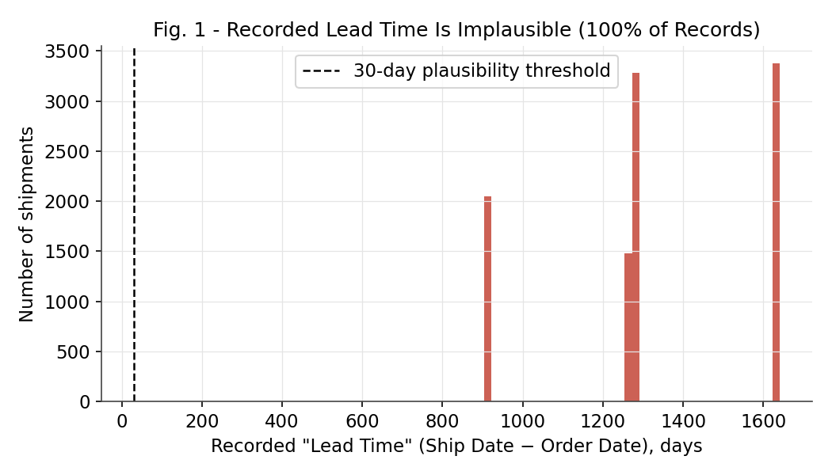
Fig. 1 — Every recorded lead time falls between roughly 900 and 1,640 days; none are realistic for candy distribution.
This is not a small number of outliers to be filtered out — per the brief's own cleaning instruction to "remove invalid or negative lead times" — it is the entire field. Two further checks confirm this is a systematic artifact rather than genuine variance: first, the day-of-year gap between Order Date and Ship Date is nearly constant (mean 177 days, standard deviation under 2 days) even though the year gap varies from 2 to 5 years, which is inconsistent with real shipment timing. Second, average lead time barely differs across ship modes (Same Day averages 1,333 days versus Standard Class's 1,314 — a 19-day spread out of ~1,300, i.e. essentially no signal), which would not occur if the field reflected real fulfillment performance. The most plausible explanation is that Ship Date was populated from an unrelated or corrupted date source during data preparation, rather than reflecting genuine shipment timing.
Consequence for this paper:
Shipping Lead Time, Delay Frequency, and time-based Route Efficiency Score — three of the five KPIs specified in the brief — cannot be reported from this dataset without materially misleading the reader. This paper reports them as a documented limitation (Section 8) rather than fabricating a lead-time ranking from unusable data, and substitutes a volume- and profitability-based route efficiency view, which the data fully supports.

5. Findings

5.1 Sales & Profitability Overview
Across all 10,194 shipments, Nassau Candy generated $141,783.63 in sales and $93,442.80 in gross profit, an overall margin of 65.9%. Profitability is heavily concentrated: Chocolate-division products from just two factories drive the business.
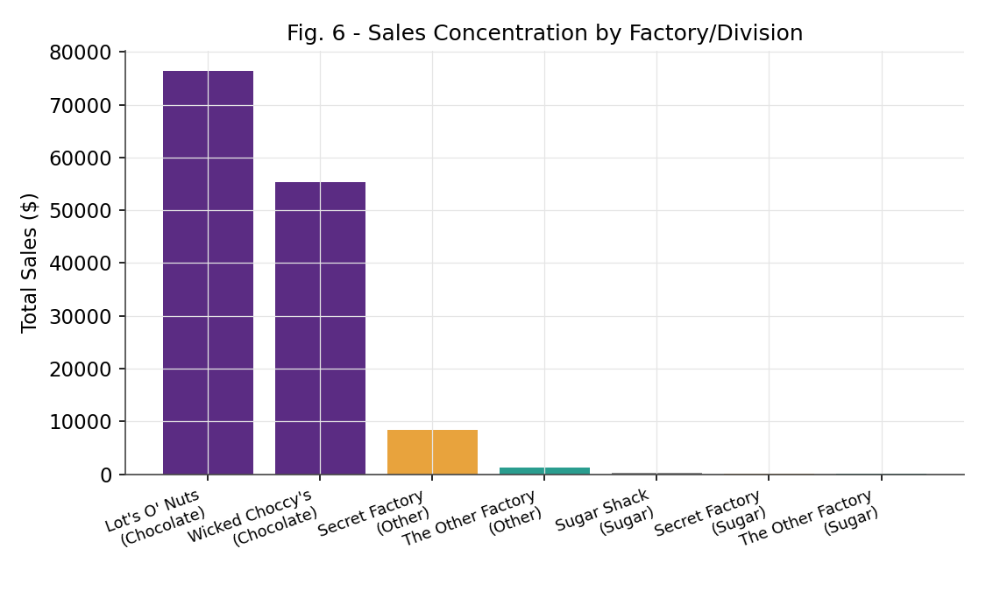
Fig. 2 — Sales concentration by factory / division.
Factory | Division | Shipments | Sales ($) | Gross Profit ($)
Lot's O' Nuts | Chocolate | 5,692 | 76,340.15 | 52,771.05
Wicked Choccy's | Chocolate | 4,152 | 55,352.75 | 36,053.57
Secret Factory | Other | 214 | 8,457.50 | 4,240.70
The Other Factory | Other | 96 | 1,205.75 | 92.75
Sugar Shack | Sugar | 33 | 220.98 | 121.23
Secret Factory | Sugar | 3 | 130.00 | 104.00
The Other Factory | Sugar | 4 | 76.50 | 59.50

5.2 Factory Margin Performance
Gross margin varies sharply by factory. Lot's O' Nuts (69.1%) and Wicked Choccy's (65.1%) — the two chocolate factories that generate 96.6% of volume — post healthy, consistent margins. The three smaller factories underperform, with The Other Factory's 11.9% margin standing out as an outlier requiring investigation.
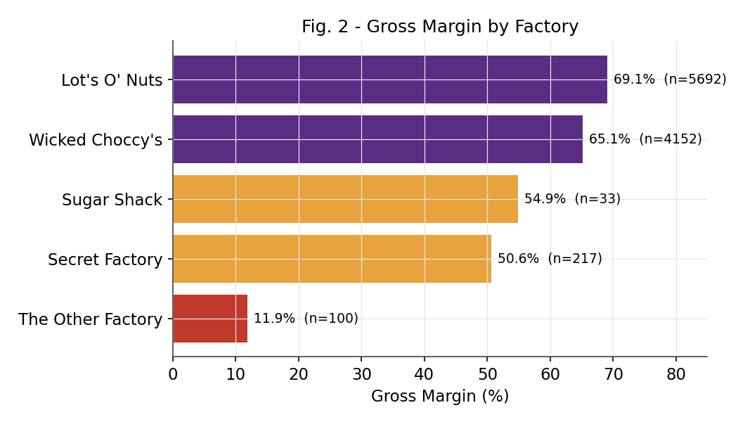
Fig. 3 — Gross margin by factory, with shipment count (n).

5.3 Regional Performance
The Pacific region leads in both shipment volume (3,253) and total sales ($46,301.53), followed by Atlantic, Interior, and Gulf. Margins are stable across regions (65.5%–66.4%), indicating that profitability differences are driven by factory and product mix rather than by region.
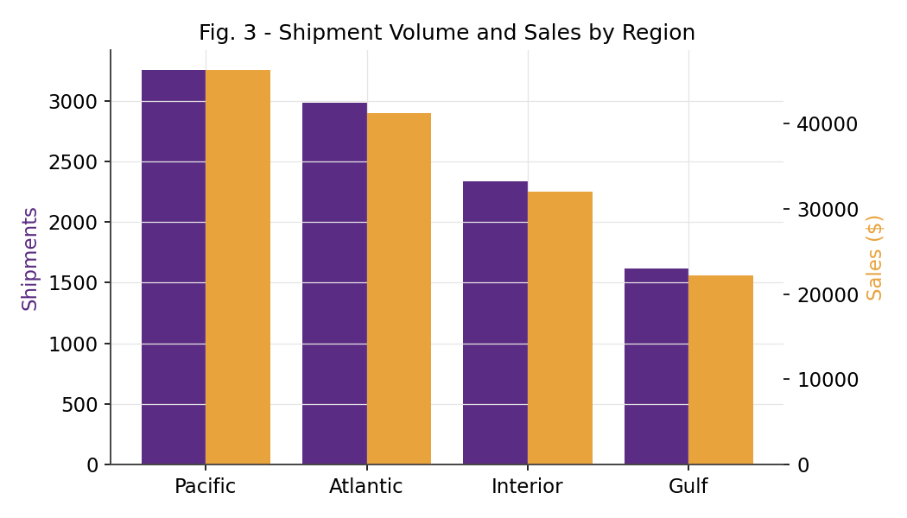
Fig. 4 — Shipment volume and sales by region.
Region | Shipments | Sales ($) | Gross Profit ($) | Margin
Pacific | 3,253 | 46,301.53 | 30,485.94 | 65.8%
Atlantic | 2,986 | 41,197.24 | 26,973.70 | 65.5%
Interior | 2,335 | 32,037.60 | 21,282.49 | 66.4%
Gulf | 1,620 | 22,247.26 | 14,700.67 | 66.1%

5.4 Geographic Bottlenecks: State-Level Concentration
Shipment volume is highly concentrated in a small number of states. California alone receives 2,001 shipments (19.6% of the network) — nearly double the next-largest state, New York (1,128). These high-volume states are the most exposed to any future service disruption and are the natural first candidates for dedicated regional carriers, satellite warehousing, or capacity planning once corrected timing data is available.
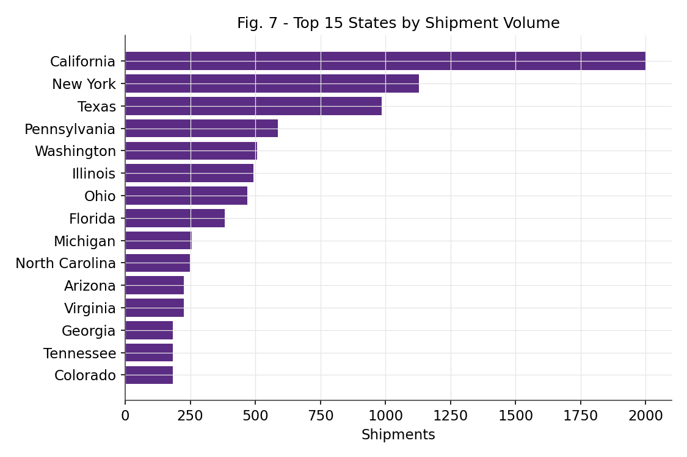
Fig. 5 — Top 15 states by shipment volume.

5.5 Route Efficiency — Volume & Profitability View
Because a valid Shipping Lead Time cannot be computed (Section 4.2), routes are ranked here by shipment volume and gross margin — the two KPIs the data supports without qualification. Each route is defined as Factory → State/Province, per the brief's route definition.
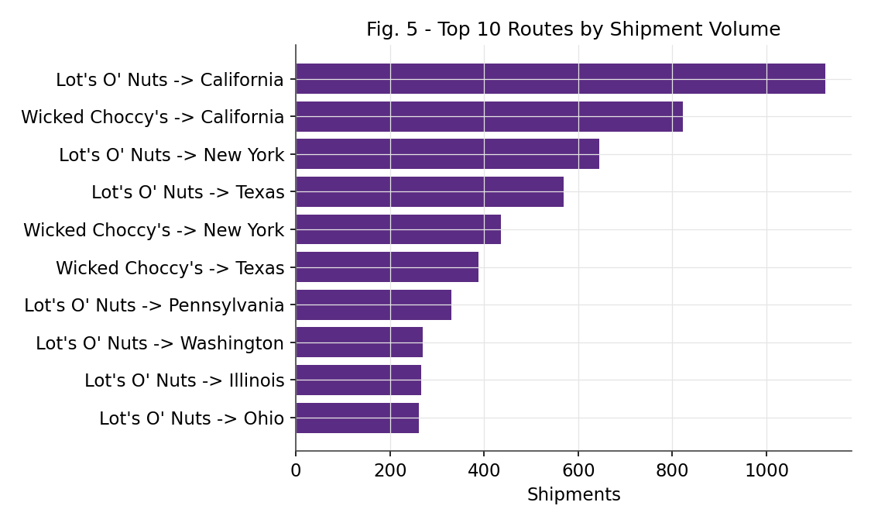
Fig. 6 — Top 10 factory → state routes by shipment volume.
Top 10 routes by shipment volume:
Route | Shipments | Sales ($) | Margin
Lot's O' Nuts → California | 1,125 | 15,044.90 | 69.1%
Wicked Choccy's → California | 823 | 11,394.00 | 65.1%
Lot's O' Nuts → New York | 645 | 8,757.81 | 69.1%
Lot's O' Nuts → Texas | 569 | 7,642.34 | 69.1%
Wicked Choccy's → New York | 436 | 5,518.25 | 65.1%
Wicked Choccy's → Texas | 388 | 5,140.50 | 65.1%
Lot's O' Nuts → Pennsylvania | 331 | 4,338.55 | 69.0%
Lot's O' Nuts → Washington | 269 | 3,492.91 | 69.2%
Lot's O' Nuts → Illinois | 267 | 3,539.21 | 69.3%
Lot's O' Nuts → Ohio | 262 | 3,472.74 | 69.1%

Bottom 10 routes by margin (minimum 15 shipments, to exclude statistically thin routes):
Route | Shipments | Sales ($) | Margin
The Other Factory → California | 21 | 233.75 | 14.4%
Secret Factory → California | 31 | 1,238.75 | 50.1%
Secret Factory → New York | 24 | 1,026.25 | 50.1%
Secret Factory → Pennsylvania | 19 | 762.50 | 50.2%
Secret Factory → Texas | 16 | 517.50 | 51.9%
Wicked Choccy's → Quebec | 24 | 254.75 | 65.0%
Wicked Choccy's → New Mexico | 17 | 229.50 | 65.0%
Wicked Choccy's → Ontario | 30 | 466.25 | 65.1%
Wicked Choccy's → Delaware | 49 | 601.50 | 65.1%
Wicked Choccy's → Wisconsin | 47 | 737.25 | 65.1%

The pattern is clear: every route below Wicked Choccy's baseline margin of ~65% belongs to Secret Factory or The Other Factory. Route weakness in this dataset is a factory-level issue (product cost/pricing structure), not a geography-level one — no single state or region shows weak margins across multiple factories.

5.6 Ship Mode Comparison
Standard Class dominates the shipment mix at 60.0% of volume, followed by Second Class (19.4%), First Class (15.2%), and Same Day (5.4%). Gross margin is essentially flat across ship modes (65.7%–66.1%), meaning shipping method is not a meaningful profitability driver in this dataset — it is a pure cost-to-serve and customer-experience lever.
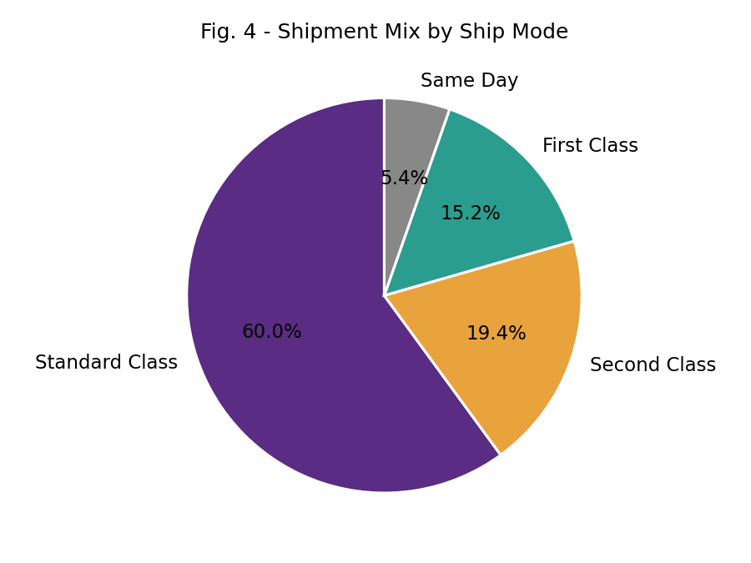
Fig. 7 — Shipment mix by ship mode.
Ship Mode | Shipments | Share | Sales ($) | Margin
Standard Class | 6,120 | 60.0% | 85,490.35 | 66.0%
Second Class | 1,979 | 19.4% | 27,860.22 | 65.7%
First Class | 1,548 | 15.2% | 21,319.39 | 65.7%
Same Day | 547 | 5.4% | 7,113.67 | 66.1%

Note on delivery speed: because Ship Date cannot be trusted (Section 4.2), this paper cannot state whether Same Day or First Class shipments are actually delivered faster than Standard Class in practice — only that the ship-mode label itself is recorded and is a valid basis for cost and mix analysis. Confirming real speed differences requires corrected shipment timestamps.

6. Key Insights Summary
- Data quality first: the Ship Date field is unusable for timing analysis in its current form across 100% of records — this must be fixed before any lead-time, delay, or on-time-delivery KPI can be trusted.
- Business concentration risk: 96.6% of shipments and the vast majority of profit flow through two factories (Lot's O' Nuts, Wicked Choccy's) and one division (Chocolate). The Sugar and other-product lines are a small fraction of volume.
- The Other Factory is a margin outlier at 11.9% gross margin — roughly 55 percentage points below the network average — driven by its Kazookles and Hair Toffee product lines.
- Geographic concentration: California, New York and Texas together account for over 40% of all shipments, making them the highest-priority states for any capacity, warehousing, or carrier-contract decisions.
- Ship mode is a cost/service lever, not a profitability lever — margins don't move with shipping method, so ship-mode choice can be optimized purely for cost and customer experience without a profit trade-off.

7. Recommendations

7.1 Immediate (Data Foundation)
- Re-extract or correct the Ship Date field at the source system before running any lead-time, on-time-delivery, or delay-frequency analysis. Given the near-constant ~177-day offset pattern identified in Section 4.2, this is very likely a fixable upstream mapping or ETL defect rather than lost data.
- Add data-validation rules (e.g., Ship Date must fall within N days of Order Date) to the order-management pipeline to prevent recurrence.

7.2 Operational
- Investigate The Other Factory's cost structure and/or pricing for Kazookles and Hair Toffee — a margin gap of this size (11.9% vs. a 50–69% network norm) is large enough to warrant a standalone cost review.
- Prioritize California, New York, and Texas for route optimization, dedicated carrier negotiations, or regional distribution points, given their outsized share of volume.
- Re-run the full Route Efficiency Score (combining lead time, delay frequency, and margin) once Ship Date is corrected — the profitability half of that score is already established in this paper (Section 5.5) and can be merged directly with corrected timing data.

7.3 Strategic
- Evaluate whether continued investment in Secret Factory, The Other Factory, and Sugar Shack's product lines is justified given they represent 3.4% of volume; consider consolidating production or renegotiating supplier terms for these lines.
- Because ship mode does not affect margin, consider shifting more volume to lower-cost standard shipping in low-urgency lanes to reduce cost-to-serve without an ordering-profitability trade-off.

8. Limitations
- Shipping Lead Time, Delay Frequency, and the time-based Route Efficiency Score specified in the original brief could not be computed reliably — see Section 4.2. All findings in this paper that reference time (e.g., ship-mode "performance") refer to volume/cost mix, not verified delivery speed.
- The dataset provides no direct link between an order line and a specific truck, carrier, or shipment leg — routes are inferred from the customer's state/region and the product's mapped factory, which is a reasonable but indirect proxy for the physical route.
- Postal code was not used for finer-grained geographic analysis in this iteration; it is available for a future ZIP-level bottleneck study.

9. Conclusion
This analysis converts Nassau Candy Distributor's raw order and shipment data into route-level operational intelligence, while being transparent about a critical data-quality defect that blocks part of the originally-scoped time-based analysis. The volume- and profitability-based findings — factory concentration, The Other Factory's margin gap, and state-level shipment concentration in California, New York, and Texas — are robust and immediately actionable. Correcting the Ship Date field is the single highest-leverage next step: it will unlock the full route efficiency scoring, delay-frequency, and ship-mode speed analysis originally specified, on top of the foundation already established here.

