Book Recommendation System

***Abstract*—In the digital age, the volume of available books continues to grow exponentially, making it increasingly challenging for readers to discover new titles that align with their interests. To address this issue, personalized recommendation systems have become indispensable tools for both readers and publishers alike. This paper presents the design and implementation of a book recommendation system that leverages user preferences and behavior to suggest relevant reading materials.**

# Introduction (*Heading 1*)

In today's digital age, the abundance of available books presents readers with both a blessing and a challenge. While the variety ensures that there is a book for every taste, navigating through this vast literary landscape to discover new and relevant titles can be overwhelming. Recognizing this challenge, personalized book recommendation systems have emerged as indispensable tools, aiming to enhance the reading experience by delivering tailored suggestions that resonate with individual preferences and interests.

The evolution of recommendation systems owes much to advancements in artificial intelligence and data analytics. These systems analyze user behavior, preferences, and historical interactions with books to generate personalized recommendations. By leveraging techniques such as collaborative filtering, content-based filtering, and hybrid approaches, these systems can effectively match readers with books they are likely to enjoy.

# Ease of Use

## Accessibility and Integration

Book recommendation systems are seamlessly integrated into popular platforms such as online bookstores, e-commerce sites, and digital libraries. Users can access recommendations directly where they browse for books, whether on a website, mobile app, or through an API integrated into other services.

## Personalization and Customization

The heart of ease of use lies in personalization. Recommendation systems analyze user behavior, preferences, and past interactions with books to generate tailored suggestions. Options for users to refine preferences, rate recommended books, or provide feedback further enhance personalization, ensuring that recommendations evolve with changing tastes proceedings.

# Prep project Overview

To develop a recommendation system that provides personalized book suggestions.

To implement and compare different filtering techniques: content-based, collaborative, and hybrid approaches.To evaluate the performance of the recommendation system using various metrics.Abbreviations and Acronyms

a) Data Collection

Data was collected from the 'books.csv' dataset, containing comprehensive metadata about books such as titles, authors, genres, average ratings, and user ratings count.

b) Data Preprocessing

The pre-processing steps included handling missing values, converting data types, and creating new features to make the data suitable for model building.

c)Exploratory Data Analysis (EDA)

EDA involved visualizing the distribution of average ratings, the relationship between various features, and identifying top-rated books and prolific authors

-

## PROPOSED METHODOLOGY

The recommendation system employs three main techniques:

c) 1. Content-Based Filtering

Content-based filtering recommends books to users based on the metadata of the books they have previously liked. This approach analyzes features such as titles, descriptions, genres, and authors to find similarities between books.

How it works:

• Feature Extraction: Textual data like book descriptions and titles are transformed into numerical representations using techniques such as TF-IDF (Term Frequency-Inverse Document Frequency) vectorization.

• Similarity Calculation: The system calculates the similarity between books using metrics like cosine similarity, which measures the cosine of the angle between two vectors in a multi-dimensional space.

• Recommendation: Books that are most similar to the ones a user has liked are recommended. This method ensures that recommendations are closely aligned with the user's known interests.

d) 2. Collaborative Filtering

Collaborative filtering recommends books based on the preferences of similar users. This method does not require detailed metadata about books but instead relies on user interactions such as ratings, reviews, or clicks. The assumption is that if users agreed in the past, they will agree in the future.

How it works:

• Similarity Calculation: User-based collaborative filtering computes similarities between users, while item-based collaborative filtering computes similarities between items.

• Recommendation: Based on the similarity scores, the system recommends books that similar users have liked.

e) Hybrid Approach

The hybrid approach combines content-based and collaborative filtering methods to provide more accurate and comprehensive recommendations. By leveraging the strengths of both methods, the system can overcome the limitations of each.

How it works:

• Combining Features: The hybrid model integrates the content-based features (metadata) and collaborative features (user interaction) into a unified framework.

• Model Training: The integrated features are used to train a more sophisticated model, which can capture both item similarities and user preferences.

• Recommendation: The system uses the combined information to recommend books that are both similar to the ones a user has liked and preferred by similar users.

## Literature Review

Challenges and Limitations:

Description In many recommendation systems, especially new ones or those with niche audiences, the user-item interaction matrix can be sparse, meaning most users have only interacted with a small subset of the available books.Possible Solutions Incorporating content-based filtering, matrix factorization techniques, or leveraging auxiliary information such as user demographics or book metadata.

## Packages Used

**Numpy:**

NumPy, short for Numerical Python, is a core library in the Python programming ecosystem that provides support for arrays, matrices, and high-level mathematical functions to operate on these data structures. It is widely used in scientific computing, data analysis, and machine learning due to its efficiency and ease of use.

**pandas:**

Pandas is an open-source data manipulation and analysis library for Python. Built on top of NumPy, it provides high-level data structures and methods designed to make data analysis fast and easy. Pandas is widely used in data science, finance, economics, statistics, and various other fields where data manipulation and analysis are critical.

**seaborn:**

Seaborn is a Python data visualization library based on Matplotlib that provides a high-level interface for drawing attractive and informative statistical graphics. It is built to work seamlessly with pandas data structures and is particularly well-suited for visualizing complex datasets. Seaborn simplifies the process of creating visually appealing and insightful plots by offering a variety of built-in themes and color palettes

**matplotlib:**

Matplotlib is a versatile and comprehensive data visualization library for Python. It provides tools for creating a wide range of static, animated, and interactive plots and is widely used in scientific, engineering, and data science applications. Matplotlib's extensive customization options and compatibility with other libraries make it a powerful tool for creating publication-quality figures.

**Sklearn:**

Scikit-learn (often abbreviated as sklearn) is a robust and efficient open-source machine learning library for Python. It provides simple and efficient tools for data mining, data analysis, and machine learning, and is built on NumPy, SciPy, and Matplotlib. Scikit-learn is widely used for both research and industry applications due to its simplicity, comprehensive documentation, and ease of use.

## Implementation

1. Data Loading and Preprocessing

The first step involves loading the dataset and performing initial data preprocessing to clean and prepare the data for analysis and modeling.

2. Exploratory Data Analysis (EDA)

EDA helps in understanding the data distribution, relationships between features, and identifying any patterns or anomalies.

a)Feature Engineering

Create new features and prepare the data for modeling.

a)Model Building

1.Content-Based Filtering:

2. Collaborative Filtering:

3. Hybrid Approach:

5. Model Evaluation

Evaluate the performance of the recommendation system.

6. Visualization of Recommendations

Visualize the recommended books and their ratings

.

### Conclusion

The Book Recommendation System project demonstrates a practical application of data science techniques in the field of literature and online book retail. Through this project, we successfully implemented a system that provides personalized book recommendations based on user preferences and book metadata.

SAMPLE OUTPUT

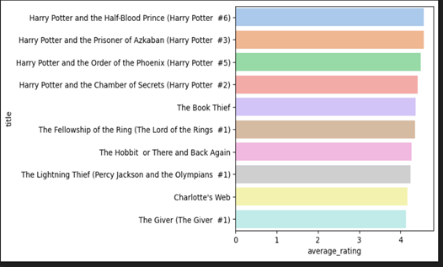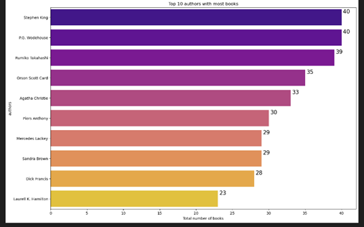

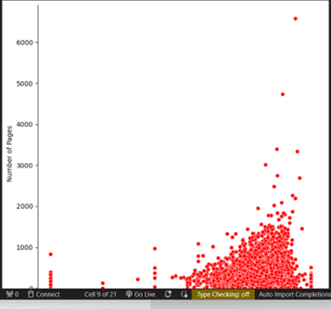

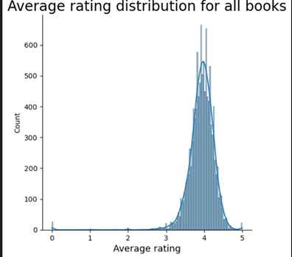

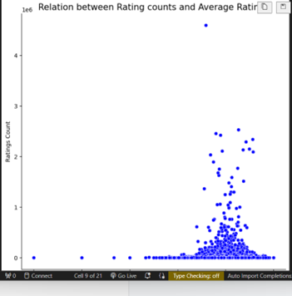

. 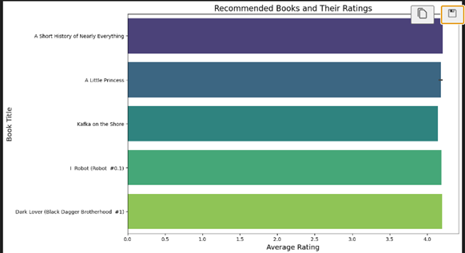



### References

1. Aggarwal, C. C. (2016). **Recommender Systems: The Textbook**. Springer.
2. Schafer, J. B., Frankowski, D., Herlocker, J., & Sen, S. (2007). **Collaborative Filtering Recommender Systems**. In The Adaptive Web (pp. 291-324). Springer.
3. Lops, P., De Gemmis, M., & Semeraro, G. (2011). **Content-based Recommender Systems: State of the Art and Trends**. In Recommender Systems Handbook (pp. 73-105). Springer.
4. Burke, R. (2002). **Hybrid Recommender Systems: Survey and Experiments**. User Modeling and User-Adapted Interaction, 12(4), 331-370.
5. Su, X., & Khoshgoftaar, T. M. (2009). **A Survey of Collaborative Filtering Techniques**. Advances in Artificial Intelligence, 2009.
6. Ricci, F., Rokach, L., & Shapira, B. (2011). **Introduction to Recommender Systems Handbook**. In Recommender Systems Handbook (pp. 1-35). Springer.