**CONTACTS**

[kthulasiraman@gmail.com](mailto:kthulasiraman@gmail.com)

+91 9952420141

No: 13, B, Shanthi Nagar, 2nd Street, Adambakkam, Chennai - 600088.

**SKILLS**

Azure DevOps ⬇⬇ ⬇⬇⬇  Docker/K8s ⬇ ⬇⬇⬇⬇  Database ⬇⬇⬇⬇⬇  Azure Infra ⬇⬇⬇⬇⬇ 

Windows ⬇⬇⬇⬇⬇ 

Linux ⬇⬇⬇⬇⬇ 

**CERTIFIED** 

**THULASIRAMAN K**

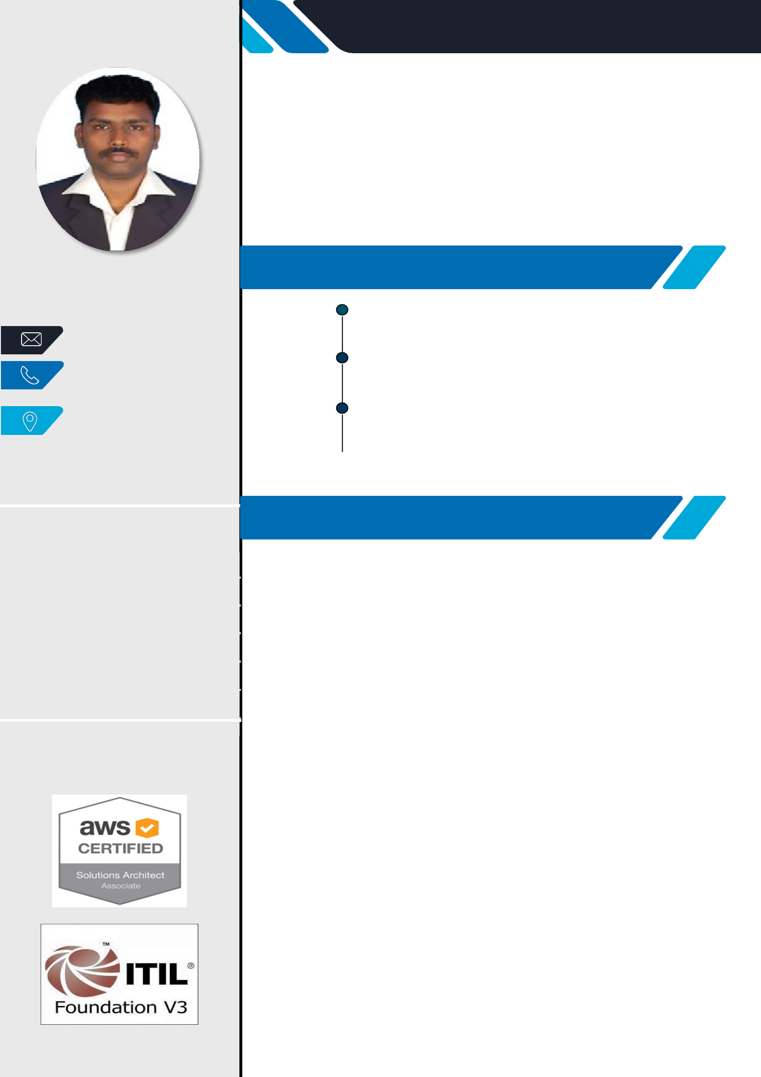

**AZURE DEVOPS ENGINEER**

Around **12+**years of experience in IT sector in Database administration, build engineering and release management process, building and deploying applications by adopting DevOps practices such as **Continuous development, Continuous Integration**

**(CI)** and **Continuous Deployment (CD)**in runtime with various tools like **Git, Github, Docker, Kubernetes** and managing cloud services with **Azure.**

**EDUCATION**

**2005–2008** **MASTERDEGREE(M.C.A**)

Annamalai university – Chidambaram.

**75 %**

**2001 – 2004** **B A C H E L O R D E G R E E (B.Sc. CS)**

St. Joseph’s college - Trichy.

**58.66 %**

|  |  |
| --- | --- |
| **2001** | **H S C** |

Government Higher Secondary School – Lalgudi.

**59.3 %**

**1999**  **SSLC**

Government Higher Secondary School – Lalgudi.

**72.3 %**

**TECHNICAL SKILLS**

**Azure Devops**

* Plan, design, implement, and maintain CI/CD solutions across all environments as applicable and defined by the business needs.
* Hands-on experience in setting up an Azure DevOps pipeline for a project (CI/CD) And Source Control systems such as GIT, Github, Azure DevOps/VSTS and TFS.
* Experience with static code analysis for codes quality and security using SonarQube and Checkmarx. Supports build and branching strategies in coordination with the development teams.

**Docker/**K**ubernetes**

* Experience in implementing containerized solution using Docker
* Experience in creating Kubernetes Cluster and configure deployments, ReplicaSets, Services and Pods.
* Experience on Microservice implementation and Autoscaling approach with Kubernetes. And Generate Kubernetes YAML configuration for Deployments
* Design and implement application environments on premises using Kubernetes infrastructure.
* Modify and maintain existing containerized applications and Kubernetes infrastructure.

**Azure Cloud**

* Having experience in Azure App Services, Azure Firewall, VNet Integrations, Application Gateways, Application Insights instrumentation, VM creation, VM Scale sets, Identity, Access, Authentication, AD integration, Azure SQL, Network, Storage, Security, Azure SQL & DR setup.

**Database (MSSQL, MySQL & PostgreSQL)**

* Hands on experience in Database Installation, Maintenance, Performance Tuning, HA/DR Planning & Implementation and Backup/Recovery Operations.
* Migrated SQL Servers from 2008/2012/2014 to 2017(standalone & cluster).
* Having experience in Azure Cloud Database model (IaaS & PaaS)

**CONFIGURATIONS**

* + **IIS**
* **GIT**
* **WEBSPHERE**
* **XAMPP**
* **SVN**
* **SHAREPOINT**
* **TFS**
* **JBOSS**

**DOMAIN KNOWLEDGE** 

* **ACTIVE DIRECTORY**
* **DNS**
* **DHCP**
* **USER AND GROUPS**

**MONITORING TOOLS**

* **NAGIOS**
* **SCOM**

**PROFESSIONAL EXPERIENCE**



**TCS –Assistant Consultant.**

1. **Jan - 2017 –Present  Project - T & I.**
   * Implementing CI/CD through Azure pipeline
   * Configure Git/Github and Provide access to the team.
   * Working knowledge on Git & GitHub to resolve merge conflicts
   * Involved in building out new environments for existing and new applications
   * Fix all deployment related issues raised by dev/testing team
   * Install Kubernetes Cluster and configure application using Docker images
   * Create a new Vnet and integrate with app services and SQL server.
   * Configure ports and enable security policy in azure portal.
   * Create and configure Azure vm, Vnet, storage, AD integration etc.,
   * Managing multiple instances of SQL server in prod/Dev/TST environment
   * Successfully Migrated 140+ SQL servers from 2008 to 2014
   * Implemented Always-ON (AAG) on SQL Server 2014.
   * Install security patches and hot fixes on all the servers as applicable.
   * Install and configure SSRS reports
   * Install and configure Mysql and Postgresql databases
   * Provide 24*7 production supports as well on call support

|  |  |
| --- | --- |
| **2** | **IBM** – **Technical Services Specialist.** |
|  | **Aug 2015– Jan 2017** |
|  | **Project -Schibsted, Oslo, Norway.** |

* MSSQL/MySQL and PostgreSQL Production environment (24x7) Support
* Configuring and maintained in SQL server’s (Backup, restore, maintenance plan, attach/detach, reporting services, trace and profiler).
* Installing, configuration and administration of high availability tools.
* Experienced in SQL Server performance tuning, monitoring and troubleshooting.
* Planning and implementing database Security by creating Logins, Users, Roles and assigning permissions according to the requirement.
* Configured log shipping and Replication for multiple databases.
* Analyze long running slow queries and tune the same to optimize application and system performance.
* Ensure the all the maintenance task and backup jobs are successfully executed as per schedule and if any job fails identify the reason and fix them
* Addressing issues related to high memory utilization, blocking, long running queries.
* Documenting procedures in runbooks.

|  |  |
| --- | --- |
|  | **CSC** – **Associate Professional System Administrator.** |
| **3** | **Feb 2014 – July 2015** |
|  | **Project –FSG, North America.** |

* Production Support for SQL server (2005 & 2008).
* Install and support SQL server (Backup, restore, maintenance plan, attach/detach, reporting services, mirroring).
* SQL Server performance monitoring and troubleshooting
* Web Server Administration/Application support in IIS / Apache.
* Experience working in daily and monthly production cycles.
* Deploy .war, .ear, .zip files in websphere application server.

**SRINSOFT TECHNOLOGIES** – **Sr.System Administrator.**

1. **Mar 2011 – Feb 2014**

**3**

* Installing windows server 2008 and configure domain controller. 
* Installing ADS, Configure user & groups, planning and implementing

group policies in Active directory, Implementing, administering and troubleshooting in Windows 2003 & 2008 Servers. 

* SQL Server 2005-2008 installation, creating, backup and restore databases. 
* Application support for IIS, PHP, SQL server 2008, MySQL. 
* Installed, Configured and Setup SharePoint server 2010. 
* Supported end-user with application related issue which include IIS, Sql server. 
* Installing and configure Symantec Endpoint production manager 12.1.1

server applies policies to all users to install and update Symantec client production. 

* Purchase a new software license and maintain software and hardware  inventory, stock, and store electronic components.

**5** **DCPL SOFTWARE (P) LTD** – **Sr.System Administrator.**

**Dec 2008 – Feb 2011**

* Server configuration and maintains both IBM and DELL. 
* Creating and Administering Microsoft Windows Servers Active

Directory, Users, groups and deploying account and security policies Workstations, and network security devices for 80 users. 

* Handling vpnZyxel firewall (zywall 35) and WI-Fi (820.11g) routers. 
* Configuring, and maintaining databases (SQL, mysql, and Oracle). Backup on Mysql 2005 using maintenance plan. 
* Create a new virtual directory in IIS and configure application and  database for a new web application.

**PROFESSIONAL EXPERIENCE - NON IT**

1. Susee group of companies From Nov 2007 to Nov 2008 as a System administrator.
2. Apollo Group of Education, From Feb 2006 to Oct 2007 as a System Administrator.
3. Akshara Computers Pvt. Ltd, From Aug 2004 to Jan 2006 as a Services Engineer.

**ACCOMPLISHMENT**

* Served as a NSS volunteer in my Under Graduation.
* Worked as a member of “Nature Club” in my Under Graduation.

**DECLARATION**

Opportunity to work in your esteemed concern, I assure You, I will work sincerely to your full satisfaction. I hereby declare that the above information is true and correct to my knowledge. If I am given an

Date:

Place: (K.Thulasiraman)