Customer Churn Analysis – PostgreSQL

🔹 Overall Churn
1. What is the overall customer churn rate?
- How many total customers do we have?
- How many have churned?
- What percentage of customers have churned?
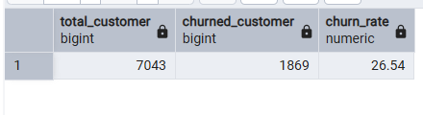

🔹 Contract Type Analysis
2. How does churn rate vary by contract type?
- Which contract types (e.g., monthly, yearly) have the highest churn?
- Are long-term contracts more effective at retaining customers?
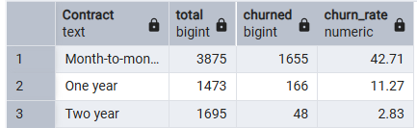

🔹 Tenure Insights
3. What is the average tenure of churned vs. retained customers?
- Do customers with shorter tenure churn more frequently?
- Is there a clear loyalty pattern based on tenure?
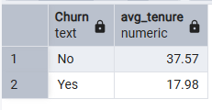

🔹 Internet Service Impact
4. How does churn differ across different internet service types?
- Which internet service category has the highest churn rate?
- Are certain services associated with higher dissatisfaction?
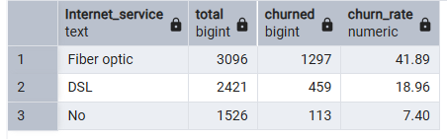

🔹 Pricing Influence
5. How do monthly charges differ between churned and non-churned customers?
- Are higher monthly charges linked to increased churn?
- Is pricing a key driver of customer attrition?
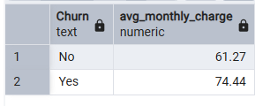

🔹 Payment Behavior
6. How does churn vary by payment method?
- Which payment methods are associated with higher churn?
- Do automatic payment methods reduce churn?
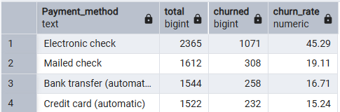

🔹 Support Services
7. What is the impact of tech support availability on churn?
- Do customers without tech support churn more?
- How significant is customer support in retention?
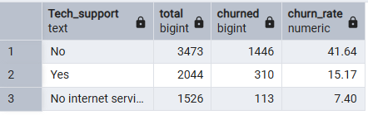

🔹 Demographics
8. Does churn differ between senior citizens and non-senior customers?
- Are senior citizens more likely to churn?
- Should retention strategies differ by age group?
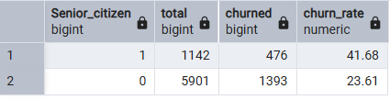

🔹 High-Value Customer Loss
9. Who are the top churned customers by total charges?
- Are high-value customers leaving?
- What is the revenue impact of these churned customers?
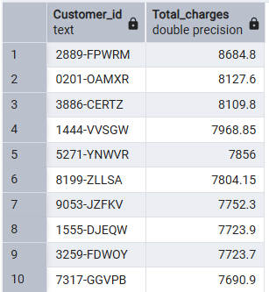

🔹 Multi-Factor Analysis
10. How does churn vary when combining contract type and internet service?
- Which combination of contract and service has the highest churn?
- Are there specific customer segments at higher risk?
