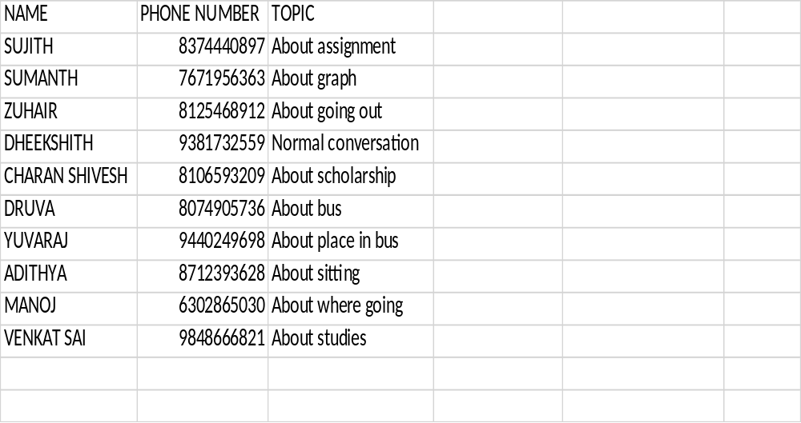
From above table we can see list of names and their phone numbers and the topic of conversation happened in between me and them individually.

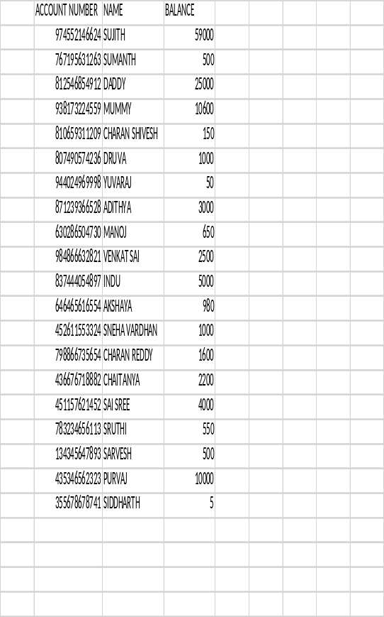
From above we can see acctount numbers of 20 members and their account balance.

