RESEARCH AND DEVELOPMENT (REAL TIME)
VITISTED GARDEN DELIGHTS FAMILY RESTAURANT (FOR TEA)

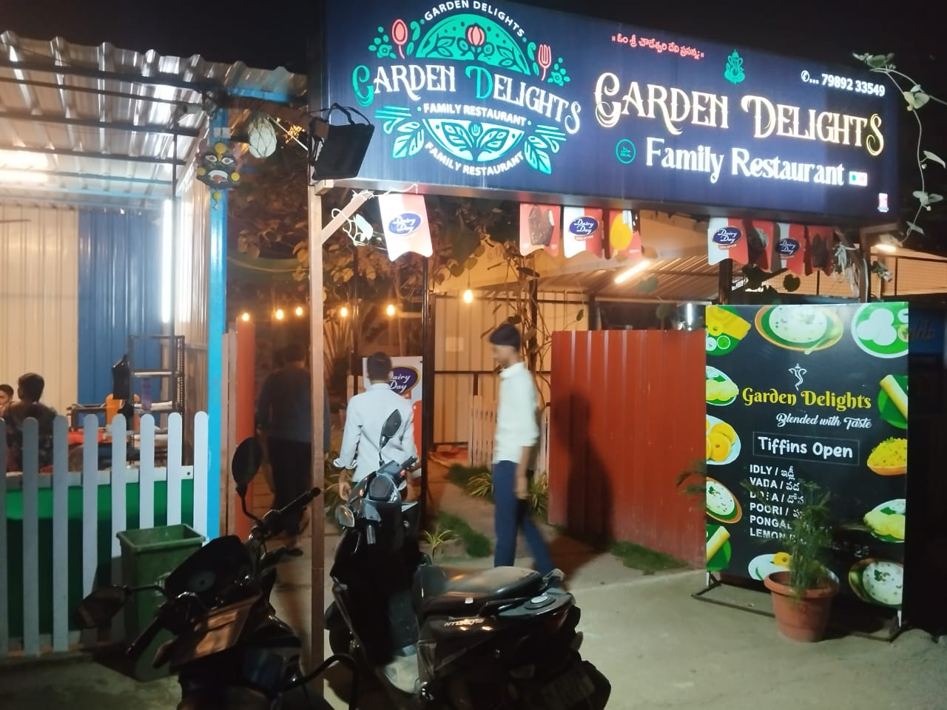
Step 1 :- We visited to Garden Delights Family Restaurant located at Reddy’s colony.
Step 2 :- In entrance there is a lighting board with restaurant name.
-> In the above pic, we can observe restaurant name with logo and top right of the board there a phone number and in middle there is a small picture of god and left to that there is a sentence in Telugu
-> In that we can observe the name of the restaurant "Garden Delights Family Restaurant", there are group of letters or characters in the board.
-> We can compare the name of the restaurant "Garden Delights Family Restaurant", with strings data type in python.
-> We can also observe the phone number in the top right of the board,(7989233549).
-> In phone number all are numbers or integers, which is related to numeric data type.
-> In numeric data type, there are three types 1. Integers 2. Float 3. Complex, the above number is comparable with the integers data type in python.
Strings :- Strings in python are surrounded by either single quotation marks, or double quotation marks.
Integer :- Int, or integer, is a whole number, positive or negative, without decimals, of unlimited length.

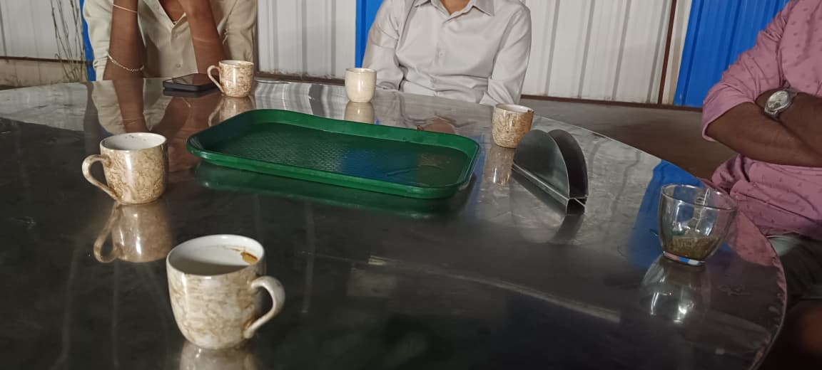
Step 3 :- There are six cups , one tray and tissue holder on the table.
-> In the above pic, we can observe there are six cups, one tray and tissue holder on the table.
-> In above pic, in the six cups the five cups are same and one is different.
-> When we compare that scenario according to python we can treat the cups, tissue holder and tray as elements. There are on the bench, we take that bench as variable.
-> We can observe that some elements are same then there are duplicate elements.
-> By observing all the elements then we can say that bench and the cups, tray and tissue holder on it, can be compared with list data type in python.
-> In list data type it allows duplicate values and list is mutable. We can keep the elements on the bench or if we want to remove the elements we can remove.
-> From above pic, the scenario is comparable to the list data type in python.
List :- Lists are used to store multiple items in a single variable.
Step 4 :- There are seven flower pots hanging to the steel rod.
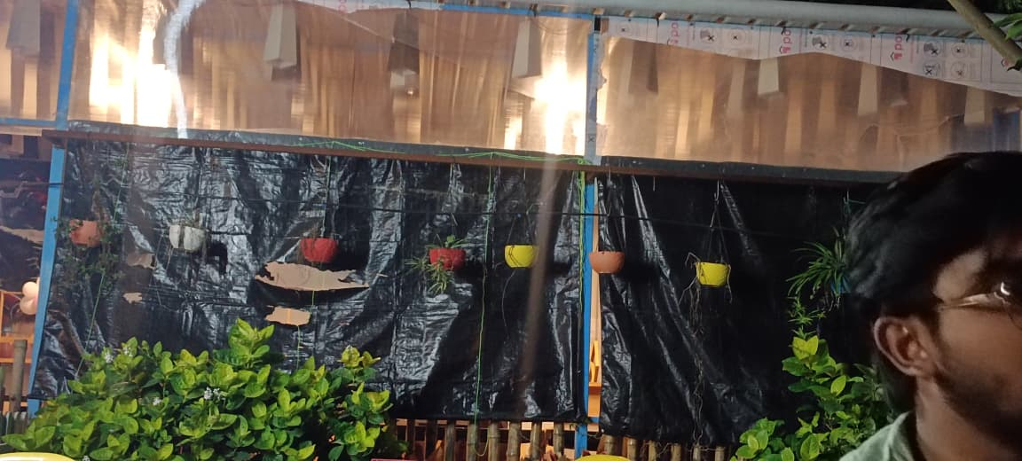
-> In above pic, we can observe the flower pots hanging in order, in those seven flower pots some are same and some are different.
-> We can compare this with tuple data type in python, then we can treat the flower pots like elements, and we can take that steel rod as variable.
-> We can observe that same colour of flower pots are there then we can say that duplicate elements are there.
-> We can also say that we cannot modify the flower pots because if the flower pot hanging were fell down and broken then we cannot modify the flower pot, if we modify also it will not look nice so we go for replace only.
-> From above all are related to the tuple data type in python, which contains duplicate elements, no modification.
Tuple:- Tuples are used to store multiple items in a single variable.
Step 5 :-

