RESEARCH ON VEGTABLE MARKET

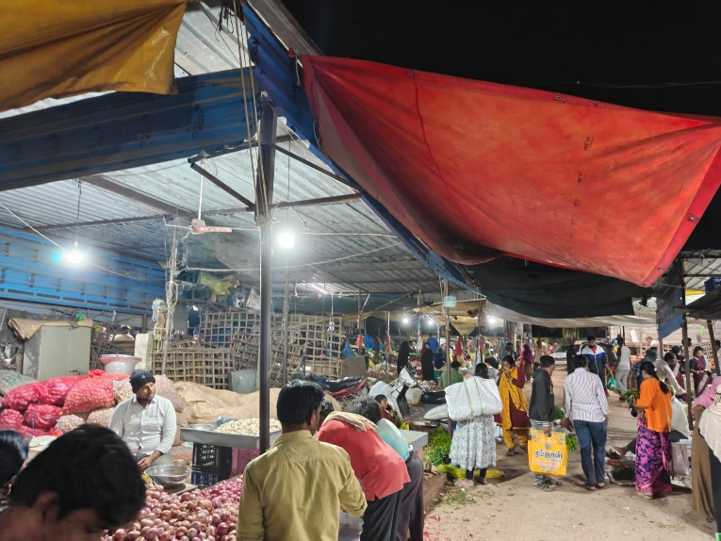
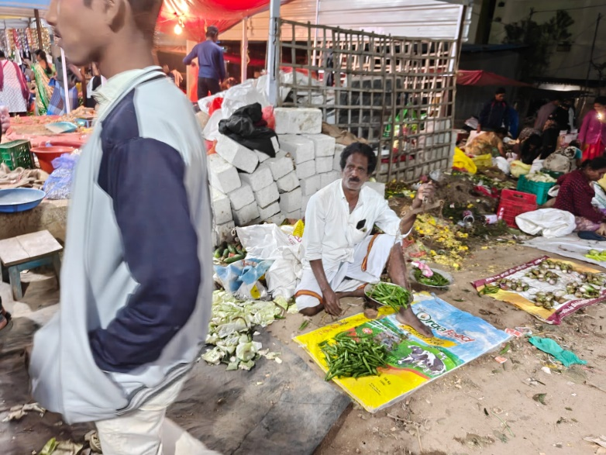
- We can observe that coustomers are buying the vegtables based on the quality and price. For example, onions price for 1kg is ₹100, and onions price for 1/2(Half)kg is 50. Here we can see the arithmetic operators, like division, multiplication, addition , etc.,

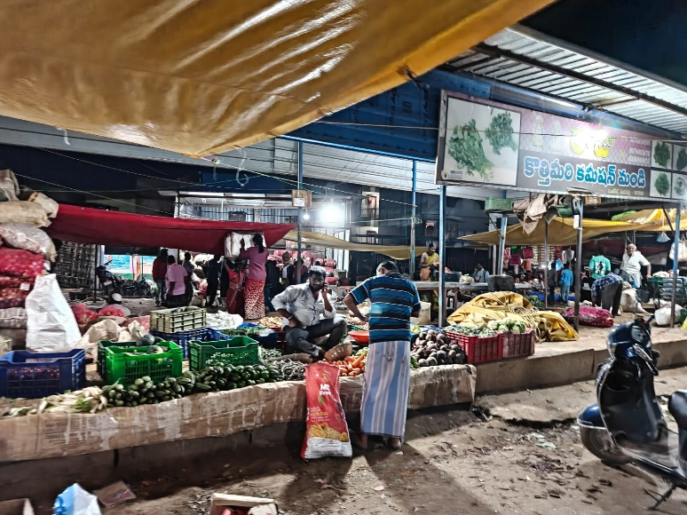
      - Here we can see that the seller comparing the weight of the vegtables with the mass, here we can see comparision operators like greater than, less than, not equal to , equal to , etc.,

- Here we can see the assignment operators, Ex : If the carrot price is ₹50 for 1/2(half) and for brinjal the price is 20 for 1/4kg, etc.,. And in that one person is bargaining to the shopkeeper.
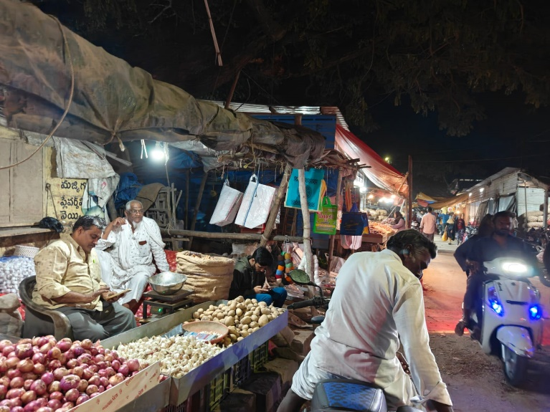

- Here we can see that there are no coustomers and the shopkeeper is seeing mobile.
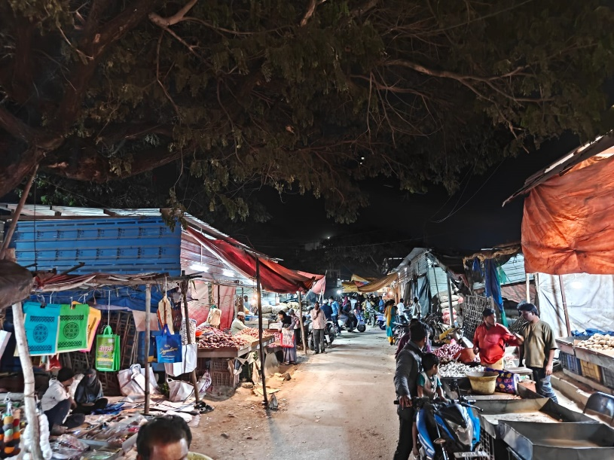

            - Here we Can see that coustomers are buying what they want and some are bargaining at the price and all are seeing the vegtables with good quality and low price.
            - There are comparing the price and quality in two or more shops and buying the things.

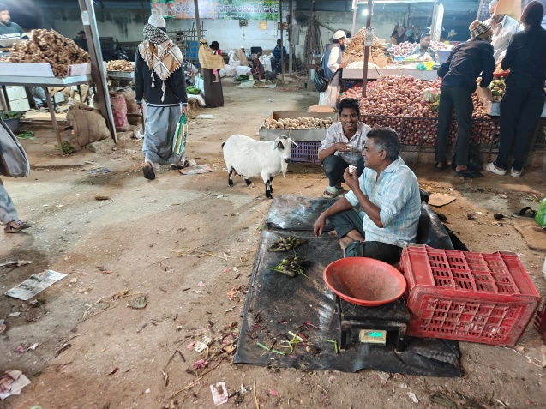
- Here we can see that the shopkeeper sold almost all the vegetables and some are only left.

