Database Design Project

Phase 1 – Enhanced Entity Relationship (EER) Diagram

Gary Steelman | [gxs112030@utdallas.edu](mailto:gxs112030@utdallas.edu)

Contents

Introduction 2

Assumptions, Limitations, and Explanations 2

Assumptions 2

Limitations 2

Explanations 3

Superclass and Subclass Relationships 3

Union Relationships 3

Enhanced Entity Relationship (EER) Diagram 4

(min, max) Elaboration for Relationships 5

Conclusion 5

Summary 5

Future Work 5

# Introduction

This report comprises four main sections:

1. Assumptions and Limitations – In this section I describe assumptions about the system and limitations imposed by the real world or the customer.
2. The EER Diagram – In this section I show the EER diagram representing the system.
3. (min, Max) Elaboration – In this section I elaborate on the quantitative constraints on relationships in the EER diagram.
4. Conclusion – In this section I summarize the report.

# Assumptions, Limitations, and Explanations

## Assumptions

Listed here are assumptions reasonably inferred from the customer’s stated requirements that were not clearly implied:

* Not all resources the library has are books, videos, magazines, or papers. The customer specifications state “most resources” are of the aforementioned types, but do not explicitly state all. For example: there may be software or electronic hardware cameras available.
* Videos may not have more than one format. For example: a specific documentary may be available on both DVD and Blu-Ray formats, but each item will be borrowed individually and should be entered into the system as different resources.
* An author may have more than one contact phone number. For example: an author may have a cell and work phone number.
* Not all persons involved with library operations are employees, readers, guests, or volunteers. The customer specifications state “most people” are of the aforementioned types, but do not explicitly state all. For example: there may be a director person who does not actively work for the specific library, but a system of libraries.
* A resource may only be of one format at a time. For example: a book may not also be a video.
* A person may hold any combination of titles. For example: an employee may also be a reader.

## Limitations

Listed here are limitations imposed directly by the real world or the customer:

* An employee may borrow and reserve library resources exactly the same as a reader, guest, or volunteer. An employee not being able to makes little to no sense.

## Explanations

### Superclass and Subclass Relationships

In this diagram I have used two superclass/subclass relationship types to simplify the diagram and reduce attribute redundancy. For example, an EMPLOYEE, VOLUNTEER, and READER are all more specific kinds of PERSONs.

* RESOURCE entity and its subclasses
  + I used an entity called RESOURCE to represent any resource the library has available to borrow or reserve.
  + I used a *distinct* subclass relationship between the RESOURCE entity and the BOOK, VIDEO, and MAG_PAP entities because resource types logically will not overlap. A BOOK will not also be a VIDEO (a BOOK adaptation to a VIDEO is not the same).
  + I used a *single line* relationship for the RESOURCE entity to its subclasses. See Assumptions for an explanation.
* CONTRIBUTOR entity and its subclasses
  + I used an entity called PERSON to represent any individual who contributes something to or uses something in a library.
  + I used an *overlapping* subclass relationship between the PERSON entity and the EMPLOYEE, READER, and VOLUNTEER entities because the requirements state that an EMPLOYEE may also be a VOLUNTEER.
  + I used a *single line* relationship for the CONTRIBUTOR entity to its subclasses. See Assumptions about the CONTRIBUTOR entity for an explanation.

### Union Relationships

In this diagram I have used three union relationship types to simplify the diagram and reduce relationship redundancy. For example, an EMPLOYEE and a VOLUNTEER may both host an EVENT, so instead of having two HOSTS_EMPLOYEE and HOSTS_VOLUNTEER relations I created a union type called HOST which HOSTS an EVENT.

* HOST entity and its union
  + I used an entity called HOST to represent any EMPLOYEE or VOLUNTEER who hosts an EVENT.
* ATTENDEE entity and its union
  + I used an entity called ATTENDEE to represent any READER or GUEST (of a reader) who attends an EVENT.
* BORROWER entity and its union
  + I used an entity called BORROWER to represent any READER or GUEST (of a reader) who can borrow OR reserve a library resource.

# Enhanced Entity Relationship (EER) Diagram

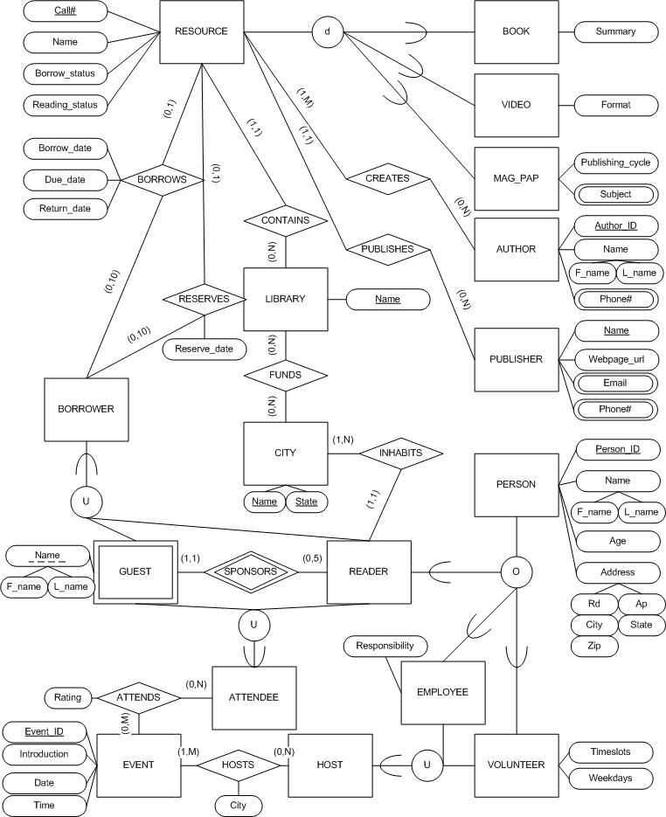

# (min, max) Elaboration for Relationships

|  |  |
| --- | --- |
| **EER Component / Numerical Expression** | **Elaboration** |
| AUTHOR (0,N) CREATES (1,M) RESOURCE | An AUTHOR may have created 0 or more RESOURCEs and a RESOURCE must have 1 or more AUTHORs. |
| PUBLISHER (0,N) PUBLISHES (1,1) RESOURCE | A PUBLISHER may have published 0 or more RESOURCEs and a RESOURCE must have been published by exactly one PUBLISHER. |
| LIBRARY (0,N) CONTAINS (1,1) RESOURCE | A LIBRARY CONTAINs 0 or more resources for use and a RESOURCE is CONTAINed by exactly one library. |
| CITY (0,N) FUNDS (0,N) LIBRARY | A CITY FUNDs 0 or more libraries (with tax money) and a LIBRARY is FUNDed by 0 or more CITYs. |
| BORROWER (0,10) BORROWS (0,1) RESOURCE | A BORROWER BORROWS 0 to 10 RESOURCEs and a RESOURCE is BORROWed by at most one BORROWER at a time. |
| BORROWER (0,10) RESERVES (0,1) RESOURCE | A BORROWER RESERVES 0 to 10 RESOURCEs and a RESOURCE is RESERVEd by at most one BORROWER at a time. |
| READER (1,1) INHABITS (1,N) CITY | A READER INHABITS exactly one city and a CITY is INHABITed by 1 or more READER. |
| READER (0,5) SPONSORS (1,1) GUEST | A READER SPONSORS 0 to 5 guests and a GUEST is SPONSORed by exactly one READER. |
| HOST (0,N) HOSTS (1,M) EVENT | A HOST HOSTS 0 or more EVENTs and an EVENT is HOSTed by at least one HOST. |
| ATTENDEE (0,N) ATTENDS (0,M) EVENT | An ATTENDEE ATTENDS 0 or more EVENTs and an EVENT is ATTENDed by 0 or more ATTENDEEs. |

# Conclusion

## Summary

In this report I discussed the assumptions inferred from the customer’s non-explicitly stated requirements. Then I showed and discussed the Enhanced Entity Relationship (EER) diagram derived from the customer’s stated requirements for the ABC Library system.

## Future Work

This report analyzed the conceptual model of the ABC Library database system. The next step is to derive an implementation and physical model. The EER diagram presented will likely change as requirements change or practical implementation details are realized. For further questions contact me at the email address on the title page.