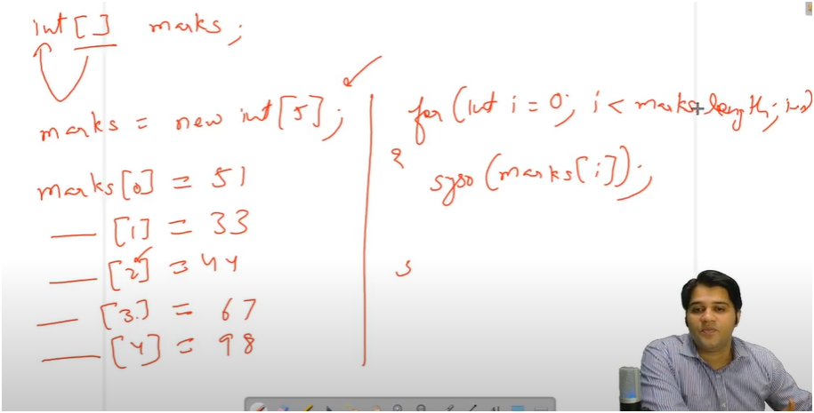

**An array is a collection of elements of the same data type stored in contiguous memory locations. It helps avoid the need to create separate variables for each value.**

* **FIRST DECLARE ARRAY**
  + int [] arr
* **THEN ALLOCATE SPACE FOR ARRAY**
  + arr=new int[space]
* **ASSIGN VALUE TO EACH SPACE**
  + arr[location]=value
* AND THEN USED FOR LOOP TO PRINT VALUE ON EACH SPACE
  + Print(arr[location])

**📌 Important Points to Remember**

* Array indexing starts from **0** (i.e., arr[0] is the first element).
* The size of the array is **fixed** after initialization.
* You can access the number of elements using arr.length.
* Arrays can store **primitive types** (like int, double) or **objects** (like String, Scanner).