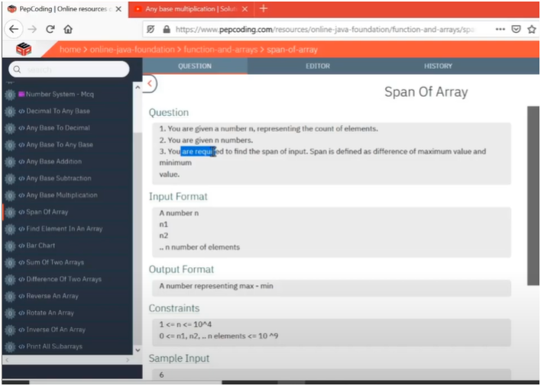

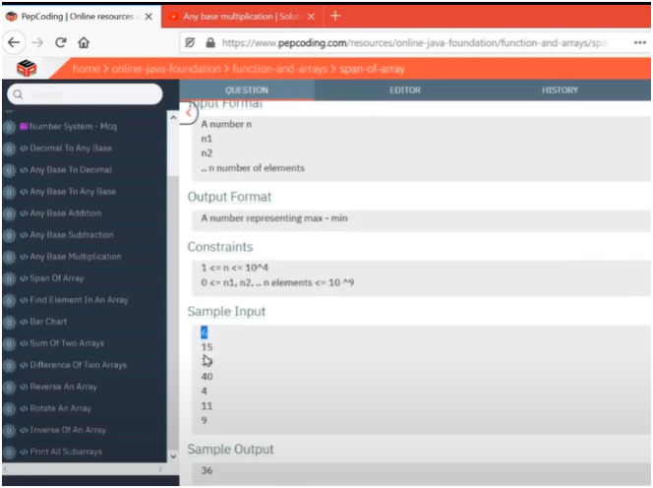

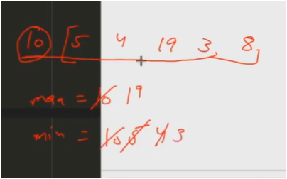

**UNDERSTANDING:-**

**IF WE OBSERVED CAREFULLY THERE IS PATTERN OF COMPARING EACH ELEMENT WITH MAX AND MIN THEN FIND THE DIFFERENCE OF THEM TO FIND SPAN**

* **FIRST DECLARE ARRAY AND ALLOCATE SPACES FOR IT**
* **THEN INSERT ELEMENTS IN EACH SPACE LOCATION**
* **THEN MAKE USE OF FOR LOOP FOR COMPARING EACH ELEMENT WITH MAX AND MIN**
* **HERE WE INTIALIZE MAX AND MIN TO STARTING ELEMENT**
  + **THEN COMPARE** 
    - **IF OTHER ELEMENT IS GREATER THAN MAX THEN UPDATE MAX**
    - **IF OTHER ELEMENT IS SMALLER THAN MIN THEN UPDATE MIN**
* **THEN FIND THE SPAN BY FINDING THE DIFFERNCE OF MA AND MIN**

**ALGORITHM**

**🧾 Step-by-Step Logic**

1. **Declare and Allocate Array**

**int[] arr = new int[size];**

1. **Input Elements into the Array**

**for (int i = 0; i < arr.length; i++) {**

**arr[i] = input.nextInt();**

**}**

1. **Initialize max and min with First Element**

**int max = arr[0];**

**int min = arr[0];**

1. **Loop through Array to Find Max and Min**

**for (int i = 1; i < arr.length; i++) {**

**if (arr[i] > max) {**

**max = arr[i];**

**}**

**if (arr[i] < min) {**

**min = arr[i];**

**}**

**}**

1. **Calculate and Print Span**

**int span = max - min;**

**System.out.println("Span: " + span);**