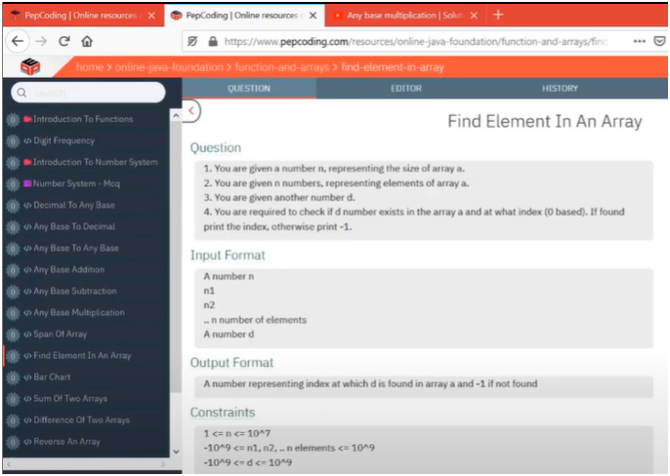

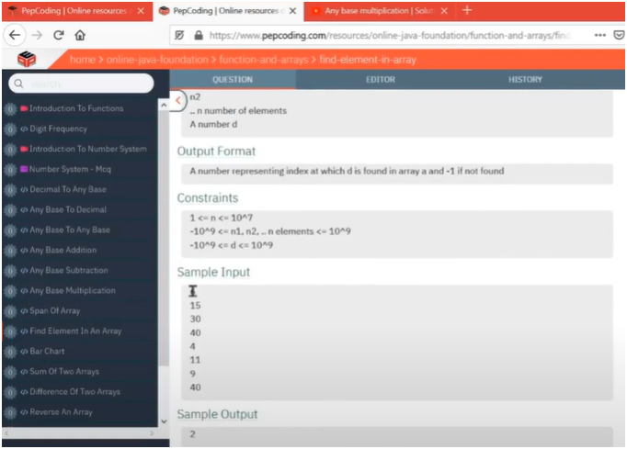

**UNDERSTANDING:-**

**IF WE OBSERVED CAREFULLY THERE IS A PATTERN WHERE WE COMPARE EACH ELEMENT TO FIND THE INDEX OF INPUT DATA THAT NEED TO BE SEARCHED**

**🔁 Process Breakdown:**

1. **Declare and create an array** using user-provided size.
2. **Fill each index** of the array with user input.
3. **Take the value (data) to search** for.
4. **Linear search logic**:
   * Start from the beginning of the array.
   * Compare each element with data.
   * If a match is found:
     + Save the index.
     + Break out of the loop (since only the first occurrence is needed).
   * If not found by the end of the loop, return -1.
5. **Print the index** where the data is found, or -1 if not found.