SUM OF TWO ARRAYS

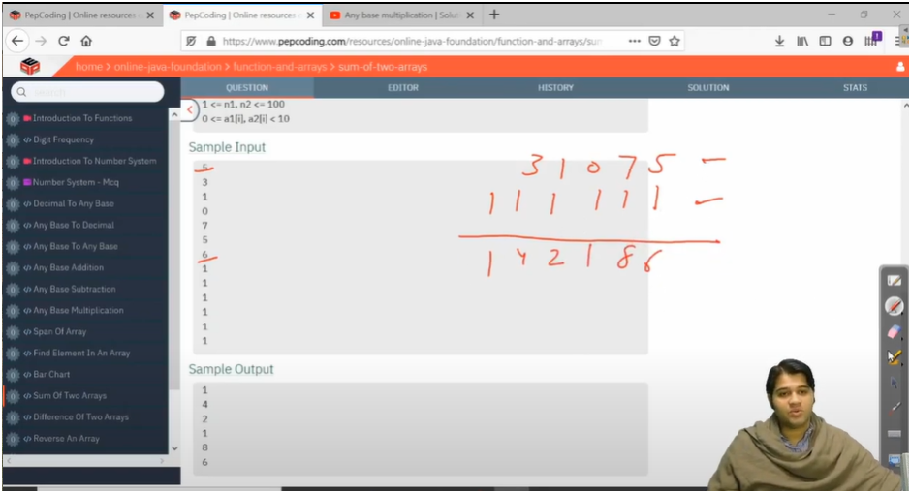

PATTERN IS ABOUT ADDING EACH ELEMENT OF TWO ARRAY ALONG WITH CARRY

* **FIRST THING GET TWO ARRAYS VALUES**
* **THEN DEFINE THE SIZE OF SUM ARRAY**
  + **THE SIZE OF SUM ARRAY DEPENDS UPON MOSTLY ON BOTH ARRAY SIZE**
    - **ONE WITH BIGGER ARRAY SIZE IS TAKEN INTO CONSIDERATION FOR SUM ARRAY SIZE**
* **THEN INTIALIZE i,j,k**
  + **BASICALLY i,j POINT TO THE LAST POSITION ELEMENT OF BOTH ARRAYS**
  + **AND k REFERS TO THE LAST POSITION ELEMENT OF SUM ARRAY**
* **NOW RUN THE WHILE LOOP UNTIL SUM ARRAY DOESN’T GET EMPTY**
* **NOW FIRST INTIALIZE CARRY TO ZERO**
  + **IF U SEE PROPERLY CARRY IS ADDED WITH ELEMENT ON POS i AND ELEMENT ON POS j**
    - **NOW START ADDING CARRY TO Ith ELEMENT AND STORE IT IN VARIABLE**
    - **THEN ADD THAT VARIABLE TO jth ELEMENT AND PROCESS GO ON**
* **BUT NOW HOW BASICALLY ADDITON HAPPENS AND HOW CARRY IS CALCULATED**
  + **IF 8+6=14 THEN CARRY IS CALCULATED BY 14/10=1 AND RESULT IS CALCULATED BY 14%10=4**
* **THEN STORE THE RESULT IN SUM ARRAY**
* **THEN JUST DECREMENT i,j,k TO MOVE FROM LAST_POS TO FIRST_POS**
* **BUT ONCE U REACHED FROM END TO START THERE CAN BE CHANCES THAT CARRY CONTAIN VALUES THEN APPLY CHECK AND PRINT SPACE AND VALUE PRESENT IN SUM ARRAY**