BASED ON THE INPUT GIVEN DESIGN EACH BAR

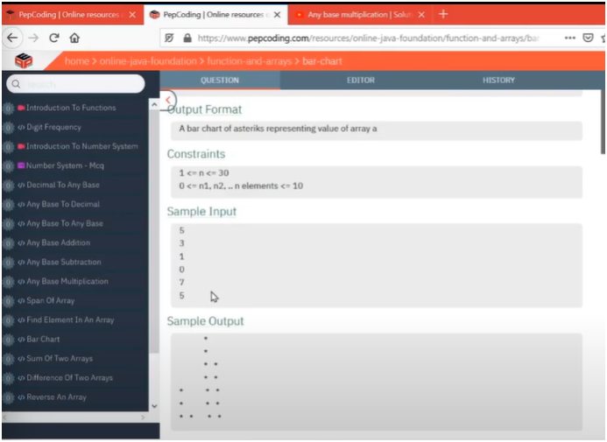

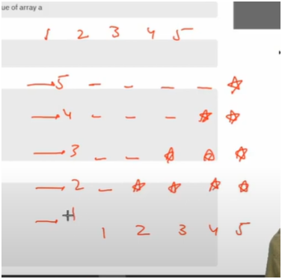

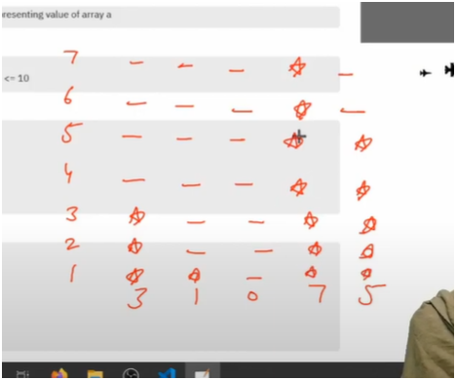

FLOORS() VS BUILDING HEIGHT

MEANS FIRST BUILDING:-3 HAS THREE FLOORS AND AFTERWARDS ALL SPACES

MEANS SECOND BUILDING:-1 HAS ONE FLOORS AND AFTERWARDS ALL SPACES AND SO ON

**SIMPLE TRIP :-**

* + GET THE MAX HEIGHT OF BUILDING THEN RUN THE LOOP FROM MAX HEIGHT TO 1
  + THIS RESULT INTO ALL HEIGHTS BETWEEN MAX HEIGHT TO 1
  + THEN COMPARE EACH HEIGHT WITH EACH BUILDING HEIGHT
    - IF CURRENT BUILDING HEIGHT IS GREATER THAN CURRENT HEIGHT
      * THEN PRINT STAR
    - OTHER WISE
      * THEN PRINT SPACES

**EG:-**

* MAX HEIGHT IS 3 AND BUILDING HEIGHTS ARE 0 1 2
* THEN COMPARE HEIGHT 3 WITH 0 1 2
  + NO CURENT BUILDING HEIGHT IS GRATER THAN HEIGHT 3 THEN PRINT SPACES
* COMPARE HEIGHT 2 WITH 0 1 2
  + THERE ARE BUILDING 2 WHICH IS EQL TO HEIGHT 2 THEN PRINT STAR
  + AND FOR 0,1 PRINT SPACES
* COMPARE HEIGHT 1 WITH 0 1 2
  + THUS BUILDING 1,2 IS GREATER THAN 2 AS WELL AS EQUAL TO THEREFORE PRINT STAR
  + AND FOR 0 PRINT SPACES