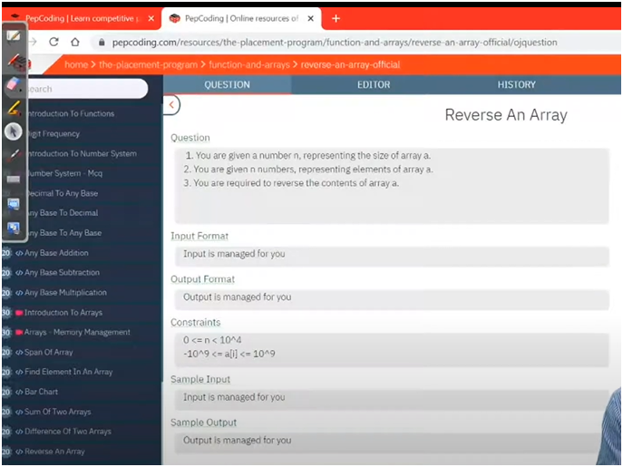

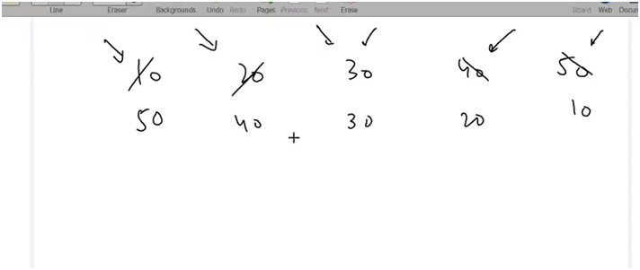

**🔍 Understanding the Logic**

* **We use two pointers:**
  + **i starts from the first index (0)**
  + **j starts from the last index (n - 1)**
* **We swap the elements at positions i and j.**
* **After each swap:**
  + **Increment i**
  + **Decrement j**
* **Repeat this until the pointers meet or cross, i.e., while i < j**

**💡 Memory Trick:**

“Start from ends, swap, and shrink the gap!”