NPR FACTORIAL

FORMULA:- nCr = n! / (r! * (n-r)!),

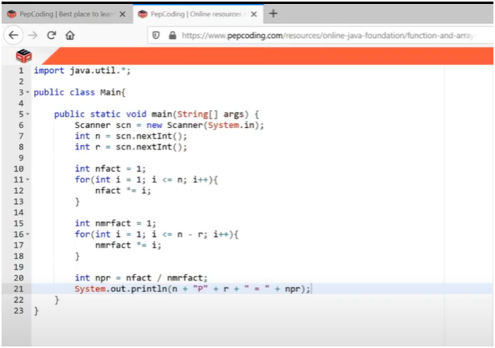

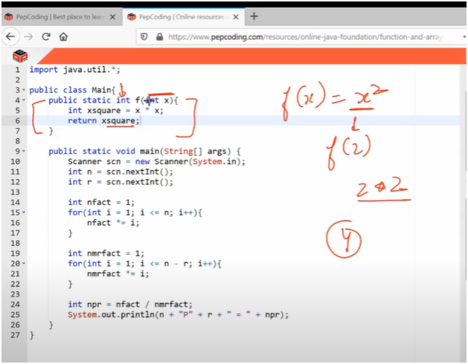

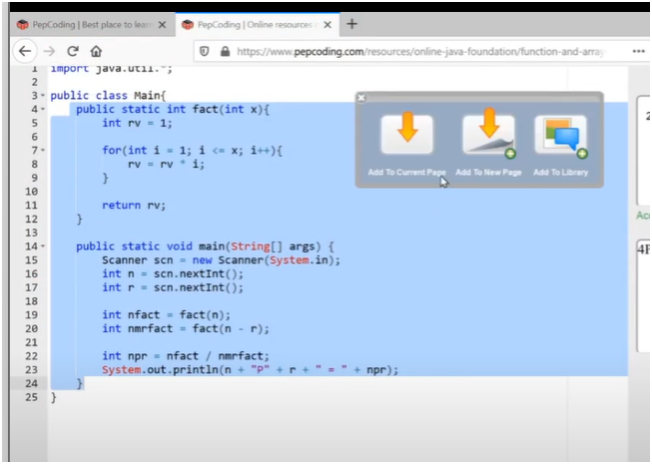

**UNDERSTANDING:-**

**📘 Functions in Java**

**🔄 What is a Function?**

A **function** is a block of code that performs a specific task and is executed only when it is called.

**🔥 Key Concept:**

* **Scope Limited:**  
  Variables declared inside a function **vanish** (are destroyed) once the function finishes execution. They **can’t be reused** outside that function.

**✅ Advantages of Using Functions:**

**1. Modularity**

* Breaks down large code into **small, manageable pieces**.
* Each function performs a **specific task**.
* Makes the code **structured and organized**.

**2. Maintainability**

* Easy to **read, understand, and debug**.
* You can **reuse** functions without rewriting code.

**3. Memory Optimization**

* **Local variables** are created and destroyed with the function.
* Only **essential data** is in memory, reducing memory usage.