To count how many times a specific digit occurs in a given number.

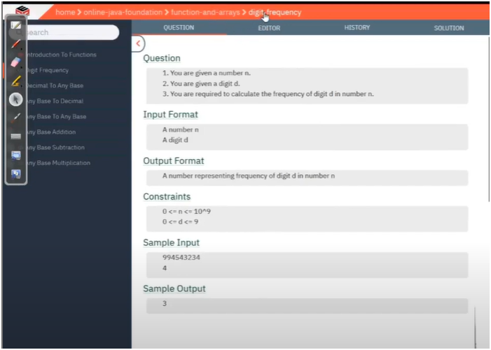

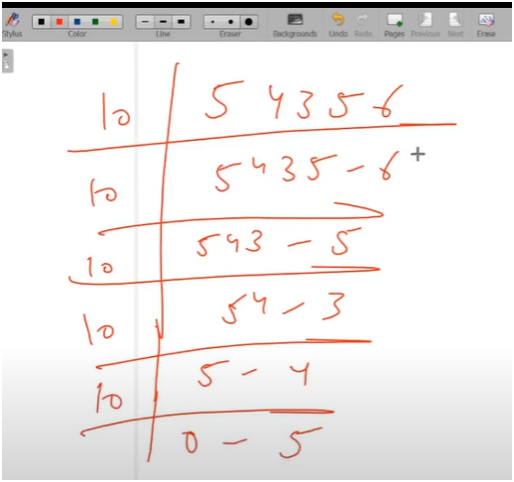

**UNDERSTANDING**

* **IF WE OBSERVED CAREFULLY THERE IS A QUOTIENT REMAINDER PATTERN TO COUNT THE DIIGTS**
* **FIRST WRITE A WHILE LOOP WHICH RUNS UNTIL QUOTIENT DOESN’T GETS EQUAL TO ZERO**
  + **IN WHILE LOOP WE CONTINUOUS MODULUS THE NUMBER BY 10 TO GET THE LAST DIGIT**
  + **AND THEN WRITE A CHECK LOOP TO COMPARE THE LAST DIGIT WITH INPUT DIGIT**
  + **IF IT IS SAME THEN INCREMENT THE COUNTER BY 1 OR ELSE NOT**
* **AND THEN PRINT THE COUNTER VALUE**

**🪜 Step-by-Step Algorithm:**

1. **Initialize a counter** to 0.
2. **Run a while loop** until the number becomes 0:
   * Extract the **last digit** using remainder = number % 10.
   * **Compare** this digit with the target digit.
     + If it matches, **increment the counter**.
   * **Remove the last digit** using number = number / 10.
3. **Print the counter** after the loop ends.