CONVERT ANY BASE NUMBER TO ANY BASE NUMBER

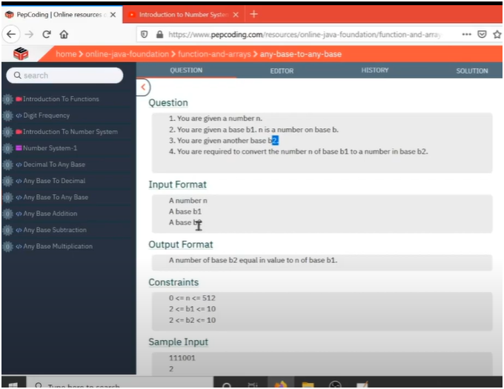

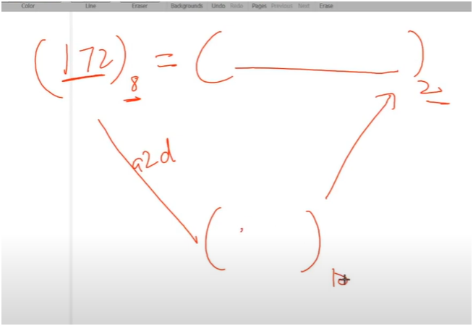

* **If we observed carefully this question is a combination of two previous questions that is**
* **FIRST convert any base number to decimal base**
  + **CONTINUOUS DIVIDE AND MODULUS BY 10 AND MULTIPLY THE REAMINDER BY INCREASING POWEROF BASE1**
* **SECOND convert decimal base number to any base**
  + **CONTINUOUS DIVIDE AND MODULUS BY RESULT BASE AND THEN MULTIPLY THE REAMINDER BY INCREASING POWER OF 10**
* **Then print the result**

Algorithm:-

**🧾 Function 1: base_to_decimal(int number, int base1)**

**✅ Converts Base1 → Decimal**

**🔁 Logic:**

* Initialize power = 1 and sum = 0
* While number ≠ 0:
  + Get last digit: dig = number % 10
  + Remove digit: number = number / 10
  + Multiply: sum += dig * power
  + Update: power *= base1
* Return sum

**📌 Example:**

num = 1172 (base 8)  
→ 2×8^0 + 7×8^1 + 1×8^2 + 1×8^3 = 634

**🧾 Function 2: decimal_to_base(int number, int base2)**

**✅ Converts Decimal → Base2**

**🔁 Logic:**

* Initialize power = 1 and sum = 0
* While number ≠ 0:
  + Get remainder: dig = number % base2
  + Reduce number: number = number / base2
  + Accumulate: sum += dig * power
  + Update: power *= 10 (for building result like 1010 for binary)
* Return sum

**📌 Example:**

634 (decimal) → 634 / 2 → remainder pattern = 1001111010