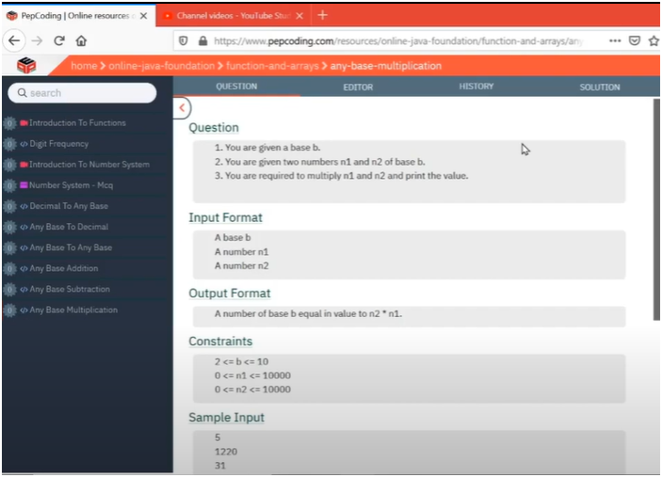

QUOTIENT ON TOP AND REMAINDER PRINT

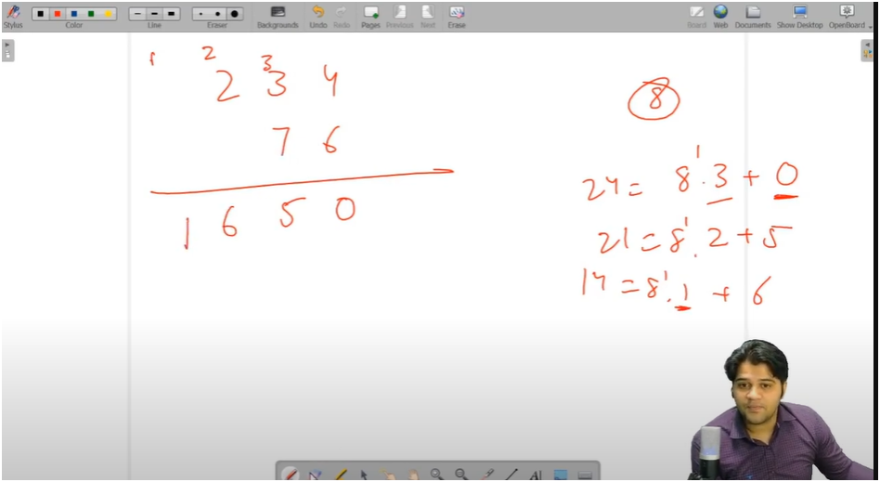

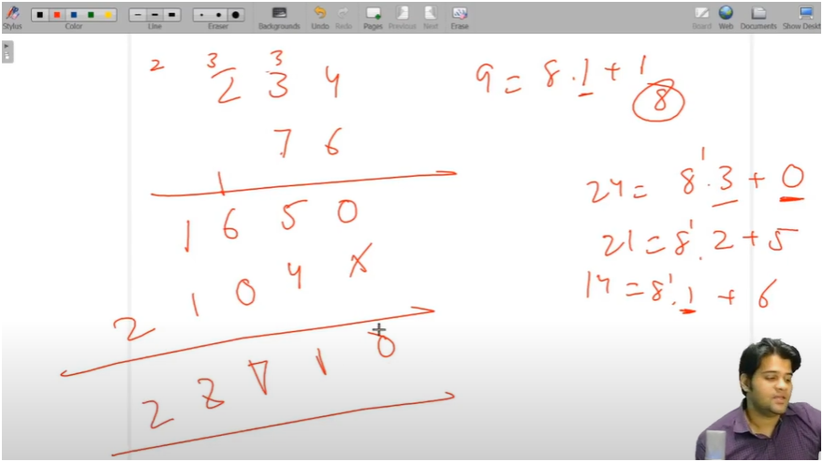

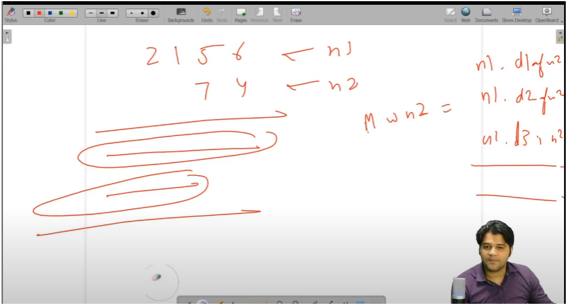

* IF WE OBSERVEED CAREFULLY IT IS A QUESTION OF BASE MULTIPLICATION AND IT CONTAINS TWO PATTERNS
  + FIRST PATTERN IS MULTIPLYING SECOND NUMBER EACH DIGITS WITH FIRST NUMBER
  + SECOND PATTERN IS OF BASE ADDITION
* **FIRST GO WITH SINGLE DIGIT MULTIPLICATION FUNCTION**
  + THE FUNCTION IS PROVIDED WITH INPUT AS NUMBER 1 AND LAST DIGIT OF NUMBER2 AND BASE
  + NOW RUN WHILE LOOP UNTIL NUMBER 1 DOESN’T GETS EQL TO ZERO
  + NOW DIVIDE AND MODULUS THE NUMBER1 BY 10 AND STORE THE REMAINDER IN LASTDIGIT
  + NOW MULTIPLY THE LAST DIGIT OF NUM2 WITH LAST DIGIT OF NUM1 AND ADD PREVIOUS CARRY IN IT AND STORED IT IN VARIABLE D
  + NOW CARRY(QUOTIENT ON TOP) IS CALCULATE BY DIVIDING THE VARIABLE D BY BASE
  + AND RESULT IS CALUCLATE BY MODULUS THE VARIABLE D BY BASE
* AND THEN RETURN RESULT BY MULTIPLYING IT BY INCREASING POWER OF 10
* **THEN WRITE THE BASE ADDITON FUNCTION**
  + HERE WE TAKE TWO NUMBERS AND BASE AS INPUT
  + ADD REMAINDERS OF BOTH NUMBERS ALONG WITH PREVIOUS CARRY STORE IT IN SUM VARIABLE
  + THEN CALCULATE CARRY BY DIVIDING THE SUM BY BASE
  + THEN CALULATE RESULT BY MODULUS THE SUM BY BASE
* THEN MULTIPLY THE RESULT BY INCREASING POWER OF 10

**MAIN FUNCTION**

* THEN WRITE THE GET PRODUCT FUNCTION WHICH PROVIDES THE INPUT TO BOTH FUNCTION
  + IT TAKES INPUT BOTH NUMBERS AND BASE
  + THEN RUN WHILE LOOP UNTIL NUMBER2 DOESN’T GETS EQUL TO ZERO
    - HERE WE CALUCATE LAST DIGIT OF NUMBER 2 BY MOULUS IT BY 10 AS WE WANT TO PASS IT TO OTHER FUNCTION
    - DIVIDE THE NUMBER2 BY 10 TO REDUCE THE NUMBER
    - SINGLE PRODUCT MULTIPLICATION
      * NOW PASS NUM1,LAST_DIGIT,BASE TO SINGLE_PRODUCT FUNCTION AND STORES THE RESULT AS MUL1
    - ADDITION OF ALL MULS
      * NOW PASS BASE,RV,MUL1 TO BASEADDITON FUNCTION
    - NOTE:-BUT AS WE KNOW SECOND MUL WILL BE SHIFTED TO LEFT SIDE BY ONE POSITION SO THAT’S WHY WE MULTIPLY MUL1 BY INCREASING POWER OF 10
* AND THEN RETURN RV