**DECIMAL(0-9)**

* HOW MANY TIMES 10,100,1000 APPEARS

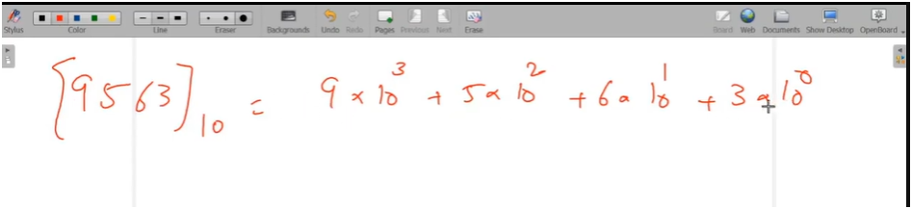

* ON EACH PLACE THE NUMBERS WILL BETWEEN 0 TO 9 THEN MAX NUMBER BE 9999 THESE MEANS EACH NUMBER BE 10 TIMES OF OTHER

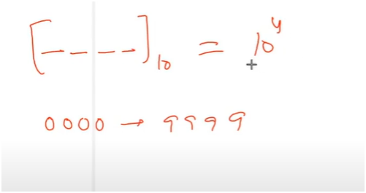

* BIGGEST DECIMAL NUMBER

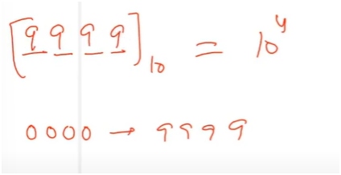

**BINNARY(0-1)**

* ON EACH PLACE THE NUMBERS WILL BETWEEN 0 TO 1 THEN MAX NUMBER BE 1111 THESE MEANS EACH NUMBER BE 2TIMES OF OTHER

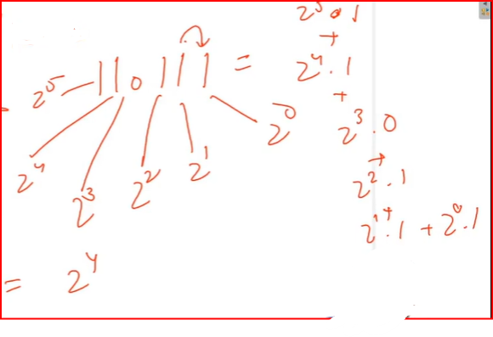

* BIGGEST BINNNARY NUMBER

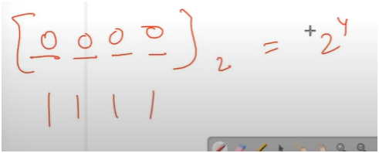

**OCTA(0-7)**

* ON EACH PLACE THE NUMBERS WILL BETWEEN 0 TO 7 THEN MAX NUMBER BE 7777 THESE MEANS EACH NUMBER BE 8TIMES OF OTHER

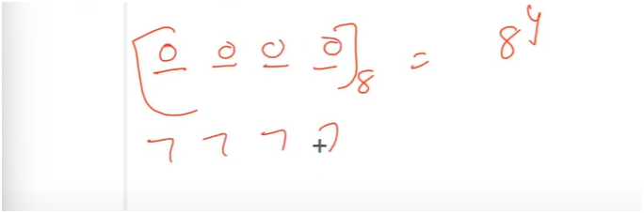

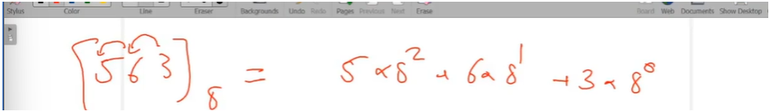

**CONVERSION OF NUMBER SYSTEMS**

* JISME CONVERT KARNA AHE USKE BASE SE CONTINUOUS DIVIDE KARO
* AGAR BASE 2 HOO THO THEN CONTINUOUS DIVIDE 2
* AGAR BASE 10 HOO THO THEN CONTINUOUS DIVIDE 10
* 🧠 **"Decimal to Any Base (Binary, Octal, etc.)** – Just **write remainders in reverse** (ulta likho)."
* 🧠 **"Any Base to Decimal** – Just **multiply each digit by its base raised to position and add all.**"

**QUOTIENT | REMAINDER PATTERN DECIMAL TO BINNARY**

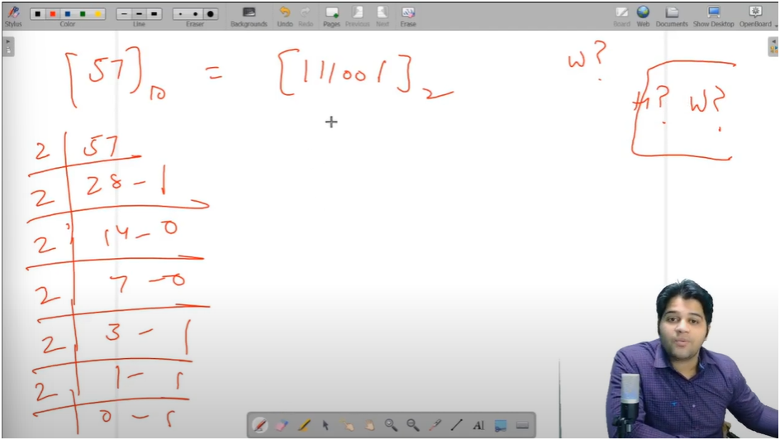

**BINNARY TO DECIMAL**

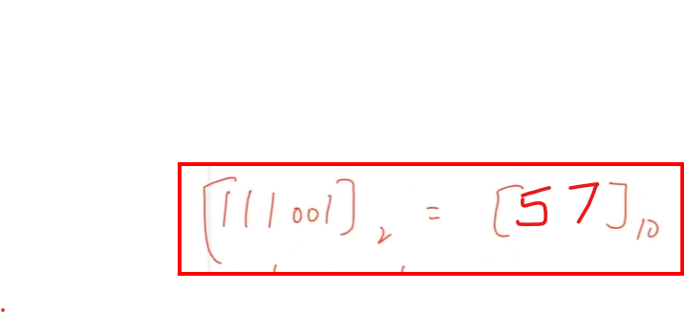

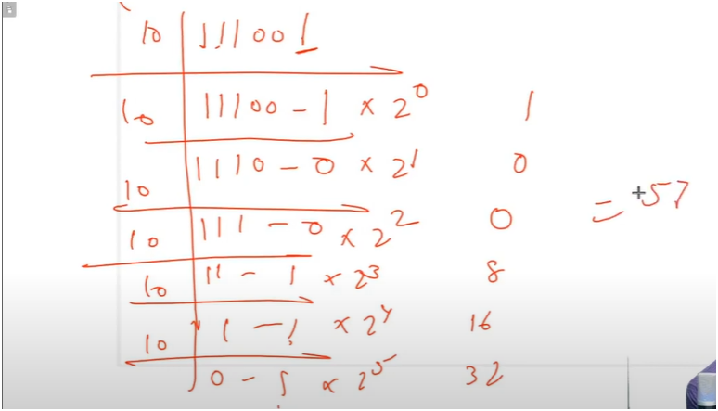

HERE CONVERSION BASE IS FIXED

**OCTA TO DECIMAL**

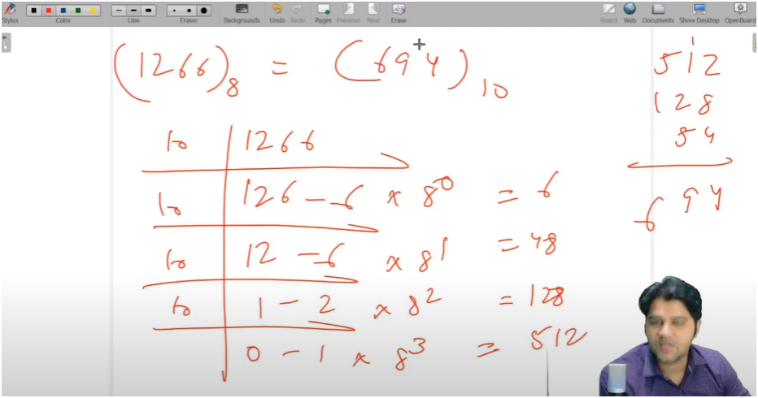

**DECIMAL TO OCTA**

