**CONVERT ANY BASE NUMBER TO DECIMAL**

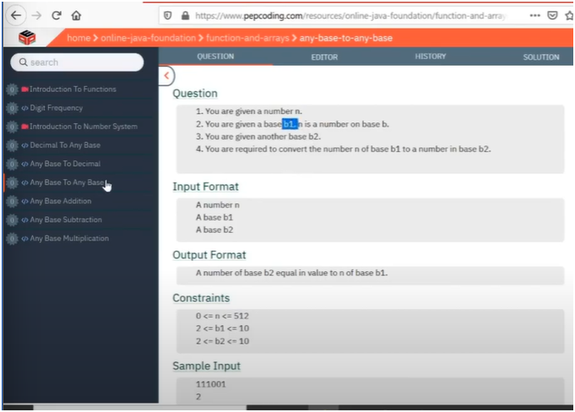

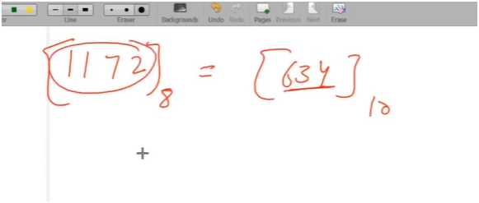

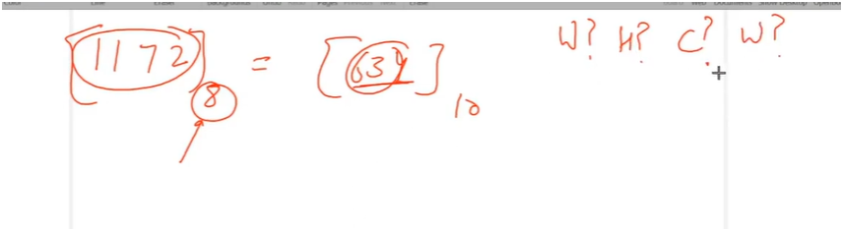

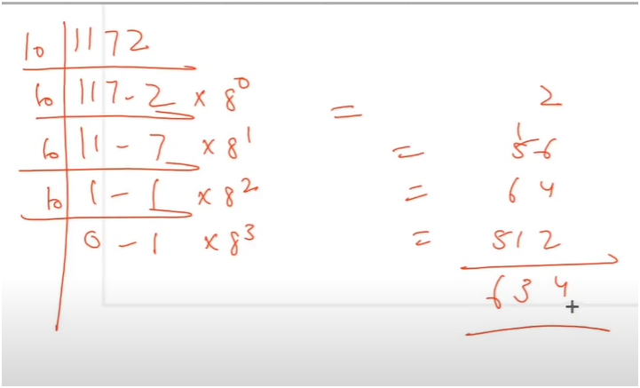

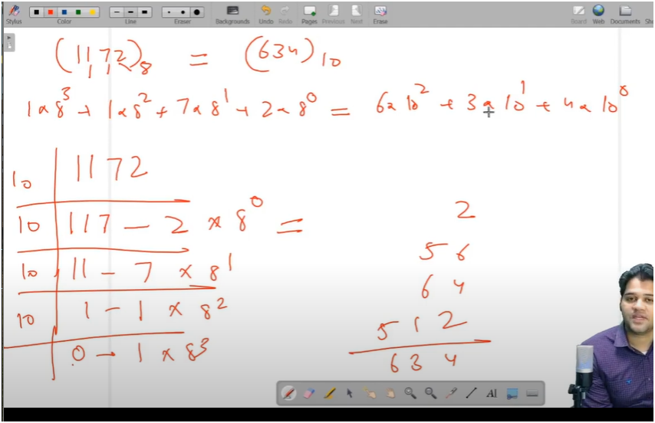

**UNDERSTANDING:-**

**TIP:-**

**Continuously modulus and divide the number by 10 (to extract each digit),  
and multiply each digit by increasing powers of the base.  
Finally, add all results to get the decimal number.**

* **IF U OBSERVE CAREFULLY WE CAN OBSERVE THERE IS QUOTIENT REMAINDER PATTERN**
* **WHERE WHILE LOOP WILL RUN UNTIL QUOTIENT NOT GETS EQUAL TO ZERO**
* **HERE WE SAVE THE REMAINDER(NUMBER MODULUS BY 10)IN DIG AND THEN MULTIPLY IT BY INCREASING POWER(BASE)**
* **IF BASE IS 8**
  + **FIRST REMAINDER 1172 MODULUS BY 10 IS 2 THEN 2*8^0 AND POWER WILL BE 1**
  + **FIRST REMAINDER 117 MODULUS BY 10 IS 7 THEN 7*8^1 AND POWER WILL BE 8**
  + **FIRST REMAINDER 11 MODULUS BY 10 IS 1 THEN 7*8^2 AND POWER WILL BE 64**
  + **FIRST REMAINDER 1 MODULUS BY 10 IS 1 THEN 2*8^3 AND POWER WILL BE 512**
* **THEN ADD ALL THIS DIGIT*POWER INTO SUM**

**ALGORITHM:-**

**🧾 Function Breakdown: converter(int number, int base)**

**This function converts a number from any given base to decimal.**

**🔁 Logic:**

* **Start with power = 1 and sum = 0**
* **While number is not 0:**
  1. **Extract the last digit: digit = number % 10**
  2. **Update number: number = number / 10**
  3. **Add: sum += digit * power**
  4. **Update power: power *= base**
* **Return sum**

**📌 Final Rule to Remember:**

🔁 **Base to Decimal**:  
**Extract each digit using % 10, multiply it by base^power,  
keep increasing the power, and sum all results.**