**CONVERT DECIMAL TO ANY INPUT BASE GIVEN**

**🔄 Key Concept:**

**Continuously divide the decimal number by the base, and collect the remainders.  
The final converted number is the reverse of these remainders.**

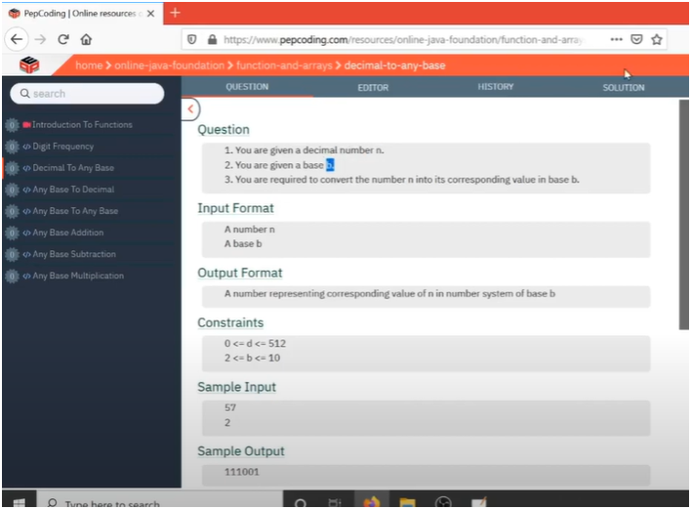

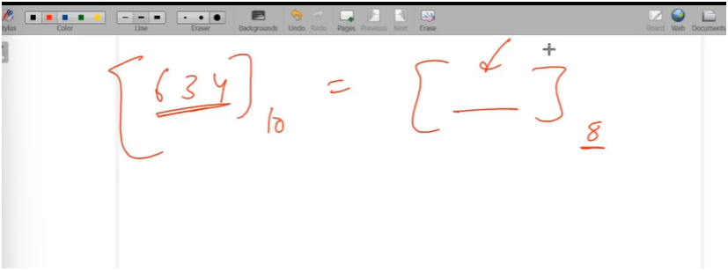

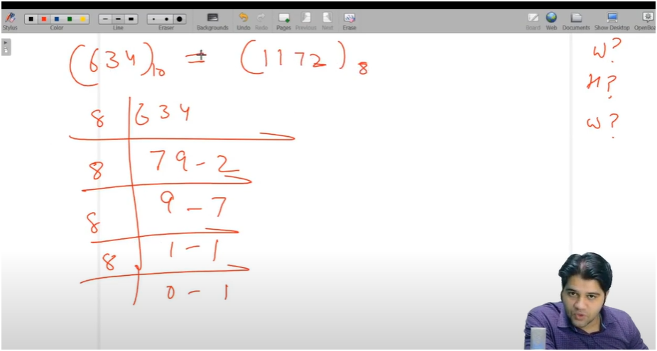

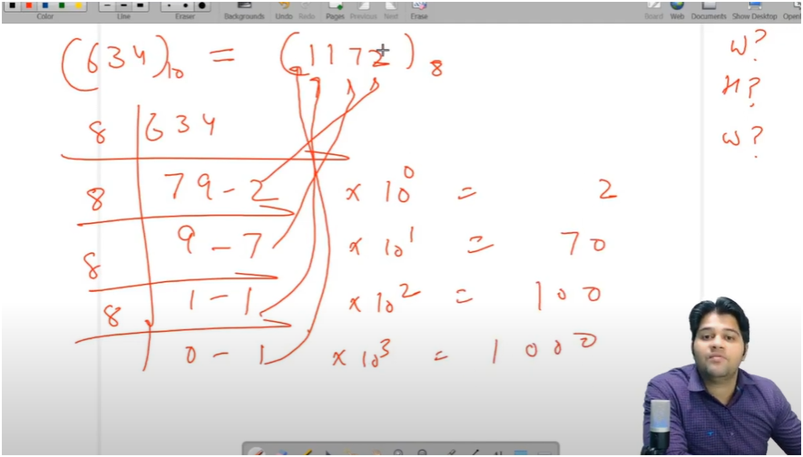

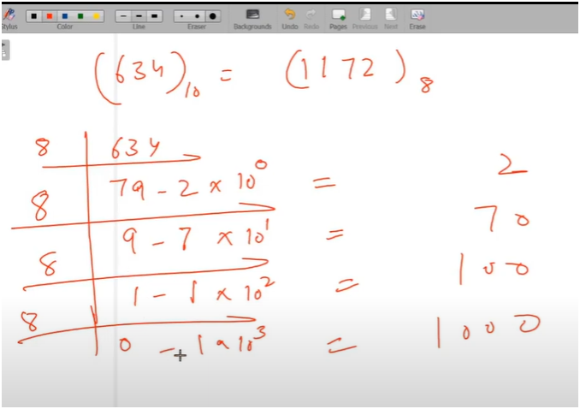

**TIP:-FOR CONVERTING DECIMAL TO ANY BASE NUMBER WE NEED TO CONTINUOUSLY DIVIDE THE NUMBER BY BASE NUMBER AND WHAT WILL BE THE REMAINDER JUST REVERSE IT**

* **IF WE OBSERVED CLEARLY THERE IS A QUOTIENT AND REAMINDER PATTERN PRESENT**
* **WE HAD USE WHILE LOOP AND THIS LOOP WILL RUN UNTIL QUOTIENT DOESN’T GETS EQUL TO ZERO**
* **THEN DO MODULUS OF NUMBER AND STORE THE LAST DIGIT IN DIG AND THEN MULTIPLY THE DIG WITH INCREASE POWER(THAT IS 10^POWER)**
* **MEANS**
  + **FOR FIRST REMAINDER IT IS 2 THEN 2 *10^0**
  + **FOR SECOND REMAINDER IT IS 7 THEN 7 *10^1**
  + **FOR THIRD REMAINDER IT IS 1 THEN 1 *10^2**
  + **FOR FOURTH REMAINDER IT IS 1 THEN 1 *10^3**
  + **FOR FIFTH REMAINDER IT IS 0 THEN 0 *10^0**
* **AND NOW JUST ADD ALL REMAINDER*POWER AND THEN RETURN THE VALUE**

**ALGORITHM:-**

**🔍 Pattern Observed: Quotient & Remainder Logic**

1. Use a **while loop**.
2. Loop runs **until the quotient becomes zero**.
3. In each iteration:
   * Use number % base to get the **last digit (remainder)**.
   * Store that digit.
   * Multiply digit by increasing powers of 10 (if you want to store result in decimal form).
   * Update number using number = number / base.

**📌 Final Rule to Remember:**

🔁 **Decimal to Any Base**: "Divide and reverse the remainders."  
➕ **To store as a number**: Multiply each remainder by increasing powers of 10 and **add**.