INVERSE A NUMBERS

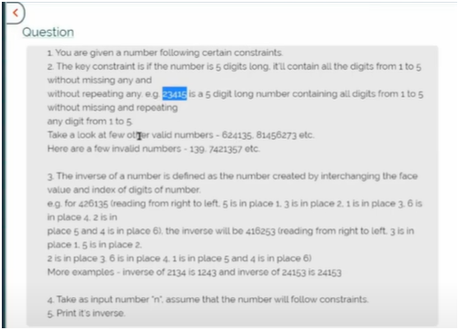

TO GET INVERSE OF ANY NUMBER FIRST OF ALL SEE ALL DIGITS ARE PRESENT IN THAT RANGE

EG:-

4132 THUS VALID NUMBER BECAUSE ALL DIGITS ARE IN RANGE FROM 1 TO 4 AND AS WELL AS THERE ARE 4 DIGITS

315462 THUS VALID NUMBER NUMBER BECAUSE ALL DIGITS ARE IN RANGE FROM 1 TO 6 AND AS WELL AS THERE ARE 6 DIGITS

139 INVALID NUMBER NUMBER BECAUSE ALL DIGITS ARE NOT IN RANGE FROM 1 TO 3 AND AS WELL AS THERE ARE 3 DIGITS

JITNA LENGTH REHEGA NUMBER KA UTNA HEE DIGITS USS LENGTH KE RANGE MAE REHENGE

NOW HOW TO DO INVERSE

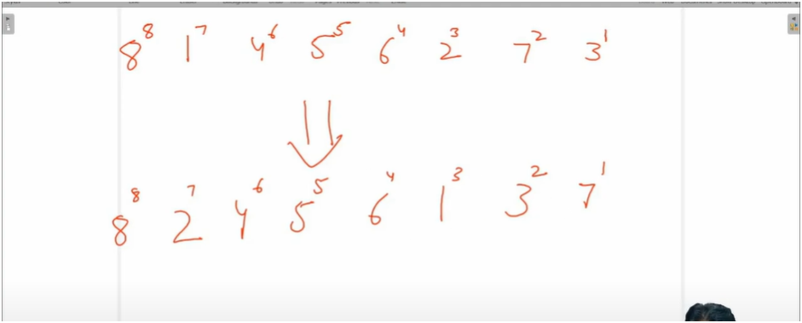

NOW SEE

3 AT FIRST POSITION

7 AT SECOND POSITION

2 AT THIRD POSITION

6 AT FOURTH POSITION

5 AT FIFTH POSITION

4 AT SIXTH POSITION

1 AT SEVENTH POSITION

8 AT EIGHT POSITION

INVERSE WILL BE JUST INTERCHANGE NUMBERS AND POSITION MEANS **1 AT THIRD POS**

1ST POS=7

2ND POS=3

3RD POS=1

4TH POS=6

5TH POS=5

6TH POS=4

7TH POS=2

8TH POS=8

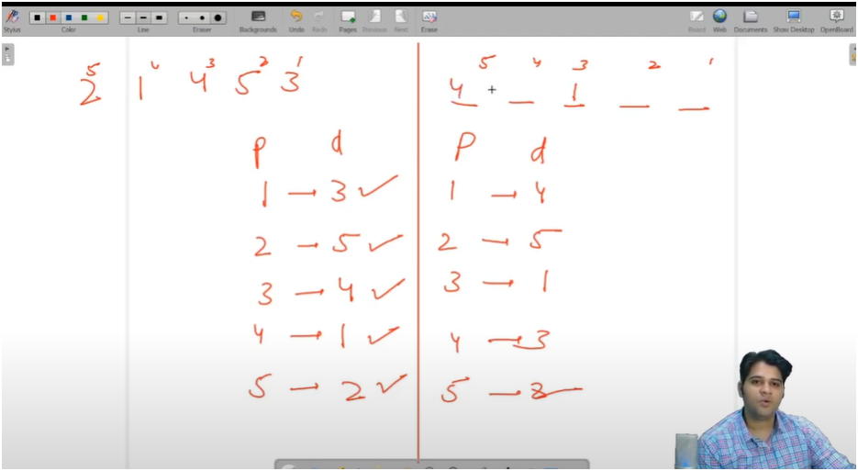

INPUT NUMBER EACH DIGIT POSITION WE CAN GET FROM MDULUS NUMBER AND THEN INCREMENTING POS BY 1

AND THEN FOR INVERSE NUMBER POSITION AND DIGIT WE CAN GET REPALCE POS AND DIG TO DIG AND POS

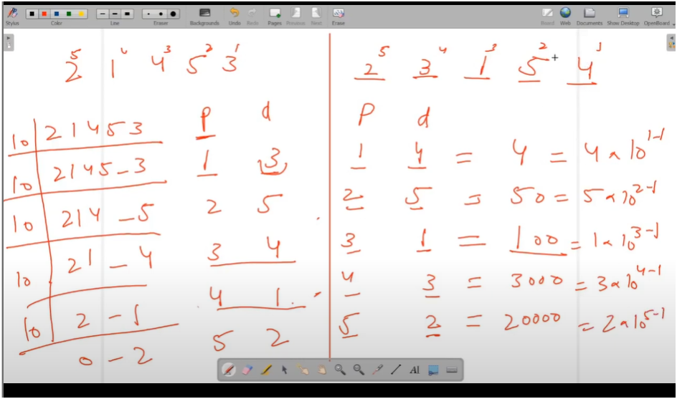

ALGO:-

**\* Algorithm to find the inverse of a number:**

**\* Example: For input 4213, output will be 2314**

**\* Explanation: The position and digit values are swapped to form the inverse**

**Position: 1 2 3 4**

**Digit: 4 2 1 3**

**Inverse: 3 1 4 2 → 2314**

**\* Step-by-step explanation:**

**1. Initialize original position `op` to 1.**

**2. Run a while loop until the number `n` becomes 0 (quotient is zero).**

**3. In each iteration:**

**\* a. Get the last digit of the original number using `od = n % 10` (original digit).**

**\* b. Set:**

**\* - Inverse position `ip = od` (digit becomes position)**

**\* - Inverse digit `id = op` (position becomes digit)**

**\* c. Update the inverse value using:**

**\* inv = inv + id * 10^(ip - 1)**

**\* d. Remove the last digit from `n` using integer division: `n = n / 10`**

**\* e. Increment the original position: `op++`**

**\* 4. Finally, print the calculated inverse.**