QUOTIENT|REMAINDER

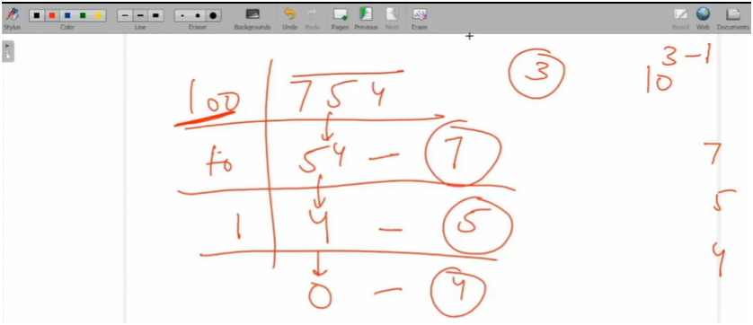

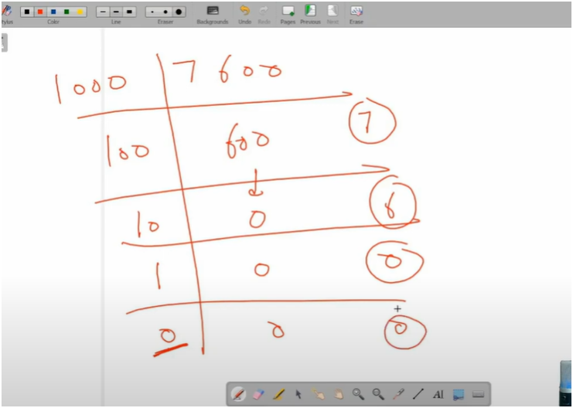

ALGO:-

FIRST COUNT DIGITS

HERE WHILE LOOP WILL RUN UNTIL UR QUOTIENT NOT GETS EQL TO ZERO

THEN PRINT EACH DIGIT OF NUMBER

HERE WHILE LOOP RUN UNTIL UR MODULUS(REMAINDER) OR DIV GETS NOT EQL TO ZERO

THEN FIRST FOR PRINTING DIGITS MAKE USE OF REMAINDER THAT IS NUMBER%10

THEN FOR RUNING WHILE LOOP MAKE USE OF QUOTIENT THAT IS NUMBER/10

THEN DECREASE DIV BY 10 FOR EACH LOOP