QUOTIENT|REMAINDER

HERE REMAINDER GIVES U LAST DIGIT OF NUMBER

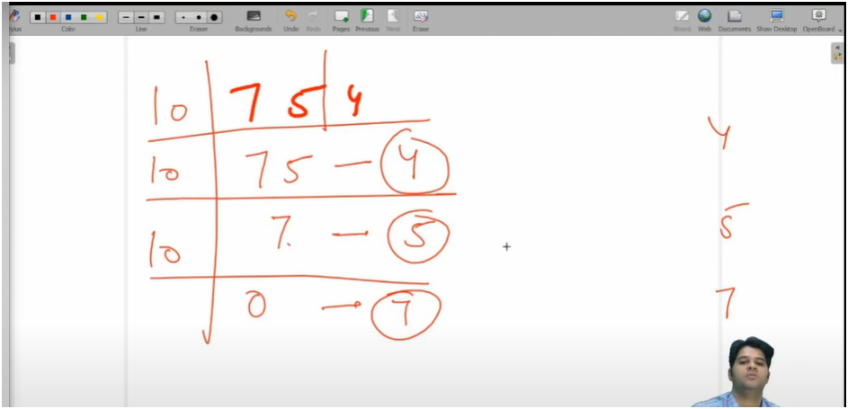

ALGO:-

HERE WHILE LOOP RUN UNTILL UR QUOTIENT NOT GETS EQUAL TO ZERO

TO INCREMENT THE LOOP WE CONTINUOUSLY DIVIDE THE NUMBER

AND TO GET LAST DIGIT WE DO MODULUS OF NUMBER

AND THEN PRINT LAST DIGIT

QUOTIENT|REMAINDER FOR COUNTING DIGITS,REVERSE NUMBER

REMAINDER|QUOTIENT TO PRINT EACH DIGIT OF NUMBER