FBONACCI

FIRST INTIALIZE TWO NUMBERS THAT IS 0 AND 1

THEN FOR THIRD NUMBER ADD FIRST AND SECOND NUMBER

THEN FOR FOURTH NUMBER ADD SECOND AND THIRD NUMBER AND SO ON

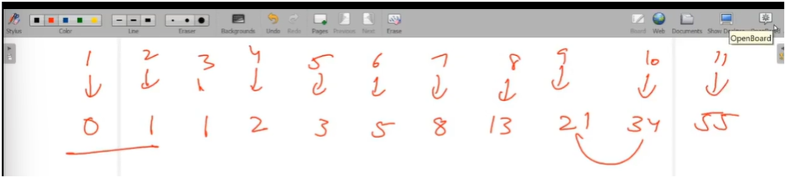

ALGO:-

FIRST INTIIALIZE I AND J TO 0 AND 1

FIRST RUN THE LOOP FOR HOW MANY FIBONNAIC NUMBERS U WANT

THEN NEXT=I+J

I=J

J=NEXT

VISUALIZATION

HERE A AND B MOVE FORWARD SO IF WE PRINT JUST A WE WILL GET RESULT

