REMAINDER WE CAN GET IT FROM MODULUS %

WE GET DIGITS

QUOTIENT WE CAN GET IT FROM DIVISION //

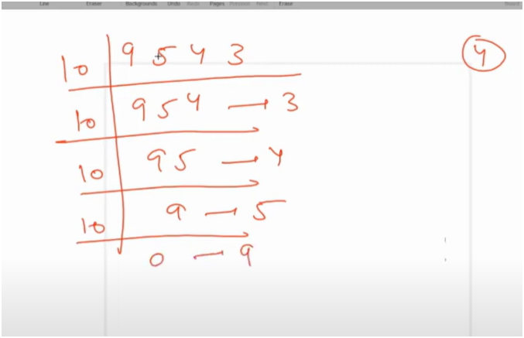

FIND THE QUOTIENT AND REMAINDER OF NUMBER

ALGO:-

STOP THE WHILE LOOP ONCE THE QUOTIENT GETS EQUAL TO ZERO

THEN CONINUE DIVIDE THE QUOTIENT TO INCREMENT THE QUOTIENT SO THAT LOOP WILL RUN